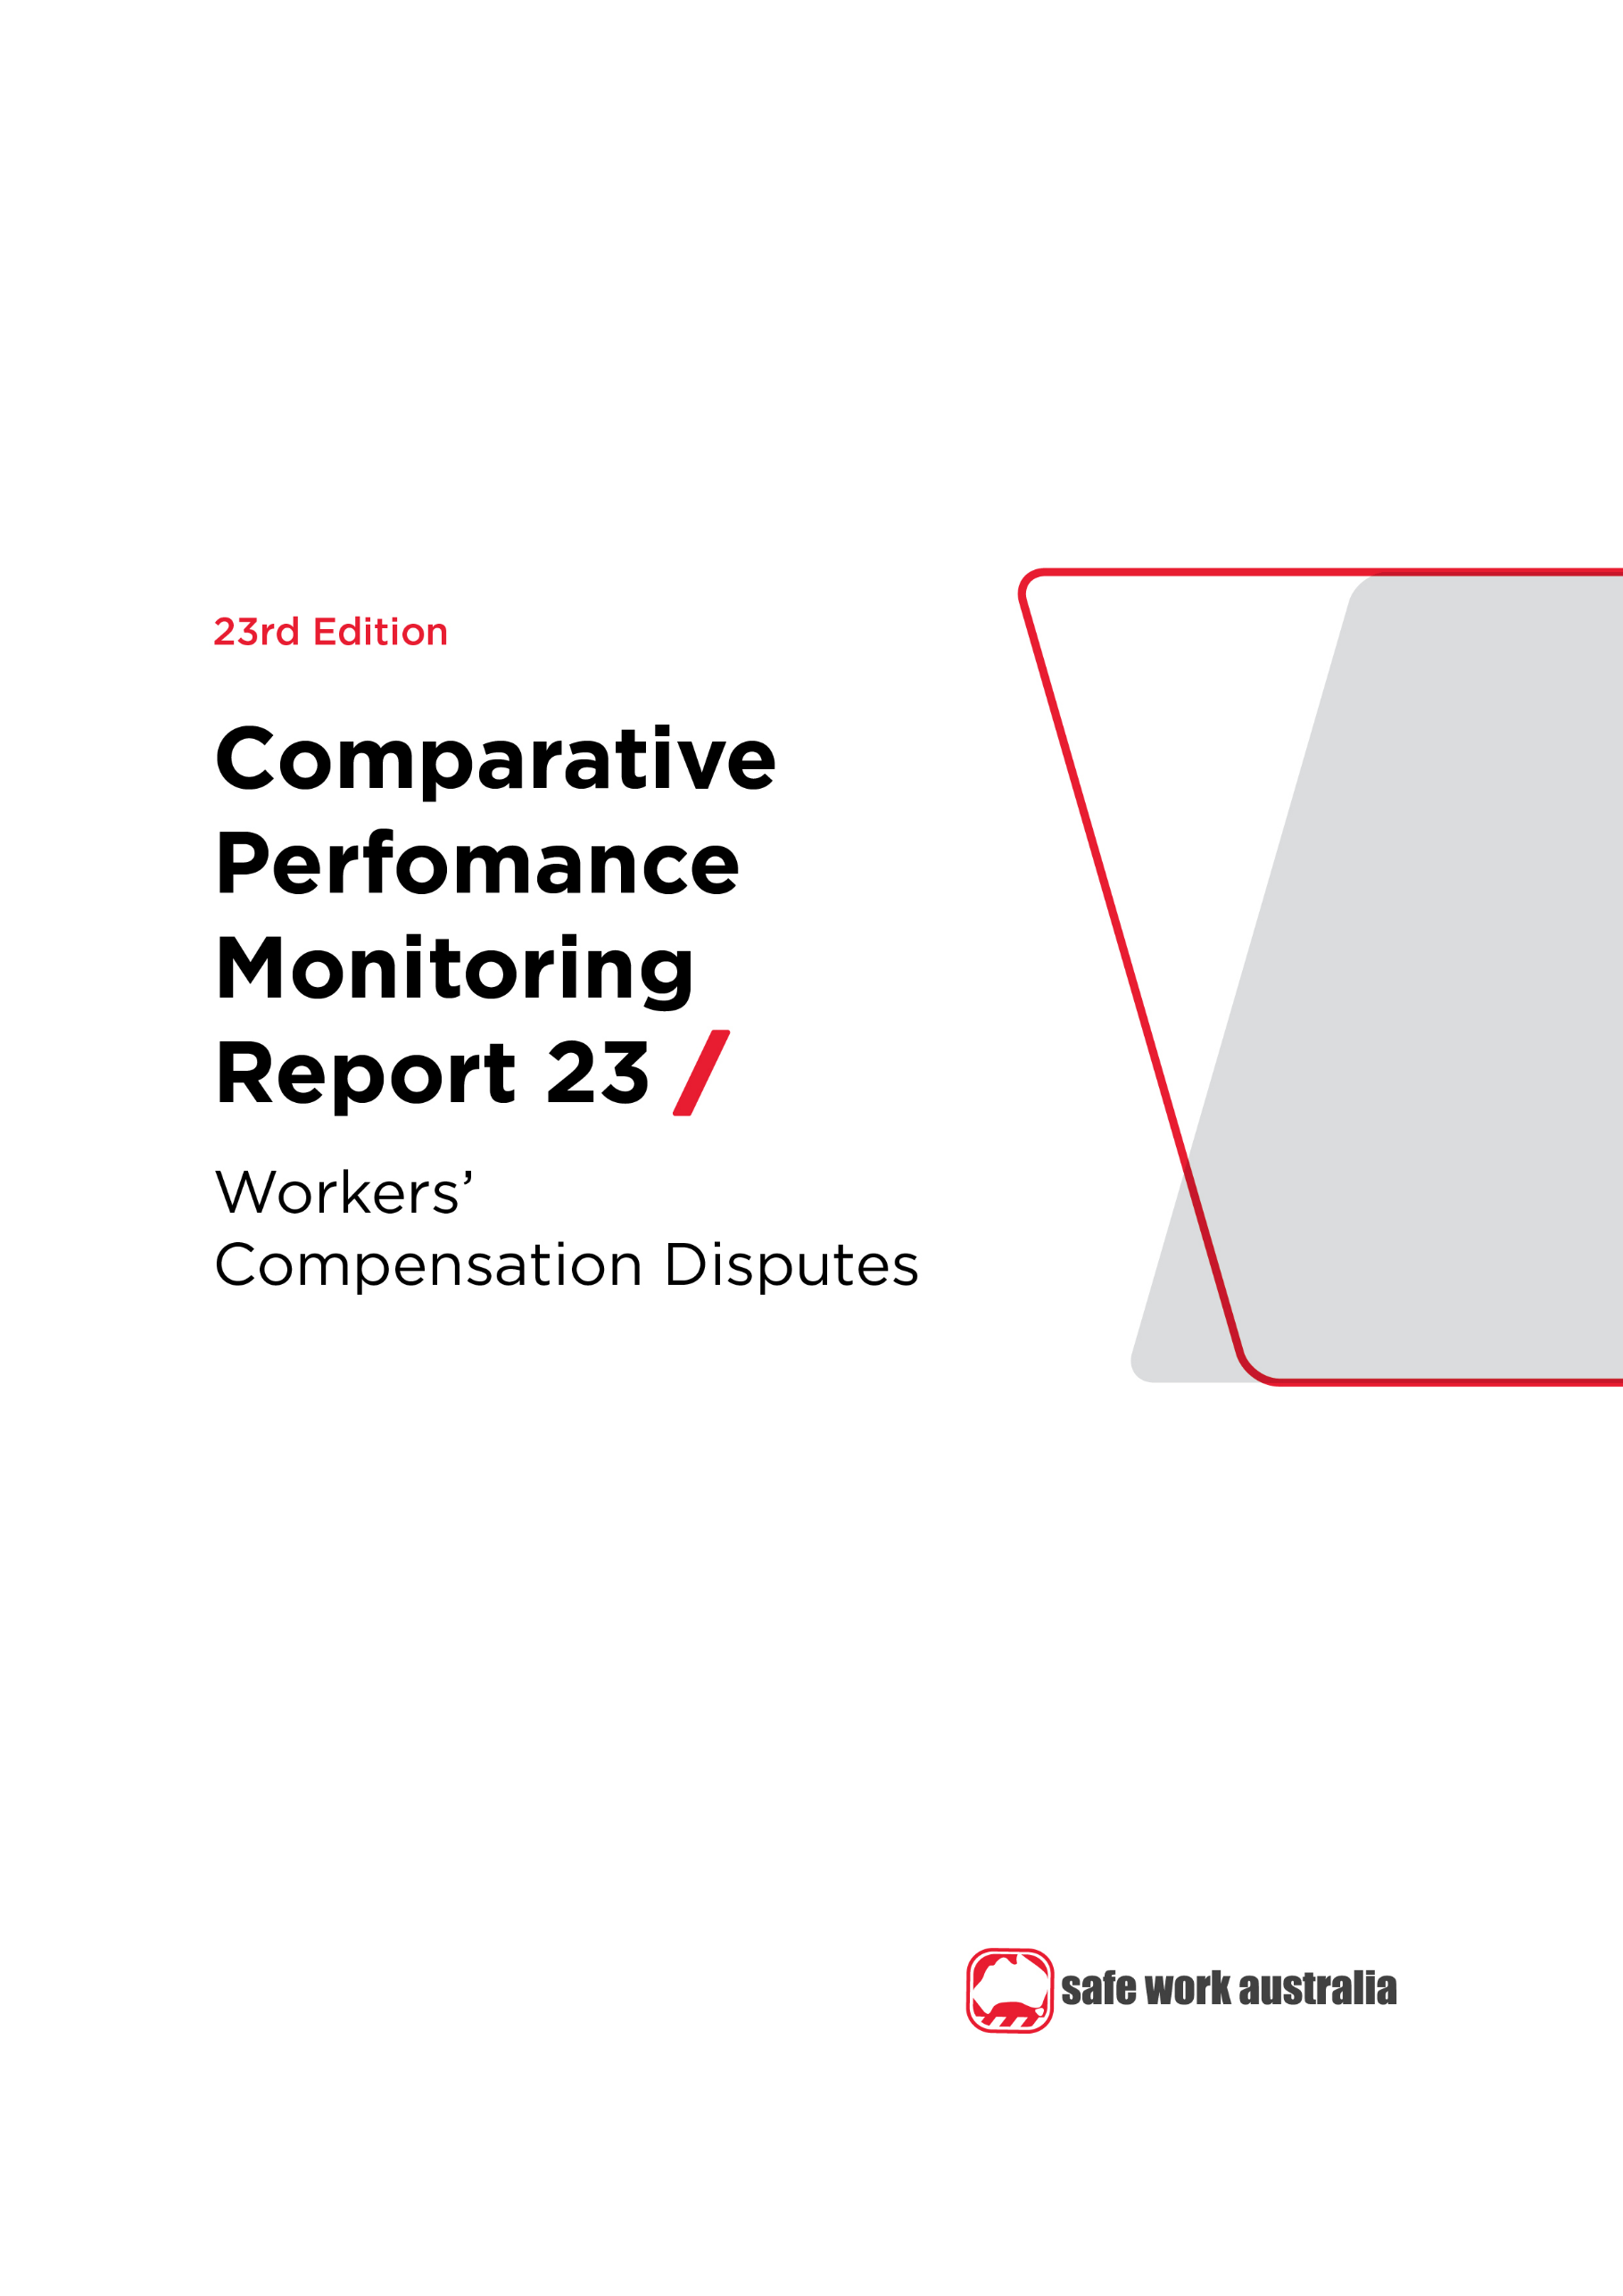

Disclaimer

Safe Work Australia is an Australian Government statutory agency established in 2009. Safe Work Australia includes Members from the Commonwealth, and each state and territory, Members representing the interests of workers and Members representing the interests of employers.

Safe Work Australia works with the Commonwealth, state and territory governments to improve work health and safety and workers’ compensation arrangements. Safe Work Australia is a national policy body, not a regulator of work health and safety. The Commonwealth, states and territories have responsibility for regulating and enforcing work health and safety laws in their jurisdiction.

**ISSN 2209-9158**

Creative Commons

With the exception of the Safe Work Australia logo, this copyright work is licensed under a Creative Commons Attribution 4.0 International licence. To view a copy of this licence, visit creativecommons.org/licenses. In essence, you are free to copy, communicate and adapt the work, even commercially, as long as you attribute the work to Safe Work Australia and abide by the other licence terms.

Contact information

Safe Work Australia | <mailto:info@swa.gov.au> | [www.swa.gov.au](http://www.swa.gov.au)

Contents

Foreword 4

1. Introduction 5

1.1 Disputation rate 5

1.2 Dispute resolution 6

Appendix 1 – Jurisdictional contact information 8

Foreword

This is the 23rd edition of the Comparative Performance Monitoring (CPM) report which provides trend analyses about work health and safety and workers’ compensation schemes operating in Australia and New Zealand.

This report has been compiled and coordinated by Safe Work Australia with assistance from representatives of all work health and safety and workers’ compensation authorities in Australia and New Zealand. Through a partnership of governments, employers and employees, Safe Work Australia leads the development of national policy to improve WHS and workers’ compensation arrangements across Australia.

The report is presented in the following sections:

* *Work health and safety performance* – provides an overview of work health and safety performance across Australia and New Zealand through analysing trends in serious claim rates and work-related fatalities across jurisdictions.
* *Work health and safety compliance and enforcement activities* – includes a jurisdictional comparison of workplace interventions, inspectorate activity, safety notices, enforceable undertakings, legal proceedings and fines.
* *Workers’ compensation premiums -* includes a national and jurisdictional overview of the standardised average premium rates by industry in the past 5 years.
* *Entitlements under workers’ compensation (scenarios)* – illustrates the differences in entitlement levels across jurisdictions under several scenarios.
* *Workers’ compensation funding – assets, liabilities and expenditure* – includes information about the different funding arrangements of the schemes and compares the differences in scheme funding arrangements and finances.
* *Workers’ compensation disputes* – includes information about disputes against an insurer’s decision or decisions relating to compensation (this section).

Previous editions of the CPM report also included return to work rates as measured in the National Return to Work Survey. At the time of writing, the latest available survey results were from the 2018 Survey. For trend data on the return to work rates (from 2012 to 2018) please refer to the [*22nd edition of the CPM (Part 3)*](https://www.safeworkaustralia.gov.au/resources-and-publications/statistical-reports/comparative-performance-monitoring-report-22nd-edition-part-3). Results from the 2021 National Return to Work Survey will be published on the [Safe Work Australia](https://www.safeworkaustralia.gov.au/data-and-research/measuring-return-work-outcomes) website from late 2021.

Readers may find the [*Comparison of Workers’ Compensation Arrangements in Australia and New Zealand*](https://www.safeworkaustralia.gov.au/workers-compensation/comparing-workers-compensation-australia) useful as it discusses the way that each scheme deals with key aspects such as coverage, benefits, self‑insurance, common law and disputes.

*About the data*

Data in this publication may differ from jurisdictional annual reports due to the use of different definitions and the application of adjustment factors to aid in the comparability of data.

These statistics should be considered in the broader context of the COVID-19 pandemic when comparing data over previous periods. The potential impact of the COVID-19 pandemic on this data are explored in the [*COVID-19 and Safe Work Australia data*](https://www.safeworkaustralia.gov.au/resources-and-publications/statistical-reports/covid-19-and-safe-work-australia-data) report.

The CPM does not currently include information or data from other industry-specific regulators that have responsibilities with respect to WHS and workers’ compensation. These include national industry-based regulators with compliance and enforcement roles such as the National Heavy Vehicle Regulator, the National Rail Safety Regulator and the National Offshore Petroleum Safety and Environmental Management Authority, and other agencies with responsibility for industry‑specific compensation claims. Further information on these regulators can be found on their respective websites.

In this report ‘Australian Government’ is used for indicators relating to WHS and workers’ compensation matters under the Australian Government jurisdiction, while ‘Comcare’ is used for the indicators relating to premium rates and entitlements.

1. Introduction

A dispute is an appeal to a formal mechanism, such as a review officer, conciliation or mediation service, against an insurer’s decision or decisions relating to compensation. Disputes exclude common law and redemptions and commutations unless they are processed as disputes through the jurisdiction’s dispute resolution system.

Data on disputes related to the Australian Capital Territory (Private) Compensation scheme are not reported in the Comparative Performance Monitoring Report.

* 1. Disputation rate

Indicator 21 shows the number of new disputes as a proportion of ‘active’ claims in the reference financial year. An active claim is described as any claim on which a payment of any type was made during the reference financial year (including claims with medical treatment costs only) regardless of when that claim was lodged.

The measure includes all disputes lodged for the year against any active claim that had any type of payment in the reference financial year. However, there could be a small number of disputes lodged against claims that are not active, such as liability disputes. The comparison of disputation rates between jurisdictions must be made with caution due to jurisdictional differences in scheme design, types of decisions that can be appealed, dispute resolution models and the cost of appeals.

**National**

* The Australian disputation rate (4.5% of active claims) in 2019–20 has **decreased by 26%** since 2015–16.

**Jurisdictions**

* 7 out of 9 Australian jurisdictions recorded decreases in disputation rates during the 5 year period (2015–16 to 2019–20).
* The largest decrease was in New South Wales (**i down 45%**), followed by Victoria (**i down 28%**).
* The 2 jurisdictions recording increases were Western Australia (**h up 14%**) and Tasmania (**h up 4%**).
* The New Zealand disputation rate is very low (0.7%) because of the universal nature of its accident compensation scheme. Since people are covered whether the incident occurs at work, home, on the road, playing sport and whether they are employed, self-employed or a non-earner (child, pensioner, student, unemployed) there are very few disputes relating to cover.

Indicator 21 – Proportion of claims with dispute

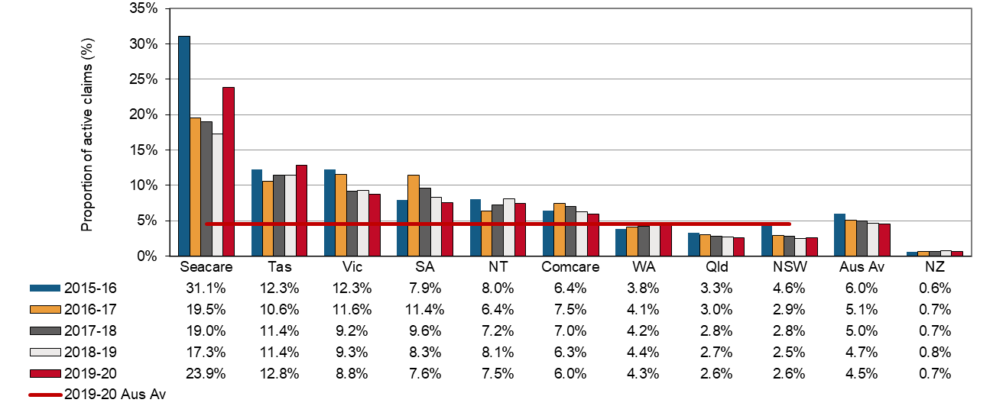

* 1. Dispute resolution

The speed with which disputes are resolved depends on the systems and processes that are in place for each jurisdiction. Generally, the simpler the process, the faster the dispute is resolved. Where there is a lag in collection, exchange and lodgment of information by one or more parties, disputes are likely to be more adversarial and therefore more costly. A high percentage of disputes resolved in a longer time frame may also indicate that there are a high number of more complex disputes being dealt with within a jurisdiction, or that there are some mandatory medical or legal processes in place that inherently delay resolution.

**National**

Indicator 22 shows that in the past 5 years, 2015–16 to 2019–20 in Australia, disputes have taken longer to resolve with:

* a substantial decrease (**i down 26%**) in the proportion of disputes resolved within one month, and
* decreases in the percentage of disputes resolved within 3 months, 6 months and 9 months (**i down** **7%, 4% and 2%,** respectively).
* In 2019–20, more than half the disputes (59%) were resolved within 3 months of the date of lodgment on average in Australia.

**Jurisdictions**

* Tasmania and Western Australia resolved the highest proportion of disputes within 3 months (74% each), followed by Queensland (71%). Since 2015–16, Tasmania recorded an increase in this proportion (**h up 5%**) while Western Australia and Queensland both recorded decreases (**i down 5% and 18%** respectively).
* In New South Wales there has been a large decrease in the proportion of disputes resolved within one month since 2015–16 (**i down** **64%**), however there were increases in the resolution rates for all other time periods for disputes resolved within 3 months (**h up** **18%**), 6 months (**h up** **7%**) and 9 months (**h up** **5%**). Overall 63% of disputes were resolved within 3 months.
* Timeliness figures for New South Wales were affected by activities such as medical specialist assessments in permanent impairment disputes and internal appeal processes for decisions by Arbitrators and assessments by Approved Medical Specialists.
* Victoria also experienced decreases in the proportion of disputes resolved since 2015–16 – with rates for one month (**i down** **44%**), 3 months (**i down** **16%**), 6 months (**i down** **9%**) and 9 months (**i down** **4%**) all decreasing.
* The resolution times for Victoria are affected by the compulsory conciliation process, which may or may not involve medical panel referral, and the fact that court litigation can only occur at the conclusion of the compulsory conciliation process.
* Comcare disputes generally take more time to resolve than disputes in other jurisdictions. Comcare recorded the lowest proportion of disputes resolved for 3 out of 4 time periods in 2019–20, with only 35% being completed within 9 months.
* As Comcare disputes are referred to an external and independent body (Administrative Appeals Tribunal), Comcare reported it has minimal control over the associated time frames for dispute resolution. Disputes tend to be complex and require a long time to resolve.
* Seacare recorded the lowest proportion of disputes resolved within one month, with only 40% completed within 9 months.
* The time it takes to resolve applications in the seafarers’ jurisdiction is influenced by many factors (such as the nature and complexity of the decisions, time needed by parties to obtain further evidence or to agree to a resolution). As the number of applications made to the Administrative Appeals Tribunal (who hear the disputes) is relatively small, any changes in the number of cases finalised can result in relatively large percentage changes in the resolution rates within the specified time frames.
* The proportion of disputes resolved in New Zealand in 2019–20 was higher than the Australian average for the 1, 6 and 9 month time periods, but lower than the Australian average for the 3 month time period.

Indicator 22 – Percentage of disputes resolved within selected time periods (cumulative)

| **Jurisdiction\*** | **Within 1 month** | **Within 3 months** | **Within 6 months** | **Within 9 months** |
| --- | --- | --- | --- | --- |
| **2015–16** |  |  |  |  |
| New South Wales | 22.8 | 53.5 | 81.9 | 90.2 |
| Victoria | 14.8 | 66.5 | 84.0 | 92.4 |
| Queensland | 9.2 | 86.5 | 95.7 | 97.5 |
| Western Australia | 41.5 | 77.8 | 86.6 | 93.5 |
| Tasmania | 60.9 | 70.9 | 80.8 | 88.3 |
| Comcare | 3.9 | 14.6 | 30.8 | 46.8 |
| Seacare | 1.6 | 14.1 | 29.7 | 39.1 |
| **Australia** | **19.7** | **63.4** | **81.9** | **89.5** |
| New Zealand | 16.5 | 62.2 | 89.7 | 96.0 |
| **2019–20** |  |  |  |  |
| New South Wales | 8.1 | 63.1 | 87.8 | 95.0 |
| Victoria | 8.4 | 56.0 | 76.5 | 89.1 |
| Queensland | 7.7 | 70.7 | 93.6 | 95.0 |
| Western Australia | 40.2 | 73.6 | 85.3 | 93.2 |
| Tasmania | 65.5 | 74.1 | 85.3 | 94.4 |
| Comcare | 4.2 | 12.5 | 21.2 | 34.8 |
| Seacare | 3.3 | 10.0 | 16.7 | 40.0 |
| **Australia** | **14.6** | **58.9** | **78.3** | **87.6** |
| New Zealand | 22.6 | 54.4 | 86.9 | 94.8 |

* South Australia and the Northern Territory cannot supply data on the time required to resolve disputes.

Appendix 1 – Jurisdictional contact information

| Jurisdiction | Organisation | Contact details |
| --- | --- | --- |
| New South Wales | State Insurance Regulatory Authority  SafeWork NSW  NSW Personal Injury Commission  icare NSW | 13 10 50  [contact@sira.nsw.gov.au](mailto:contact@sira.nsw.gov.au)  [www.sira.nsw.gov.au](http://www.sira.nsw.gov.au/)  contact@safework.nsw.gov.au  [www.safework.nsw.gov.au](http://www.safework.nsw.gov.au/)  1800 742 679  [www.pi.nsw.gov.au](http://pi.nsw.gov.au/)  [www.icare.nsw.gov.au](http://www.icare.nsw.gov.au) |
| Victoria | WorkSafe Victoria | Advisory Service 1800 136 089  [info@worksafe.vic.gov.au](mailto:info@worksafe.vic.gov.au)  [www.worksafe.vic.gov.au](http://www.worksafe.vic.gov.au/) |
| Queensland | Office of Industrial Relations | Infoline 1300 362 128  [www.worksafe.qld.gov.au](https://www.worksafe.qld.gov.au/) |
| Western Australia | WorkCover WA  Department of Mines, Industry Regulation and Safety – WorkSafe | 1300 794 744  [www.workcover.wa.gov.au](http://www.workcover.wa.gov.au/)  1300 307 877  [www.dmirs.wa.gov.au](http://www.dmirs.wa.gov.au/) |
| South Australia | ReturnToWorkSA  SafeWork SA | 13 18 55  [www.rtwsa.com](http://www.rtwsa.com/)  1300 365 255  [www.safework.sa.gov.au](http://www.safework.sa.gov.au/) |
| Tasmania | WorkSafe Tasmania | 1300 366 322 (inside Tas)  (03) 6166 4600 (outside Tas)  [wstinfo@justice.tas.gov.au](mailto:wstinfo@justice.tas.gov.au)  [www.worksafe.tas.gov.au](http://www.worksafe.tas.gov.au/) |
| Northern Territory | NT WorkSafe | 1800 019 115  [ntworksafe@nt.gov.au](mailto:ntworksafe@nt.gov.au)  [www.worksafe.nt.gov.au](http://www.worksafe.nt.gov.au/Pages/default.aspx) |
| Australian Capital Territory | WorkSafe ACT | 13 22 81  [www.worksafe.act.gov.au](https://www.worksafe.act.gov.au/) |
| Seacare | Seacare Authority | (02) 6275 0070  [seacare@comcare.gov.au](mailto:seacare@comcare.gov.au)  [www.seacare.gov.au](http://www.seacare.gov.au/) |
| Australian Government | Comcare | 1300 366 979  [www.comcare.gov.au](http://www.comcare.gov.au/) |
| New Zealand | Accident Compensation Corporation  WorkSafe New Zealand | 64 7 848 7400  [www.acc.co.nz](http://www.acc.co.nz/)  0800 030 040  [www.worksafe.govt.nz](http://www.worksafe.govt.nz) |