Measuring respirable crystalline silica

2020

Report into the effectiveness of sampling and analysis of respirable crystalline silica at a workplace exposure standard eight hour time weighted average of 0.02 mg/m3



Disclaimer

Safe Work Australia is an Australian Government statutory agency established in 2009. Safe Work Australia includes Members from the Commonwealth, and each state and territory, Members representing the interests of workers and Members representing the interests of employers.

Safe Work Australia works with the Commonwealth, state and territory governments to improve work health and safety and workers’ compensation arrangements. Safe Work Australia is a national policy body, not a regulator of work health and safety. The Commonwealth, states and territories have responsibility for regulating and enforcing work health and safety laws in their jurisdiction.

ISBN XXXX-XXXX (Print)

ISBN XXXX-XXXX (Online PDF)

ISBN XXXX-XXXX (Online DOCX)

Creative Commons

With the exception of the Safe Work Australia logo, this copyright work is licensed under a Creative Commons Attribution 4.0 International licence. To view a copy of this licence, visit creativecommons.org/licenses In essence, you are free to copy, communicate and adapt the work for non-commercial purposes, as long as you attribute the work to Safe Work Australia and abide by the other licence terms.

Contact information

Safe Work Australia | <mailto:info@swa.gov.au> | [www.swa.gov.au](https://sharedservicescentre.sharepoint.com/sites/swa-businesssupport/Communication/www.swa.gov.au)

**Contents**

**Research report** 5

**Acknowledgements** 5

**Executive Summary** 6

**Results** 6

**Recommendations for improvement of uncertainties in measuring RCS** 6

**1.** **Introduction** 7

**1.1 Polymorphs of crystalline silica** 7

**2.** **Sampling respirable dust** 8

**2.1 Personal monitoring** 8

**2.2 Sampling equipment for respirable dust** 10

**2.3 Bulk and static air sampling techniques** 10

**3.** **Sampling methodology** 12

**3.1 Number of personal monitoring air samples required in a workforce** 12

**3.2 Interpreting sampling results** 12

**3.3 Measurement requirements for eight hour and 12 hour adjusted WES** 14

**4.** **Analytical equipment, techniques and methods** 16

**4.1 Analytical equipment and techniques** 16

4.1.1 Analysis by XRD 16

4.1.2 Analysis by FTIR 17

4.1.3 Sample filters 18

**4.2 Country specific RCS sampling and analytical methods** 18

**5.** **Sources of error when sampling RCS** 20

**5.1 Exposure assessment strategies** 20

**5.2 Sampler error** 20

**6.** **Analytical Methods: detection limits and measurement uncertainty** 22

**6.1 Detection limits** 22

**6.2 Measurement uncertainty** 23

**7.** **RCS analysis: calibration and measurement uncertainty** 24

**7.1 Calibration of analytical equipment** 24

7.1.1 Calibration standards 24

7.1.2 PSD and calibration 24

**7.2 Measurement uncertainty in analytical methods** 25

**8.** **Management of bias and error in analytical methods: interlaboratory proficiency testing** 27

**8.1 Proficiency testing** 27

**8.2 RCS analysis accreditation and proficiency testing agencies** 29

**9.** **9. Discussion** 30

**9.1 Sampling programs and equipment** 30

9.1.1 Sampling programs 30

9.1.2 Sampling equipment – samplers and sample pumps 30

**9.2 Analytical processes and reporting** 31

9.2.1 Analytical methods 31

9.2.2 Calibration and proficiency testing 31

9.2.3 Reporting 33

**10.** **Conclusion** 34

**11.** **Recommendations to improve RCS measurement** 35

**12.** **References** 36

**13.** **Appendices** 41

**Appendix A: Comparison of respirable dust efficiency curves** 41

**Comparison of respirable dust efficiency curves** 41

**Appendix B: Comparison of respirable dust sampler 50% cut off point** 43

**Research report**

# **Acknowledgements**

This Report was written by Laurie Glossop and Chris White with the draft report being reviewed by several people with significant knowledge and experience in relation to respirable crystalline silica. The reviewers did this work on a voluntary basis which was much appreciated.

This final report has taken into account the reviewers’ comments, but the report has not adopted all their suggested changes, so the report is not necessarily endorsed by the reviewers.

The reviewers in alphabetical order were:

* Ian Firth
* Akemi Ichikawa
* Peter Knott
* Martin Mazereeuw.

**Executive Summary**

Following an independent review of the workplace exposure standard (WES) for respirable crystalline silica (RCS), the health-based recommendation for RCS was to reduce the workplace exposure standard eight hour time weighted average (WES-TWA) exposure from 0.1 to 0.02 milligrams per cubic metre (mg/m3). However, stakeholders raised concerns about whether this WES could be accurately measured with sufficient precision, particularly when the TWA needs to be adjusted to account for work shifts much longer than eight hours. As a result, Ministers for Work Health and Safety (WHS) agreed to reduce the WES-TWA for RCS to 0.05 mg/m3 and agreed for Safe Work Australia to undertake further work to investigate the measurement concerns.

Safe Work Australia engaged Glossop Consultancy to research and report on the uncertainty and effectiveness of sampling and analysis of RCS at and below a WES-TWA of 0.02 mg/m3. In the remainder of the report the WES-TWA will be written simply as WES for readability.

The report was informed through a literature review and targeted interviews with domestic and international experts in occupational hygiene and laboratory analysis.

## **Results**

Accurately measuring RCS exposures is dependent on correct sampling (respirable dust samplers and representative exposures), proficient analysis and reporting of results with the degree of uncertainty of the measurement included. This report found that uncertainty in measurement is significantly increased at and below a WES of 0.02 mg/m3. The uncertainties for measuring RCS are compounded by several factors including sampling error, analytical uncertainty and laboratory reporting and performance.

## **Recommendations for improvement of uncertainties in measuring RCS**

To assist with improving available methods, it is recommended that further work be undertaken to:

1. Introduce or encourage a system of RCS sampler validation including requiring manufacturers to demonstrate that their equipment performs in accordance with the Australian Standard for respirable dust. The current Australian Standard adopts the International Standards Organisation respirable dust definition.
2. Review standing guidelines on sampler compliance with respirable dust efficiency curves with a view to adopt international standards for compliance in Australia.
3. Require all laboratories that undertake RCS sample analysis to:
   * be enrolled in an appropriate quality assurance program, and
   * report limits of detection, limits of quantitation and uncertainty with RCS sample results.
4. Improve quality assurance programs and for them to provide validation samples to reflect real world RCS samples that often have interfering minerals in analysis and to provide sample filter loadings closer to the Limit of Detection (LoD) and Limit of Quantitation (LoQ).
5. Develop a comprehensive suite of guidance materials aimed at improving best practice throughout the air monitoring and analysis process as has been adopted for asbestos.

* + - 1. **Introduction**

Setting a standard for a working lifetime of exposure to a hazardous chemical is both a matter of science and judgement. The rationale for the recommended workplace exposure standard (WES) for respirable crystalline silica (RCS) is primarily based on the dose-response relationships observed in epidemiological studies of exposed cohorts for specific endpoints, such as silicosis or lung cancer. The focal point of exposure assessment – both sampling and analysis – is to determine the quantity of crystalline silica in the respirable fraction of dust. Measuring the respirable fraction of dust is important as this is the size fraction that penetrates to the non-ciliated and gas-exchange areas of the lungs and where the toxic effect of RCS is exhibited (Daniels et al., 2020; Eschenbacher, Kullman, & Gomberg, 2000; Standards Australia, 2009).

This report reviews the current methodologies for the sampling, analysis and reporting of RCS in the occupational setting at a health-based workplace exposure standard 8- hour time weighted average (WES) of 0.02 mg/m3 proposed by Safe Work Australia (SWA). In many workplaces the adjusted WES will be 30% lower due to the extended 12 hour shifts practised in some industries, especially mining. This means an adjusted WES of 0.014 mg/m3 must be complied with.

**1.1 Polymorphs of crystalline silica**

The major polymorphs (same chemical formula, but different crystalline structure) of crystalline silica are:

* $α$-quartz
* cristobalite
* tridymite
* chert
* tripoli, and
* some, even rarer polymorphs.

The most common exposure is to $α$-quartz (commonly termed quartz) followed by cristobalite (comparatively uncommon). Exposure to other polymorphs is much rarer again, to the extent their review is not warranted. One exception is chert – a cryptocrystalline form of silica that is found in abundance in the iron ore deposits of Western Australia (Trendall & Blockley, 1970). Chert is considered by the International Agency for Research on Cancer (IARC) to be a human carcinogen like $α$-quartz (IARC, 1997).

In this report the term RCS predominantly refers to the respirable fraction of $α$-quartz.

* + - 1. **Sampling respirable dust**

**2.1 Personal monitoring**

The procedure for personal monitoring of respirable dust is set out *in AS 2985-2009: Workplace atmospheres – Method for sampling and gravimetric determination of dust* (Standards Australia, 2009).

The standard requires the use of size-selective samplers that conform to the sampling efficiency curve specified in ISO 7708:1995: *Air quality – Particle size fraction definitions for health-related sampling for respirable dust* (International Organization for Standarization, 1995).

In the case of the respirable fraction of dust, samplers must collect a distribution of particle sizes according to the sampling efficiency curve. This distribution represents dust that can reach into the unciliated sections of the lungs where it may consequently cause disease.

The ISO 7708:1995 respirable convention for the collection efficiency of a sampler expressed as a percentage of the inhalable fraction is described as having a median diameter (D50) of 4.25 micrometres (microns; µm) equivalent aerodynamic diameter from a cumulative lognormal distribution having a geometric standard deviation of 1.5. Table 1 (from AS 2985-2009) sets out the respirability of particulate with an equivalent aerodynamic diameter ranging from 0 to 18 µm (with a D50 of 4.25 µm). In the highlighted example (in red in Table 1 below), 2% of particles with an equivalent aerodynamic diameter of 10 µm will be captured on the filter and 98% will not be captured.

Table 1: Respirability of particulate matter (Standards Australia, 2009)

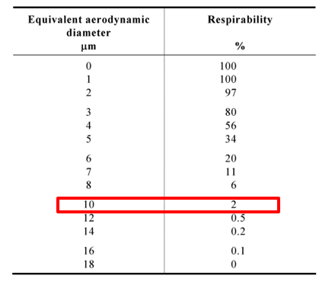

ISO 7708:1995 (pp.6-7) refers to two respirable conventions; that which is expressed as a percentage of the of the inhalable convention with a D50 of 4.25 µm; and that which expressed as a percentage of the of the total airborne particles with a D50 of 4.0 µm. Noting the technical difficulties of measuring total airborne particles the standard defines the respirable fraction as the “*Mass fraction of inhaled particles which penetrate to the unciliated airways*” (1995, p.2).

However, while AS 2985-2009 requires the respirable convention (as expressed as a percentage of the of the inhalable convention with a D50 of 4.25 µm) some organisations (ACGIH, NIOSH, CEN) refer to sampler efficiencies with a D50 of 4.0 µm. For example, Figure 1 shows the sampling convention referenced by EN 481:1993 *Workplace atmospheres. Size fraction definitions for measurement of airborne particles*. This definition relates to total dust and not the inhalable fraction which has led to some confusion when referring to the respirable efficiency curve.

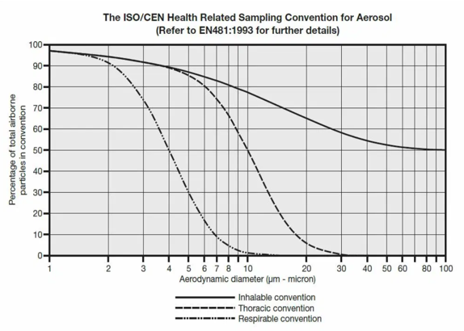

Figure 1: ISO/CEN sampling conventions (note: x-axis is logarithmic starting at 1µm)

The selection of one convention over the other will have consequences in terms of the required sampler efficiency; and increased measurement uncertainty while both conventions are in use.

The procedure for the set-up and use of personal monitoring (sampling) equipment for the measurement of respirable dust exposures is provided in AS 2895-2009.

This standard provides example flow rates for various samplers to enable the required capture of the ISO 7708:1995 curve (Figure 1 above; 2.2 litres per minute [L/min] for British Cast Iron Research Association [BCIRA] and Safety in Mines Personal Equipment for Dust Sampling [SIMPEDS] cyclones and 2.5 L/min for aluminium cyclones). However, flow rates for other samplers may be set by the manufacturer to meet the ISO 7708:1995 curve.

In order to be representative of an individual’s exposure, personal sampling must be carried out within an individual’s breathing zone, defined as a “… *hemisphere of 300 mm (30 cm) radius extending in front of the face and measured from the mid-point of a line joining the ears*” (Standards Australia, 2009, p. 6). An illustration of a worker’s breathing zone is provided in Figure 2.

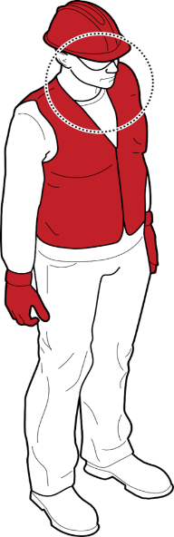

30cm breathing zone

**Figure 2:** Worker breathing zone from which personal samples must be taken

**2.2 Sampling equipment for respirable dust**

The predominant sampler type used in Australia for personal monitoring for respirable dust is the miniature cyclone elutriator that uses either a 25 millimetre (mm) or 37 mm diameter filter. A detailed description of the range of sampling devices available in Australia can be found in the Australian Institute of Occupational Hygienists (AIOH) Technical Paper: *Size-Selective Samplers for Respirable Dust Sampling – Guidance Information* (AIOH, 2020).Alternatives to current samplers are reviewed in Section 8 of this report.

For a sampler to collect the respirable fraction of dust, sampling pumps are required to draw air through the dust sampler at a specified flow rate. These pumps are separate apparatus to the sampler itself and, as with samplers, a variety of manufacturers supply personal sampling pumps. Pumps must be able to sustain accurate and precise flow rates for the required sampling period (possibly up to 12 hours, and at least half the shift length) while compensating for back-pressure generated by the various sections of the sampler (such as the elutriator, filter and dust deposit) across a range of occupational environments. Alternative sampler types and pumps are also reviewed in Section 8 of this report.

**2.3 Bulk and static air sampling techniques**

There is a qualitative relationship between the percentage of crystalline silica present in an ore or a product (for example, engineered stone) in its bulk form and the percentage of RCS emitted during processing of the ore or product. The actual concentration of RCS inhaled when breathing needs to be measured by personal air sampling. Accordingly, an estimate of the percentage of crystalline silica in the work environment can be determined using the process of bulk sampling and analysis for hazard identification.

It should be noted that the percentage of crystalline silica within a bulk material is often significantly greater than the RCS obtained from personal or static air sampling. This can be due to the percentage of non-respirable crystalline silica or the presence of other very small mineral particles (such as clay) that, when airborne, are almost entirely in the respirable fraction. The changes in crystalline silica content of the different dust size fractions are preferably determined by X-Ray Powder Diffraction (XRD) because of less interferences from other minerals.

Products containing bulk crystalline silica (for example, some powdered tile grouts) may also contain a significant percentage of crystalline silica in the respirable fraction. The Globally Harmonized System of Classification and Labelling of Chemicals (GHS) requires that products containing greater that 0.1% weight for weight (w/w) of a carcinogen be identified and have the appropriate labelling and information on the safety data sheet (Safe Work Australia, 2020). For RCS, this requires the application of a method that has been developed for determining the size-weighted relevant fine fraction (SWeRF) of RCS. In this method (also known as the size weighted respirable fraction), the RCS concentration is either calculated from a bulk analysis or determined through sedimentation to obtain the respirable dust fraction from the bulk crystalline silica. In either case, the powder is then analysed for RCS content with XRD or Fourier Transform-Infrared Spectroscopy (FTIR) (Pensis, Luetzenkirchen, & Friede, 2014). Often the calculation method significantly overestimates the RCS because of other minerals such as clay or talc that have much higher concentrations in the respirable fraction than the bulk material.

The characterisation of the potentialexposure context and the assessment of control effectiveness can be determined through static air monitoring. While the sampling equipment and analytical methods remain the same as for personal monitoring for RCS, static air monitoring is taken at fixed locations with the sampler head positioned at head height (Safe Work Australia, 2013).

While both bulk and static air sampling have useful applications in characterising RCS risk, personal monitoring is the only measure of individual exposure from which compliance with the WES can be demonstrated and effective risk management can be implemented.

* + - 1. **Sampling methodology**

Sampling methodology for RCS falls into two categories:

* the set-up and use of personal monitoring equipment in the field, and
* the broader context in which personal sampling occurs (discussed below).

The sampling methodology requires an understanding of where exposures may occur, the individuals or groups that are exposed and the tasks and work environment in which the airborne hazardous chemicals are generated (AIHA, 2015; Steer & Langley, 2019).

**3.1 Number of personal monitoring air samples required in a workforce**

Since it is rarely practical to measure all individuals within an exposed workforce, occupational hygiene monitoring programs often carry out representative sampling of a Similar Exposure Group. The Similar Exposure Groups (SEG[1]) Baseline Strategy developed and implemented by the American Industrial Hygiene Association (AIHA) is regularly used in Australia. In this strategy a minimum of 6 to 10 samples are drawn from a SEG to obtain statistical significance (AIHA, 2015).

An alternative and more recent approach to establish the initial risk is set out in CEN-EN 689:2018 *Workplace exposure - Measurement of exposure by inhalation to chemical agents - Strategy for testing compliance with occupational exposure limit values*. CEN-EN 689:2018 describes a two-step method that requires less sample numbers in the initial phase of sampling than recommended by the AIHA strategy, while still obtaining statistical significance (Comite Europeen de Normalisation, 2018).

**3.2 Interpreting sampling results**

There are several approaches for stating and interpreting sampling results against a WES (Reed, Pisaniello & Benke, 2019). Rappaport and Selvin (1987) developed a method for evaluating the mean exposure of a SEG against the WES to assess risk from chronic exposure to hazardous chemicals such as RCS over a working lifetime. In the following year, Rappaport, Selvin and Roach (1988) referred to the Occupational Safety and Health Administration (OSHA) requirement for an action level (AL) of 50% of the WES to demonstrate compliance. Rappaport et al. noted that if the mean exposure of the SEG is maintained below the AL, then less than 12% of individual exposures would exceed the WES. It should be noted that this method is not applicable for STEL or peak exposures.

Current monitoring programs often stipulate an AL above which an investigation is recommended to validate exposure controls (typically 50% of the WES). The concept has its basis in statistical theory; as the variability in a set of results increases, so does the potential for the true mean to exceed the WES (AIHA, 2015; Grantham, 2001; Grantham & Firth, 2014). The AL remains an important metric for assessing exposure risk.

While many data sets are normally distributed, occupational hygiene monitoring results are often described by a lognormal distribution. AIHA (2015, p.30) describe the lognormal distribution as “…*there is a physical lower limit for possible values (such as zero), when large values sometimes occur, and when processes that generate or control exposures tend to interact in a multiplicative manner*” (AIHA, 2015, p. 130). Figure 3 presents an idealised lognormal distribution for a set of fictitious monitoring results with a WES of 0.05 mg/m3. The metrics of interest are the arithmetic mean and the 95% confidence interval (CI) of the mean and the 95th percentile.

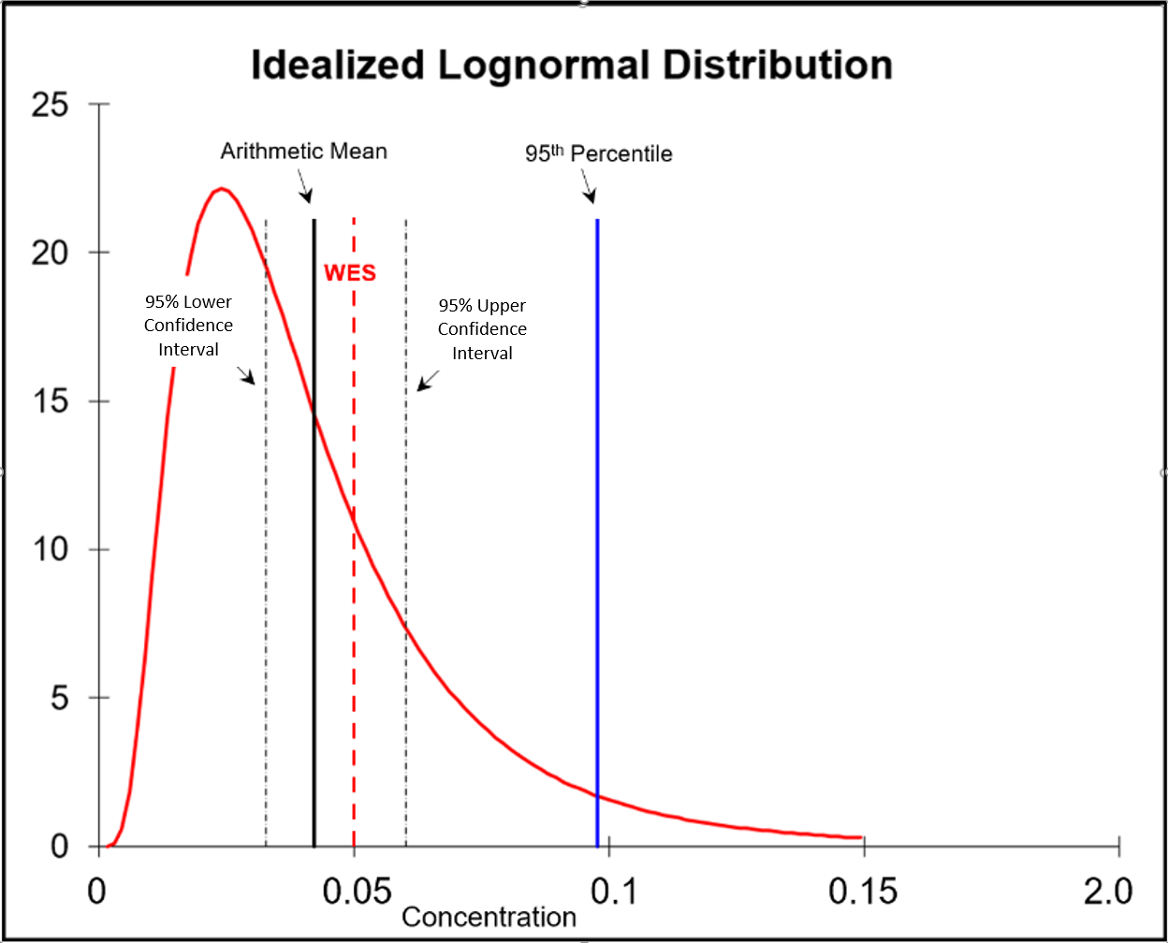

**Figure 3:** Lognormal distribution of a set of example monitoring results showing the arithmetic mean, 95% upper and lower CI of the mean, and the 95th percentile of the sample results   
Source: IHSTAT software - AIHA (2020)

While the calculated arithmetic mean in the example illustrated in Figure 3 is just below the WES, it has been derived from just one sample of the population. The interval between the lower and upper CI represents the range of values in which there is a 95% certainty that the true mean (of the population) lies between. In the example above, the 95% CI includes the WES. Therefore, it could not be stated that the mean of the SEG is below the WES.

While the 95% lower and upper CI relate to the calculated arithmetic mean, the 95th percentile indicates the value that 95% of the set of monitoring results are below the WES. The application of the 95th percentile as recommended by the AIHA (2015) is set out in Table 2.

**Table 2:** Ranking exposure profile risk relative to the SEG’s  
Source: AIHA (2015, p. 57)

| **SEG exposure risk rating** | **95th Percentile Relative to the OEL TWA  (i.e. WES in Australia)** |
| --- | --- |
| **0** | <1% of the OEL (95th percentile less than 0.01 x OEL) |
| **1** | <10% of the OEL (95th percentile less than 0.1 x OEL) |
| **2** | 10-50% of the OEL (95th percentile between 0.1 and 0.5 x OEL) |
| **3** | 50-100% of the OEL (95th percentile between 0.5 and 1.0 x OEL) |
| **4** | >100% of the OEL (95th percentile greater than 1.0 x OEL) |

In recent years, there has been a trend in Australia to assess exposure profiles against the more conservative decision metric of the 95th percentile of the distribution of sample results (as per the AIHA, 2015). This approach is reflected in at least one state regulator’s advice (WA Department of Mines Industry Regulation & Safety, 2018).

In the AIOH Risk Management Guidebook: *Simplified Occupational Hygiene Risk Management Strategies,* the authors demonstrate how occupational hygiene hazards can be assessed using a consequence/likelihood matrix to develop criteria for the frequency of continued air monitoring (see Table 3 below). In the case of in-air exposure potential (i.e. the potential to inhale a contaminant), quantitative exposure descriptors for likelihood are based on the mean of a SEG against the WES (Firth, van Zanten & Tiernan, 2006).

**Table 3:** Using the SEG’s exposure profile to determine monitoring frequency   
Source: Firth et al. (2006, p. 25)

|  |  |  |
| --- | --- | --- |
| **Likelihood** | **Estimate of the mean of the exposure profile against the TWA-WES** | **Possible criteria for air monitoring frequency** |
| **Almost Certain** | Mean > 10 x WES | Reduce exposure and monitor weekly |
| **Likely** | Mean > WES but < 10 x WES | Monitor monthly until exposure reduced |
| **Possible** | Mean 50-100% WES | Monitor half yearly to quarterly |
| **Unlikely** | Mean 10-50% WES | Monitor yearly |
| **Rare** | Mean < 10% WES | Monitoring not required (provided no change to process, materials or controls |

As discussed above, the AL is a precautionary approach due to the distribution of results around the mean that may indicate a number of true exposures are above the WES. The underlying rationale is that as a set of sample results become increasingly variable (as represented by the geometric standard deviation [GSD]), the risk of the true mean being at or above the WES also increases (Grantham, 2001). Grantham and Firth (2014) make the point that if a GSD is 1.7 or greater, the AL must be below 50% of the WES because there is a 95% chance of the true mean being no different from the WES.

Grantham (2001) previously noted that more common GSDs experienced in occupational hygiene (of 2 and above; illustrated in Table 2) require an AL of 40% of the WES. This has significant implications in terms of identifying triggers for compliance and ALs that would fall below the analytical limit of quantitation (further discussed below in Section 4).

From the discussion above, it can be seen that setting a WES for a hazardous chemical requires the sampling and analytical methods to reliably quantify concentrations down to at least 10% of the standard in order for risk management strategies to be applied.

**3.3 Measurement requirements for eight hour and 12 hour adjusted WES**

A significant proportion of exposure to RCS in Australia occurs in the mining and construction sectors, which combined have a workforce of approximately 1.6 million people (Department of Education Skills and Employment, 2020). Mining often occurs in remote locations where there can be logistical impediments to ensuring that monitoring programs are fully representative of exposure profiles. This may include the limitation to account for exposure patterns between day and night shift or the impact of seasonal variations.

Workers in construction and particularly mining, often work extended shifts of 12 hours (and sometimes more), requiring a correction to the WES using adjustment models (Firth & Drolet, 2014; Safe Work Australia, 2013). In Western Australia, for example, the mine safety regulator has adopted the modified Quebec Model, resulting in a common adjustment for 12 hour shifts of 0.7-times the WES for chronic exposures including RCS (WA Department of Mines Industry Regulation & Safety, 2018).

The obligation to measure at 50 and 10% of the WES and 12 hour adjusted WES has significant implications in terms of analytical quantitation limits, as demonstrated in Table 4 in which the adjustment is for a fly-in fly-out roster of two weeks on and one week off.While the analytical limits for measuring RCS are discussed in section 6 below, it is unlikely that RCS can be accurately and precisely measured below 0.02 mg/m3.

Table 4: Concentrations of RCS to be quantified for 8 and 12 hour WES at 0.02 mg/m3

| **WES parameter** | **Concentration of RCS (mg/m3)** |
| --- | --- |
| WES | 0.02 |
| WES action level (50%) | 0.01 |
| 10% WES | 0.002 |
| 12 hr adjusted WES | 0.014 |
| 12 hr adjusted WES action limit (50%) | 0.0085 |
| 12 hr adjusted WES (10%) | 0.0014 |

* + - 1. **Analytical equipment, techniques and methods**

**4.1 Analytical equipment and techniques**

The two most commonly used technologies for analysing RCS are X-ray powder diffraction (XRD) and Fourier transform-infrared spectroscopy (FTIR) (Chubb & Cauda, 2017). A third technique, Raman spectroscopy, is showing potential for RCS analysis, but the analytical equipment is not yet readily available or validated in Australia (Stacey, Mader, & Sammon, 2017).

In Australia, the analytical method for the determination of an RCS concentration is specified in the National Health and Medical Research Council (NHMRC; 1984) *Method for the Measurement of Quartz in Respirable Dust by Infrared Spectroscopy and X-Ray Diffractometry.* The NHMRC method remains current in Australia even though it is based on knowledge and practices from 35 years ago.

More recent analytical methods for RCS by XRD and FTIR are described in ISO 16258:2015 *Workplace air — Analysis of respirable crystalline silica by X-ray diffraction (*Part 1: Direct on-filter method and Part 2: Method by Indirect analysis) and ISO 19087:2018 *Workplace air — Analysis of respirable crystalline silica by Fourier-Transform Infrared Spectroscopy*.

Both the NHMRC and ISO methods are comprehensive and provide information on instrumental parameters, the sensitivity of different sampling apparatus, the use of different filters and sample treatment to remove interferences. Analysis is described for the most common RCS polymorphs, $α$-quartz and cristobalite and excludes the far less common polymorphs such as tridymite, because a standard reference material is not available.

4.1.1 Analysis by XRD

XRD is used to identify crystalline minerals and measure their concentration in a sample. In the case of atmospheric samples, the analysis can be carried out using a direct-on-filter approach. In the case of bulk samples, the material is finely ground prior to placement in a holder for analysis (Dutrow, 2020). The XRD limit of detection for individual minerals is approximately 0.5% by weight of the sample.

The XRD process involves directing X-rays at the sample and analysing crystalline minerals through range of angles with the X-ray detector following the rotation of the sample. Each mineral produces a unique spectral signature with characteristic peaks. When analysis is carried out for a pure known mineral, a single identifying peak is usually sufficient to confirm its presence. Mixtures of minerals often do not cause interferences to the analysis; but when that is the case, generally there is a second or third peak that can be used in the analysis. For example, the XRD spectra of $α$-quartz, as shown in Figure 4, has three sharp spectral peaks (Q(100), Q(101) and Q(112)) that could all be used for determining the concentration of α-quartz.

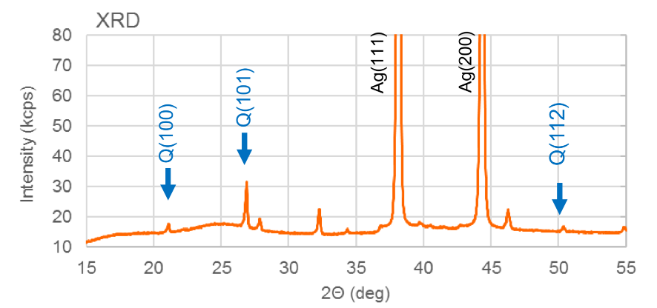

**Figure 4:** Example of XRD spectra of pure $α$-quartz   
Source: Mazereeuw et al. (2019); the silver (Ag) is from the filter which is coated in silver.

Two methods for RCS analysis by XRD are available:

* Direct-on-filter method: dust on the 25 mm sampler filter is directly analysed by the instrument (NHMRC, 1984).
* Method by indirect analysis: dust on a substrate (i.e. filters or foams), where dust from the substrate is recovered, treated and redeposited on another filter for analysis by the instrument (NHMRC, 1984).

4.1.2 Analysis by FTIR

FTIR is a technique that provides information on the chemical bonding of a substance and can be used to identify both organic and inorganic materials. It is also possible to measure the concentration of a substance in a given sample using FTIR. The absorption of infrared radiation (IR) by the sample causes molecular vibrations and these molecular vibrations result in absorbance at specific infrared wavelengths for specific functional groups in the substance (Chen et al., 2015; Stacey, Clegg, Morton, & Sammon, 2020). The remaining transmittance of light at each IR frequency produces a spectrum of signal intensity (pattern) that can be compared with known absorbance patterns to identify specific substances and measure their concentration in a sample (for quantitative analysis of pure α-quartz; see Figure 5 below).  
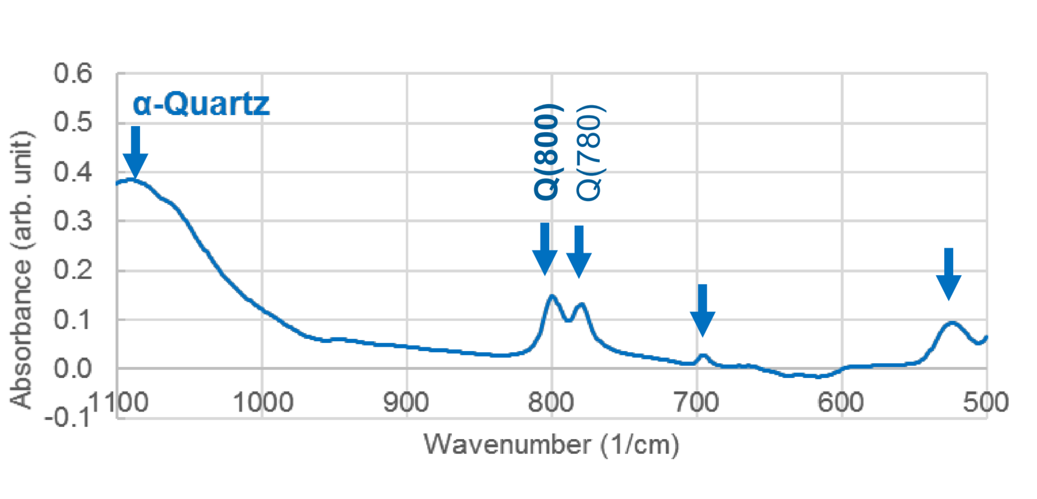

**Figure 5:** Example of FTIR spectra of pure α-quartz  
Source: Mazereeuw et al. (2019)

In contrast to XRD, FTIR is subject to interferences caused by multiple substances in a mixed RCS sample, including the filter material itself. These interferences are common in mining samples, where workers can be exposed at the same time to many minerals in the dust in a single shift. In analysing α-quartz by FTIR, there are many common minerals that absorb in the IR spectra at the same wavelength including kaolinite, muscovite and even amorphous silica (HSE UK, 2015; Ichikawa, Volpato, O’Donnell, & Mazereeuw, 2019; Ojima, 2003). This means if α-quartz and cristobalite are present in a mixed sample, FTIR is unable to distinguish the individual polymorphs because the absorption peaks overlap.

The NHMRC (1984) provides three methods for the analysis of RCS by FTIR:

* Direct-on-filter method: dust on the filter is directly analysed by the instrument (requires the filter for the sampler to be the same size as for the FTIR analytical instrument).
* Indirect method by redeposition: dust is recovered from the sampler collection substrate and redeposited onto a filter for analysis.
* Indirect method by potassium bromide (KBr) pellet: dust is recovered from the sampler collection substrate and pressed into a potassium bromide (KBr) pellet for analysis.

4.1.3 Sample filters

It is important to note that the NHMRC and ISO direct on-filter methods (for both XRD and FTIR) require the use of 25 mm diameter filters for sample collection. These methods limit the choice of samplers that can be used in the field because the most common filter sizes for samplers are 25 and 37 mm. Where 37 mm diameter filters are used, these are typically required to be ashed or dissolved and then redeposited on 25 mm filters to enable indirect analysis. Measuring directly on 37 mm filters by FTIR is further complicated by the IR beam which is only 6 to 11 mm wide depending on the brand of instrument. This limited beam width results in inconsistent analysis of a filter with the potential to miss significant sections of sample and impacting on the accuracy of the result. The distribution of dust on the filter is typically more concentrated in the centre of the filter than the edge.

**4.2 Country specific RCS sampling and analytical methods**

Preferred sampling and analysis techniques vary internationally. Table 5 sets out sampling and analytical methods for RCS for several developed countries, including Australia where it can be seen that analytical methods, samplers and analytical equipment are country specific. The variation in the limits of quantitation (LOQ) form part of the sources of error discussed in Sections 5 and 6.

**Table 5:** Analytical methods for the analysis of RCS (Deutche Gesetzliche Unfallverisicherung, 2016)

| **Country** | **Method** | **Sampler - Cyclone** | **Flow rate (L/min)** | **Sample air volume (m3)** | **Analytical Equipment** | **LoQ (mg/m3)** |
| --- | --- | --- | --- | --- | --- | --- |
| **UK** | MDHS 101/2 | Dorr-Oliver  Higgins-Dewell  GK 2.63 | 1.7  2.2  4.2 | 0.6 | XRD  FTIR | 0.05  0.02 |
| **USA** | NIOSH 7500 | Dorr-Oliver  Higgins-Dewell  SKC (Al) | 1.7  2.2  2.5 | 0.5 | XRD | 0.03 |
| **USA** | NIOSH 7602 | Dorr-Oliver  Higgins-Dewell  SKC (Al) | 1.7  2.2  2.5 | 0.5 | IR | 0.03 |
| **USA** | NIOSH 7603 | Dorr-Oliver  Higgins-Dewell | 1.7  2.2 | 0.5 | IR | 0.065 |
| **USA** | OSHA ID-142 | Dorr-Oliver | 1.7 | 0.4 | XRD | 0.025 |
| **Germany** | BIA 8522 | FSP-BIA | 2 | 1 | FTIR | 0.035 |
| **Spain** | INSHT MTA/MA-036 | Dorr-Oliver | 1.7 | 0.4 | IR | 0.06 |
| **Spain** | INSHT MTA/MA-057 | Dorr-Oliver | Sampler dependent | n/a | n/a | n/a |
| **France** | MétroPol 049 | Dorr-Oliver | 1.7 | 0.6 | XRD | 0.05 |
| **Australia** | NHMRC (1984) | Higgins-Dewell (SKC HD - common in mining) | 2.2–3 | ≥0.7 | XRD  FTIR | 0.02 |

* + - 1. **Sources of error when** **sampling RCS**

There are a number of sources of error in the sampling of RCS, especially when sampling for RCS in the presence of other airborne contaminants that interfere with analytical methods.

**5.1 Exposure assessment strategies**

While a full description of how a monitoring program is developed is beyond the scope of this report, the limitations inherent in exposure assessment cannot be ignored.

As Ramachandran (2019) points out, the challenge (in terms of the statistical expression of results) “…*is to capture the large variability in exposures through appropriate strategies and estimate these statistics, given that the resources needed for large numbers of monitoring data are typically limited*”. There is limited predictive capacity in the comparison of the 95th percentile (or 95% upper CI of the mean) with a compliance standard. This comparison and to make a compliance decision is both a qualitative and quantitative process (Ramachandran, 2019).

Occupational Hygiene Monitoring and Compliance Strategies (Grantham and Firth, 2014) provides strategies for optimising workplace monitoring programs to consider data variability.

**5.2 Sampler error**

The following steps are key to reduce sampler errors:

* adherence to the method for sampling and gravimetric determination of respirable dust set out in AS 2985 (Standards Australia, 2009)
* pump calibration and pre and post-sample flow rate measurements to avoid equipment error (such as excessive pulsation) and filter overloading (indicated by excessive flow reduction), and
* the accurate determination of the volume of air sampled together with the sample mass.

A number of studies have published comparisons of respirable dust samplers that reveal significant variation in sampling efficiency from the required ISO 7708:1995 sampling efficiency curve (Belle, 2019; Görner et al., 2001; Lee et al., 2015; Stacey et al., 2013; Verpaele & Jouret, 2012; see also Appendix 2 for a comparison of the 50% cut point for a range samplers). This matter was highlighted in 2019 when a manufacturer of miniature cyclones, SKC Ltd, issued a press release that stated two of its plastic miniature cyclones (Models 225-69 & 225-69-37) were found to oversample dust by up to 30%, requiring an increase in the sampler flow rate from 2.2 to 3.0 L/min to compensate for the error (SKC, 2018).

By definition, a sampler that does not conform to the ISO 7708:1995 sampling efficiency curve is biased such that it over and/or under samples dust at different size fractions. An example of non-conforming samplers reviewed by Belle (2019) is shown in Figure 6 below (also see Appendix 1 for a bias map of 15 samplers compared by Görner et al., 2001). Figure 6 illustrates two non-conforming samples (shown with the red cross) and one conforming sampler (shown with the green tick).

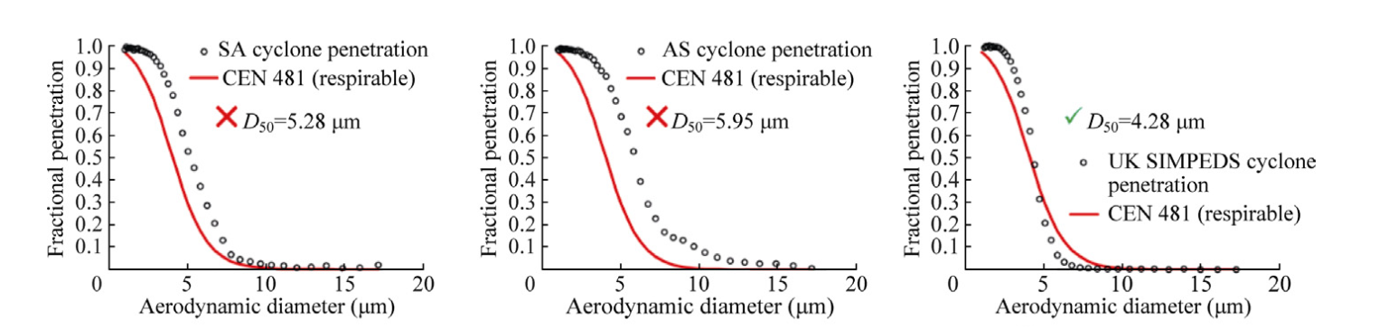

Figure 6: Sampler efficiency curves in relation to ISO 7708 respirable curve

Flow rate has a significant impact on sampler efficiency as demonstrated in Figure 7. Lee et al. (2015) describe the effect of increasing flow rates on the efficiency curve by use of a single high flow sampler (GK4.126). At all flow rates, oversampling occurs at the lower half (smaller) of the particle size range, with most under sampling occurring at the upper half (larger) of the particle size range as the flow rate is increased.

The particle size distribution (PSD) of dusts containing RCS is not fixed but varies based on the matrix from which it is generated and the processes involved in that generation (Johnson & Esmen, 2004). Therefore, the impact of over or under sampling warrants careful consideration as the bias may be significant to the extent that the results may have questionable value and cannot be relied upon as true indicators of exposure to RCS. Ramachandran (2005) highlights this significance in the statement: “…*the mass of a single 10 μm particle is equal to the mass of 1,000 particles with a diameter of 1 μm. Therefore, larger particles have a disproportionate impact on the total mass of an aerosol*”. Samplers exhibiting a positive bias (oversampling) at larger particle sizes are less desirable than those exhibiting positive bias at smaller particle sizes because a small number of larger particles has a large effect on the total mass whereas a large number of smaller particles has minimal effect on the total mass.

The effect of PSD on analytical methods is discussed further in Section 7.1.2.

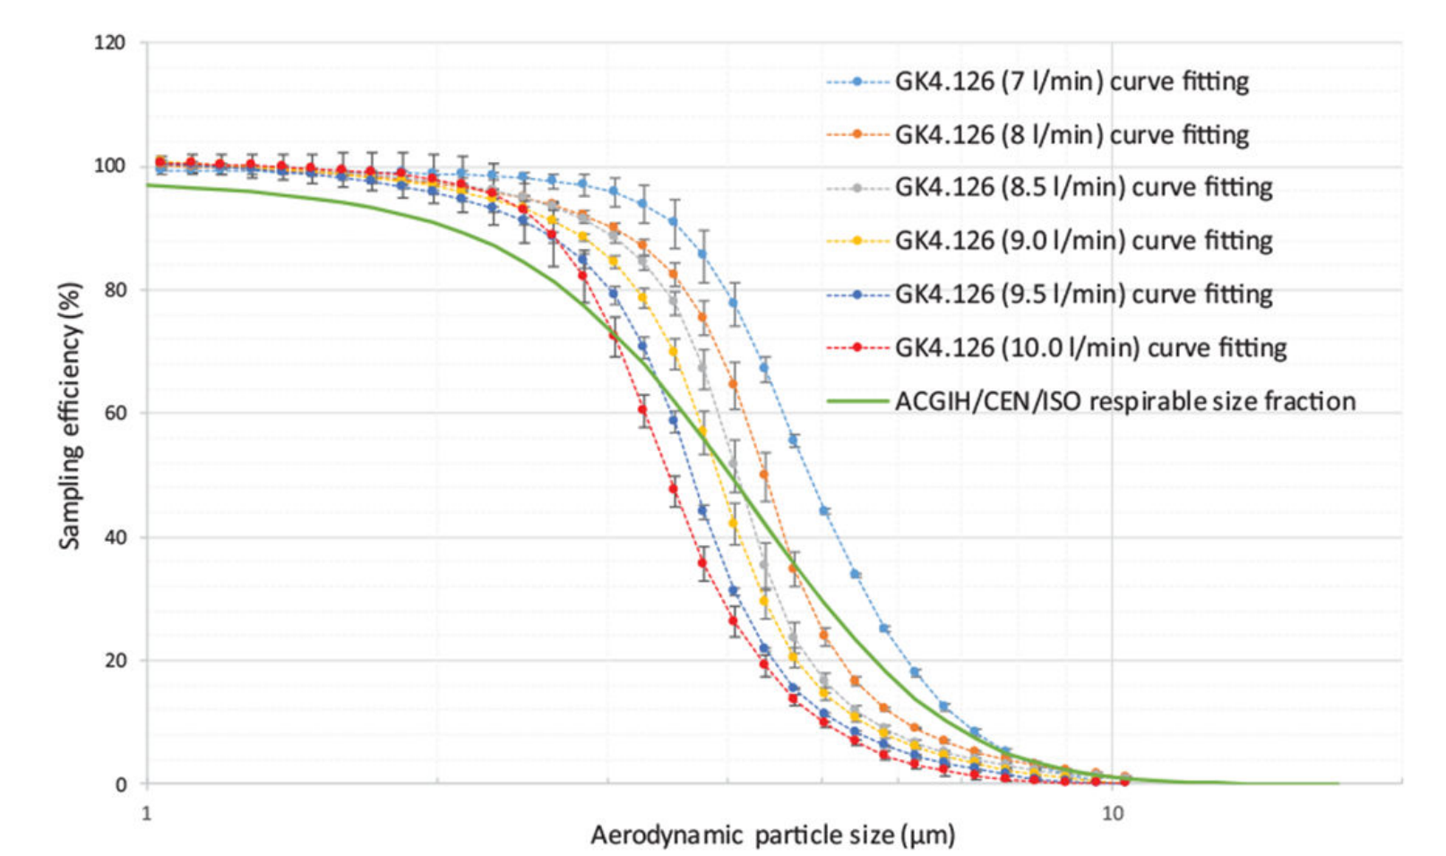

**Figure 7:** Effect of sampler flow rate on sampler efficiency (Lee et al. 2015)

* + - 1. **Analytical Methods: detection limits and measurement uncertainty**

**6.1 Detection limits**

Unfortunately, the definitions of *limit of detection* are not clear or consistent. Lavín et al. (2018) identify a significant difference in the description of the limit of detection (LoD) by different agencies. They cite the International Union of Pure and Applied Chemistry’s (IUPAC) definition as being the “…*smallest solute concentration that a given analytical system is able to distinguish with a reasonable reliability of a sample without analyte*”. This is in contrast to the definition of the LoD by Eurochem and the United States Pharmacopeia as being “… *the lowest amount of analyte in a sample that can be detected, but not necessarily quantified, under the stated experimental conditions*” (Lavín et al., 2018, p. 2).

Lavin et al. make the point that the latter definition leads directly to the concept of limit of quantitation (LoQ), which is defined as “…*the minimum amount of analyte in a sample whose concentration can be determined with acceptable accuracy and precision under certain experimental conditions*” (2018, p. 3).

Armbruster and Pry (2008) make the salient observation that in some contexts, detection limits (both LoD and LoQ) are not given prominence and this is particularly the case where the normal range of measurements fall well outside of such limits (for example, blood cholesterol results). However, in the case of RCS (and many other analytes), a clear understanding of the difference between the LoD and LoQ is vital for the reliability of results, as measured concentrations regularly approach these limits.

Currie (2004) gives some insight into the problems associated with the naming protocols for LoD and LoQ. In reviewing the variation in nomenclature Currie found that the variance in meaning attached to “detection limit” resulted in “*numerical values that spanned three orders of magnitude, when applied to the same specific measurement process*” (2004, p.10). The author then provides an example of the consequences of differing interpretations of the LoD in an interlaboratory comparison for low concentrations of arsenic (As) where “*several laboratories failed to detect the As, yet their reported “detection limits” lay far below quantitative results reported by other laboratories; and the range of reported values spanned nearly five orders of magnitude*”(Currie, 2004, p. 11).

Straightforward definitions for detection limits (Armbruster & Pry, 2008, pp. 49-51) are set out as below:

**Limit of blank (LoB):** the highest apparent analyte concentration expected to be found when replicates of a blank sample containing no analyte are tested.

**Limit of detection (LoD):** the lowest analyte concentration likely to be reliably distinguished from the LoBand at which detection is feasible. LoD is determined by utilising both the measured LoB and test replicates of a sample known to contain a low concentration of the analyte.

**Limit of quantitation (LoQ):** the smallest concentration of an analyte that can be reliably measured by an analytical procedure. The limit of quantitation is the lowest concentration at which the analyte can not only be reliably detected but at which some predefined goals for bias and imprecision are met. The LoQ may be equivalent to the LoD or it could be at a much higher concentration.

These three aspects of the limits can be visualised as set out by Little (2015) in Figure 8.

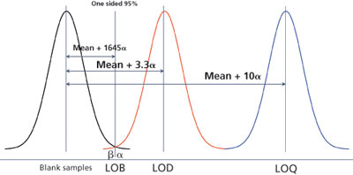

Figure 8: Limit of blank vs limit of detection vs limit of quantitation (Little, 2015)

As shown by Armbruster and Pry (2008) and Figure 8, it is essential that the LoD and LoQ are clearly defined in measurement and reporting processes, as concentrations of analyte approaching these limits are subject to rapidly increasing uncertainty.

**6.2 Measurement uncertainty**

As the ISO/IEC Guide 98-1:2009 *Uncertainty of Measurement* (International Organization for Standardization, 2009)points out, measurement of any property of a substance is subject to uncertainty. As obtained data (for example, measurements of a concentration of analyte) approaches the LoD of a measurement technique, the uncertainty in the results increases significantly. This means that the closer the measurement is to the LoD, the less certainty there is that the result is accurate.

* + - 1. **RCS analysis: calibration and measurement uncertainty**

In its metrology training package, the European Comission: Joint Research Centre (2012, p. 30) make the point that estimating measurement uncertainty (for a defined measurand) is a function of measurement procedure validation. The process of verifying that a procedure is fit for purpose (i.e. for solving a particular analytical problem) is put in the following terms: “*Which analyte can it determine, in which matrices, in the presence of which interference? - Within these conditions (to be defined) what uncertainty can be achieved?*”. The questions posed by the European Commission are well placed in the context of measuring RCS. This means that the subject of interferences and the limits of measurement in analytical techniques are highly relevant to the accurate assessment of RCS at a WES of 0.02 mg/m3.

**7.1 Calibration of analytical equipment**

7.1.1 Calibration standards

The analysis for RCS by XRD or FTIR requires analytical equipment to be calibrated against control samples of pure quartz, cristobalite etc., from which a calibration curve can be created (Mazereeuw et al., 2019). Calibration curves plot the measured intensity against a range of control sample masses. When analysis of sample filters is undertaken, the signal is compared against the calibration curve to estimate the mass of RCS.

The accuracy of analytical results is dependent on the purity of the calibration standards. The use of lower purity or variable purity calibration standards reduces analytical accuracy and increases measurement uncertainty that laboratories will be blinded to. This will also increase the variability of inter-laboratory results. In a comparison of seven silica calibration standards using FTIR, Verma and Shaw (2001) found up to 30% variability in reported relative purity and PSD.

7.1.2 PSD and calibration

Chubb and Cauda (2017) make the point that the PSD of silica calibration standards should conform as closely as possible to the ISO 7708:1995 sampling efficiency curve for respirable dust. The particle size influences spectrophotometric peaks in different ways based on the analytical method being used. In the case of XRD, signal peaks (i.e. reported RCS concentration) increase as particle size increases. In the case of FTIR, signal peaks (i.e. reported RCS concentration) decrease as particle size increases (Bhaskar, Li, & Xu, 1994; Chubb & Cauda, 2017; Verma & Shaw, 2001).

The use of different calibration standards between laboratories increases variation in reported results. The effect of different calibration standards with differing PSD’s is highlighted in a study by Addison (1991, cited in Verma & Shaw, 2001) in which samples were analysed by laboratories using three different calibration standards. Verma and Shaw (2001, p.434) summarise the outcome: “*The study concluded that particle size and mineralogical interferences can contribute to differences of up to 30% in quartz content, despite efforts to control for both these factors*”.

When differences in the PSD between workplace samples and calibration standards are combined with the analytical method employed, may produce higher levels of inconsistency and inaccuracy in results. Stacey et al. (2009) describe the issues arising out of PSD of calibration standards and the analytical methods. Calibration standards with a greater proportion of smaller particles (<2 μm) may have different values for the forms of RCS (increasing levels, in relative terms, of amorphous silica on the surface of the particle), decreasing the magnitude of XRD peak. FTIR accuracy is affected more by particle size variation rather than the degree of crystallinity, with increased variability in IR absorbance at both ends of the size spectrum (within the respirable dust range) when there is a greater proportion of smaller particles in the calibration standard. Stacey et al. (2009) suggest that the discrepancy between the PSD of the calibration standard, workplace samples and the analytical methods employed, will impact on the accuracy of results.

**7.2 Measurement uncertainty in analytical methods**

Beside the variation of results between laboratories (further discussed under the proficiency testing in Section 8 of this report), a significant amount of variation is inherent in the analytical methods for determining the concentration of RCS. For example, the UK HSE (2015) describes the qualitative LoD for RCS (pure quartz) for direct-on-filter analysis of RCS using XRD as being “…*three times the standard deviation of the count rate of the background over an appropriate scan range of a clean sample filter*”. This equates to an LoD of a sample mass of 5 to10 μg of pure quartz, which is equivalent to a concentration of 0.02 mg/m3 quartz for an air sample of 500 L taken over four hours at 2.2 L/min. Additionally, as real-world samples may also contain significant interferences, the HSE suggest that the LoQ is likely to be around ten times the standard deviation from measurements taken on blank filters (HSE, 2015). This equates to a LoQ of a sample mass of 25 μg quartz for the strongest XRD peak, which is equivalent to a concentration of 0.05 mg/m3 for an air sample of 500 L taken over four hours at 2.2 L/min (HSE, 2015).

The HSE does not refer to an LoQ for RCS analysis by XRD. They do describe the expanded uncertainty limits which are required to be “…*less than ±30% when measuring 0.5 to 2 times the limit value and less than ±50% when measuring 0.1 to <0.5 x the limit value*”(HSE, 2015, p. 11). At the strongest XRD peak, the minimum mass of quartz required to obtain an expanded uncertainty at ±30% is 25 μg, while the minimum mass of quartz required to obtain an expanded uncertainty at ±50% is 5 μg.

Uncertainty in measurement values for RCS is acknowledged in US NIOSH Method 7500 (National Institute for Occupational Safety and Health, 2003) of analysis using XRD states an estimated LoD of 0.005 mg (5 μg) with an intra-laboratory relative standard deviation of 8% (at analyte range of 0.05 to 0.2 mg per sample). However, the overall relative standard deviation for intra- and inter-laboratory increases to 28% at the same analyte range of 0.05 to 0.2 mg.

FTIR analysis of RCS is also subject to uncertainty from interferences to the absorbance peak of silica from clay and mica-based minerals including kaolinite and calcite which are often found in mining and other workplaces (Harper, Sarkisian, & Andrew, 2014; Hart et al., 2018; Ichikawa et al., 2019; Verpaele & Jouret, 2012). Ichikawa et al. (2019) on comparison of analytical methods suggest that the measurement area of the on-filter analysis by FTIR scan is considerably smaller than XRD (8 mm in diameter compared to 25 mm which equates to only 10% of the filter area) which increases the risk of non-representative measurement.

In a performance comparison of four FTIR instruments, Ashley et al. (2020) note that beam width ranged from 6 to 11 mm allowing for analysis of only 3.1 to 10.5% of the deposition area of a 37 mm filter. If the underlying assumption of quantitation is based on an even distribution of calibration material on the filter, violations of this assumption in real-world samples (i.e. uneven deposition of dust on a filter) will contribute to errors in reported masses. If the filter is unevenly loaded there will be widely varying results depending on the area analysed. Even collecting several measurements across the filter and averaging the response does not fully resolve this issue if the loadings are uneven. In these situations, the dust should be redeposited onto a blank filter to give an even distribution and a more accurate result.

Stacey et al. (2020, p. 14) make the important point: “*The sample deposit area is a significant factor that affects measurement sensitivity and LoD for all analytical techniques measuring RCS (i.e. XRD, FTIR and Raman). Smaller sample deposit areas improve measurement sensitivity because the sample either becomes more concentrated or more of the sample is within the analysis area of the instrument*”.

As noted in the discussion of calibration standards, the percentage of amorphous silica may increase (in relative terms) when there is an increase in the proportion of smaller particle sizes (Stacey et al., 2009). The presence of amorphous silica is equally important in workplace samples given its potential for causing “*serious analytical errors*” in FTIR analysis for RCS (Ojima, 2003, p. 94). Ojima points out that the effect of the presence of amorphous silica in a sample results in FTIR analysis overestimating RCS content and in doing so, applies a stricter WES than legally required.

* + - 1. **Management of bias and error in analytical methods: interlaboratory proficiency testing**

An analytical method that is fit for purpose must be valid and reliable (Bernal, 2014). The analytical results must be presented in a meaningful way (including the estimate of uncertainty) from which logical conclusions can be drawn. Currie (1999) notes that proficiency testing is a crucial aspect of interlaboratory comparison that is fundamental to obtaining consistent results.

**8.1 Proficiency testing**

Proficiency testing is a process for interlaboratory comparison of analytical results (for a specific analyte) to determine the accuracy of results that the laboratories can achieve (Royal Society of Chemistry, 2005). During the proficiency testing process, pure samples of the analyte to be tested are prepared by a sub-group of reference laboratories before distribution to participating laboratories. An assigned value is developed for the mass of each sample from the average of the reference laboratories’ results (Harper et al., 2014). The samples are then provided to participating laboratories for analysis. Results from each laboratory are converted into z-scores of a standard normal distribution to allow comparison between laboratories to the assigned value for the tested analyte and the probability of a score occurring within the distribution of results (McLeod, 2017; Stacey, 2007).

In the guide for end-users, the Analytical Methods Committee for the Royal Society of Chemistry (2005, p. 1) note that “*laboratories complying with the PT [proficiency testing] scheme’s fitness for purpose criterion will commonly produce scores falling between -2 and 2. They might expect to produce a value somewhat outside this range occasionally by chance, roughly about one time in twenty, so an isolated event of this kind is not of great moment*.”

Figure 9 shows an example of the standard normal distribution curve and the percentage of score that fall within each z-score either side of the mean; 95% of all scores will fall between -2 and +2 z-scores.

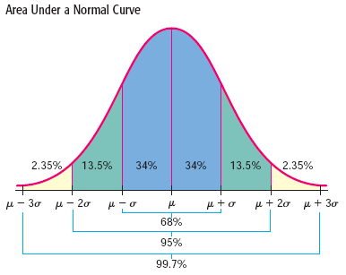

**Figure 9:** Standard normal distribution curve   
Source: (McLeod, 2017)

While the normal range of proficiency testing results can be as much as $±$ 2 z-scores, the degree of accuracy required for the method to be considered as fit for purpose is a separate matter. If all participating laboratories have high levels of accuracy and precision for a particular analyte, a spread of $±$ 2 z-scores may be comparatively inconsequential. On the other hand, less sensitive methods may produce much greater variation such that z-scores represent a greater proportion of the mean.

Indeed, a method’s sensitivity will be set to produce the requisite accuracy results with a variance $±$ 2 z-scores based on cost and technical feasibility. In that regard, the Royal Society of Chemistry (2005) makes the observation: “*As a rule of thumb, to improve the accuracy of a measurement by a factor of two decreases the chance of an incorrect (i.e.. expensive) decision but increases the cost of analysis by a factor of four*".

In a review of proficiency testing results for RCS in the United States, Harper and Sarkisian (2014) suggests that the most significant limiting factor for comparing interlaboratory results is the increase in variability of results at low RCS sample mass loadings. This conclusion is supported by the findings of Cox (2016) who comments on the variability of results in proficiency testing. Cox explains this as an example of the estimated true value of 0.14 from Figure 10 below and suggest that:

“*…this wide range implies that an employer or other entity who receives a laboratory report of, say, 0.06 or 0.09 mg (the two lowest individual laboratory estimated values for this reference value) cannot be reasonably sure (for example, 95% confident) that the true value is less than 0.10 mg. Conversely, the wide vertical scatter of estimates around the reference values that are below 0.10 mg implies that receiving a lab result of 0.12 or even 0.18 mg, does not imply that the true value exceeds 0.10 mg*”.

It is clear that the extent of variability has significant implications for attaining and demonstrating regulatory compliance.

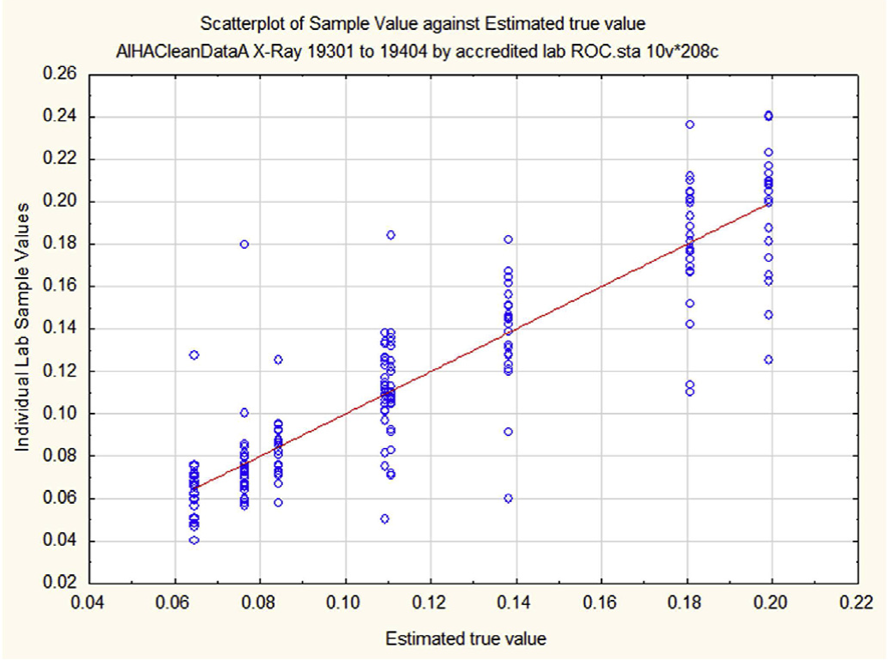

**Figure 10:** AIHA IHPAT results  
Source: Cox, 2016

**8.2 RCS analysis accreditation and proficiency testing agencies**

The accreditation body for RCS analysis in Australia is the National Association of Testing Authorities (NATA). NATA does not conduct its own proficiency testing; laboratories seeking accreditation must participate in an international proficiency testing scheme. There are two recognised international proficiency testing agencies: LGC Standards (UK) and AIHA Proficiency Analytical Testing Program (IHPAT).

NATA confirmed it has only accredited eight laboratories in Australia for RCS analysis. All eight have undertaken proficiency testing through the LGC program; only one of which is accredited for XRD (N. Shepherd, unpublished information collected by Glossop Consultancy in writing this report, 17 April 2020). No Australian laboratories are currently undergoing proficiency testing in the IHPAT program for RCS (A. Oler, unpublished information collected by Glossop Consultancy in writing this report, 17 April 2020).

Proficiency testing programs predominantly formulate idealised samples (that are not typical representations of field samples) for program participants with the following limitations:

* samples are prepared with pure reference quartz without interfering minerals that would normally be present in a workplace collected sample
* filter loadings are low and uniform and not representative of ‘real-world’ samples
* the lowest amount of quartz is approximately 60 μg; this is approximately ten times the LoD and three times the LoQ
* laboratories are not required to determine their own LoD or LoQ, and
* results are considered acceptable if they are within ±2 z-scores.

While similar to the program run by LGC, the AIHA IHPAT program (American Industrial Hygiene Association, 2017) attempts to replicate ‘real-world’ samples:

* the free silica (quartz) sample set includes four 5.0 μm 37 mm PVC (polyvinyl chloride) loaded filter samples
* sample sets contain differing silica concentrations and also include a background matrix
* the background matrix includes a rotating basis of coal mine dust, talc, calcite or a combination of talc and coal mine dust to represent the interfering minerals, and
* the set includes a blank 5.0 μm 37 mm PVC filter.

Participants report in milligrams (mg) of quartz per filter. The free silica (quartz) sample concentration range is generally between 0.05–0.225 mg (50–225 μg) for both programs. The inclusion of talc and calcite in the IHPAT samples is useful as it replicates the interference of these minerals on the FTIR process (American Industrial Hygiene Association, 2017). None of the programs include cristobalite for analysis.

* + - 1. **Discussion**

This report demonstrates the variability present in the available monitoring programs and sampling methods for RCS along with the inherent uncertainty in analytical methods. Measurement uncertainty is exacerbated by the reduction in concentrations of RCS at a WES of 0.02 mg/m3. This Section reviews the limitations of current sampling and analytical methods with the goal of identifying potential areas of improvement.

**9.1 Sampling programs and equipment**

9.1.1 Sampling programs

A rigorous approach to monitoring programs is central to reducing variability in RCS risk assessment, particularly in terms of defining SEGs and ensuring sampling is sufficient and representative of the working environment. Similarly, the correct application of statistical analysis is vital in interpreting monitoring results.

9.1.2 Sampling equipment – samplers and sample pumps

As previously stated, AS 2985 (Standards Australia, 2009) requires that size selective samplers must meet the requirements of the ISO 7708:1995 sampling efficiency curve. The means by which manufacturers can meet such requirements is set out in the CEN-EN 13205 *Workplace exposure - Assessment of sampler performance for measurement of airborne particle concentrations* series of standards:

* Part 1: General Requirements
* Part 2: Laboratory Performance Test Based on Determination of Sampling Efficiency
* Part 3: Analysis of Sampling Efficiency Data
* Part 4: Laboratory Performance Test Based on Comparison of Concentrations
* Part 5: Aerosol Sampler Performance Test and Sampler Comparison Carried Out at Workplaces
* Part 6: Transport and Handling Tests.

While the current range of cyclone samplers may not precisely meet the requirements of ISO 7708:1995, an equally significant issue is the ability of samplers to capture sufficient RCS mass for analysis at the lower concentrations demanded by the WES over a full shift at flow rates of 2–3 L/min. For example, the volume of air required to detect RCS at a TWA WES of 0.02 mg/m3 (adjusted for a 12 hour shift to 0.014 mg/m3) would be at least 4 m3. To obtain that volume of air, the sampling pump would be required to have a flow rate of approximately 5.5 L/min. In order to meet the sampling efficiency curve, a size-selective sampler designed for that flow rate would be required.

High flow samplers that are close to meeting the ISO curve are available but require further investigation. A recent addition to the size selective sampler range is the SKC Parallel Particle Impactor (PPI) that can operate at flow rates of 2, 4 and 8 L/min (SKC, 2018). The PPI consists of an inlet plate of four inlets with separate impactor plates that are each set to sample a quarter of the ISO 7708:1995 sampling efficiency curve. The four sample flows are deposited on a single 37 mm filter and subsequently redeposited onto a silver filter for analysis by XRD. The company claims the sampler closely follows the ISO curve at each of the flow rates (SKC, 2018). The PPI has yet to be reviewed by the AIOH.

High flow sampling also requires higher capacity pumps with sufficient running time to obtain the required air volume. Such equipment is becoming available; a high flow pump is commercially available that is able to run at 12 L/min for a minimum of eight hours at low back pressure. This pump’s battery life is highly dependent on back pressure; the higher the back pressure caused by the filter material and dust loading, the shorter the battery life (Sensidyne, 2019).

**9.2 Analytical processes and reporting**

9.2.1 Analytical methods

In comparing XRD and FTIR methods for field samples from international laboratories participating in proficiency testing from 2014 to 2017, Ichikawa et al. (2019) found that XRD and FTIR are highly correlated for pure quartz samples. However, when comparing the methods where real-workplace samples were analysed, 32% of FTIR analyses failed due to dust overloading and material interference causing the samples to not comply with the HSE quality criteria (2019).The remaining results showed that FTIR values were approximately 10% higher than XRD due to the interferences from other minerals.

Ichikawa et al. (2019) demonstrated that XRD was able to maintain accuracy with higher filter loadings of up to 2 mg in contrast to the 1 mg limit for FTIR. The authors also suggest that the LoD of XRD can be reduced further by extending the scanning time (increasing the scanning time of analysis significantly) and using high quality detectors.

Alternative analytical techniques are also under investigation. Stacey et al. (2017) applied Raman Spectroscopy to RCS analysis demonstrating its viability for reaching an LoD approaching 1/10th of current XRD and FTIR techniques. While the process involved sample redeposition onto a silver filter prior to analysis, the authors suggested that a direct-on-filter method is possible, reducing analysis time and cost. In continuing research using Raman Spectroscopy to analyse redeposited sample containing RCS, Stacey et al. (2020) confirmed the viability of the method to detect RCS at lower mass concentrations than XRD or FTIR with uncertainty estimates that were comparable to XRD.

9.2.2 Calibration and proficiency testing

Proficiency testing is a vital part of intra- and interlaboratory consistency and ongoing improvement, yet NATA reports just eight laboratories participating in the LGC program, only one of which is accredited for XRD (N. Shepherd, unpublished information collected by Glossop Consultancy in writing this report, 17 April 2020).

The reliability of proficiency testing is equally dependent on the calibration of the analytical equipment and the representativeness of the reference standard material. In comparing the purity of seven quartz standards from a previous study relative to a newer standard (NIST-SRM 1878a), Verma and Shaw (2005) identified a variation of approximately 24%. In other words, the reference material used for proficiency testing samples could vary as much as 24% before any additional analytical variation comes into play. Given this finding, a review of crystalline silica reference standards in current use across Australia is warranted to ensure consistency.

Further, the lack of participation in proficiency testing through NATA makes it impossible to determine if laboratories seek to calibrate analytical equipment to match the PSD of workplace samples to avoid reductions in accuracy (Stacey et al., 2009).

The results from a proficiency testing round give some perspective to the proportionally high variance in RCS analysis when compared to other analytes (unpublished information collected by Glossop Consultancy in writing this report*,* 2020)*.* Figure 11 shows proficiency testing results for manganese (Mn) with a relative standard deviation of approximately 4.3%. In comparison, the results for respirable grade quartz as shown in Figure 12 have an RSD of 12.8%; approximately three times the amount of variation observed for manganese.

The variation of results for quartz should be considered in the context of the mass involved and the fact that samples were prepared with reference standard material. The assigned value for the quartz mass in Figure 12 was 181 μg. This highlights the potential for high measurement uncertainty when dealing with real-world samples inclusive of interfering minerals at a TWA of 0.02 mg/m3.

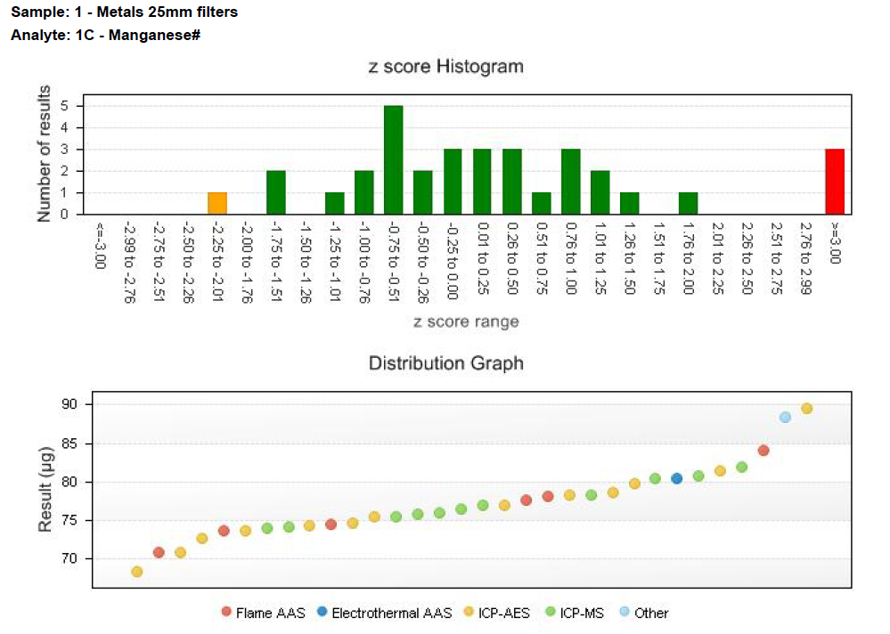

**Figure 11:** Example of PT results for manganese (Mn)

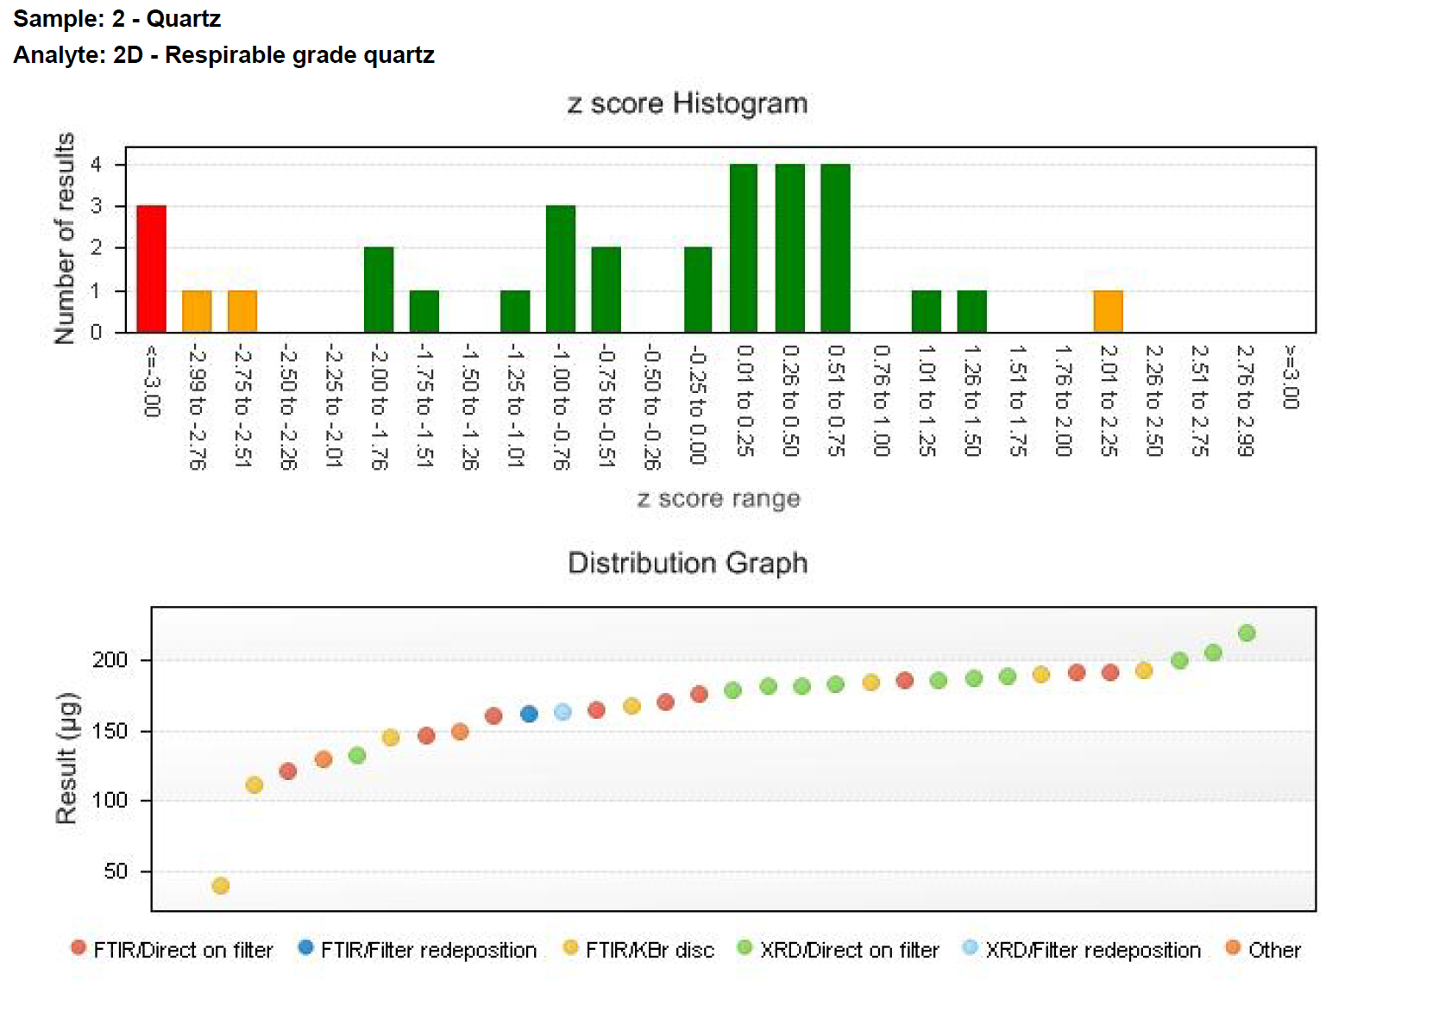

**Figure 12:** Example of PT results for quartz

9.2.3 Reporting

The outcome of sampling and analysis is reported in laboratory results. However, even when variability in sampling and analysis are reduced to their lowest extent possible, the way in which results are presented may lead to ambiguity and uncertainty.

Reporting should include both the results and the uncertainty in terms of the range of values that encompass them and the associated confidence level (European Comission: Joint Research Centre, 2012) as shown in Figure 13:

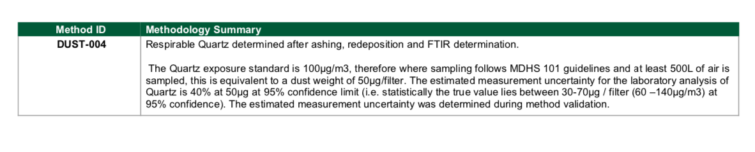

**Figure 13:** Example of laboratory measurement summary   
Source: Envirolab Services, 2020 before the WES was lowered to 0.05 mg/m3

* + - 1. **Conclusion**

At the time of writing this report, measurement of RCS to demonstrate compliance with a WES of 0.02 mg/m3 (including when it is adjusted for extended work shifts) is not achievable in Australia with available sampling and analysis equipment. There is significant uncertainty that increases as the WES is reduced. Variability in rigorous approach to monitoring programs and sampler efficiencies are substantial factors affecting the reliability of assessments of exposure to RCS. Similarly, the lack of proficiency testing of all Australian laboratories that undertake analysis of RCS samples and the inherent variability within proficiency testing is highly problematic. The matter is further compounded by the increased measurement uncertainty in analytical methods arising from the reduction in the WES

Cox (2016) brings perspective to the challenge of reducing exposure concentrations of RCS to levels that are approaching our current capacity to measure them with the following statement:

*“A regulation that tells employers “Do not exceed concentration C” can only be effective if it is possible to determine, with useful reliability, when a workplace is in compliance. As permitted concentrations become lower, determining compliance can become more difficult, requiring increasingly accurate and precise laboratory measurements.”*

Current sampling and analytical equipment and techniques in use around the country often provide users with little or no indication of the levels of uncertainty contributing to the final reported result. On the contrary, results reported to be under the WES may be at or above the WES when uncertainty is taken into consideration (and vice versa).

The pressing issue is for employers, unions, industry bodies and government agencies to recognise, understand and support the need for improved sampling and analytical methodologies in the context of measuring RCS.

These issues will continue to impact upon the ability to accurately assess and manage risk associated with worker exposure to RCS until the matter is broadly reviewed by the main stakeholders (for example, Standards Australia, the Royal Australian Chemical Institute, the Australian Institute of Occupational Hygienists, the National Association of Testing Authorities, TestSafe Australia, and WHS Regulators) and a program of guidance is established.

* + - 1. **Recommendations to improve RCS measurement**

The measurement of RCS is dependent on good sampling and proficient analysis. Measuring a WES for RCS of 0.02 mg/m3 (adjusted to 0.014 mg/m3 for some 12 hour shifts) can’t be undertaken with accuracy until such time as methods with sufficient sensitivity, reliability and accuracy are available and valid.

To enable the accurate measurement and sufficient certainty when measuring RCS, the following should be undertaken:

**Sampling and analytical improvements**

1. A system of sampler validation for respirable dust samplers sold in Australia should be established. This should include the provision of details of samplers’ performance by manufacturers as measured by recognised independent testing facility in relation to the ISO 7708:1995 sampling efficiency curve (for example, demonstrating performance in accordance with EN 13205-1).
2. The guidelines for respirable dust samplers should be reviewed with a view to examining the applicability of EN 13205 in Australia.

Analysis improvements

1. All laboratories that analyse RCS samples should be enrolled in a proficiency testing scheme and demonstrate proficiency for the analysis of RCS.
2. All laboratories should report the analytical method’s LoD and LoQ with sample results.
3. Calibration and reference standards used by laboratories to validate analytical methods and complete proficiency testing requirements should be of a high quality and reflect real-world samples. This includes research into PSD across a range of occupational environments and include interfering minerals for FTIR analysis.
4. Reporting of RCS concentrations with the correct number of significant figures and the level of uncertainty.

**Guidance materials**

1. Develop guidance material for monitoring airborne RCS that includes information about:

* sampling methodologies
* analytical methods
* laboratory best practice
* measurement and reporting of uncertainty
* interpretation of results, and
* compliance decisions.
  + - 1. **References**

AIHA. (2015). *A strategy for assessing and managing occupational exposures* (B. W. Jahn S, Ignacio J, Ed. Fourth ed.). Virginia: Amercian Industrial Hygiene Association.

AIHA. (2020). IH Apps & Tools. Retrieved from <https://www.aiha.org/public-resources/consumer-resources/topics-of-interest/ih-apps-tools>

AIOH. (2020). *Size-Selective Samplers for Respirable Dust Sampling – Guidance Information*. Technical Paper. Australian Institute of Occupational Hygienists,. Melbourne.

American Industrial Hygiene Association. (2017). Industrial Hygiene Proficiency Analytical Testing (IHPAT) Program Scheme Plan. In (pp. 10). Falls Church, Virginia: AIHA PAT.

Armbruster, D. A., & Pry, T. (2008). Limit of blank, limit of detection and limit of quantitation. *The Clinical Biochemist Reviews, 29*(Suppl 1), S49-S52. Retrieved from <https://www.ncbi.nlm.nih.gov/pubmed/18852857>

Ashley, E. L., Cauda, E., Chubb, L. G., Tuchman, D. P., & Rubinstein, E. N. (2020). Performance Comparison of Four Portable FTIR Instruments for Direct-on-Filter Measurement of Respirable Crystalline Silica. *Annals of Work Exposures and Health*. doi:10.1093/annweh/wxaa031

Belle, B. (2019). Evaluation of gravimetric sampler bias, effect on measured concentration, and proposal for the use of harmonised performance based dust sampler for exposure assessment. *International Journal of Mining Science and Technology, 29*(3), 445-452. doi:10.1016/j.ijmst.2018.07.009

Bernal, E. (2014). Limit of Detection and Limit of Quantification: Determination in Gas Chromatography,. In Xinghua Guo (Ed.), *Advances in Gas Chromatography* (pp. 34). doi:10.5772/57341

Bhaskar, R., Li, J., & Xu, L. (1994). A Comparative Study of Particle Size Dependency of IR and XRD Methods for Quartz Analysis. *American Industrial Hygiene Association Journal, 55*(7), 605-609. doi:10.1080/15428119491018682

Chen, Y., Zou, C., Mastalerz, M., Hu, S., Gasaway, C., & Tao, X. (2015). Applications of Micro-Fourier Transform Infrared Spectroscopy (FTIR) in the Geological Sciences—A Review. *International Journal of Molecular Sciences, 16*(12), 30223-30250. doi:10.3390/ijms161226227

Chubb, L., & Cauda, E. (2017). Characterizing Particle Size Distributions of Crystalline Silica in Gold Mine Dust. *Aerosol and air quality research, 17*(1), 24-33. doi:10.4209/aaqr.2016.05.0179

Comite Europeen de Normalisation. (2018). CEN-EN 689: Workplace exposure - Measurement of exposure by inhalation to chemical agents - Strategy for testing compliance with occupational exposure limit values. In (pp. 58).

Cox, J. L. A. (2016). How accurately and consistently do laboratories measure workplace concentrations of respirable crystalline silica? *Regulatory Toxicology and Pharmacology, 81*, 268-274. doi:10.1016/j.yrtph.2016.09.008

Currie, L. A. (2004). Uncertainty in measurements close to detection limits: detection and quantification capabilities. In *Quantifying uncertainty in nuclear analytical measurements*. Vienna, Austria: International Atomic Energy Agency.

Daniels, R. D., Gilbert, S. J., Kuppusamy, S. P., Kuempel, E. D., Park, R. M., Pandalai, S. P., . . . Paul, A. S. (2020). *Current Intelligence Bulletin 69: NIOSH Practices in Occupational Risk Assessment*. Cincinnati, OH: National Institute for Occupational, Safety and Health (NIOSH) Retrieved from <https://www.cdc.gov/niosh/docs/2020-106/>

Department of Education Skills and Employment. (2020). Labour Market Information Portal. Retrieved from <https://lmip.gov.au/>

Deutche Gesetzliche Unfallverisicherung. (2016). *Method for the determination of quartz and cristobalite*. Heidelberg, Germany: Wiley

Dutrow, B. L. (2020). X-ray Powder Diffraction (XRD). Retrieved from <https://serc.carleton.edu/research_education/geochemsheets/techniques/XRD.html>

Eschenbacher, W. L., Kullman, G. J., & Gomberg, C. C. (2000). Pulmonary Effects of Inhaled Mineral Dusts. In R. L. Harris (Ed.), *Patty's Industrial Hygiene* (5 ed., Vol. 1). New York, USA: John Wiley & Sons.

European Comission: Joint Research Centre. (2012). Analytical measurement: measurement uncertainty and statistics. In N. Macjen, Gegevicius, V, (Ed.), Training in Metrology in Chemistry.

Firth, I., & Drolet, D. (2014). Development of a Tool for the Adjustment of Workplace Exposure Standards for Atmospheric Contaminants Due to Extended Work Shifts. *J Health & Safety Research & Practice 6*(2), 6-10.

Firth, I., van Zanten, D., & Tiernan, G. (2006). *Simplified Occupational Hygiene Risk Management Strategies* Tullarmarine, Melbourne: Australian Institute of Occupational Hygienists Inc.

Görner, P., Wrobel, R., Micka, V., Skoda, V., Denis, J., & Fabriès, J. F. (2001). Study of fifteen respirable aerosol samplers used in occupational hygiene. *Ann Occup Hyg, 45*(1), 43-54. doi:10.1016/s0003-4878(00)00014-4

Grantham, D. (2001). *Simplified monitoring strategies*. Melbourne: Australian Institute of Occupational Hygienists.

Grantham, D., & Firth, I. (2014). Occupational Hygiene Monitoring and Compliance Strategies.

Harper, M., Sarkisian, K., & Andrew, M. (2014). Assessment of Respirable Crystalline Silica Analysis Using Proficiency Analytical Testing Results from 2003–2013. *Journal of Occupational & Environmental Hygiene, 11*(10), D157-D163. doi:10.1080/15459624.2014.930561

Hart, J. F., Autenrieth, D. A., Cauda, E., Chubb, L., Spear, T. M., Wock, S., & Rosenthal, S. (2018). A comparison of respirable crystalline silica concentration measurements using a direct-on-filter Fourier transform infrared (FT-IR) transmission method vs. a traditional laboratory X-ray diffraction method. *Journal of Occupational and Environmental Hygiene, 15*(10), 743-754. doi:10.1080/15459624.2018.1495334

HSE. (2015). *Crystalline silica in respirable airborne dust: Direct-on-filter analyses by infrared spectroscopy or X-ray* London: Health and Safety Executive Retrieved from <https://www.hse.gov.uk/pubns/mdhs/pdfs/mdhs101.pdf>

HSE UK. (2015). Crystalline silica in respirable airborne dust: Direct-on-filter analyses by infrared spectroscopy or X-ray London: Health and Safety Executive

IARC. (1997). IARC Working Group on the Evaluation of Carcinogenic Risks to Humans: Silica, some silicates, coal dust, and para-aramid fibrils, Lyon, France.

Ichikawa, A., Volpato, J., O’Donnell, G., & Mazereeuw, M. (2019). Comparison of X-ray Diffraction and Infrared Spectroscopy: Methods for the Analysis of Respirable Crystalline Silica of Workplace Air Samples. NSW: TestSafe Australia

International Organization for Standardization. (2009). ISO/IEC GUIDE 98-1:2009 Uncertainty of measurement — Part 1: Introduction to the expression of uncertainty in measurement. In. Geneva: Switzerland: International Organization for Standardization.

International Organization for Standarization. (1995). ISO 7708-1995: Air quality - Particle size fraction definition for health-related sampling. In. Geneve: Switzerland: International Organization for Standarization.

Johnson, D. L., & Esmen, N. A. (2004). Method-induced Misclassification for a Respirable Dust Sampled Using ISO/ACGIH/CEN Criteria. *Annals of Work Exposures and Health, 48*(1), 13-20. doi:10.1093/annhyg/meg082

Lavín, Á., Vicente, J. d., Holgado, M., Laguna, M. F., Casquel, R., Santamaría, B., . . . Ramírez, Y. (2018). On the Determination of Uncertainty and Limit of Detection in Label-Free Biosensors. *Sensors (Basel, Switzerland), 18*(7), 2038. doi:10.3390/s18072038

Lee, T., Harper, M., Kashon, M., Lee, L. A., Healy, C. B., Coggins, M. A., . . . O’Brien, A. (2015). Silica Measurement with High Flow Rate Respirable Size Selective Samplers: A Field Study. *Annals of Work Exposures and Health, 60*(3), 334-347. doi:10.1093/annhyg/mev081

Little, T. (2015). Method Validation Essentials, Limit of Blank, Limit of Detection, and Limit of Quantitation. *BioPharm International, 28*(4), 48-51.

Logan, P., Ramachandran, G., Mulhausen, J., & Hewett, P. (2009). Occupational Exposure Decisions: Can Limited Data Interpretation Training Help Improve Accuracy? *The Annals of Occupational Hygiene, 53*(4), 311-324. doi:10.1093/annhyg/mep011

Mazereeuw, M., Volpato, J., & Ichikawa, A. (2019). *State-of-the-art analysis of respirable crystalline silica by direct-on-filter XRD and recent findings from workplace samples*. Sydney: Testsafe Australia Retrieved from <https://www.aioh.org.au/static/uploads/files/1445-c10-3-martin-mazereeuw-wfodkrscvgkp.pdf>

McLeod, S. A. (2017). Z-score: definition, calculation and interpretation. . Retrieved from <https://www.simplypsychology.org/z-score.html>

National Institute for Occupational Safety and Health. (2003). *Analytical Method 7500 SILICA, CRYSTALLINE, by XRD (filter redeposition)*. Cincinnati, Ohio: Centre for Disease Control

NHMRC. (1984). Method for Measurement of Quartz in Respirable Airborne Dust by Infrared Spectroscopy and X-Ray Diffractometry. Canberra: National Health & Medical Research Council

NMAM. (2016). Factors Affecting Aerosol Sampling. In *NIOSH Manual of Analytical Methods (NMAM)* (5th ed.). Retrieved from <https://www.cdc.gov/niosh/nmam/pdf/NMAM_5thEd_EBook-508-final.pdf>

Ojima, J. (2003). Determining of Crystalline Silica in Respirable Dust Samples by Infrared Spectrophotometry in the Presence of Interferences. *Journal of Occupation Health, 45*(2), 94-103. doi:10.1539/joh.45.94

Pensis, I., Luetzenkirchen, F., & Friede, B. (2014). SWeRF—A Method for Estimating the Relevant Fine Particle Fraction in Bulk Materials for Classification and Labelling Purposes. *Annals of Work Exposures and Health, 58*(4), 501-511. doi:10.1093/annhyg/met076

Ramachandran, G. (2019). Progress in Bayesian Statistical Applications in Exposure Assessment. *Annals of Work Exposures and Health, 63*(3), 259-262. doi:10.1093/annweh/wxz007

Rappaport, S. M., & Selvin, S. (1987). A Method for Evaluating the Mean Exposure from a Lognormal Distribution. *American Industrial Hygiene Association Journal, 48*(4), 374-379. doi:10.1080/15298668791384896

Rappaport, S. M., Selvin, S., & Roach, S. A. (1988). A Strategy for Assessing Exposures with Reference to Multiple Limits. *Applied Industrial Hygiene, 3*(11), 310-315. doi:10.1080/08828032.1988.10389863

Reed, S., Pisaniello, D., & Benke, G. (2019). *Principles of occupational health and hygiene: an introduction* (3 ed.). Crows Nest: Sydney: Allen & Unwin.

Royal Society of Chemistry. (2005). What is proficiency testing? Guide for end-users of chemical data. In *AMC Technical Briefs*. London: The Royal Society of Chemistry.

Safe Work Australia. (2013). *Guidance on the interpretation on workplace exposure standards for airborne contaminants*. Canberra: Safe Work Australia Retrieved from <https://www.safeworkaustralia.gov.au/system/files/documents/1705/guidance-interpretation-workplace-exposure-standards-airborne-contaminants-v2.pdf>

Safe Work Australia. (2020). Hazardous Chemical Information System (HCIS): Reference Information: Cut Off Concentrations. Retrieved from <http://hcis.safeworkaustralia.gov.au/SearchKey#Notes>

Sensidyne. (2019). Gilian 12 Air Sampling Pump (4 - 12 LPM). Retrieved from <https://www.sensidyne.com/air-sampling-equipment/gilian-air-sampling-pumps/gilian-12-air-sampling-pump-(4-12-lpm)/>

SKC. (2018). SKC Plastic Cyclone Notice. In *Models 225-69 with 25mm cassette and 225-69-37 with 37mm cassette*. Dorset, UK: SKC LTD.

Stacey, P. (2007). Analytical Performance Criteria. *Journal of Occupational and Environmental Hygiene, 4*(1), D1-D4. doi:10.1080/15459620601027997

Stacey, P., Clegg, F., Morton, J., & Sammon, C. (2020). An indirect Raman spectroscopy method for the quantitative measurement of respirable crystalline silica collected on filters inside respiratory equipment. *Analytical Methods*. doi:10.1039/D0AY00165A

Stacey, P., Kauffer, E., Moulut, J.-C., Dion, C., Beauparlant, M., Fernandez, P., . . . Wake, D. (2009). An International Comparison of the Crystallinity of Calibration Materials for the Analysis of Respirable α-Quartz Using X-Ray Diffraction and a Comparison with Results from the Infrared KBr Disc Method. *Annals of Work Exposures and Health, 53*(6), 639-649. doi:10.1093/annhyg/mep038

Stacey, P., Mader, K. T., & Sammon, C. (2017). Feasibility of the quantification of respirable crystalline silica by mass on aerosol sampling filters using Raman microscopy. *Journal of Raman Spectroscopy, 48*(5), 720-725. doi:10.1002/jrs.5113

Stacey, P., Mecchia, M., Verpaele, S., Pretorius, C., Key-Schwartz, R., Mattenklott, M., . . . Frost, G. (2013). Differences Between Samplers for Respirable Dust and the Analysis of Quartz - An International Study. *Silica and Associated Respirable Mineral Particles*, 73-102. doi:10.1520/STP156520120188

Standards Australia. (2009). AS 2985 - 2009 Workplace atmospheres-method for the sampling and gravimetric determination of respirable dust. In (Vol. AS 2985-2009). Homebush NSW: Standards Australia.

Steer, C., & Langley, C. (2019). *The hazardous work environment: the occupational hygiene challenge* (3 ed.). Crows Nest, Sydney: Allen & Unwin.

Trendall, A. F., & Blockley, J. G. (1970). *Bulletin 119: The iron formations of the Precambrian Hamersley Group, Western Australia*. Perth, Western Australia: WA Government Publisher.

Verma, D. K., & Shaw, D. S. (2001). A comparison of international silica (α-quartz) calibration standards by Fourier transform–infrared spectrophotometry. *The Annals of Occupational Hygiene, 45*(6), 429-435. doi:10.1093/annhyg/45.6.429

Verma, D. K., & Shaw, D. S. (2005). Comparison of Crystalline Silica (α-Quartz) Calibration Standards NIST-SRM 1878 and NIST-SRM 1878a by Fourier Transform Infrared Spectrophotometry. *The Annals of Occupational Hygiene, 49*(4), 359-361. doi:10.1093/annhyg/meh109

Verpaele, S., & Jouret, J. (2012). A Comparison of the Performance of Samplers for Respirable Dust in Workplaces and Laboratory Analysis for Respirable Quartz. *Annals of Work Exposures and Health, 57*(1), 54-62. doi:10.1093/annhyg/mes038

WA Department of Mines Industry Regulation & Safety. (2018). *Preparation of a health and hygiene management plan - guide*. Perth: Department of Mines Industry Regulation and Safety Retrieved from <http://www.dmp.wa.gov.au/Documents/Safety/MSH_G_HHMP.pdf>

* + - 1. **Appendices**

# **Appendix A: Comparison of respirable dust efficiency curves**

Source: Görner et al. 2001

## **Comparison of respirable dust efficiency curves**

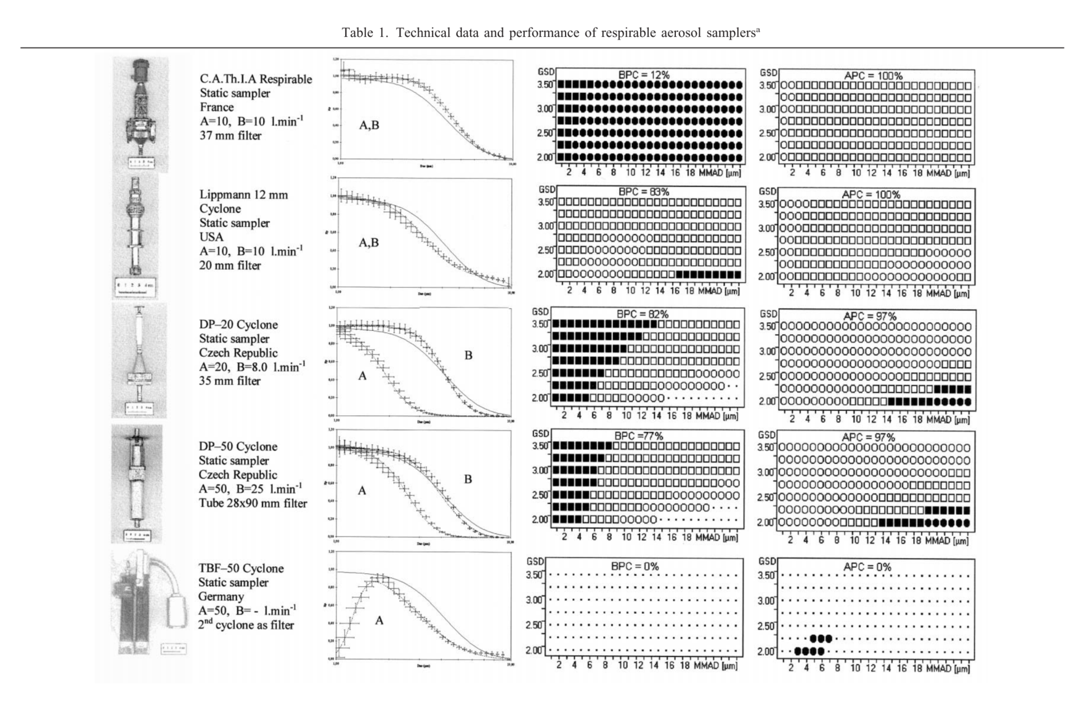

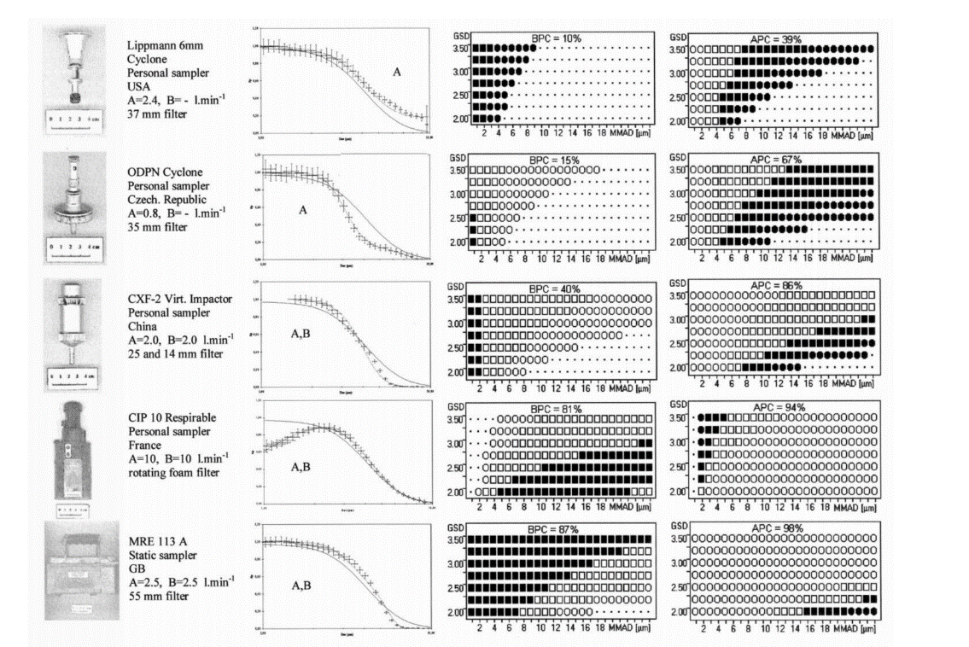

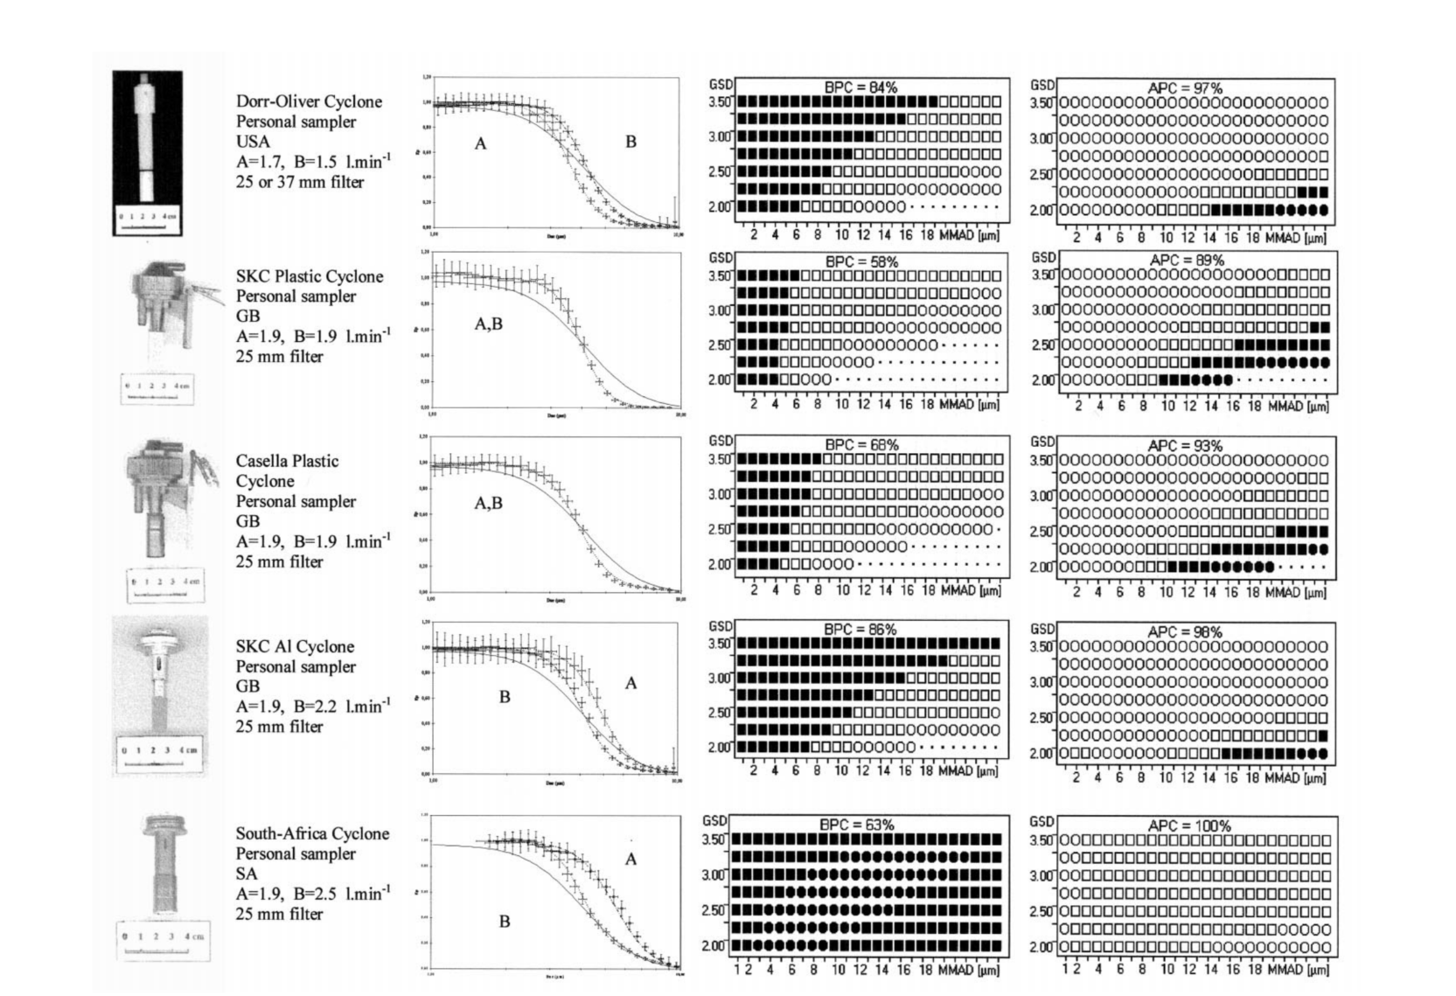

# **Appendix B: Comparison of respirable dust sampler 50% cut off point**

Source: Görner et al. 2001

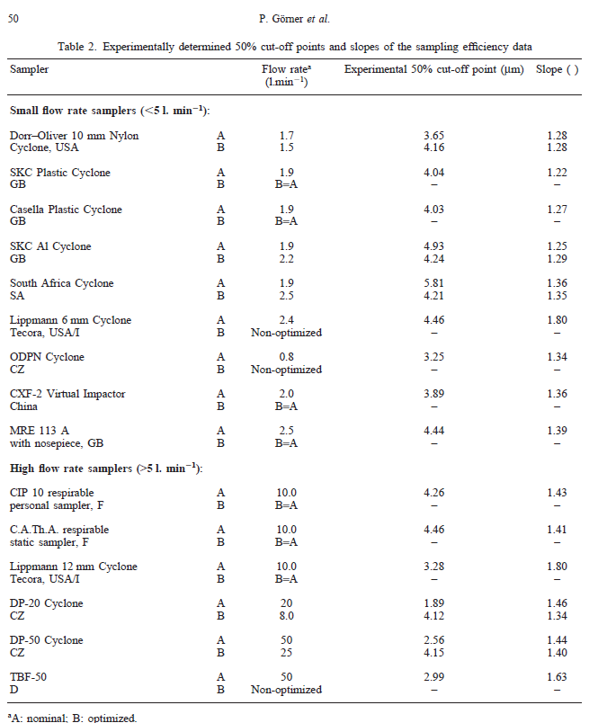

1. A Similar Exposure Group (SEG) is a group of workers having the same general exposure profile for the agent(s) being studied because of the similarity and frequency of the tasks they perform, the materials and processes with which they work and the similarity of the way they perform those tasks (Logan, Ramachandran, Mulhausen, & Hewett, 2009)