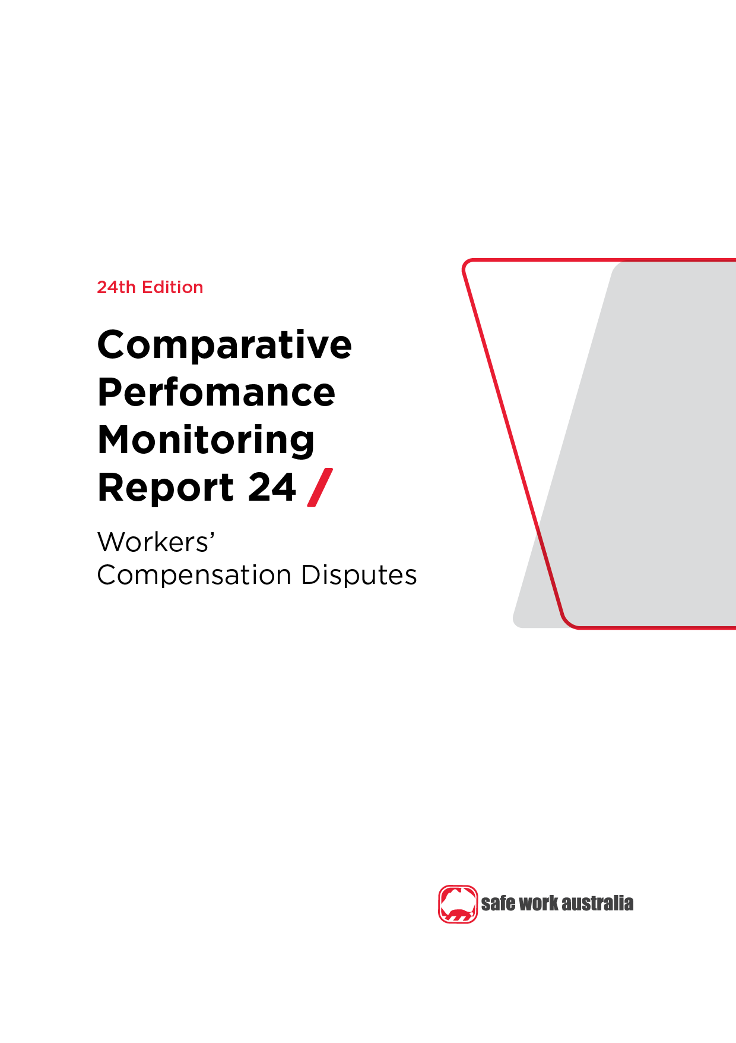

Disclaimer

Safe Work Australia is an Australian Government statutory agency established in 2009. Safe Work Australia includes Members from the Commonwealth, and each state and territory, Members representing the interests of workers and Members representing the interests of employers.

Safe Work Australia works with the Commonwealth, state and territory governments to improve work health and safety and workers’ compensation arrangements. Safe Work Australia is a national policy body, not a regulator of work health and safety. The Commonwealth, states and territories have responsibility for regulating and enforcing work health and safety laws in their jurisdiction.

**ISSN 2209-9158**

Creative Commons

With the exception of the Safe Work Australia logo, this copyright work is licensed under a Creative Commons Attribution 4.0 International licence. To view a copy of this licence, visit creativecommons.org/licenses. In essence, you are free to copy, communicate and adapt the work, even commercially, as long as you attribute the work to Safe Work Australia and abide by the other licence terms.

Contact information

Safe Work Australia | <mailto:info@swa.gov.au> | [www.swa.gov.au](http://www.swa.gov.au)

Comparative Performance Monitoring (CPM) 24th edition indicators

The CPM comprises of 23 Work Health and Safety and Workers’ Compensation measurement indicators spread over 6 sections. The bolded indicators are included in this section.

**Work Health and Safety Performance**

Indicator 1 – Incidence rates of serious injury and disease claims by jurisdiction

Indicator 2 – Frequency rates of serious injury claims by jurisdiction

Indicator 3 – Incidence rates of long term (12 weeks or more compensation) injury and disease claims by jurisdiction

Indicator 4 – Frequency rates of long term (12 weeks or more compensation) injury and disease claims by jurisdiction

Indicator 5a and 5b – Self-insured claims: number and proportion of serious claims by jurisdiction

Indicator 6 – Serious claims: Percentage involving selected periods of compensation

Indicator 7a and 7b – Traumatic injury worker fatalities: number and rate of incidents not on a public road, by state of death

Indicator 8 – Compensated fatalities involving occupational diseases by jurisdiction

Indicator 9 – Size of business

Indicator 10a to 10h – Proportion of serious claims by mechanism of incident

Indicator 11a to 11s – Incidence rates of serious claims by industry

**Work Health and Safety Compliance and Enforcement Activities**

Indicator 12a – Work health and safety intervention activity by jurisdiction

Indicator 12b – Work health and safety inspectorate activity by jurisdiction

Indicator 12c – Work health and safety notices and enforceable undertakings by jurisdiction

Indicator 12d – Work health and safety legal proceedings and fines by jurisdiction

**Workers’ Compensation Premiums**

Indicator 13 – Standardised average premium rates (including insured and self-insured sectors) by jurisdiction

Indicator 14a to 14s – Australian average premium rates by industry

**Entitlements under Workers’ Compensation**

Indicator 15 – Average percentage of pre-injury earnings for selected periods of incapacity as at 1 January 2021

Indicator 16 – Estimated entitlements payable for permanent incapacity as at 1 January 2021

Indicator 17 – Estimated entitlements payable for a workplace fatality as at 1 January 2021

**Workers’ Compensation Funding**

Indicator 18 – Standardised ratio of assets to net outstanding claim liabilities for centrally funded schemes

Indicator 19 – Standardised ratio of assets to net outstanding claim liabilities for privately underwritten schemes

Indicator 20a and 20b – Scheme expenditure ($m and %)

Indicator 21 – Direct compensation payments by type and jurisdiction

**Workers’ Compensation Disputes**

**Indicator 22 – Proportion of claims with dispute**

**Indicator 23 – Percentage of disputes resolved within selected time periods (cumulative)**

Contents

Foreword 5

Introduction 6

1.1 Disputation rate 6

Indicator 22 – Proportion of claims with dispute 7

1.2 Dispute resolution 7

Indicator 23 – Percentage of disputes resolved within selected time periods (cumulative) 8

Appendix 1 – Jurisdictional contact information 9

Foreword

This is the 24th edition of the Comparative Performance Monitoring (CPM) report which provides trend analyses about work health and safety (WHS) and workers’ compensation schemes operating in Australia and New Zealand.

This report has been compiled and coordinated by Safe Work Australia with assistance from representatives of all WHS and workers’ compensation authorities in Australia and New Zealand. Through a partnership of governments, employers and employees, Safe Work Australia leads the development of national policy to improve WHS and workers’ compensation arrangements across Australia.

The report is presented in the following sections:

* *Work health and safety performance* – provides an overview of WHS performance across Australia and New Zealand through analysing trends in serious claim rates and work-related fatalities across jurisdictions.
* *Work health and safety compliance and enforcement activities* – includes a jurisdictional comparison of workplace interventions, inspectorate activity, safety notices, enforceable undertakings, legal proceedings and fines.
* *Workers’ compensation premiums -* includes a national and jurisdictional overview of the standardised average premium rates by industry in the past 5 years.
* *Entitlements under workers’ compensation (scenarios)* – illustrates the differences in entitlement levels across jurisdictions under several scenarios.
* *Workers’ compensation funding – assets, liabilities and expenditure* – includes information about the different funding arrangements of the schemes and compares the differences in scheme funding arrangements and finances.
* *Workers’ compensation disputes* – includes information about disputes against an insurer’s decision or decisions relating to compensation (this section).

Previous editions of the CPM report also included return to work rates as measured in the National Return to Work Survey. Results from the latest [*National Return to Work Survey*](https://www.safeworkaustralia.gov.au/data-and-research/measuring-return-work-outcomes) (2021) and earlier surveys are available on the [*Safe Work Australia*](https://www.safeworkaustralia.gov.au/) website. For trend data on the return to work rates (from 2012 to 2018) please refer to the [*22nd edition of the CPM (Part 3)*](https://www.safeworkaustralia.gov.au/resources-and-publications/statistical-reports/comparative-performance-monitoring-report-22nd-edition-part-3).

*About the data*

Comparisons of CPM measures/outcomes across the jurisdictions workers’ compensation schemes should be made with caution due to the differences in design, coverage, definitions and processes. Readers may find the [*Comparison of workers’ compensation arrangements in Australia and New Zealand*](https://www.safeworkaustralia.gov.au/resources-and-publications/reports/comparison-workers-compensation-arrangements-australia-and-new-zealand-2019) useful in comparing the differences in key aspects of each scheme. Additionally, data in this publication may differ from jurisdictional annual reports due to the use of different definitions and the application of adjustment factors to aid in the comparability of data.

The CPM does not currently include information or data from other industry-specific regulators that have responsibilities with respect to WHS and workers’ compensation. These include national industry-based regulators with compliance and enforcement roles such as the National Heavy Vehicle Regulator, the National Rail Safety Regulator and the National Offshore Petroleum Safety and Environmental Management Authority, and other agencies with responsibility for industry‑specific compensation claims. Further information on these regulators can be found on their respective websites.

In this report ‘Australian Government’ is used for indicators relating to WHS and workers’ compensation matters under the Australian Government jurisdiction, while ‘Comcare’ is used for the indicators relating to premium rates and entitlements.

Introduction

A dispute is an appeal to a formal mechanism, such as a review officer, conciliation or mediation service, against an insurer’s decision or decisions relating to compensation. Disputes exclude common law and redemptions and commutations unless they are processed as disputes through the jurisdiction’s dispute resolution system.

Data on disputes related to the Australian Capital Territory (Private) Compensation scheme are not reported in the Comparative Performance Monitoring Report.

* 1. Disputation rate

Indicator 22 shows the number of new disputes as a proportion of ‘active’ claims in the reference financial year. An active claim is any claim on which a payment of any type was made during the reference financial year (including claims with medical treatment costs only) regardless of when that claim was lodged.

The measure includes all disputes lodged for the year against any active claim that had any type of payment in the reference financial year. However, there could be a small number of disputes lodged against claims that are not active, such as liability disputes. The comparison of disputation rates between jurisdictions must be made with caution due to jurisdictional differences in scheme design, types of decisions that can be appealed, dispute resolution models and the cost of appeals (see Table 2.9 in [*Comparison of workers’ compensation arrangements in Australia and New Zealand*](https://www.safeworkaustralia.gov.au/resources-and-publications/reports/comparison-workers-compensation-arrangements-australia-and-new-zealand-2019) for differences between the schemes).

**National**

* The Australian disputation rate (4.2% of active claims) in 2020–21 has **decreased by 17%** since 2016–17.

**Jurisdictions**

* 7 out of 9 Australian jurisdictions recorded decreases in disputation rates during the 5 year period (2016–17 to 2020–21).
* Large decreases were observed in Victoria (**i down 35%**), and Comcare (**i down 20%**). Seacare also reported a decrease (**i down 26%**), recording a rate of 15% (of active claims) in 2020-21 from a high dispute rate of 24% in 2019–20.
* The 2 jurisdictions recording increases were the Northern Territory (**h up 26%**) and Western Australia (**h up 6%**).
* The New Zealand disputation rate is very low (0.8%) because of the universal nature of its accident compensation scheme. Since people are covered whether the incident occurs at work, home, on the road, playing sport and whether they are employed, self-employed or a non-earner (child, pensioner, student, unemployed) there are very few disputes relating to cover.

Indicator 22 – Proportion of claims with dispute

Indicator 22 – Proportion of claims with dispute.
This bar graph shows the proportion of claims with dispute by jurisdiction from 2016-17 to 2020-21, and the Australian average for 2020-21.


* 1. Dispute resolution

The speed with which disputes are resolved depends on the systems and processes that are in place for each jurisdiction. Generally, the simpler the process, the faster the dispute is resolved. Where there is a lag in collection, exchange and lodgment of information by one or more parties, disputes are likely to be more adversarial and therefore more costly. A high percentage of disputes resolved in a longer time frame may also indicate that there are a high number of more complex disputes being dealt with within a jurisdiction, or that there are some mandatory medical or legal processes in place that inherently delay resolution.

**National**

Indicator 23 shows that in the past 5 years, 2016–17 to 2020–21 in Australia, disputes have taken longer to resolve.

* In 2020–21, more than half the cumulative disputes (59.3%) were resolved within 3 months of the date of lodgment on average in Australia. This is slightly lower (**i down** **6%)** than in 2016–17, when 63.2% of cumulative disputes had been resolved within the same time period (3 months from lodgment).
* There were also decreases in the percentage of disputes resolved within 1 month, 6 months, and 9 months (**i down** **9%, 5% and 3%,** respectively).

**Jurisdictions**

* In 2020–21, Queensland resolved most of its disputed claims within 3 months (86.2%), followed by Western Australia (72.1%) and Tasmania (67.5%).
* By comparison, in 2020-21 Comcare (8.4%) and Seacare (10.9%) resolved relatively few of their disputed claims in this timeframe.
  + Comcare and Seacare disputes generally take more time to resolve than disputes in other jurisdictions due to the complexity of these disputes. The resolution of applications is also influenced by factors such as the nature of the decisions and time needed by parties to obtain further evidence or to agree to a resolution. As the number of applications made to the Administrative Appeals Tribunal (who hear the disputes) is relatively small (particularly in Seacare), any changes in the number of cases finalised can result in relatively large percentage changes in the resolution rates within the specified time frames.
  + Seacare and Comcare consistently recorded the lowest proportion of disputes resolved across all measured time periods (1 month, 3 months, 6 months, and 9 months).
* In 2020–21, Queensland (99.9%) resolved most of its disputes within 9 months. However, they also recorded fewest disputes resolved within one month at 0.8%, **i** **down 91%** from 9.2% in 2016–17.
* In New South Wales there has been a large increase in the proportion of disputes resolved within one month since 2016-17 (**h up** **104%**). The resolution rates over other time periods, within 3 months (**h up** **10%**), 6 months (🡪 **0%**), and 9 months (**h up** **1%**), were either flat or relatively minor. Overall, 56.9% of disputes were resolved within 3 months.
* Victoria experienced decreases in the proportion of disputes resolved since 2016–17 – with resolution rates within one month (**i down** **32%**), 3 months (**i down** **17%**), 6 months (**i down** **14%**) and 9 months (**i down** **8%**) all decreasing.
  + The resolution times for Victoria are affected by the compulsory conciliation process, which may or may not involve medical panel referral, and the fact that court litigation can only occur at the conclusion of the compulsory conciliation process.
* NZ and Australia have comparable dispute resolution times, with more than 50% of disputes resolved within 3 months and over 75% resolved within 6 months.

Indicator 23 – Percentage of disputes resolved within selected time periods (cumulative)

| **Jurisdiction\*** | **Within 1 month** | **Within 3 months** | **Within 6 months** | **Within 9 months** |
| --- | --- | --- | --- | --- |
| **2016–17** |  |  |  |  |
| New South Wales | 4.5 | 51.9 | 84.7 | 92.9 |
| Victoria | 14.8 | 66.5 | 84.0 | 92.4 |
| Queensland | 9.2 | 81.2 | 95.6 | 97.2 |
| Western Australia | 40.6 | 78.6 | 87.6 | 94.5 |
| Tasmania | 57.7 | 67.5 | 78.4 | 85.8 |
| Comcare | 6.1 | 14.9 | 28.4 | 42.6 |
| Seacare | 4.7 | 12.5 | 18.8 | 34.4 |
| **Australia** | 15.4 | 63.2 | 81.8 | 89.3 |
| New Zealand | 11.9 | 33.1 | 77.7 | 91.0 |
| **2020-21** |  |  |  |  |
| New South Wales | 9.2 | 56.9 | 84.5 | 93.8 |
| Victoria | 10.1 | 55.5 | 72.1 | 84.7 |
| Queensland | 0.8 | 86.2 | 99.7 | 99.9 |
| Western Australia | 35.5 | 72.1 | 82.6 | 91.1 |
| Tasmania | 57.5 | 67.5 | 80.8 | 90.7 |
| Comcare | 3.6 | 8.4 | 18.7 | 31.4 |
| Seacare | 2.2 | 10.9 | 13.0 | 26.1 |
| **Australia** | 14.1 | 59.3 | 77.3 | 87.0 |
| New Zealand | 22.1 | 50.1 | 77.6 | 90.0 |

* South Australia and the Northern Territory cannot supply data on the time required to resolve disputes.

Appendix 1 – Jurisdictional contact information

| Jurisdiction | Organisation | Contact details |
| --- | --- | --- |
| New South Wales | State Insurance Regulatory Authority  SafeWork NSW  NSW Personal Injury Commission  icare NSW  Independent Review Office | 13 10 50  [contact@sira.nsw.gov.au](mailto:contact@sira.nsw.gov.au)  [www.sira.nsw.gov.au](http://www.sira.nsw.gov.au/)  contact@safework.nsw.gov.au  [www.safework.nsw.gov.au](http://www.safework.nsw.gov.au/)  1800 742 679  [www.pi.nsw.gov.au](http://pi.nsw.gov.au/)  <https://www.icare.nsw.gov.au/>  13 94 76  [www.iro.nsw.gov.au](http://www.iro.nsw.gov.au/) |
| Victoria | WorkSafe Victoria | Advisory Service 1800 136 089  [info@worksafe.vic.gov.au](mailto:info@worksafe.vic.gov.au)  [www.worksafe.vic.gov.au](http://www.worksafe.vic.gov.au/) |
| Queensland | Office of Industrial Relations | Infoline 1300 362 128  [www.worksafe.qld.gov.au](https://www.worksafe.qld.gov.au/) |
| Western Australia | WorkCover WA  Department of Mines, Industry Regulation and Safety – WorkSafe | 1300 794 744  [www.workcover.wa.gov.au](http://www.workcover.wa.gov.au/)  1300 307 877  [www.dmirs.wa.gov.au](http://www.dmirs.wa.gov.au/) |
| South Australia | ReturnToWorkSA  SafeWork SA | 13 18 55  [www.rtwsa.com](http://www.rtwsa.com/)  1300 365 255  [www.safework.sa.gov.au](http://www.safework.sa.gov.au/) |
| Tasmania | WorkSafe Tasmania | 1300 366 322 (inside Tas)  (03) 6166 4600 (outside Tas)  [wstinfo@justice.tas.gov.au](mailto:wstinfo@justice.tas.gov.au)  [www.worksafe.tas.gov.au](http://www.worksafe.tas.gov.au/) |
| Northern Territory | NT WorkSafe | 1800 019 115  [ntworksafe@nt.gov.au](mailto:ntworksafe@nt.gov.au)  [www.worksafe.nt.gov.au](http://www.worksafe.nt.gov.au/Pages/default.aspx) |
| Australian Capital Territory | WorkSafe ACT | 13 22 81  [www.worksafe.act.gov.au](https://www.worksafe.act.gov.au/) |
| Seacare | Seacare Authority | (02) 6275 0070  [seacare@comcare.gov.au](mailto:seacare@comcare.gov.au)  [www.seacare.gov.au](http://www.seacare.gov.au/) |
| Australian Government | Comcare | 1300 366 979  [www.comcare.gov.au](http://www.comcare.gov.au/) |
| New Zealand | Accident Compensation Corporation  WorkSafe New Zealand | 64 7 848 7400  [www.acc.co.nz](http://www.acc.co.nz/)  0800 030 040  [www.worksafe.govt.nz](http://www.worksafe.govt.nz) |