Prevention of   
vehicle roll-aways and   
safe immobilisation

This fact sheet provides guidance for persons conducting a business or undertaking and workers about managing the risks of vehicle roll-aways at the workplace.

Introduction

Vehicles that are not immobilised properly can pose serious risks to workers and others. Vehicle roll-aways result in a significant number of serious injuries and fatalities in Australia each year.

Roll-aways can occur with any type of mobile plant including cars, forklifts, trucks, tractors, trailers, passenger vehicles and heavy machinery. Roll-aways can occur on worksites, car parks, maintenance yards or when a vehicle is parked on the side of the road.

When vehicles that have not been safely immobilised roll-away, a person could be hit, crushed, trapped or run over, leading to serious injuries or fatalities. Injuries can also occur when a person tries to enter or exit a vehicle that has begun to roll-away.

## What is meant by a vehicle roll-away?

A roll-away incident involves the unintentional movement of a vehicle because it has not been properly immobilised. This can include when the vehicle brakes are not adequately applied or engaged, when doing repairs on the vehicle, during loading and unloading, or when coupling or uncoupling a truck and trailer.

Roll-away incidents can be caused by:

* vehicles parked on an incline or unstable ground with brakes not engaged properly
* equipment failure or inadequate maintenance of the braking system
* starting a vehicle while it is in gear
* accidental use of the vehicle controls
* wheels not correctly immobilised, and
* a lack of information, training and instruction for workers on how to correctly immobilise vehicles, including hired vehicles.

## Who has duties under the law in relation to vehicle roll aways?

There are a number of duty holders who have a role in managing the risks of vehicle roll aways in the workplace, including:

* persons conducting a business or undertaking (PCBUs), including those with management or control of plant
* designers, manufacturers, importers, suppliers and installers of plant
* officers, and
* workers.

What does a PCBU need to do?

Under the model WHS Act, a PCBU has a general duty to manage risks to health and safety in the workplace by eliminating risks so far as is reasonably practicable. If risks remain, the PCBU must minimise risks so far as is reasonably practicable.

The model WHS Regulations also include more specific requirements for PCBUs to manage the risks of plant in the workplace. These duties include ensuring, so far as is reasonably practicable, the provision and maintenance of safe plant, (including ensuring plant is inspected and maintained in accordance with the manufacturer’s instructions) and the safe use, handling, storage and transport of plant.

PCBUs with management or control of plant at a workplace must manage risks to health and safety associated with plant. This includes ensuring:

* maintenance, inspection and testing of plant is carried out by a competent person, and
* plant that is not in use is left in a state that does not create a risk to the health or safety of any person.

PCBUs with management or control of powered mobile plant at a workplace must ensure that the plant does not collide with any person or thing.

Further guidance on the risk management process for plant is in the [model Code of Practice: Managing the risks of plant in the workplace.](https://www.safeworkaustralia.gov.au/doc/model-code-practice-managing-risks-plant-workplace)

## The risk management process

Identifying the hazards and risks associated with roll-aways in the workplace is an important first step to meeting duties under the model WHS laws.

This involves a systematic approach to:

* Identify hazards – find out what could cause harm.
* Assess risks, if necessary – understand the nature of the harm that could be caused by the hazard, how serious the harm could be and the likelihood of it happening. This step may not be necessary if you are dealing with a known risk with known controls. Eliminate risks so far as is reasonably practicable.
* Control risks – if it is not reasonably practicable to eliminate the risk, implement the most effective control measures that are reasonably practicable in the circumstances in accordance with the hierarchy of control measures, and ensure they remain effective over time. Review control measures to ensure they are working as planned.

## Control measures

The WHS Regulations require duty holders to work through the hierarchy of control measures when managing the risks of plant. The hierarchy ranks control measures from the highest level of protection and reliability to the lowest.

You must always aim to eliminate a hazard, which is the most effective control. If this is not reasonably practicable, you must minimise the risk by working through the other alternatives in the hierarchy until the risk has been reduced as far as is reasonably practicable. This will usually involve doing more than one thing to eliminate or minimise risks.

Further guidance on the risk management process and the hierarchy of control measures is in the [Code of Practice: How to manage work health and safety risks](https://www.safeworkaustralia.gov.au/doc/model-code-practice-how-manage-work-health-and-safety-risks).

### Eliminating the risk

You must always aim to eliminate the risk of vehicle roll-away. For example, organise the work so that vehicles are not required in the workplace.

If it is not reasonably practicable to eliminate the risk of vehicle roll-away, you must minimise the risk by doing one or more of the following:

### Substitution

*Substitution* involves minimising the risk by substituting or replacing a hazard or hazardous work practice with something that gives rise to a lesser risk. For example, where possible, park off street on a level, flat surface instead of on the street or a slope.

### Isolation

*Isolation* involves minimising the risk by isolating or separating the hazard from any person exposed to it. For example, use concrete barriers or overhead walkways to separate mobile plant from workers, or establish a clearly marked exclusion zone around the vehicle where necessary, for example immediately downhill from a truck or trailer being unloaded.

### Engineering controls

*Engineering controls* are physical control measures used to minimise risk.

Consider using wheel chocks. A wheel chock is an example of a simple engineering control. A wheel chock is a wedge-shaped object with a non-slip bottom surface that can be placed behind or in front of a wheel to prevent it from rolling away.

Chocking on level ground may not generally be required but should be considered when a vehicle is immobilised for maintenance purposes or when coupling or uncoupling trailers.

Care should be taken when installing and removing wheel chocks as this can place workers in the direct line of the wheel if a roll-away was to occur.

#### **Other engineering controls**

Other engineering controls may involve design changes. For example, consider using a park brake alert system or a fail-safe automatic braking system that instantly applies the vehicle park brake if it is not applied by the driver or operator before they exit the cabin. Vehicle modifications should only be undertaken by a competent person and modifications should comply with Australian Design Rule standards.

If you have applied all possible substitution, isolation and engineering controls, and risk still remains, you must use *administrative controls* or *personal protective equipment* to further minimise risks, so far as is reasonably practicable.

### Administrative controls

*Administrative controls* are work methods or procedures that are designed to minimise exposure to a hazard. The following are examples of administrative controls:

* Provide workers with training on how to safely immobilise a vehicle.
* Conduct regular toolbox talks to remind workers of the control measures available to prevent vehicle roll-aways.
* Park on level, flat ground and off-street where possible.
* Park with wheels turned so that, if the vehicle rolled, it would roll towards the kerb, where possible.
* Except when parked for maintenance work, park the vehicle in the correct gear. For automatic transmission vehicles, this will usually be ‘park (P)’. For manual transmission vehicles:
  + put the vehicle in first gear when facing uphill
  + put the vehicle in reverse when facing downhill.
* When parked for maintenance work, vehicles should not be parked in gear as this may cause them to move if started.
* Ensure plant attachments, e.g. blades, buckets and rippers are on the ground.
* Apply the handbrake before exiting the vehicle.
* Turn the engine off and remove the keys to prevent anyone starting the vehicle.

### Personal protective equipment

Personal protective equipment (PPE) cannot assist in preventing a vehicle roll-away. However, if a roll away occurs, PPE such as a hard hat or steel cap boots may help protect workers from injury.

## Review of control measures

Control measures must be maintained so they remain fit for purpose, suitable for the nature and duration of work and are installed, set up and used correctly. The control measures put in place to protect health and safety should be regularly reviewed to make sure they are effective. If the control measure is not working effectively, it must be revised to ensure it is controlling the risk.

## Combining control measures

In most cases, a combination of the control measures will provide the best solution to minimise the risk to the lowest level reasonably practicable. For example, using barriers to separate plant and pedestrians as well as following safe procedures when immobilising a vehicle.

You should check whether your chosen control measures introduce new hazards. For example, placing and removing chocks can be hazardous if the vehicle is not immobilised.

**Figures 1 and 2** on the next 2 pages show examples of how control measures can be used in combination to help prevent vehicle roll aways.

**Figure 1** Examples of control measure combinations used to prevent vehicle roll-aways  
  
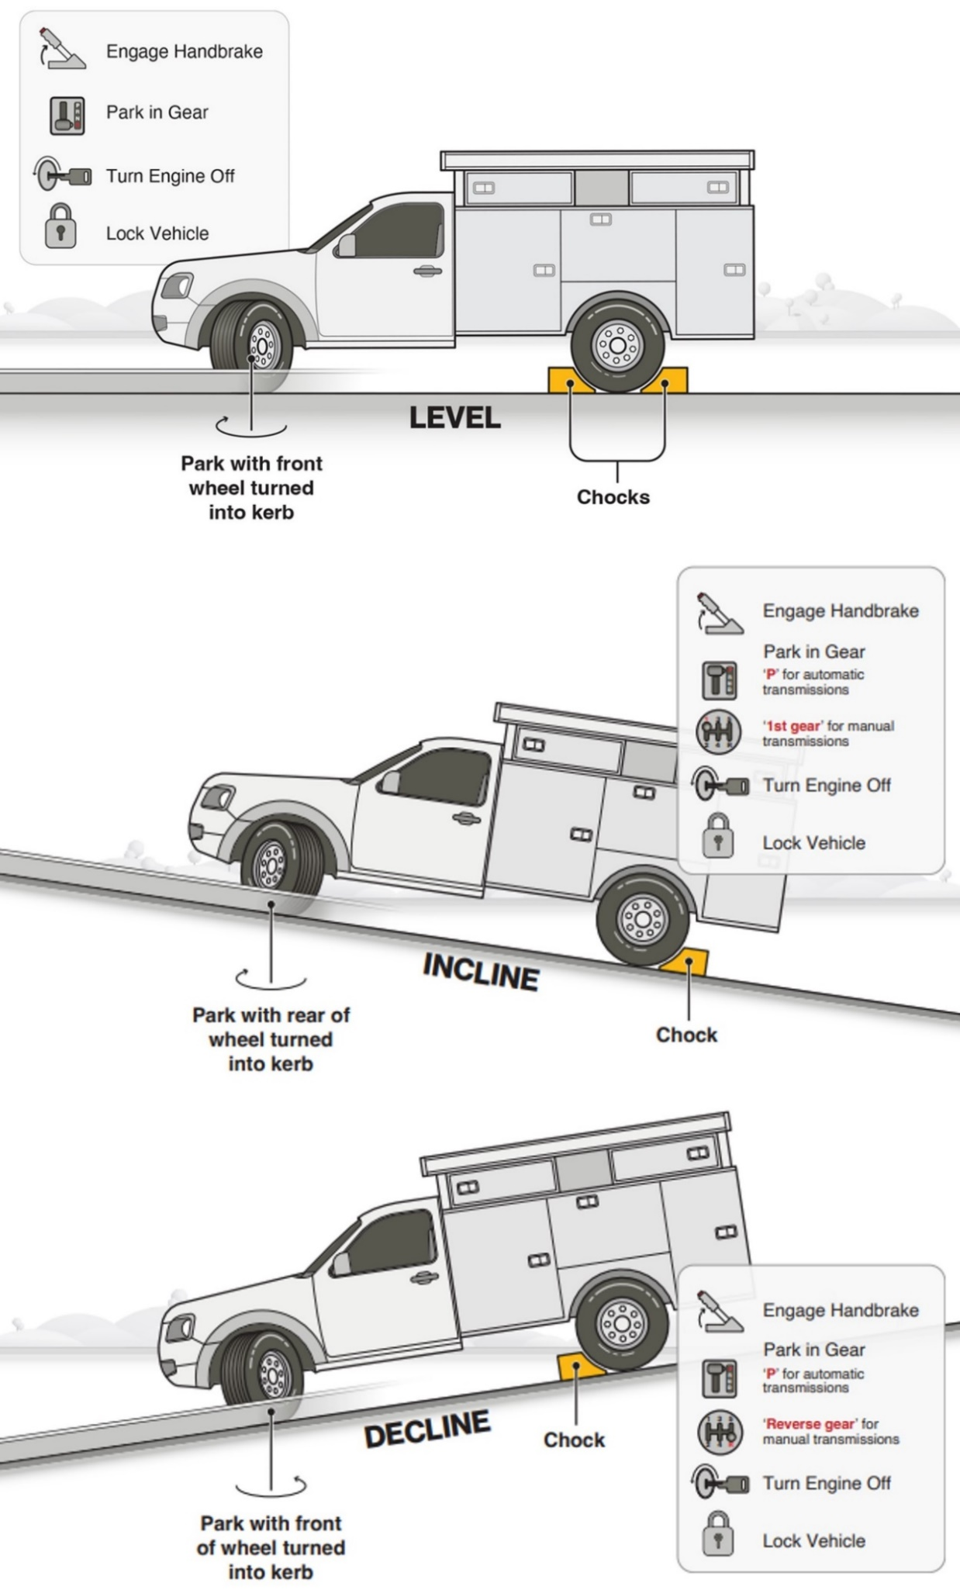

**Figure 2** Correct placement of wheel chocks on a vehicle with more than 2 axles

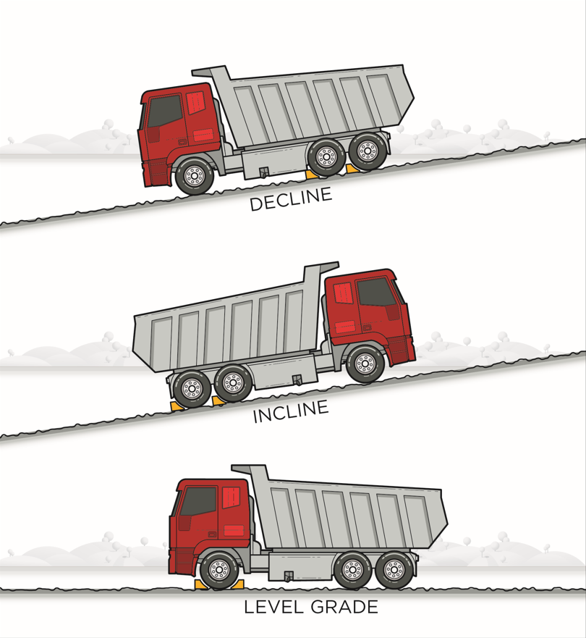

## Effective use of wheel chocks

* Chocks should be placed in the centre of, and square to, the tyre as illustrated below.

**Figure 3** Correct placement of wheel chocks

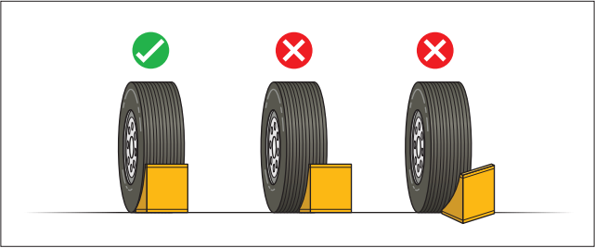

* Leave a slight gap between the chock and the wheel, to indicate whether the vehicle has moved since placing the chocks. Leaving a gap may not be appropriate when people are working around the vehicle, such as when undertaking repair or maintenance work.
* Always check for vehicle movement prior to removing chocks.
* Do not forcibly remove a chock from beneath a wheel. A tightly wedged chock is an indication that the vehicle has moved and may continue to roll once the chock is removed.
* Do not stand in the potential direction of roll while placing or removing chocks.
* Do not attempt to re-enter a vehicle if it has started to roll.
* Do not try to stop or enter the pathway of a moving vehicle.

Examples of how to place wheel chocks on a vehicle with more than 2 axles are shown in **Figure 2.**

Further information is available in the following Safe Work Australia publications:

* [Model Code of Practice: Managing risks of plant in the workplace](https://www.safeworkaustralia.gov.au/doc/model-code-practice-managing-risks-plant-workplace)
* [Guidance Material - Traffic management](https://www.safeworkaustralia.gov.au/safety-topic/managing-health-and-safety/traffic-management)

You may also find additional information published by the [WHS regulator in your jurisdiction](https://www.safeworkaustralia.gov.au/law-and-regulation/whs-regulators-and-workers-compensation-authorities-contact-information).