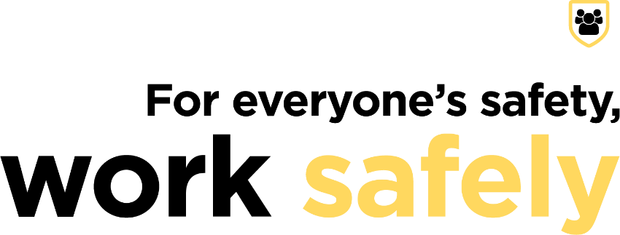

MEDIA RELEASE
We’re building a safe and healthy workplace during
National Safe Work Month
[insert workplace] is committed to building a safe and healthy workplace this National Safe Work Month.
Safe Work Australia data shows that each year up to 200 workers are fatally injured at work and around 120,000 workers are compensated for a serious work-related injury or illness.
NAME, ROLE AT ORGANISATION recognises that making work health and safety a priority benefits everyone. That’s why we’re taking part in the for everyone’s safety, work safely National Safe Work Month campaign to work together to build a safe and healthy workplace for all.
“National Safe Work Month in October is an important event on the calendar each year for NAME OF ORGANISATION. It highlights the importance of working together and having an open dialogue on work health and safety.
“We want all of our workers to get home safely, and I encourage other businesses to join National Safe Work Month and raise awareness of work health and safety in their workplaces,” NAME said.
The for everyone’s safety, work safely campaign is a national awareness campaign led by Safe Work Australia and supported by Safe Work Australia Members and other stakeholders.
For more information about National Safe Work Month, or to download resources, go to the campaign website: safeworkmonth.swa.gov.au.

