Engineered stone prohibition

Guidance for PCBUs

September 2024

Disclaimer

Safe Work Australia is an Australian Government statutory agency established in 2009. Safe Work Australia includes Members from the Commonwealth, and each state and territory, Members representing the interests of workers and Members representing the interests of employers.

Safe Work Australia works with the Commonwealth, state and territory governments to improve work health and safety and workers’ compensation arrangements. Safe Work Australia is a national policy body, not a regulator of work health and safety. The Commonwealth, states and territories have responsibility for regulating and enforcing work health and safety laws in their jurisdiction.

ISBN 978-1-76114-000-6 (Online PDF)

ISBN 978-1-76114-050-1 (Online DOCX)

Creative Commons

With the exception of the Safe Work Australia logo, this copyright work is licensed under a Creative Commons Attribution 4.0 International licence. To view a copy of this licence, visit creativecommons.org/licenses. In essence, you are free to copy, communicate and adapt the work for non-commercial purposes, as long as you attribute the work to Safe Work Australia and abide by the other licence terms.

Contact information

Safe Work Australia | <mailto:info@swa.gov.au> | [www.swa.gov.au](http://swa.hosts.application.enet/business-support/Communication/Documents/www.swa.gov.au)

Table of Contents

1. Introduction 4

1.1 Summary 4

1.2 How to use this guide 5

2. Engineered stone prohibition 6

2.1 Why is engineered stone prohibited? 6

2.2 What is prohibited? 6

2.3 Definition of engineered stone and the scope of the prohibition 7

2.4 Permitted work for research & analysis and to sample & identify 8

2.5 Permitted work for repair, removal, minor modification and disposal of legacy engineered stone 9

3. Notification of work with legacy engineered stone 11

3.1 Notification of work with legacy engineered stone 11

3.2 Summary of notification obligations 13

4. Controlled Processing 14

4.1 Engineered stone, sintered stone and porcelain products 14

4.2 Respiratory Protective Equipment 15

5. Exemptions from the prohibition 17

5.1 Exemption from the engineered stone prohibition 17

5.2 Application for an exemption 17

5.3 How WHS regulators make decisions 18

5.4 Outcome of an application 19

5.5 Summary of the exemption process 19

5.6 Duties for PCBUs working with exempt engineered stone 19

Appendix A – Glossary 21

Appendix B – Notification flowchart 23

Appendix C – Exemption flowchart 24

* + 1. Introduction
       1. Summary

From 1 July 2024, a person conducting a business or undertaking (PCBU) must not carry out, or direct or allow a worker to carry out, work that involves the manufacture, supply, processing, or installation of engineered stone benchtops, panels, and slabs. This is referred to as the ‘engineered stone prohibition’ in this guide.

|  |
| --- |
| For specific details about the implementation of the engineered stone prohibition in your jurisdiction, **please** [**refer to the WHS regulator**](https://www.safeworkaustralia.gov.au/law-and-regulation/whs-regulators-and-workers-compensation-authorities-contact-information) for the jurisdiction in which you carry out work on engineered stone. |

Importantly, the engineered stone prohibition only applies to engineered stone benchtops, panels and slabs. Engineered stone products not in these forms are not prohibited. Further, because sintered stone and porcelain products that do not contain resin are excluded from the definition of engineered stone, the prohibition does not apply to these products.

|  |
| --- |
| The WHS Regulations include specific requirements in relation to work involving the processing of materials containing at least 1% crystalline silica (referred to as crystalline silica substances or CSSs), including sintered stone, porcelain products and engineered stone. For more information about the CSS regulations, please refer to the [Working with crystalline silica substances: Guidance for PCBUs](https://www.safeworkaustralia.gov.au/doc/working-crystalline-silica-substances-guidance-pcbus). |

There are limited exceptions from the prohibition which permit legacy engineered stone benchtops, panels and slabs to be processed in certain circumstances. For permitted work with legacy engineered stone:

* any processing must be controlled
* the PCBU must comply with notification requirements before carrying the work out, and
* the PCBU must comply with any other relevant WHS duties in relation to the work, including those relating to crystalline silica substances as set out in Chapter 8A of the WHS Regulations.

Under the WHS Regulations, a person may apply for an exemption from the prohibition for a type of engineered stone product. A WHS regulator may grant an exemption if certain criteria are met. An exemption granted by a WHS regulator is recognised by all WHS regulators with a corresponding WHS law in relation to granting engineered stone prohibition exemptions.[1]

The purpose of this guide is to assist PCBUs to understand their obligations in relation to the engineered stone prohibition.

A glossary of terms used in the guidance is at Appendix A.

* + - 1. How to use this guide

This document provides guidance to assist PCBUs to meet their obligations under the WHS Regulations in relation to the engineered stone prohibition.

* **Part 2 - Engineered stone prohibition:** Explains the scope of the engineered stone prohibition, why it was introduced, what is prohibited under the WHS Regulations, and the limited circumstances in which work with engineered stone is permitted.
* **Part 3 -** **Notification of work with legacy engineered stone:** Provides guidance on a PCBU’s obligation to notify the WHS regulator before any permitted work with legacy engineered stone is carried out.
* **Part 4** **-** **Controlled processing:** Provides guidance on complying with the obligation to ensure that any processing of a CSS, including engineered stone is controlled.
* **Part 5 - Exemptions from the prohibition on application:** Provides guidance on how to make an application to a WHS regulator to request an exemption from the prohibition in respect of a type of engineered stone benchtop, panel, or slab.

This guide includes references to various legal requirements under the WHS Act and Regulations. These are included for convenience only and should not be relied on in place of the full text of the WHS Act or WHS Regulations.

This guide should be read in conjunction with:

* [model Code of Practice: How to manage work health and safety risks](https://www.safeworkaustralia.gov.au/system/files/documents/1901/code_of_practice_-_how_to_manage_work_health_and_safety_risks_1.pdf)
* [model Code of Practice: Construction work](https://www.safeworkaustralia.gov.au/system/files/documents/1901/code_of_practice_-_construction_work.pdf)

* [Working with crystalline silica substances: Guidance for PCBUs](https://www.safeworkaustralia.gov.au/doc/working-crystalline-silica-substances-guidance-pcbus)
* [National Exemption Framework](https://www.safeworkaustralia.gov.au/national-exemption-framework)
* [Workplace exposure standards for airborne contaminants (2024)](https://www.safeworkaustralia.gov.au/doc/workplace-exposure-standards-airborne-contaminants-2024)
* [Health monitoring for persons conducting a business or undertaking](https://www.safeworkaustralia.gov.au/doc/health-monitoring-persons-conducting-business-or-undertaking-guide)
* [Health monitoring for crystalline silica](https://www.safeworkaustralia.gov.au/doc/health-monitoring-crystalline-silica)

|  |
| --- |
| This guidance is relevant to all jurisdictions with harmonised WHS laws. **Refer to your** [**WHS regulator**](https://www.safeworkaustralia.gov.au/law-and-regulation/whs-regulators-and-workers-compensation-authorities-contact-information) for information about how the prohibition and related regulations apply in your jurisdiction, including any Codes of Practice that may be in place. |

In this guide, the word ‘must’ indicates a legal requirement that must be complied with. The word ‘should’ indicates a recommended course of action, while ‘may’ is used to indicate an optional course of action.

* + 1. Engineered stone prohibition
       1. Why is engineered stone prohibited?

Crystalline silica is the crystalline form of silicon dioxide, a naturally occurring mineral that is found in most soils and rocks, including granite and sandstone, and is a component of artificial products like concrete, mortar, ceramic tiles, and engineered stone. Engineered stone can contain up to 97% crystalline silica.

The processing of engineered stone such as cutting, grinding and polishing with a power tool can create substantial volumes of dust. When being processed, products that contain crystalline silica generate dust that includes airborne particles that can be inhaled deep into the lungs. This is known as respirable crystalline silica (RCS).

Exposure to RCS can lead to serious respiratory diseases such as silicosis, progressive massive fibrosis, chronic obstructive pulmonary disease, chronic bronchitis, and lung cancer. RCS also increases the risk of developing chronic kidney disease, autoimmune disorders, and other adverse health effects.

There has been a significant increase in cases of silicosis in Australia in recent years, particularly in workers exposed to RCS from processing engineered stone. Many of these cases are in younger workers who are experiencing faster disease progression (accelerated silicosis[2]). Silicosis is an irreversible and debilitating disease which can be fatal. Silicosis and other silica-related diseases are entirely preventable by either eliminating or minimising exposure to RCS.

In response to the significant increase in cases of silicosis, particularly in younger engineered stone workers, WHS ministers unanimously agreed to prohibit the manufacture, supply, processing and installation of engineered stone benchtops, panels and slabs.

|  |
| --- |
| **Further information** about [crystalline silica and silicosis](https://www.safeworkaustralia.gov.au/safety-topic/hazards/crystalline-silica-and-silicosis) is available on Safe Work Australia’s website. |

* + - 1. What is prohibited?

|  |
| --- |
| **WHS Regulation 529D**  Prohibition of work involving engineered stone benchtops, panels or slabs. |

Under regulation 529D, it is an offence for a PCBU to carry out work involving the manufacture, supply, processing or installation of engineered stone benchtops, panels or slabs. It is also an offence for a PCBU to direct or allow a worker to carry out this type of work.

There are limited exceptions to the prohibition for which work with engineered stone benchtops, panels or slabs is permitted. These are:

* for research and analysis
* to sample and identify engineered stone
* for removal, repair and minor modification of legacy engineered stone, and
* disposal of engineered stone.

See Parts 2.4 and 2.5 of this guide for further information.

* + - 1. Definition of engineered stone and the scope of the prohibition

For the purposes of the WHS Regulations, engineered stone is defined as a crystalline silica substance (CSS) that is an artificial product containing 1% or more crystalline silica[3] (as a weight/weight concentration) that is created by combining materials such as natural stone, water, resins, or pigments and becomes hardened.

The prohibition applies to engineered stone (as described above):

* benchtops
* panels, and
* slabs.

Exclusions

The prohibition does not apply to engineered stone products that are not benchtops, panels or slabs, such as finished products including jewellery, garden ornaments, sculptures and kitchen sinks. The prohibition does not apply to these types of finished products because they are not intended to be further processed to be used or installed.

The prohibition does not apply to porcelain or sintered stone benchtops, panels or slabs, provided they do not contain resin.

Additionally, the prohibition does not apply to other artificial products including:

* concrete and cement products,
* bricks, pavers and other similar blocks,
* ceramic wall and floor tiles,
* roof tiles,
* grout, mortar and render, and
* plasterboard.

The prohibition does not apply to natural stone benchtops, panels or slabs. For example, the manufacture, supply, installation or processing of a granite benchtop is not prohibited. However, as natural stone (such as granite) is a type of CSS, PCBUs still owe a duty to ensure the health and safety of workers who are processing natural stone products and must meet the duties that apply to work involving the processing of a CSS. Please refer to the [Working with crystalline silica substances: Guidance for PCBUs](https://www.safeworkaustralia.gov.au/doc/working-crystalline-silica-substances-guidance-pcbus).

|  |
| --- |
| If your product **does not** meet the definition of engineered stone or falls under one of the exclusions outlined above, then it is not prohibited.  However, if it is a CSS and you intend to process it, please refer to Part 4 of the [Working with crystalline silica substances: Guidance for PCBUs](https://www.safeworkaustralia.gov.au/doc/working-crystalline-silica-substances-guidance-pcbus) for information about identifying and managing risks from RCS, including assessing the risk of processing the CSS and ensuring the processing is controlled. |

* + - 1. Permitted work for research & analysis and to sample & identify

|  |
| --- |
| **WHS Regulations 529E and 529F**  Exceptions for research and analysis, and to sample and identify engineered stone. |

Regulations 529E and 529F permit the installation, supply and controlled processing of engineered stone benchtops, panels or slabs for the purposes of:

* genuine research and analysis, and
* to sample and identify engineered stone.

See Part 4 for the requirements for controlled processing of engineered stone.

|  |
| --- |
| 1. **Examples of genuine research and analysis**  * A university-based researcher is studying the ability of various materials commonly found in homes to resist the impact of the spread of fire. A business is permitted to supply a legacy engineered stone benchtop from their stockpile to the researcher for this study. In turn, the researcher, who is trained and proficient in using hand and power tools and who understands the risks of RCS, may process the engineered stone such as by cutting the benchtop to suit the needs of their research. Before processing the benchtop, the researcher must assess whether or not the processing is high risk and, if so, comply with the additional regulations for high risk processing of a crystalline silica substance. The researcher must also ensure that the processing is controlled. * A PCBU provides a laboratory with product samples to be tested for crystalline silica content. Although the product was labelled as crystalline silica-free, the test results return levels 1% or greater. The work undertaken by the lab is classified as genuine research and analysis. |

* + - 1. Permitted work for repair, removal, minor modification and disposal of legacy engineered stone

|  |
| --- |
| **WHS Regulation 529F**  Exception to process legacy engineered stone for repair, removal, minor modification and disposal. |

Engineered stone benchtops, panels and slabs are currently installed in many homes and other settings throughout Australia. These installed products, and any stock of uninstalled engineered stone held by PCBUs (e.g., suppliers and distributors) after the commencement of the prohibition. are referred to as legacy engineered stone.

Regulation 529F permits the controlled processing of legacy engineered stone benchtops, panels or slabs for the limited purposes of:

* removal, repair and minor modification to previously installed engineered stone, or
* disposal of engineered stone (i.e. after removal or disposal of uninstalled stock).

|  |
| --- |
| Uninstalled stock may only be processed for the purposes of disposal. Therefore, it is not permitted to process uninstalled stock for the purposes of, for example, repairing or making minor modifications to an installed benchtop. Additionally, once any legacy engineered stone is removed (uninstalled), it can only be further processed for the purpose of disposal and not for other purposes.  For information regarding the reinstallation of legacy engineered stone benchtops, panels or slabs, please refer to your WHS regulator. General information on reinstallation is also available in the [frequently asked questions (FAQ)](https://www.safeworkaustralia.gov.au/esban/faq) section on Safe Work Australia’s [Engineered Stone Ban website](https://www.safeworkaustralia.gov.au/esban/faq). |

This means that PCBUs are permitted to carry out, or direct workers to carry out, the repair, minor modification, removal or disposal of legacy engineered stone involving processing provided:

* the regulations relating to the processing of a crystalline silica substance are complied with, including assessing whether the processing is high risk (see the [Working with crystalline silica substances: Guidance for PCBUs](https://www.safeworkaustralia.gov.au/doc/working-crystalline-silica-substances-guidance-pcbus))
* the WHS regulator is notified of the work (see Part 3), and
* processing is controlled (see Part 4).

Meaning of minor modification

Due to the diverse types of PCBUs expected to work with legacy engineered stone, including tradespersons such as builders, electricians, tilers and carpenters, the phrase **minor modification** is not defined and has its ordinary meaning.

Making a minor modification to an installed engineered stone product involves a change or alteration to the product that is limited in scope and where the relevant features and purpose of the product remain. For example, drilling a larger diameter hole in a kitchen benchtop to allow the installation of a new mixer tap would be a minor modification.

Disposal of legacy engineered stone

The prohibition of engineered stone allows for the processing of installed and uninstalled engineered stone benchtops, panels and slabs for the purposes of disposal, provided the processing is controlled.

Processing of legacy engineered stone for disposal (for example, crushing engineered stone off-cuts) must be controlled and the disposal must comply with any applicable jurisdictional waste management requirements (such as quantity or dust level limits of the load or watering prior to tipping).

The exception for disposal does not permit repurposing or reusing of processed legacy engineered stone, including crushed stone.

|  |
| --- |
| 1. **Examples of permitted work with legacy engineered stone**   The following examples of work with legacy engineered stone are permitted, provided the PCBU:   1. assesses the risk of any processing of legacy engineered stone to determine if it is high risk and, if so, complies with the additional requirements for high risk processing (see Parts 4 and 5 of the [Working with crystalline silica substances: Guidance for PCBUs](https://www.safeworkaustralia.gov.au/doc/working-crystalline-silica-substances-guidance-pcbus)), 2. provides prior notice of the work to the WHS regulator, and 3. ensures any processing of the engineered stone is controlled.   **Examples**:   * A worker repairs a crack in an engineered stone benchtop installed in a kitchen. To repair the engineered stone, a worker needs to fill the crack with liquid resin and use power tools to level and re-polish the engineered stone. * A worker makes a minor modification by creating a hole in splashback to install a new power point. The worker uses a power drill to create the hole. * A worker replaces the stovetop in an engineered stone benchtop. The replacement stovetop is the same dimensions as the existing one but has slightly different installation specifications. To install it, the worker uses a power tool to trim one side of the existing hole in the engineered stone benchtop to make the minor modification to fit the replacement stovetop correctly. * A worker uses power tools to remove an engineered stone benchtop and splashback as part of a kitchen renovation. The worker then uses a mechanical plant with wet dust suppression methods to crush the engineered stone to facilitate easier disposal. The crushed stone is then taken to a local waste management site. |

* + 1. Notification of work with legacy engineered stone
       1. Notification of work with legacy engineered stone

|  |
| --- |
| **WHS Regulation 529G**  Notification of particular processing of legacy engineered stone. |

Initial notification of work

PCBUs must provide a written notice to the WHS regulator if they intend to carry out permitted work with legacy engineered stone – i.e., work that involves processing to:

* repair, make minor modification to, or remove an engineered stone benchtop, panel or slab that is already installed, or
* dispose of an engineered stone benchtop, panel or slab, whether it is installed or not.

The notification may be relied on for up to 12-months. It is not a task or project-based notification. Rather, it is expected that the PCBU considers the work likely to be carried out involving the processing of engineered stone during the 12-months from the date of notification.

|  |
| --- |
| The notification:   * is current for a 12-month period, and * is not required for every new job with legacy engineered stone.   The PCBU must describe the types of work that will be carried out on engineered stone during the 12-months from the date of notification. |

If the PCBU intends to carry out permitted work with legacy engineered stone in more than one jurisdiction, notification must be provided to the WHS regulator for each jurisdiction in which the work is carried out using the form approved by the relevant regulator.

|  |
| --- |
| **When multiple PCBUs have a duty to notify** the WHS regulator about the same permitted work, section 46 of the model WHS Act requires the PCBUs to consult, co-operate and co-ordinate activities to ensure the WHS regulator is notified about that work. |

A PCBU must notify the WHS regulator *before* any permitted work with legacy engineered stone is carried out.

However, if a PCBU carries out work that they did not know was permitted work with legacy engineered stone (e.g., due to misidentifying the engineered stone as another type of product), the PCBU must notify the WHS regulator *as soon as practicable* after becoming aware that the work involved processing legacy engineered stone.

Once the PCBU submits the notification to the WHS regulator, they do not have to wait for a receipt of notification from the WHS regulator to begin the permitted work.

PCBUs must use the notification form published by the WHS regulator. WHS regulators will, at a minimum, require the following information:

* the type of work being carried out (i.e., repair, minor modification, removal or disposal),
* a description of the work (e.g., repairing kitchen benchtops), and
* the estimated frequency and duration of the work to be conducted, (e.g., approximately one repair per week, and less than 30 minutes per repair).

|  |
| --- |
| For further information on the notification process, including the approved notification form, **refer to the WHS regulator** in the [jurisdiction](https://www.safeworkaustralia.gov.au/law-and-regulation/whs-regulators-and-workers-compensation-authorities-contact-information) where the permitted work is to be carried out.  Please note, Victoria does not require PCBUs to submit a notification for permitted work with legacy engineered stone. If you are a PCBU who works in Victoria, please refer to [WorkSafe Victoria](https://www.worksafe.vic.gov.au/). |

The information provided to the WHS regulator in the notification will enable the regulator to have oversight of the PCBUs in their jurisdiction whose workers may be exposed to RCS while working with legacy engineered stone.

WHS regulators have powers to investigate and enforce WHS laws. The WHS regulator may rely on those powers to obtain further information from the PCBU about work with legacy engineered stone, and the PCBU’s compliance with relevant duties under the WHS laws.

Re-notification

|  |
| --- |
| **WHS Regulation 529H** Notification because of a change in information previously provided to the WHS regulator.  **WHS Regulation 529I** Re-notification 12 months after the previous notification for continuing work with legacy engineered stone. |

A PCBU must re-notify the WHS regulator within 30 calendar days of the following occurring:

* The PCBU becomes aware of a change to the information provided in the previous notification. In this case, the re-notification must state and describe the information that has changed (e.g., an increase or decrease in the frequency and/or duration of the work or a change in the type of work with legacy engineered stone). A re-notification is not required if the PCBU ceases to carry out work with legacy engineered stone.
* The 12-month anniversary of the most recent notification made to the WHS regulator, unless the PCBU has ceased to carry out work with legacy engineered stone.

Once the PCBU submits the re-notification to the WHS regulator, they do not have to wait for a receipt of notification from the WHS regulator to continue the permitted work.

Evidence of notification

|  |
| --- |
| **WHS Regulation 529J**  Duty to keep notice given under Part 8A.3 |

Each time a PCBU notifies the WHS regulator, the PCBU must be given an acknowledgement from the WHS regulator.

A PCBU must keep a copy of their notification form for a period of 5 years, and ensure it is readily accessible and allow a person (e.g., a worker, health and safety representative or member of the public) to access a copy upon request.

For best practice, a PCBU should also keep their acknowledgment of notification from the WHS regulator as evidence of the date the notice was submitted.

* + - 1. Summary of notification obligations

A flowchart summary of the notification obligations for permitted work with legacy engineered stone can be found in Appendix B.

* + 1. Controlled Processing
       1. Controlled processing of legacy engineered stone (a type of crystalline silica substance)

|  |
| --- |
| **WHS Regulation 529B**  When processing of CSS is controlled  **WHS Regulation 529C**  Duty for processing of a CSS to be controlled |

A PCBU must not carry out, or direct or allow a worker to carry out, processing of legacy engineered stone (regardless of whether it is high risk or not) unless the processing is controlled.

Under regulation 529B(1) of the WHS Regulations, the processing of a CSS is controlled if:

1. control measures to eliminate or minimise risks arising from the processing are implemented so far as is reasonably practicable; and
2. at least 1 of the following or engineering control measures are used during the processing:
3. the isolation of a person from dust exposure;
4. a fully enclosed operator cabin fitted with a high efficiency air filtration system;
5. an effective wet dust suppression method;
6. an effective on-tool extraction system;
7. an effective local exhaust ventilation system;

and

1. a person still at risk of being exposed to respirable crystalline silica after 1 or more of the measures in paragraph (b) are used:
2. is provided with respiratory protective equipment (RPE); and
3. wears the RPE while the work is carried out.

If it is not reasonably practicable to implement at least one of the isolation or engineering controls outlined in paragraph (b) above, the processing of a CSS will only be considered controlled if a person who is at risk of being exposed to RCS during processing of a CSS is:

* provided with appropriate RPE, and
* wears the RPE correctly while the work is carried out.

|  |
| --- |
| Please refer to Part 4 of the [Working with crystalline silica substances: Guidance for PCBUs](https://www.safeworkaustralia.gov.au/doc/working-crystalline-silica-substances-guidance-pcbus) for further information about control measures and personal protective equipment, including respiratory protective equipment. |

* + 1. Exemptions from the prohibition
       1. Exemption from the engineered stone prohibition

|  |
| --- |
| **WHS Regulation 689A** Exemption from the engineered stone prohibition |

The WHS Regulations allow a WHS regulator to exempt a type of engineered stone from the prohibition. If an exemption is granted, the engineered stone prohibition will not apply if a PCBU carries out work involving the type of engineered stone that has been exempted.

An exemption from the engineered stone prohibition may only be granted if the WHS regulator is satisfied that granting the exemption will result in a standard of health and safety that is at least equivalent to the standard that would have been achieved without that exemption.

An exemption granted by the WHS regulator of one jurisdiction will also apply in all jurisdictions except Victoria.[4]

|  |
| --- |
| **Note:** The exemption applies to a type of engineered stone. Once a type of engineered stone is exempted, any PCBU will be able to work with that type of engineered stone so long as they can satisfy any conditions imposed on the exemption. |

* + - 1. Application for an exemption

|  |
| --- |
| **WHS Regulations 689B and 690** Application for exemption |

A person may apply to a WHS regulator to exempt a type of engineered stone from the prohibition.

Before applying for an exemption, the person must consult with the Safe Work Australia Members who represent the interests of employers and workers (social partners).

|  |
| --- |
| **For further information** about Safe Work Australia’s social partners, see Safe Work Australia’s [website](https://www.safeworkaustralia.gov.au/law-and-regulation/model-whs-laws/national-exemption-framework). |

The person must provide written notice to each social partner:

* stating that they intend to apply to a WHS regulator for an exemption
* inviting the social partner to make a submission for the regulator (within a reasonable period), and
* informing the social partner that the submission must be provided to the regulator as part of the application.

The person must also provide a copy of the proposed exemption application to each social partner together with the written notice.

When applying to the WHS regulator for an exemption, the applicant must provide the following:

* a written application in the manner and form required by the WHS regulator
* the written notice that was provided to each of the social partners, and
* any submissions made to the applicant by the social partners.

|  |
| --- |
| **For further information** on the application process, see the Guide for exemption applicants in the [National Exemption Framework](https://www.safeworkaustralia.gov.au/national-exemption-framework#:~:text=The%20framework%20guides%20the%20granting,work%20health%20and%20safety%20regulator.). |

* + - 1. How WHS regulators make decisions

|  |
| --- |
| **WHS Regulation 689C** Notifying persons of application for exemption  **WHS Regulation 689D** Regulator to be satisfied of certain matters  **WHS Regulation 689E** Safe Work Australia may issue and publish document in relation to exemptions |

Upon receiving an exemption application, a WHS regulator must provide the application documents to each corresponding WHS regulator.

Additionally, the WHS regulator may choose to provide the application documents to the following classes of persons, and invite them to make a submission in respect of the exemption application:

* employer organisations that include employers who engage in work involving engineered stone,
* unions representing employees whose work includes work involving engineered stone, or
* persons who have qualifications, knowledge, skills and experience relating to engineered stone.

The WHS regulator must not grant an exemption unless it is satisfied that granting the exemption would result in a standard of health and safety that is at least equivalent to the standard that would have been achieved without that exemption.

When deciding this matter, the WHS regulator must have regard to:

* any submissions received by the WHS regulator from the above parties (i.e., corresponding WHS regulators, employee groups, employer groups and technical experts)
* any submission made by social partners and provided by the applicant with the application, and
* the Engineered Stone Prohibition exemption common decision-making criteria published on the Safe Work Australia website under the [National Exemption Framework](https://www.safeworkaustralia.gov.au/national-exemption-framework#:~:text=The%20framework%20guides%20the%20granting,work%20health%20and%20safety%20regulator.).
  + - 1. Outcome of an application

|  |
| --- |
| **WHS Regulation 676** Reviewable decisions  **WHS Regulation 694** Notice of decision in relation to exemption  **WHS Regulation 695** Publication of exemption |

The WHS regulator will inform the applicant of the outcome of the exemption application.

If the exemption is granted, the WHS regulator must additionally:

* publish its reasons for granting the exemption within 14 days, and
* notify each corresponding regulator that the exemption is granted.

Once granted, exemptions will be recognised automatically in all jurisdictions with a corresponding WHS law for granting an exemption from the engineered stone prohibition; PCBUs should not apply for the same exemption in multiple jurisdictions.

|  |
| --- |
| **Please note** that Victoria’s Occupational Health and Safety laws do not provide for automatic mutual recognition of exemptions granted by other jurisdictions. If you are a PCBU who works in Victoria, please refer to [WorkSafe Victoria](https://www.worksafe.vic.gov.au/) for more information about the recognition of exemptions. |

If an application for an exemption is refused by the WHS regulator, the applicant may apply to the [relevant external review body] for review of the decision. Unless a longer period is allowed by the [external review body], the application for external review must be made within 28 days after the day on which the decision to refuse the exemption first came to the applicant’s attention.

* + - 1. Summary of the exemption process

A flowchart summary of the exemption process for engineered stone can be found in Appendix C.

* + - 1. Duties for PCBUs working with exempt engineered stone

|  |
| --- |
| **WHS Regulation 691** Conditions of exemption |

The WHS regulator may impose any condition it considers appropriate on an exemption from the engineered stone prohibition. This may include, for example, control measures for the manufacture, supply, processing or installation of an exempt engineered stone product, and/or requirements to undertake air monitoring, and monitor the health of persons at the workplace who may be exposed to RCS. A PCBU granted an exemption must comply with the conditions imposed on the exemption.

If an exemption is granted, PCBUs that are designers, manufacturers, importers or suppliers of an exempt type of engineered stone must still comply with the existing ‘upstream’ duties[5] in the WHS Act (sections 22-26) to ensure, so far as is reasonably practicable, that the design, manufacture, importation and supply of the exempt type of engineered stone is without risks to health and safety.

Discharging these upstream duties may require the designers, manufacturers, importers or suppliers of the exempt type of engineered stone to carry out, or arrange for, calculations, analysis, testing or examination of the product.

Further, designers, manufacturers, importers and suppliers must, so far as reasonably practicable, give current relevant information to downstream users of the stone (including to PCBUs who will install the stone) about:

* the purpose for which the type of engineered stone was designed or manufactured,
* the results of any calculations, analysis, testing or examination in relation to the type of engineered stone, including any hazardous properties identified by testing, and
* any conditions necessary to ensure that the type of engineered stone is without risks to health and safety when used for a purpose for which it was designed or manufactured, including any conditions placed on the use of the type of engineered stone as part of the exemption granted by the WHS regulator.

Appendix A – Glossary

|  |  |
| --- | --- |
| Key terms | Meaning |
| Crystalline silica substance (CSS) | means material that contains at least 1% crystalline silica, determined by weight/weight concentration. |
| Controlled processing | The processing of a CSS is controlled if:   1. control measures to eliminate or minimise risks arising from the processing are implemented so far as is reasonably practicable; and 2. at least 1 of the following measures are used during the processing: 3. the isolation of a person from dust exposure; 4. a fully enclosed operator cabin fitted with a high efficiency air filtration system; 5. an effective wet dust suppression method; 6. an effective on-tool extraction system; 7. an effective local exhaust ventilation system; and 8. a person still at risk of being exposed to respirable crystalline silica after 1 or more of the measures in paragraph (b) are used: 9. is provided with respiratory protective equipment (RPE); and 10. wears the RPE while the work is carried out.   However, if it is not reasonably practicable to implement at least one of the isolation or engineering controls outlined in paragraph (b) above, the processing of a CSS is controlled if a person who is at risk of being exposed to RCS during processing of a CSS is:  a) provided with appropriate RPE; and  b) wears the RPE correctly while the work is carried out. |
| Crystalline silica | The crystalline form of the abundant naturally occurring mineral silica or silicon dioxide (SiO2). It includes cristobalite, quartz, tridymite and tripoli and is present in almost all types of rocks, sand, clay, shale and gravel and in construction materials such as concrete, tiles and bricks. |
| Engineered stone | Engineered stone:   1. is an artificial product that: 2. contains 1% or more crystalline silica determined as a weight/weight (w/w) concentration; and 3. is created by combining natural stone materials with other chemical constituents such as water, resins or pigments; and 4. becomes hardened; but 5. does not include the following: 6. concrete and cement products; 7. bricks, pavers and other similar blocks; 8. ceramic wall and floor tiles; 9. grout, mortar and render; 10. plasterboard 11. porcelain products that do not contain resin 12. sintered stone that does not contain resin 13. roof tiles |
| Hazard | A situation or thing that has the potential to harm a person. Hazards at work may include, noisy machinery, a moving forklift, chemicals (including respirable crystalline silica), electricity, working at heights, a repetitive job, bullying and violence at the workplace. |
| Legacy engineered stone | Any previously installed engineered stone or stock of engineered stone that was not installed prior to the commencement of the engineered stone prohibition. |
| May | ‘May’ indicates an optional course of action. |
| Must | ‘Must’ indicates a legal requirement exists that must be complied with. |
| Person Conducting a Business or Undertaking (PCBU) | A PCBU is an umbrella concept which intends to capture all types of working arrangements or relationships.  A PCBU includes a:   * company, * unincorporated body or association, and * sole trader or self-employed person.   Each individual who is in a partnership that is conducting a business or undertaking will individually be a PCBU.  A volunteer association or elected members of a local authority will not be a PCBU. |
| Personal protective equipment (PPE) | Anything used or worn by a person to minimise risk to the person’s health and safety. |
| Processing | Processing, in relation to legacy engineered stone means using power tools or other mechanical plant to crush, cut, grind, trim, sand, abrasive polish or drill the engineered stone. |
| Respiratory protective equipment (RPE) | PPE that:   1. is designed to prevent a person wearing the equipment from inhaling airborne contaminants; and 2. complies with AS/NZS 1716:2012 (Respiratory protective devices) and with AS/NZS 1715:2009 (Selection, use and maintenance of respiratory protective equipment). |
| Risk | The possibility harm (death, injury or illness) might occur when exposed to a hazard. |
| Should | ‘Should’ indicates a recommended course of action. |
| Worker | Any person who carries out work for a person conducting a business or undertaking, including work as an employee, contractor or subcontractor (or their employee), self-employed person, outworker, apprentice or trainee, work experience student, employee of a labour hire company placed with a 'host employer' or a volunteer. |
| Workplace | Any place where work is carried out for a business or undertaking and includes any place where a worker goes, or is likely to be, while at work. This may include offices, factories, shops, construction sites, vehicles, ships, aircraft or other mobile structures on land or water. |

Appendix B – Notification flowchart

When does a PCBU need to notify the WHS regulator of their plan to process legacy engineered stone?

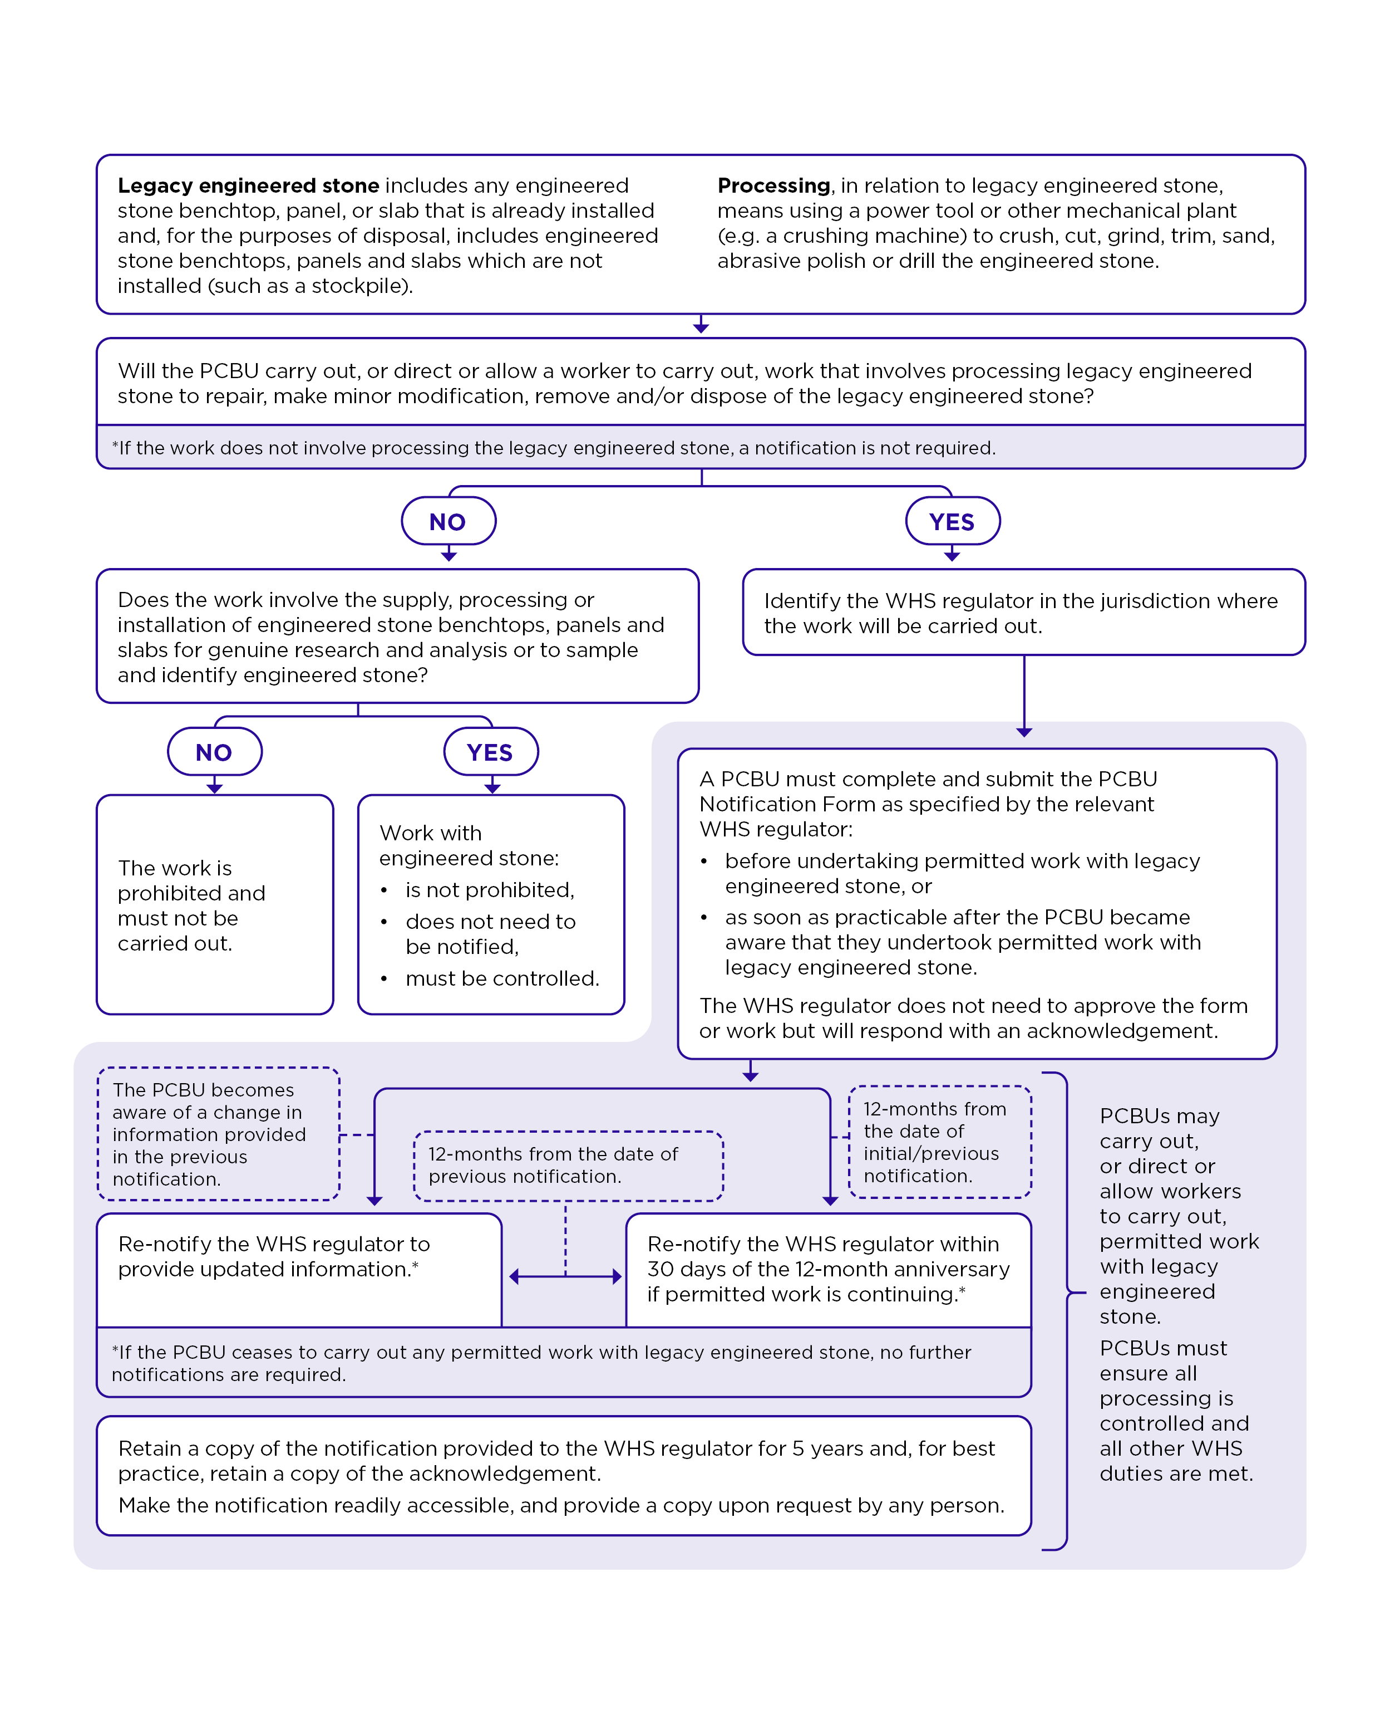

Appendix C – Exemption flowchart

Exemption from the engineered stone ban

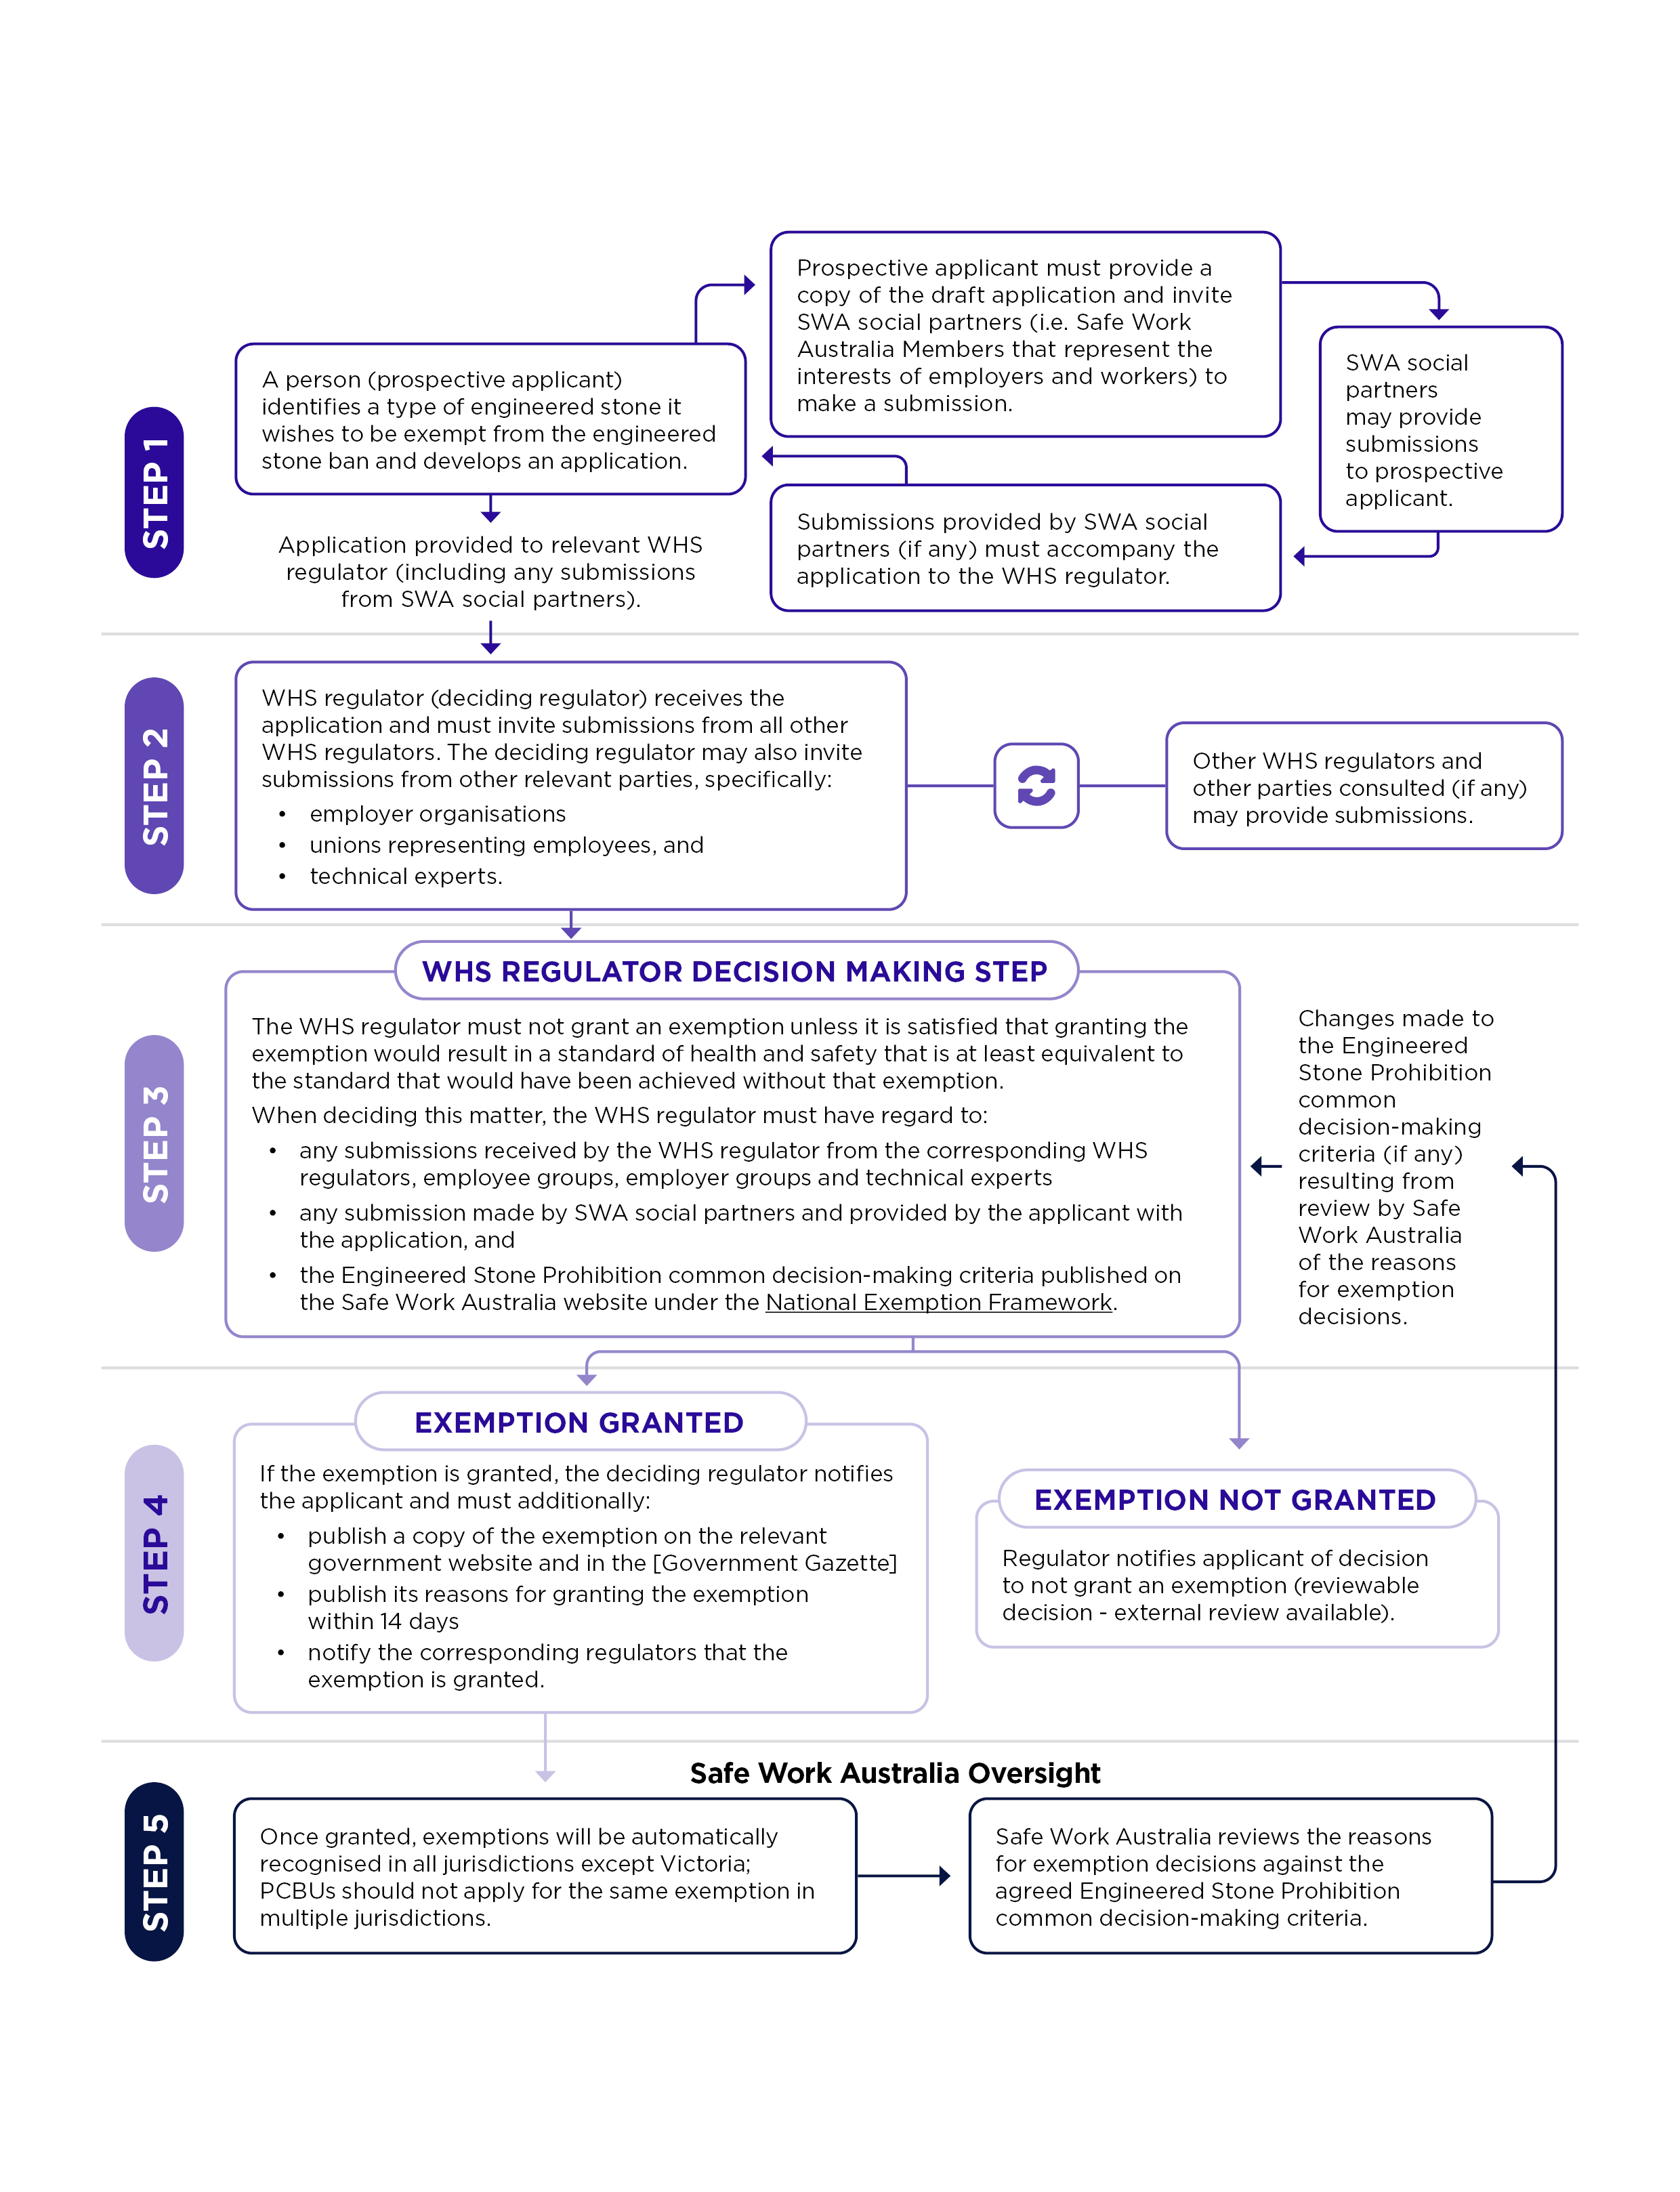

1. Victoria is the only jurisdiction that does not have a corresponding WHS law for the mutual recognition of an exemption from the prohibition granted by another WHS regulator with respect to a type of engineered stone. A person would need to separately apply for an exemption in Victoria.
2. Accelerated silicosis results from short term exposure to large amounts of RCS (1 to 10 years of exposure)
3. Crystalline silica includes cristobalite, quartz, tridymite and tripoli forms.
4. Victoria is the only jurisdiction that does not have a corresponding WHS law for the mutual recognition of an exemption from the prohibition granted by another WHS regulator with respect to a type of engineered stone. A person would need to separately apply for an exemption in Victoria.
5. These are referred to as ‘upstream’ duties because they apply to PCBUs who, as designers, manufacturers, importers and suppliers, are higher up in the supply chain and can therefore potentially impact those who use, in this case, engineered stone products ‘downstream’ in the supply chain or later in the lifecycle of the products.