Asbestos Exposure and Compliance Study of Construction and Maintenance Workers

Asbestos Exposure and Compliance Study of Construction and Maintenance Workers

Acknowledgements
The Asbestos Exposure and Compliance Study was undertaken for Safe Work Australia by Barry Pratt & Associates Pty Ltd. The project team was:
Barry Pratt Director, Barry Pratt & Associates Pty Ltd
Bryan Bottomley Director, Bryan Bottomley & Associates Pty Ltd
Brian Eva Principal Consultant, Eva & Associates Pty Ltd

Specific project elements were undertaken by the following:
Sweeney Research, Melbourne,
CATI telephone interviews and compilation of responses to the questionnaire
Identifibre Pty Ltd, Melbourne,
sample collection of pre-construction site clearance work and asbestos fibre analysis
Hibbs & Associates Pty Ltd, Sydney
asbestos task simulation, sample collection and fibre analysis.

The report was written by Barry Pratt (Barry Pratt & Associates), Fleur de Crespigny and Su Mon Kyaw-Myint (Safe Work Australia).

Disclaimer
The information provided in this document can only assist you in the most general way. This document does not replace any statutory requirements under any relevant State and Territory legislation. Safe Work Australia is not liable for any loss resulting from any action taken or reliance made by you on the information or material contained on this document. Before relying on the material, users should carefully make their own assessment as to its accuracy, currency, completeness and relevance for their purposes, and should obtain any appropriate professional advice relevant to their particular circumstances.
To the extent that the material on this document includes views or recommendations of third parties, such views or recommendations do not necessarily reflect the views of Safe Work Australia or indicate its commitment to a particular course of action.

Copyright Notice
© Commonwealth of Australia 2009

ISBN 978-0-642-32947-9 [PDF] 978-0-642-32948-6 [RTF]

This work is copyright. Apart from any use as permitted under the Copyright Act 1968, no part may be reproduced by any process without prior written permission from the Commonwealth available from the Attorney-General’s Department. Requests and inquiries concerning reproduction and rights should be addressed to:

Commonwealth Copyright Administration
Attorney-General’s Department
3 - 5 National Circuit
Barton ACT 2600
Email: commonwealth.copyright@ag.gov.au
Web: www.ag.gov.au

Table of contents
Glossary vi
Executive summary vii
1 Introduction 1
1.1 Background and aims of the study 1
1.2 Working with key stakeholders 1
2 Literature review 3
2.1 Compliance and exposure studies of tradespeople 3
3 Project methodology 6
3.1 Selection of target occupations 6
3.2 Study Design 6
3.2.1 Focus groups 6
3.2.2 Computer assisted telephone interviews (CATI) 7
3.2.3 Workplace face-to-face interviews 7
3.2.4 Atmospheric sampling 7
3.3 Data analysis 8
3.4 Human ethics research clearance 8
4 Guidance for the management of asbestos 9
4.1 Guidance from OHS jurisdictions 9
4.2 Information from trade associations and unions 10
5 Focus groups 12
5.1 Perceptions of the risk of asbestos 12
5.2 Where are ACMs encountered? 12
5.3 How do workers know they are working with ACMs 14
5.4 Work practices when working with ACMs 15
5.5 General issues raised by focus groups 17
6 Telephone survey and face-to-face interviews 19
6.1 Telephone survey 19
6.1.1 Profile of telephone survey participants 19
6.1.2 Knowledge about the risk of asbestos 21
6.1.3 Perception of the risk of exposure 26
6.1.4 Identifying asbestos containing materials 30
6.1.5 Working with asbestos containing materials 32
6.1.6 Factors motivating and enabling safe handling procedures 40
6.1.7 Barriers to safe handling procedures 41
6.2 Face-to-face interviews 43
6.2.1 Profile of face-to-face interview participants 43
6.2.2 Responses to additional questions 45
7 Atmospheric sampling of tasks involving ACMs 52
7.1 Pre-construction site clean up 52
7.2 Working with asbestos cement sheet 53
7.3 Working with electrical switchboard backing material 54
7.4 Working with asbestos core fire doors 55
7.5 Working in a ceiling space containing ACMs 55
7.6 Summary 56
8 Conclusions 58
A Appendices 64
A.1 Survey questionnaire 64
A.2 Additional questions asked during face-to-face interviews 72
References 62
List of Figures 75
List of Tables 77

Glossary

AC | Asbestos Cement
ACCI | Australian Chamber of Commerce and Industry
ACM | Asbestos Containing Materials
ACTU | Australian Council of Trade Unions
AI Group | Australian Industries Group
AMWU | Australian Manufacturing Workers Union
ASCC | Australian Safety and Compensation Council
AWU | Australian Workers Union
CEPU | Communications Electrical Plumbing Union
CFMEU | Construction, Forestry, Mining and Energy Union
ETU | Electrical Trades Union
f / mL | Fibres per Millilitre
HIA | Housing Industry Association
MBAV | Master Builders Association of Victoria
mL / min | Millilitres per Minute
MPAV | Master Painters Association of Victoria
MPMSAA | Master Plumbers and Mechanical Services Association of Australia
NATA | National Association of Testing Authorities
NHMRC | National Health and Medical Research Council
NECA | National Electrical and Communications Association
NOHSC | National Occupational Health and Safety Commission
OHS | Occupational Health and Safety
PPE | Personal Protective Equipment
SWA | Safe Work Australia
TWA | Time Weighted Average
VECCI | Victorian Employers Chamber of Commerce and Industry
VTHC | Victorian Trades Hall Council
WES | Workplace Exposure Standard

Executive summary
The use of asbestos has been banned in Australia since 2003. However, as a result of the widespread use of asbestos in the past, there remains a large amount of asbestos containing materials (ACMs) in older buildings. These ACMs include asbestos cement sheet walls, asbestos cement pipes and asbestos containing electrical switchboards.
Construction and maintenance workers are likely to be involved in work tasks that may disturb ACMs. Therefore, there is a substantial risk of potential exposure to asbestos in these workers unless occupational health and safety (OHS) requirements on the management and control of asbestos are followed. To date, little research has been undertaken on these tradespersons and their awareness and compliance with OHS regulations relating to asbestos.
The aims of the current study were to determine in construction and maintenance workers:
- current levels of awareness of the risk of exposure to asbestos
- current levels of compliance with OHS legislative requirements for working with ACMs
- key perceptions, attitudes and motivations that act as barriers and enablers to compliance, and
- current level of exposure to asbestos in selected construction and maintenance work activities.
This study was conducted in five stages: 1) literature review; 2) focus groups with workers, employer organisations, unions and OHS authorities; 3) telephone survey of workers; 4) face-to-face interviews; and 5) atmospheric sampling. Four trades were selected as target occupations for this study: electricians, plumbers, carpenters and painters.
This study showed that:
- Most tradespersons were aware of the potential health risks of asbestos.
- Tradespersons had an understanding of the mechanism by which ACMs give rise to harmful inhalation of asbestos fibres.
- This high level of general awareness is not accompanied by the knowledge of how to recognise or control the risk of working with ACMs. Although tradespersons believe they can identify many or most ACMs, in practice, the ability of tradespersons to reliably identify ACMs was limited. This was generally because their identification skills were insufficient, asbestos registers were often absent or inaccurate and few premises had labelling of materials or areas containing ACMs.
- Almost all tradespeople surveyed thought they could protect themselves from the risk of asbestos. However, the overall level of compliance with safety procedures was much less than that estimated by these workers.
- The most common precautions used when working with asbestos were respirators and avoiding breaking ACMs.
- There was inappropriate disposal of asbestos and personal protective equipment (PPE) contaminated with asbestos.
In general, it was clear that the high level of awareness and confidence of tradespeople in being able to protect themselves from asbestos was not matched by putting the necessary safety precautions into place. A considerable percentage of workers in this study did not implement the necessary safety precautions for:
- identifying ACMs
- preventing contamination of surrounding areas
- work practices to prevent generation of airborne fibres (such as wetting down, use of low speed tools)
- personal protection measures such as wearing of disposable overalls and personal decontamination on completion of work
- decontamination of site, and
- safe disposal of asbestos waste.
Determination that ACMs are present at premises was found to be the most critical step in implementing safe handling procedures for working with asbestos. Other enablers for following safe work practices were ‘wanting to protect yourself’, ‘provision of necessary safety equipment’ and ‘co-workers following safe work procedures’. The most important barriers to compliance were identified as ‘I don’t think there is much risk to myself from exposure to asbestos’, ‘I am prepared to take the risk’, ‘lack of necessary safety equipment’ and ‘not aware of the presence of asbestos’. These findings highlight that the increase in the ability to identify ACMs and provision of safety equipment are particularly important for safe handling of ACMs.
When examined by trade, some differences in risk perception and safety practices were observed. Electricians recorded the greatest percentage of workers who thought that it was very likely that they would be exposed to asbestos fibres, while painters recorded the greatest percentage of workers (57%) who thought it was very unlikely they would be exposed to asbestos fibres. While electricians thought they were more likely to be exposed, they were also more likely to feel that they were unable to protect themselves from asbestos compared to other workers. Plumbers were the most confident at identifying ACMs, with almost half of them indicating that they could readily identify ACMs. In contrast, only 30% of painters said they could identify ACMs and a further 40% said they were either unable to identify or only had a limited ability to identify ACMs. In terms of safety practices, carpenters were most likely to undertake a site inspection or check for asbestos, with 87% saying they would do this. In comparison, just 63% of painters said they would check for the presence of asbestos / undertake a site inspection. Differences in PPE use was also observed between the trades. Painters were most likely to use dust masks (94%) whereas electricians were least likely to use dust masks (85%). A similar pattern was also observed for the use of disposable overalls.
This study also found that the current framework of information and guidance on asbestos has not been sufficient to provide tradespeople with the knowledge on how to safely work with ACMs. Face-to-face interviews found that the relevant legislation and codes of practice have been read by less than half of tradespeople. Focus groups identified trade specific information, either as trade specific guidance from OHS authorities, trade associations or unions, as more useful than a general code of practice on asbestos such as the national code of practice because these materials were more practical and contained relevant and specific examples that could be applied to their work.
Atmospheric monitoring of selected work tasks involving ACMs confirmed the potential risk of exposure when working on fire doors containing friable asbestos and when undertaking work in ceiling spaces containing ACMs. However, for other work tasks such as drilling or sanding asbestos cement sheet, asbestos fibre levels were low or below reporting levels. This indicates that work on ACMs, even with power tools, does not necessarily generate significant asbestos fibres in the worker’s breathing zone. However, further monitoring of a larger range of work activities examining type of ACM, material condition, tool used and their speed etc are needed to provide a clearer picture of which activities generate significant asbestos fibre levels.
This study has provided much needed information on levels of risk awareness, compliance with safe work practices and barriers and enablers to compliance. Based on the findings of this study, it is suggested that:
- Asbestos awareness campaigns be conducted to:
  - maintain current level awareness of the risk of asbestos
  - increase awareness of the requirements and the roles of asbestos registers, and
  - increase awareness that improving skills in identification of ACMs is essential for safe working with ACMs.
- Measures are implemented to ensure that up-to-date and accurate asbestos registers are kept and appropriate labelling of ACMs are displayed in the required premises.
- Industry and trade specific guidance be developed on working safely with asbestos, including illustrated guidance on identification of ACMs.
- All jurisdictions take an integrated approach with their legislation for asbestos risk management so that it covers all premises, including domestic premises.
- More practical options for disposal of small quantities of asbestos be developed jointly by municipalities, environmental authorities and the trade associations.
- All future trade training incorporates asbestos training specific to the trade and that all existing tradespeople receive an information pack on identification and safe work practices for asbestos that is developed jointly by OHS authorities, trade associations and trade licensing boards.

Introduction

Background and aims of the study
Since 1988 Safe Work Australia and its predecessors - the National Occupational Health and Safety Commission (NOHSC) and the Australian Safety and Compensation Council (ASCC) - have provided guidance material to help minimise occupational exposure to asbestos (NOHSC 2005a; 2005b). For many years, all Australian jurisdictions have had legislation in place to control exposure from asbestos in the workplace. In 2003 a ban was implemented across Australia prohibiting the use of all forms of asbestos, with only very limited exemptions provided. However, because of the large volume of asbestos containing materials (ACMs) previously used in construction and manufacturing, there is still substantial potential for workers to be exposed to asbestos in the course of their work, e.g. electricians, telecommunications installers, plumbers, gasfitters, roofers, painters, carpenters and maintenance workers. In this context, it is relevant to note that recent epidemiological studies have shown a significantly increased incidence of mesothelioma in British carpenters, plumbers, electricians and painters due to their past exposure to asbestos (Rake et al. 2009).
As the consequences of ongoing worker exposure to asbestos include an increase in the likelihood of serious illness and death (e.g. from asbestosis, lung cancer and mesothelioma), it is vital to implement effective strategies to prevent this exposure.
The aims of this project were to determine:
- current levels of compliance with occupational health and safety (OHS) legislative requirements (safe work practices) for working with ACMs
- current levels of awareness and knowledge of the risk of exposure to asbestos and the control measures necessary to prevent exposure
- current levels of exposure to asbestos in selected construction and maintenance work activities, and
- key perceptions, attitudes and motivations that act as barriers and enablers to compliance (implementation of safe work practices).
The results of this study will be used to inform effective strategies to eliminate, or further reduce, worker exposure to asbestos. Reduction in worker exposure to asbestos will lead to a lower incidence of asbestos related disease - reducing both individual suffering and the current substantial cost to families and the community.

Working with key stakeholders
In order to gain the greatest possible support for the study, links were established at an early stage of the study with:
- representative bodies for employers of occupations that are the subject of the study
(e.g. Master Plumbers and Mechanical Services Association of Australia [MPMSAA], National Electrical and Communications Association [NECA], Master Painters Association of Victoria [MPAV], Master Builders Association of Victoria [MBAV], Housing Industry Association [HIA], Australian Chamber of Commerce and Industry [ACCI], Victorian Employers Chamber of Commerce and Industry [VECCI] and Australian Industries Group [AI Group])
- representative bodies for workers (e.g. Communications Electrical Plumbing Union [CEPU], Electrical Trades Union [ETU], Construction Forestry Mining and Energy Union [CFMEU], Australian Workers Union [AWU], Australian Manufacturing Workers Union [AMWU], Australian Council of Trade Unions [ACTU] and Victorian Trades Hall Council [VTHC])
- the OHS authority in each of the Australian jurisdictions that is responsible for the control of workplace exposure to asbestos, and
- Safe Work Australia.
These links also assisted in the conduct of focus groups, refining the research strategy and selection of the most effective way of drawing a representative sample from the occupations included in this study.

Literature review

Compliance and exposure studies of tradespeople
There are only limited reports in the literature of studies of the perceptions, behaviour and exposure of tradespeople working with asbestos. Most of the more detailed studies have been undertaken in the United Kingdom (UK).

UK Asbestos workers study
Stewart-Taylor and Cherrie sought to test the hypothesis that there was a causal association between workers’ perceptions of the risks from handling hazardous materials, their behaviour while working and their consequent exposure (Stewart-Taylor & Cherrie 1998). They monitored the exposure of 17 asbestos workers undertaking remedial work on panels containing asbestos. Each worker completed a questionnaire designed to assess their knowledge of asbestos health hazards, perceptions of the causes of airborne asbestos and their awareness of methods to prevent exposure. The study concluded that ‘workers whose perception of the risks was poorer were found to be more likely to use power tools to remove asbestos containing material (ACMs). However, fibre exposure was not found to be directly associated with risk perception.’

HSE Plumbers study
Burdett and Bard used personal passive (electrostatic) samplers to assess the exposure of industrial plumbers to asbestos (Burdett & Bard 2007). Plumbers completed an activity log to identify the tasks undertaken during the sampling period. The results of transmission electron microscope analysis of the samplers showed that during the first round of sampling, 62% of workers had been exposed to >5μm long asbestos fibres. Subsequent sampling, for those with the highest levels in stage one, showed a slight decrease in the percentage of workers exposed, possibly due to the increased awareness arising from stage one. The authors concluded that ‘the frequency with which asbestos is knowingly or unknowingly disturbed is the key determinant of the exposures to plumbers and other workers.’
In association with the above monitoring project on plumbers, Bard and Burdett had participants complete a questionnaire designed to gather information on their age, employment status, perceptions of frequency of working with asbestos and knowledge of precautions to limit exposure to asbestos (Bard & Burdett 2007).
The different sources of data were then used to compare the perceptions of plumbers with their actual exposure levels. Where plumbers reported that they were working with asbestos, 93% had positive passive sampler results. However of those reporting that they did not work with asbestos, 53% had positive passive sampler results. Overall plumbers were only aware of about one third of their contacts with asbestos materials – ‘their expectations and awareness of work with asbestos were therefore far lower than found during the period of monitoring.’ Their awareness of the methods of work required to prevent exposure was considered to be low.

HSE Maintenance worker study
In a study commissioned by the UK Health and Safety Executive, O’Regan et al interviewed 60 construction and maintenance workers who worked with asbestos containing materials, including electricians, carpenters, plumbers and painters (O’Regan et al. 2007). The main messages recalled by workers from their training were about the health consequences of asbestos exposure, without necessarily having the information on how to recognise or deal with asbestos materials that they encountered. Workers noted a number of factors which led to them denying or ignoring the importance or relevance of the risk, including – ‘most asbestos has been removed’, ‘exposure only occurs in extreme cases’, ‘some levels of asbestos are safe’, ‘other risks are more important’ and economic factors. Many workers were considered to have no strategy for identifying asbestos. Although a range of safe working procedures were identified by workers, many had inadequate understanding of the type of personal protective equipment (PPE) required, decontamination and disposal.
The study identified four key factors in understanding the behaviour of maintenance workers:
- technical issues, relating to the complexity of messages about asbestos, its effects and how to deal with it effectively
- psychological issues, concerning an individual’s attitudes towards risk, health and the specific risks posed by asbestos
- cultural factors, such as pressures from their employers, clients and co-workers, which are largely driven by economic as well as social pressures, and
- control factors, namely the extent to which individuals feel that they are able to control their work environment. These are linked to the nature of the employment contract an individual has, and their labour market capital.

Swedish construction workers
A study was undertaken to examine the trends in mesothelioma incidence amongst construction workers in Sweden (Engholm & Englund 2005). They concluded that ‘a possible decline in pleural tumours among men in the population at large, following the cessation of asbestos use 25 years earlier, may not be applicable to an end-user sector like construction work. In occupations charged with repairing and refurbishing work, there may even have been an increase lately’. The job categories of concern included electricians, floor layers and painters.

ACT Asbestos Taskforce
The Australian Capital Territory (ACT) Asbestos Task Force undertook a comprehensive study into the prevalence of asbestos in buildings within the ACT and the concerns of both the building occupants and the tradespeople who undertook work on these buildings (ACT Asbestos Task Force 2005). Their study identified the presence of asbestos in a substantial proportion of buildings and noted that ‘general community awareness does not equate to specific knowledge of safe management practice’ and ‘members of the building industry and other trades whose work involves handling, disturbing and removing ACMs are at greatest risk of exposure to asbestos fibre’.
The study also provided estimates of asbestos fibre concentrations for a range of work tasks involving ACMs.
Although tradespeople were generally aware of the risk, many instances of unsafe handling practices were identified.

Other studies and reviews
In 2006, the Heads of Australian Workplace Safety Authorities conducted a campaign on OHS in demolition work and associated asbestos removal (Heads of Workplace Safety Authorities 2008). Of all of the issues targeted across 376 sites, performance was poorest for asbestos removal.
The Australian Department of Health & Ageing contracted enHealth to undertake a study of the management of asbestos in the non-occupational environment (enHealth & Department of Health & Ageing 2005). This study did not specifically examine the exposure of tradespeople working in these premises. However, it highlighted the wide range of circumstances in which workers could encounter asbestos and management steps that would increase the likelihood of them being made aware of the presence of asbestos before commencing work at these premises.
The ASCC (now Safe Work Australia) published a review in 2008 of Asbestos exposure, management and control: National and international experiences (ASCC 2008). In addition to reviewing most of the references above, it provides a discussion of, and the underlying arguments for, the policies and practices adopted overseas for management and / or removal of in situ asbestos.

Summary
This review of limited literature on exposure to asbestos and safety practices shows that construction and maintenance trade workers had the potential to be exposed to asbestos, especially since they were likely to work in domestic premises where labelling of ACMs was either absent or inadequate. It has also been shown that tradespeople were aware of the risk of asbestos. Despite this awareness, safety procedures were not always followed. This may be due to workers’ inadequate understanding of the appropriate PPE, disposal and decontamination measures. It has also been suggested that risk perception and economic factors may also play a role in compliance with safety procedures for asbestos.

Project methodology

Selection of target occupations
The purpose of this research is to develop an understanding of the potential on-going exposure of workers to in-situ asbestos. With this in mind, the occupations included in the study were selected from those that may commonly encounter in-situ asbestos during their work, but do not have a primary role of working with asbestos products (as would be the case for asbestos removalists and roofers replacing asbestos cement roofing). Their selection was based on the experience of OHS regulators, industry associations, unions, OHS consultants and researchers. These occupations have also been reported in the literature as those with potential exposure to asbestos (O’Regan et al. 2007). The occupations selected for inclusion in the study were:
- plumbers (potential exposure from penetrations through asbestos-cement sheets in walls, ceilings, roofs etc, asbestos cement flues and piping, asbestos lagging of pipes, ducts and hot water services)
- electricians (potential exposure from penetrations through asbestos-cement sheets in walls, ceilings, roofs etc, working on distribution panels containing asbestos, working in spaces containing ACMs)
- painters (potential exposure from preparation of asbestos cement surfaces, removal of minor amounts of asbestos-containing products), and
- carpenters and builders who undertake renovation of older buildings (potential exposure from cutting, drilling and removal of and working near ACMs).

Study Design
Data collection was undertaken in four stages. These were:
- Focus groups
- Computer assisted telephone interviews (CATI)
- Workplace face-to-face interviews and observations, and
- Atmospheric sampling.

Focus groups
The aim of the focus groups was to obtain a broad picture of the views about asbestos risk and how it is managed from those directly working with it, those providing advice about it and those responsible for its regulation. Participants were also asked about their use of available guidance materials and whether they found these materials helpful. The results of the focus groups were also used to inform the development of the CATI survey and tasks selected for atmospheric sampling.
Seven focus groups were conducted of workplace parties (employers, employer organisations, employees, unions and apprentices), OHS consultants (occupational hygienists) and OHS agencies. Focus groups were conducted either by:
- Teleconferences for:
- OHS consultants who undertake assessments of asbestos at workplaces, and
- OHS regulatory agencies with responsibility for workplace asbestos.
- Round-the-table meetings for:
- Union representatives: CEPU, CFMEU, AMWU, ETU and VTHC
- Individual workers
- Employer organisations: MBAV, MPMSAA, NECA, MPAV and VECCI
- Individual employers, and
- Apprentices.

Computer assisted telephone interviews (CATI)
A CATI survey was conducted by Sweeney Research, a market research company. The tradespeople for telephone interviews were randomly selected by Sweeney Research from source lists for each of the trades. Screening questions limited final participants to those who worked, at least part of the time, with ACMs. Quotas, of at least 60 interviews within each occupation, were set for the four key occupations / trades of interest to the current study.

A total of 262 tradespeople were surveyed using the CATI method. A copy of the survey used in the CATI survey is provided in Appendix A.1. This survey was developed based on information from the literature review, focus groups and consultation with Safe Work Australia. The survey collected information on the tradesperson’s age, training on asbestos, experience and employment status. In addition, it contained questions on the tradesperson’s knowledge about the risk of asbestos, his / her perception of the risk of exposure to asbestos, identification of ACMs, safety procedures followed when working with ACMs and enablers and barriers to following safe handling procedures.

Workplace face-to-face interviews
There were two key objectives in the face-to-face interviews. The first aim was to gain a greater understanding of selected issues that could not be fully explored in a telephone survey and the second, to make an assessment of the likelihood of exposure to asbestos of the participating tradespeople. The interviews were arranged in advance and the nature of tradespersons’ work schedules meant that on the day there was a balance between interviews on worksites and at their office or workshop.
The first part of the workplace interview was structured interviewing of tradespeople as per the questions in the CATI survey (Appendix A.1). Once this was completed, the interviewer asked some additional questions regarding asbestos exposure and safe handling practices (Appendix A.2). A total of 61 face-to-face interviews were undertaken in Melbourne (25), Brisbane (17) and Hobart (19) with plumbers (18), electricians (25), painters (6) and carpenters (12).
For this phase of the study, tradespeople were randomly selected from Yellow Pages directory listings for their trade, with only those undertaking renovation or maintenance work involving ACMs being included in the final selection.
Participation in the interviews was voluntary and some bias may be introduced by this factor. As these face-to-face interviews could last up to an hour of the respondent’s time, it is likely that those who have an interest in OHS and / or the risk of asbestos were more likely to participate. There were also indications during the initial telephone contact that those willing to participate were generally more interested in and better informed about OHS and / or the risk of asbestos.

Atmospheric sampling
Atmospheric sampling was carried out for a range of representative tasks involving work on or near ACMs. The tasks selected included several that had been highlighted as of concern in the focus group discussions.
Atmospheric sampling was undertaken separately from workplace interviews. This was because it was difficult to schedule work that involved handling of ACMs at the same time as workplace visits for face-to-face interviews. Therefore, atmospheric sampling was either undertaken during major works involving ACMs that the researchers were aware of or by setting up simulated work conditions with ACMs. Sampling of preconstruction clean up work and work in ceiling spaces containing ACMs was undertaken at actual work sites. Atmospheric samplings of other work tasks were based on simulated work conditions. Atmospheric sampling was largely undertaken by Hibbs & Associates Pty Ltd except for preconstruction clean up which was undertaken by Identifibre Pty Ltd.
Asbestos sampling involves drawing air through a filter at a known rate using a small pump. The filters are subsequently analysed and the number of fibres per ml of air sampled calculated. Static samples are taken at a fixed location within a workplace. Personal samples are taken with a sample filter in a badge pinned on the outside of worker’ clothing in the position of the worker's collar (i.e. the samples are collected from the workers ‘breathing zone’). The sample collection and the analysis for airborne respirable fibres were undertaken by National Association of Testing Authorities (NATA) accredited laboratories in accordance with the NOHSC ‘Guidance note on the membrane filter method for estimating airborne asbestos fibres’ (NOHSC 2005c). During this work, all operators wore full protective clothing appropriate for work with asbestos and measures were in place to contain asbestos to the area in which simulated work with asbestos was being undertaken. It should be noted that the two companies who conducted atmospheric sampling for the current study used different flow rates for sampling; however, all flow rates fell within the NOHSC recommended range of 0.4L-8L / min.
The sampling results were then compared to the workplace exposure standard (WES) of 0.1 fibre / mL TWA 8hr (ASCC Hazardous Substances Information System).

Data analysis
This report contains descriptive analyses of the CATI survey data and the data arising from the additional questions posed in the face-to-face interviews. The data arising from the face-to-face interviews that correspond with the CATI interviews have not been included in these analyses owing to the different survey approaches. This ensures that the data are not biased by survey technique.
Further in-depth analysis of these data in relation to barriers and enablers of compliance will be presented in a separate and subsequent report.

Human ethics research clearance
Human ethics approval was obtained from the Behavioural and Social Sciences Ethical Review Committee of the University of Queensland, project number 2009000112. All participants in the survey were advised that their participation was voluntary, that all survey responses, discussions and observations arising were confidential and that results and reports from the study would not identify workers or their employers.

Guidance for the management of asbestos
A key part of identifying factors that influence awareness of asbestos risk and compliance with safety practices was to determine what information is currently available and is being used. This section summarises the guidance materials available for risk management of asbestos. The findings from focus groups specific to the guidance materials being discussed below are also included as they provide a picture of the use and perception of the usefulness of these guidance materials.

Guidance from OHS jurisdictions
There is comprehensive legislation in all jurisdictions covering the removal of asbestos and management of asbestos at workplaces, including a ban on the use of asbestos products. This legislation is supported by codes of practice and other guidance published by OHS regulatory agencies. Employers, self-employed contractors and individual workers are required to implement the legislation in the specific circumstances of their workplaces. It is unknown how effective the available guidance is at providing the necessary information on how to work with ACMs in circumstances ranging from asbestos removal in a major manufacturing facility to a small maintenance job in a home.

Legislation
Each jurisdiction has regulations for the management of asbestos in the workplace. In most jurisdictions this legislation is separate from public health and environmental legislation for asbestos. The focus groups indicated that, with a few exceptions, employers, contractors and workers have not seen these regulations and are unlikely to use them as a resource for guidance on safe handling procedures for ACMs.

Codes of practice
NOHSC, a predecessor of Safe Work Australia, published in April 2005:
- Code of Practice for Safe Removal of Asbestos, 2nd edition [NOHSC: 2002(2005)] (NOHSC 2005a)
- Code of Practice for the Management and Control of Asbestos in the Workplace [NOHSC: 2018(2005)] (NOHSC 2005b), and
- Guidance Note for the Membrane Filter Method [NOHSC: 303(2005)] (NOHSC 2005c).
The codes of practice and guidance note were intended to be the basis for codes of practice in each jurisdiction. The national codes of practice have been adopted as approved codes of practice in Queensland, Western Australia (WA), South Australia (SA) (removal code only) and the Northern Territory (NT), and are referred to by Workplace Standards Tasmania for guidance in managing asbestos.
New South Wales (NSW) WorkCover has published a Guide – Working with asbestos (2008), which makes extensive reference to the national codes of practice (WorkCover NSW 2008). The guide includes photographs of different types of asbestos and specific safety procedures.
In 2008, WorkSafe Victoria published the Compliance Code: Managing Asbestos in Workplaces and Compliance Code: Safe Removal of Asbestos (WorkSafe Victoria 2008b). These publications only make reference to the national code as a source of further information. The Victorian compliance codes include many practical examples, photographs and other illustrations.
The national codes of practice were considered by focus groups to be ‘too hard to apply to workplaces’ being written in ‘difficult’ language and lacking sufficient practical examples. The Victorian Compliance Codes and the NSW Guide were found to be more readily used by workplace parties because they contained more practical information and illustrations of ACMs likely to be found at workplaces.

Other guidance from OHS jurisdictions
A considerable amount of further guidance information is provided by jurisdictions, usually through the website of the OHS agency. For example, the ACT provides, through a dedicated website (www.asbestos.act.gov.au), a substantial range of information on asbestos in the home and non-residential buildings. The information includes health effects of asbestos, identification of asbestos products (illustrated), safe work practices, PPE, removal and disposal. A series of worksheets is provided for common work tasks with ACMs (e.g. drilling, cutting and sanding of asbestos cement (AC) sheet, removal of tiles from AC sheet).
The NSW Guide is supplemented with two industry specific publications – Guidance note – Working with asbestos in the motor vehicle industry (WorkCover NSW 2005) and Guidelines for working on electrical meter panels identified as containing asbestos (NSW Electrical Industry Asbestos Awareness Committee 2002). Guidance for households is provided in Fibro and asbestos – A renovator’s and homeowner’s guide (WorkCover NSW undated).
In Victoria, the Compliance Codes are supported by Asbestos – A handbook for workplaces (WorkSafe Victoria 2008a), which has a well-illustrated section on the range of ACMs commonly encountered. For the homeowner, guidance is given in Asbestos in the home – health and safety in the home (Department of Human Services Victoria 2003).
SafeWork SA has published Asbestos – What you should know (SafeWork SA undated-a), Asbestos and the home renovator (SafeWork SA 2006) and Asbestos and the home mechanic (SafeWork SA undated-b).
The WA Department of Commerce provides a range of basic advice through their website and have published a Guidance note: Asbestos materials in the automotive repair industry (Commission for Occupational Safety and Health WA 2007).
Workplace Standards Tasmania provides brief guidance on their website in Management (of asbestos) in buildings and Asbestos in your home (Workplace Standards Tasmania undated).
The Queensland Workplace Health and Safety Division provides a range of online information covering legislation, where asbestos is found, information for householders and renovators, identification and management of asbestos, safe working practices when maintaining asbestos, and asbestos removal.
Both employers and workers present at the focus groups found the guidance material targeted at specific industries to be the most useful – ‘It applies directly to the work we do.’ The range of material provided through the ACT asbestos website was considered to be the most comprehensive information available.

Information from trade associations and unions

Trade associations
Each of the trades that are included in this project have trade associations, some of which are national and some of which cover only one or a few of the jurisdictions. The services provided are commonly restricted to members of the association.
Most of the trade associations have undertaken a range of activities in order to provide members with awareness of the health risks of asbestos containing materials and safety procedures for working with them. However, the scope of guidance provided by trade associations varies considerably from minimal to quite comprehensive programs. Representative examples of the publications and services provided are outlined below:
- NECA published in 2006 a National asbestos management plan for electrical and communications contracting industry (NECA 2006). The publication includes sections from identification of asbestos through to required control measures for asbestos, and includes several specific safe-working procedures.
- MPAV in association with partners in the paint industry and WorkSafe Victoria published Industry standard – Surface coating industry, which covers a wide range of hazard management topics including sub-section 6.5.10 on materials containing asbestos (MPAV 2009).
- MPMSAA has a range of information on their website on types of ACMs, a risk assessment pro forma for working with ACMs and procedures for common asbestos related tasks. MPMSAA have run asbestos awareness programs for plumbers since 2004.
- MBAV runs training courses for members on several aspects of working with asbestos in the building industry.
In the focus groups, members who had used the information and services provided for guidance on safe working with asbestos generally expressed the view that this information is particularly valuable because it is specific to their trade.
Although focus groups indicated that guidance from trade associations was useful, it should be noted that there are limitations on the use of information from trade associations, including:
- not all tradespeople are members of trade associations
- not all trade association members take advantage of the available information, and
- Industry associations are not fully effective for all trades in all jurisdictions.

Unions
Each of the unions that represent the trades in this study provides OHS support for work associated with asbestos and have undertaken campaigns with the long-term aim of having asbestos removed from workplaces. Representative examples of available guidance are outlined below:
- AMWU has a comprehensive Health and Safety Handbook in which chapter 4 deals with asbestos in the workplace, and
- Plumbing Trades Employees Union (part of CEPU) has information sheets available on its website – Asbestos a major health hazard (Workers Health Centre 2002b), Fact sheet - Asbestos removal (Workers Health Centre 2002a).
The focus groups indicated that the guidance material and assistance on safe work practices for ACMs were valued by union members. However, a substantial proportion of tradespeople are not union members, particularly those undertaking domestic and smaller commercial work.

Focus groups

Perceptions of the risk of asbestos
The focus groups of OHS consultants and OHS regulatory agencies were asked for their assessment of the perceptions of workplace parties (employers and workers) about the risk of working with asbestos containing materials. The following views and observations were presented during discussion.

Overall perceptions of risk of ACMs in the workplace
The perception of the workplace parties about the risk of asbestos in the workplace was considered to vary widely, from it being seen as an extremely high risk (one of the highest workplace risks) to a view that there is no real risk for most workers. The following additional points were made:
- The difference between hazard and risk was not well understood, often as a result of a lack of awareness of the role of exposure leading to risk.
- Safety (immediate) hazards were considered to be better understood and to have a higher level of compliance with the necessary preventive measures.
- The perception of the risk of asbestos was seen as somewhat dependent on whether the environment was controlled (e.g. the asbestos risk was considered low in the highly regulated situation of removal by licensed asbestos removalists).

Factors likely to diminish the perception of risk
The following factors were considered as contributing to people underestimating the risk of asbestos:
- Many people in the workplace do not appreciate the long delay between exposure and the occurrence of asbestos-related disease.
- The lack of immediate risk can lead to people becoming indifferent to the risk.
- Because the airborne fibres are not readily seen, this can be equated to there being no risk.

Factors likely to increase the understanding of risk
An understanding of the nature and severity of risk was considered to be improved through:
- Awareness of the nature of the risk provided by information in the media, from industry associations and unions. It was noted that the risk of asbestos was often exaggerated in public (media) discussions about asbestos.
- Training about the risks of asbestos and the measures required to prevent exposure to it.

Factors that increase acceptance of the risk
A number of factors were considered to underlie the accepting or ignoring of the risk of asbestos in the workplace:
- Many employers and workers consider that undertaking small and / or occasional tasks with ACMs will not have an adverse impact on their health.
- There are instances of the attitude that ‘the job has to get done’ and the workplace parties do not want the work delayed just because some ACMs are involved.
- Where others in the workplace (co-workers, supervisors) accept or ignore the risk of asbestos, a worker may follow this lead rather than asserting their own view or their right to protect themselves. This was considered to be more likely when their co-workers were more senior or more experienced.

Where are ACMs encountered?
Each of the seven focus groups was asked to identify the types of ACM that they encountered in their work and the type of work activities associated with them. There was some variation depending on the trade and experience of the participants, but the overall picture provided was essentially the same for each group.

Types of ACMs
The types of ACM encountered are listed below (the number of focus groups noting the material being given in brackets):

- AC sheet – walls, eaves (7)
- AC roofing (6)
- AC water and drainage pipes (6)
- asbestos insulation and lagging – around pipes, ducts and hot water services (6)
- electrical switchboard backings - e.g. ‘Zelemite’ (6)
- AC pits - telecommunications, drainage (4)
- sprayed fire proofing containing asbestos (4)
- asbestos gaskets (4)
- asbestos-cement flues (3)
- asbestos seals - ovens, furnaces (3)
- vinyl flooring and underlay (3)
- asbestos core fire doors (2)
- millboard (2)
- mastic and sealant - e.g. ‘Malthoid’, ‘Black Jack’ (2), and
- brake and clutch friction pads (1).

This list should not be considered as exhaustive, but represents those materials more commonly found by those in the focus groups.

Common activities in which ACMs are encountered
The types of workplace activities in which ACMs were considered to be likely to give rise to asbestos exposure were (the number of focus groups noting the material being given in brackets):

- uncovering buried AC products (6)
- work in ceiling spaces beneath asbestos-cement roofs (5)
- drilling or cutting of AC sheets (5)
- encountering ACMs in concealed spaces (3)
- removing of AC sheet (eaves and walls), often greater than 10m² (2)
- removing of AC roofing and flues (2)
- drilling or cutting of electrical backing boards (2)
- drilling or cutting AC pipes (2)
- smashing / breaking up of AC sheets, roofing materials or pits (2)
- general damage to ACMs on site (2)
- roof cleaning, including with high pressure water (2)
- painters cleaning down surfaces (2)
- results of demolition by others (1)
- maintenance (1), and
- dumped asbestos waste (1).

Particular concern was expressed where AC products were weathered and / or brittle and when work with them was undertaken in confined spaces.

How do workers know they are working with ACMs
Focus groups were asked to identify the main ways that contractors and workers would be able to determine that ACMs were at a work site. Their responses with associated discussion are summarised below as:
- Enquiries to building / site owner or manager, where:
- many building owners / managers do not know whether asbestos is present, and
- a lot of contractors and workers do not ask about asbestos.
- Asbestos registers, which are:
- often absent, i.e. level of compliance is low, larger more organised workplace are more likely to have a register
- not always made available, either through the lack of a proactive approach to making it available, or deliberately withholding it
- not necessarily requested by the contractor
- often incomplete or inaccurate, and
- always absent for domestic premises because there is no requirement for a register (considered to be a highly significant issue).
- Labels on ACMs, which are:
- relatively uncommon
- subject to confusion between general area labels and labels for specific ACM items
- confusing when some ACMs have been removed or replaced and some have not
- absent because building owners / managers are often reluctant to label ACMs
- often painted over or hidden, and
- overall not seen as a reliable way to identify ACMs.
- Knowledge of workers, where:
- most people use their judgement
- not all workers are familiar with ACMs; it depends on how long they have been in the trade and the training they have received, and
- you cannot rely on worker knowledge to identify ACMs.
- The age of the building is taken as an indicator of the possible presence of ACMs (i.e. ACMs could be present in buildings erected or renovated prior to 1985).

The following overall observations were also made about determining that ACMs are present:
- Many contractors and workers make an assumption that a material is, or is not, an ACM without proper checks.
- Larger industrial, commercial and government agency premises are more likely to have a comprehensive approach to managing asbestos risk, as required by legislation – identification, register, labelling and a risk management plan.
- It is more likely that ACMs will be identified where a job safety analysis (JSA), or equivalent, is undertaken for the work.
- Materials that are painted are often more difficult to identify.
- Contractors and workers do not necessarily put into practice the ‘precautionary principle’, i.e. if material is suspected of being or could be ACM, treat it as if were ACM.

Work practices when working with ACMs

Are sufficient precautions taken when working with ACMs?
In their discussion of the level of precautions taken when working with ACMs, focus groups raised the following observations or issues:
- In larger premises, ACMs are often removed before work is undertaken by tradespeople.
- The lack of appropriate safe handling precautions was often a consequence of not realising that there were ACMs present.
- Breaking or smashing of asbestos-cement sheet had often been observed.
- Inappropriate use of power tools was often observed, e.g. high-speed tools generating considerable dust.
- There were many instances of only basic PPE being used – ‘ordinary’ (non-P2) dust masks and standard work-clothes or overalls.
- The use of PPE was compromised by a lack of training about its use and correct fit.
- Reasons for not using respiratory protection included that it was uncomfortable particularly in hot weather.
- Housekeeping and clean-up were often poor.
- Concerns were expressed about what happens to asbestos waste where proper disposal sites were not close to the work site or where contractors considered disposal costs excessive.
- The overall level of compliance was considered to be low, with the exception of licensed removalists. Although it was noted that not all asbestos removalists took the full precautions required.
- The desire to ‘finish the job quickly’ was considered to be a factor contributing to not applying safe handling practices.
- It was considered that there was a lot of ‘corner cutting’ with asbestos handling procedures even when the safe work procedures were known.
- Many small companies expressed the view that full compliance was too costly, especially the cost of asbestos waste disposal.
- The level of safety precautions taken in work on domestic premises is low. This problem is exacerbated by the low level of inspection for domestic work.
- The National Code of practice for the management and control of asbestos in workplaces was not considered to be an effective document for people to apply. Concerns were expressed about the language being confusing and the lack of practical examples.

What factors facilitate implementing of safe handling precautions?
Focus groups considered that the following factors enabled or motivated the implementation of appropriate safe handling procedures for working with ACMs:
- clear determination (identification) that ACMs are present
- a high level of awareness about the risks associated with asbestos (includes media campaigns)
- individual perception of ACMs as a potential risk
- availability of safe handling procedures for ACMs
- availability of suitable PPE and related safety equipment for the safe handling of asbestos
- employers with effective overall OHS management, which was often considered to be associated with:
- larger employers
- sites with continuity of occupancy
- employers with a proactive and consultative approach to OHS
- a positive safety culture
- a well structured framework for managing OHS
- good supervision to ensure that safe handling procedures are followed
- specific training for the safe handling of ACMs
- regulations for the management of asbestos in workplaces
- a high level of inspection by the OHS regulator, or an expectation that their site was likely to be inspected
- prosecution of non-compliance with safe handling requirements for asbestos
- positive co-worker influence, and
- presence of strong union influence at the site.

What factors act as barriers to implementing of safe handling precautions?
Focus groups considered that the following factors acted as barriers to the implementation of appropriate safe handling procedures for working with ACMs.
Many of these factors were the absence, or reverse, of those given as facilitating factors:
- not knowing that ACMs are present
- lack of awareness of the risk of asbestos
- individual perception that asbestos is not a risk to them
- no safe handling procedures for work with ACMs
- lack of training in the safe handling of ACMs
- lack of suitable PPE and related safety equipment
- lack of, or poor, supervision
- negative co-worker influence (‘other workers don’t follow the rules’)
- lack of inspection by OHS regulator
- small employers
- ‘temporary’ workplaces, and
- poor safety culture – workers afraid to raise their concerns about ACMs.
Other barriers discussed included the following views or perceptions:
- Getting asbestos disease was often thought be ‘a lottery’ and there was not much the individual worker could do to prevent it.
- Some tradespeople were prepared to take the risk, especially with small or occasional jobs.
- Safe handling procedures were viewed by some as taking too much time.
- The full asbestos procedures were often considered to be too costly, especially for the disposal of asbestos. The cost that was the barrier may be either the actual or perceived cost.
- The use of the full PPE makes the job harder or is uncomfortable.
- Many tradespeople lacked confidence in being able to identify ACMs and in following the necessary safe handling procedures.
- Tradespeople were often uncertain about where to get advice on working with ACMs.
- There was abuse of the 10m² rule – more AC sheet is removed by some tradespeople than is allowed.
- The paperwork component of regulations is considered to be burdensome.
- Many interpreted a lack of signage or register as meaning that ACMs were not present at the site.
- Poorly informed colleagues and ‘professionals’ often provided misleading advice.

General issues raised by focus groups
Focus groups raised a number of issues of general concern including:
- There needs to be readily available information on the range of ACMs and where they are likely to be found.
- The current separation of public health and workplace requirements for asbestos was counterproductive.
- Better education / training of apprentices was required about the risk and safe handling of ACMs.
- Mandatory controls are required for domestic premises – e.g. asbestos ’survey’ before major renovation work or sale. This would ensure that tradespeople had access to reliable information about the presence of ACMs in residences.
- The standard of asbestos registers needs to be raised so that contractors and workers have confidence that the information is complete and accurate.
- There was a need for public education to provide a balanced awareness of the serious health effects of asbestos.
- The safe disposal of asbestos needs to be facilitated by ready access to disposal sites with a costing structure that does not act as a barrier to small businesses.
- There needs to be a better understanding of the 10 m² rule – it does not mean that for less than 10m² there is no risk.
- The current legislation for asbestos does not create an imperative to eliminate the asbestos from a site. Union representatives strongly emphasised that asbestos removal should be the starting point.
Outcomes of the focus groups informed the development of the questionnaire used in the CATI survey and face-to-face interviews. The next chapter presents descriptive results from the CATI survey and face-to-face interviews.

Telephone survey and face-to-face interviews

Telephone survey

Profile of telephone survey participants
Table 6-1 presents a summary of the demographic and employment characteristics of the telephone survey participants. The vast majority of the workers who participated in the CATI surveys were male (only six females were interviewed). Figure 6-1 depicts the age distribution of the survey participants and shows that most workers were at least 45 years or more in age. Consequently, it is not surprising that 97% of the workers surveyed had been employed in their trade for more than ten years.
The majority of the workers surveyed resided in Victoria, NSW and Queensland (Figure 6-2). There were no participants from WA or the NT.
The CATI survey participants were distributed reasonably evenly across the four trades surveyed (Figure 6-3). At least 60 workers were interviewed within each trade. Plumbers accounted for the largest cohort (26%) of survey participants, while carpenters were the smallest group (23% of the tradespersons surveyed).

Table 6-1 Summary profile of telephone survey participants
Demographic / employment characteristic | Summary statistics
Gender | 98% of survey participants were male
Age | 70% of survey participants were aged 45 years or more
State of residence | 77% of survey participants lived in Victoria, NSW or Queensland
Trade | The four trades (Plumber, Electrician, Painter and Carpenter) were evenly represented in the survey
Years in trade | 97% of survey participants had worked in their trade for more than 10 years
Employment status | 92% of survey participants were self employed
Worked alone / with others | 74% of survey participants worked with others

Figure 6-1 The age distribution of the participants in the CATI survey participants
Figure 6-2 The percentage of survey participants by state / territory of residence

Figure 6-3 The percentage of the survey participants by trade

The majority of the workers interviewed were self employed (Figure 6-4). Approximately 57% of the participants were self employed and employing others and a further 34% were self employed but working on their own. Of the 8% of survey participants who were working for an employer, 82% were permanent or ongoing employees, 9% worked on fixed term contracts and 9% worked on a temporary or casual basis. Because employees constituted such a small proportion of the workers surveyed, employment status cannot be considered in any further analyses.
Approximately 74% of the survey participants worked with others in their job. However, the percentage of workers who worked with others varied considerably between the trades (Figure 6-5). Plumbers were most likely to report that they worked alone (40% of plumbers surveyed), while carpenters were the least likely to report that they worked alone (12% of carpenters surveyed).

Figure 6-4 The percentage of survey participants by employment status

Figure 6-5 The percentage of workers who worked alone / with others within each trade

Knowledge about the risk of asbestos
Only about 40% of the trades workers surveyed reported that they had completed any specific OHS training related to safe working with asbestos. The percentage of workers who had received training varied considerably between the trades (Figure 6-6). Approximately 46% of Electricians reported they had completed training while only 31% of painters reported they had completed training.

Figure 6-6 The percentage of workers who reported that they had completed specific OHS training relating to asbestos within each trade

Despite the relatively low percentage of workers who reported they had completed training, 49% of the survey participants reported that they knew a lot about the risk of asbestos. A similar percentage claimed that they knew a little about the risk of asbestos and only 2% said that they didn’t know much about the risk of asbestos. The trades differed considerably in the percentage of workers that gave these responses (Figure 6-7). Carpenters had the greatest percentage of workers (60%) who reported they knew a lot about the risk of asbestos while painters had the smallest percentage (33%). Painters and plumbers were the only trades with workers who reported that they didn’t know much about asbestos.
Figure 6-7 The percentage of workers within each trade who reported they knew a lot, a little or not much about the risk of asbestos

When is asbestos harmful?
The survey participants were asked ‘When, or under what circumstances can asbestos containing materials be harmful to people’. The responses were spontaneous and multiple responses were accepted. The responses are summarised in Figure 6-8.
The most common responses to this question were those relating to disturbing asbestos and when fibres are airborne. One third of respondents (33%) stated that asbestos is harmful when cut, drilled, broken or sanded and 32% thought asbestos is harmful when it is dust particles or fibres. About 15% of survey participants stated that asbestos is harmful when inhaled and 12% of respondents stated that asbestos is harmful when it is airborne. Although the more common responses to this question were related to ACMs being disturbed or airborne, approximately 12% respondents thought that asbestos was harmful all the time. Responses to this question indicate that survey participants have a general understanding that asbestos is harmful when it is airborne and of the work procedures that make asbestos dangerous. However, some of the responses indicated that some survey participants have an incorrect understanding of when ACMs are dangerous. For instance a small percentage of workers thought that skin contact was harmful or that asbestos is harmful all the time.
Figure 6-8 The percentage of the survey participants who gave each response to the question: when or under what circumstances can asbestos containing materials be harmful to people.

Reponses given by less than 1.5% of the survey participants are not shown.

Where was knowledge about asbestos obtained
Survey participants were also asked ‘where they learned about the risks of asbestos’. Like the previous question, the response was spontaneous and multiple responses were accepted. However, the responses were assigned to predetermined categories by the interviewer. As shown in Figure 6-9, more than one third (35%) of the survey participants said they learned about the risk of asbestos from trade training. Newspapers and television news were also identified as a common information source by 29% of the workers surveyed. Other information sources were OHS training (24%) and co-workers (17%). Only 3% of respondents indicated that they obtain information on the risk of asbestos from Work Safe / WorkCover. Only 8% of survey participants stated that they learned about the risk of asbestos from their boss. However, this corresponds precisely with the percentage of workers in the survey who were employees. There were only two responses categorised within ‘Other’ that were provided by more than 3% of the survey participants. Of these, personal experience or knowledge gained on the job or site was cited by 11% of employees as a source of information about the risks of asbestos. However, this response could possibly be classified within some of the predetermined categories such as from co-workers, my boss, or trade training.
Figure 6-9 The percentage of survey participants who gave each response to the question ‘where have you learned about the risks of asbestos?’.

The graph divides the responses into two sections; the predetermined responses and responses that were outside these categories (other response categories). The other response categories presented were limited to those that were given by 3% or more of the survey participants.

Approximately 42% (111) of participants provided multiple responses when asked where they learned about the risks of asbestos. These participants were then asked which of the information sources they cited was most useful. The information source most commonly nominated as most useful was trade training, with 18% of the subsample of workers providing this response (Figure 6-10). Co-workers were also considered one of the most useful sources of information, with 15% of those workers who provided multiple responses nominating them as a useful source of information. Least useful of the predetermined response categories was Worksafe / Workcover advertising. Least useful from the presented ‘Other’ response category was information from the internet / website.
Figure 6-10 The percentage of survey participants who thought the information sources were most useful.

Only participants who provided multiple responses to Question 11 (presented in Figure 6-9) were asked this question.

All survey participants were asked why the information source was useful to them. As can be seen in Figure 6-11, the main reasons survey participants thought their information sources were useful can be divided into three main categories of response; those relating to health risks, safe handling, and quality / relevant information. Each of these categories had one main response. Thirty-seven percent of survey participants thought that the information was useful because it ‘made them aware of the dangers’, while 27% said that the information source informed them of the ‘necessary safety measures / safety gear required’. Approximately 22% of survey participants said the information source was useful because it provided ‘useful, specific and relevant information’.
In summary, there is general awareness of the risk associated with asbestos, but often this does not extend to an understanding of how to identify materials containing asbestos and the full extent of the safety measures required to prevent harmful exposure. This has been found in previous studies (O’Regan et al. 2007).

Figure 6-11 The percentage of survey participants who provided each response to the question ‘why was this information source (about the risks of asbestos) useful to you?’

Not all the responses provided by survey participants are shown.

Perception of the risk of exposure
Participants in the CATI survey were asked when ‘thinking about all that you know about asbestos, what is the main message that you can recall about asbestos and its risk to workers?’ Responses were spontaneous and multiple responses were allowed. Figure 6-12 depicts the main responses provided by the survey participants. Responses provided by less than 4% of survey participants are not shown in this graph. The most commonly provided response (22% of survey participants) was that you should not handle or touch asbestos and that you should leave it alone. It was clear from the responses that a large percentage of the survey participants understood that airborne asbestos fibres are dangerous and have long term health effects when they are inhaled. Just over 9% of survey participants said that the main message they recalled about asbestos was that they should use a professional or someone who is licensed to remove it.

Figure 6-12 The percentage of survey participants who gave each response to the question ‘thinking about all you know about asbestos, what is the main message that you can recall about asbestos and its risk to workers?’

Personal exposure risk
Survey participants were asked to rate the likelihood that they will be exposed to asbestos fibres in their current job. Most workers (45%) thought that it was very unlikely that they would be exposed and only 11% of workers thought it was very likely that they would be exposed to asbestos fibres. When the individual trades are examined (Figure 6-13), it is clear that the trades differ in their perception of personal risk of exposure to asbestos fibres. Electricians recorded the greatest percentage of workers who thought that it was very likely that they would be exposed to asbestos fibres, while painters recorded the greatest percentage of workers (57%) who thought it was very unlikely they would be exposed to asbestos fibres. Despite the different patterns of perception of personal risk, there was no difference between the trades in terms of mean ranking of personal risk. The mean ranking within each trade was 2, indicating that most workers thought it was unlikely that they would be exposed to airborne asbestos fibres in their current job.
Figure 6-13 The percentage of workers within each trade by how they rated their likelihood of being exposed to airborne asbestos fibres in their current job
The participants in the survey were also asked to rank how harmful they think working with ACMs could be for their health. Overall, 51% of workers thought that working with asbestos could be extremely harmful or possibly fatal while 8% of workers thought that working with asbestos was not very harmful. As can be seen in Figure 6-14, the trades differed in how they rated how harmful working with asbestos could be for their health. Painters recorded both the largest percentage of workers (12%) who thought that working with asbestos was not very harmful and the largest percentage of workers who thought that it was extremely harmful or fatal (57%). They also had the greatest percentage of workers (6%) who didn’t know how harmful working with asbestos might be for their health. In comparison, just 3% of electricians thought that working with asbestos was not very harmful and only 47% of electricians thought that working with asbestos was extremely harmful or fatal. Similar to the findings about risk of exposure to asbestos and despite the differences in rating patterns between the trades, there was no difference between the trades in terms of mean ranking of health consequences. The mean ranking for each of the four trades was 4, which indicates that most workers consider working with asbestos as very harmful to their health.
Figure 6-14 The percentage of workers within each trade by how they rated how harmful exposure to asbestos could be for their health

Although workers consider asbestos very harmful to their health, only around 85% of workers felt that they were able to protect themselves from asbestos. There was very little difference between the trades in this matter (Figure 6-15). However, while about 87-88% of carpenters, plumbers and painters thought they could protect themselves, only 81% of electricians felt they could protect themselves from asbestos.
Figure 6-15 The percentage of workers in each trade who feel that they can protect themselves from asbestos

How do others rate the risk of working with asbestos?
The survey participants were asked how they thought other important people in their lives rated the seriousness of the risk of working with ACMs. Figure 6-16 shows that most of the participants thought that their partners, colleagues, employer and friends would rate working with asbestos as extremely high risk. Interestingly, a large percentage of survey participants did not know how their employer would rate the risk of working with asbestos. This result could be due to the small number of workers in the survey who were employees. Close friends were considered least likely to rate the risk of working with asbestos as extremely high risk.
Figure 6-16 The percentage of workers who thought that the above people would rate the seriousness of the risk of working with materials containing asbestos

Survey participants were also asked to rate the risk of working with asbestos compared to other common occupational hazards. As seen in Figure 6-17, slightly more workers considered working near unguarded machinery as extremely high risk (59%) compared to working with ACMs (56%). Working with volatile solvents was rated as the next high risk hazard after working with unguarded machinery and working with ACMs. Almost one in five (17%) workers considered working at heights above two metres as no risk or negligible risk (rating of 1). In contrast, less than 5% of workers rated the other three hazards as no risk or negligible risk.
Figure 6-17 Risk rating of asbestos compared to other occupational hazards

The responses about relative risk may be more about risk awareness and acceptability of risk, rather than a considered evaluation of the actual risks involved. The high awareness of asbestos risk was discussed above. More extensive questions would be required to gain a clearer understanding of the perceptions of construction and maintenance workers about relative risk.

Identifying asbestos containing materials
Participants in the CATI survey were asked how they would normally find out whether or not ACMs are present at a work site. A series of options were read out and participants were allowed to provide multiple responses, including specifying other ways of determining whether there is asbestos at a work site. The majority of participants (75%) thought they were able to identify many or most ACMs. Approximately 85% of respondents said that the age of the building was a key factor in their assessment and 81% stated they used their own experience to identify ACMs. Other ways of identifying ACMs were information given as labels (50% of respondents), from the building owner / manager (47%), asbestos register (36%), other workers (34%), and employer (26%).
Figure 6-18 depicts the percentage of workers in each trade who said they would do these things to find out whether or not ACMs are present at work site. With a few exceptions, the four trades tended to report similarly. The age of the building and using own experience were the most common ways of finding out whether asbestos is present. Carpenters were more likely than the other trades to look for labels on materials, ask the owner / manager of the premises and ask their employer. Electricians were most likely to ask to see the asbestos register. Painters recorded the lowest percentages of workers in six out of the seven options and were the only trade to record someone who said they would do nothing. However, that said, there was only one case where a person said they would do nothing.
There were very few ‘other’ responses provided. However, the most common of these were as follows; visual inspection / know what to look for (1.5% of workers), refer to an asbestos contractor (1.2% of workers) and check site for warning labels or signs (1.2% of workers). This showed that, in identifying ACMs, great emphasis is placed on personal experience and less emphasis on asbestos registers. The relatively low reliance on asbestos registers is a combination of several factors:
- at premises requiring the keeping of an asbestos register, the register was often not made available or was incomplete or inaccurate
- at domestic premises there is no requirement for a register, and
- many tradespeople had not heard of asbestos registers.
Figure 6-18 The percentage of workers within each trade that said they would do these things to find out whether asbestos containing materials are present at a work site

There was considerable variation between the trades in terms of how well workers thought they could identify asbestos (Figure 6-19). Painters were the only trade in which workers reported they could not identify asbestos containing materials. Furthermore, 36% of painters said they had a limited ability to identify ACMs. This was more than double the percentage of carpenters (15%) who thought they had a limited ability to identify asbestos. Plumbers were the most confident they could identify ACMs, with 47% saying they could readily identify most of them. Carpenters were also confident in identifying ACMs, with 85% saying they could readily identify most or could identify many of them.
Figure 6-19 The percentage of workers within each trade by how well participants think they are able to identify materials that contain asbestos

Working with asbestos containing materials
Participants in the survey were asked how often they work at a site where there are ACMs. Almost half (41%) said they rarely work where there are ACMs. Only 5% of workers stated that they work with ACMs every day.
When examined by trade, more than 50% of painters rarely work at a site containing asbestos whereas electricians recorded the greatest percentage of workers (9%) who worked with asbestos every day (Figure 6-20). The average rating for electricians was 2.4, which is a low to intermediate frequency of working at a site with asbestos. Carpenters (1.9), painters (2.0) and plumbers (2.0) had slightly lower average ratings. These results indicate that workers in these trades do not often work at sites with asbestos.
Figure 6-20 The percentage of workers within each trade by how they rated how often they work at a site where there are asbestos containing materials
Figure 6-21 shows the types of ACMs that the survey participants reported they worked with or near. The most commonly reported ACM was asbestos cement sheet walls, eaves and roofing materials. Overall, 91% of workers reported that they worked with or near these substances. The next most common ACM was asbestos cement flues or pipes but only 52% of survey participants reported that they worked with these substances. Not surprisingly, plumbers were most likely of the trades to report that they worked with or near cement flues or pipes. There were other noticeable trade specific patterns in terms of working with or near substances. For example, 94% of electricians reported that they worked with backing for electrical switchboards or millboard but less than 25% of workers in the other trades reported that they worked with or near this substance.
Figure 6-21 The percentage of workers within each trade who reported they worked with or near these types of asbestos containing materials

Precautions taken in working with asbestos containing materials
Survey respondents were asked a series of questions about how they worked with ACMs. The question was asked in five sections: 1) precautions before starting work, 2) precautions in the way workers work, 3) the types of tools used, 4) how workers protect themselves and 5) precautions taken on completion of the work with ACMs. For each section, spontaneous responses were noted and were then followed up with specific prompted questions.
The spontaneous answers often did not relate directly to the question asked, but rather were general or overall precautions taken. However these spontaneous responses provide a good picture of dominant themes in precautions applied when working with ACMs.
The first question that was asked of the survey participants was ‘when you are carrying out any work involving asbestos, what precautions do you take before you start work?’. As can be seen in Figure 6-22, the main spontaneous responses to this question can be grouped into two distinct categories of response: 1) avoid contact with asbestos and employ professionals to remove it, and 2) wear protective clothing and equipment. Figure 6-22 only shows responses given by 10% or more of the survey participants. However, other responses included ‘assess the risk’ (8% of workers), ‘avoid breaking materials’ (5% of workers) and ‘inform all workers’ (3% of workers).
Figure 6-22 The main spontaneous responses to the question what precautions do you take before you start work and the percentage of workers who gave each response

Only responses given by 10% or more of workers are shown.

Just over 10% of workers spontaneously said they would check for the presence of asbestos or do a site inspection before they started work. However, when prompted for this action, 71% of workers said they would do it before starting work. Of the trades, carpenters were most likely to undertake a site inspection or check for asbestos, with 87% saying they would do this (Figure 6-23). In comparison, just 63% of painters said they would check for the presence of asbestos / undertake a site inspection.
Figure 6-23 The percentage of workers within each trade that would take these precautions before starting work with asbestos containing materials

Only small percentages of workers spontaneously gave the two other responses that were sought in the prompted question. Just 5% of workers spontaneously said they would cordon off areas, whereas when prompted, 39% said they would do this before working with asbestos. Likewise, just 1% of workers spontaneously said they would get instructions but 39% said they would do this when prompted. There was not a lot of difference between the trades in terms of the percentage of workers who said they would get instructions. However 52% of carpenters said they would cordon off areas compared to 32% of electricians.
The second question that was asked of the survey participants was ‘what precautions do you take in the way that you work (when working with ACMs)?’ The main responses, shown in Figure 6-24, concern either use of protective clothing and equipment, not touching asbestos and getting professionals to remove it, or the actions taken when handling asbestos. Protective clothing and equipment (masks) were the most commonly provided responses.
Similar to the previous section, much smaller percentages of workers spontaneously gave the responses that were sought in the prompted component of this question. Only 11% of workers spontaneously said they would avoid breaking materials but when prompted, 81% said they would take this action. Likewise, only 9% of workers said they would wet down materials, whereas when prompted, 63% of workers said they would do this when they worked with asbestos.
Figure 6-24 The main spontaneous responses to the question what precautions do you take in the way that you work and the percentage of workers who gave each response

Only responses given by 8% or more of workers are shown.

Figure 6-25 below shows the percentage of workers within each trade who said, when prompted, they would avoid breaking materials and / or wet down materials when working with asbestos. There was not a great deal of difference between the trades in the percentage of workers who said they would take these precautions. However, larger percentages of carpenters and plumbers said they would take these actions than electricians or painters.
Figure 6-25 The percentage of workers within each trade who said they would take these precautions when they work with asbestos

Tool use
Survey participants were asked what type of tools they used when they worked with ACMs. The most commonly reported tool type was hand tools, with 47% of workers reporting that they use them when working with asbestos. Drills were reported to be used by 15% of workers and painting tools (paintbrushes, rollers and spray guns) by 13% of workers. When workers were specifically asked about their use of hand tools and whether or not they only used slow speed power tools, the percentage of workers who reported they used these tools increased. Approximately 76% of workers used hand tools and 48% used only slow speed power tools. As is shown in Figure 6-26, hand tool use was least common in painters (61% of workers) and electricians were most likely to report that they used only slow speed hand tools (69% of workers) when working with asbestos.
Figure 6-26 The percentage of workers within each trade who said they used hand tools and / or only slow speed power tools

How do workers protect themselves when working with asbestos?
The participants in the survey were asked how they protected themselves when carrying out any work involving ACMs. As can be seen in Figure 6-27, over 54% of workers reported that they used a mask to protect themselves. Of these, about 15% specified that the mask they used was a dust mask. Approximately 47% of workers reported that they used protective clothing and almost half of these reported using disposable overalls. About 15% of workers reported that they wore breathing equipment, respirators or ventilators to protect themselves and around 9% of workers said that they didn’t touch anything with asbestos in it as a method of protecting themselves.
Figure 6-27 The main spontaneous responses to the question how do you protect yourself when carrying out any work involving asbestos containing materials and the percentage of workers who gave each response

When the survey participants were specifically asked about their use of measures to protect themselves, 90% of workers said that they used dust masks. There was very little difference between the trades in the percentage of workers who reported using dust masks. However, painters, with 94% of workers, were most likely to use dust masks while electricians, with 85% of workers, were least likely to use dust masks (see Figure 6-28). The use of disposable overalls was less common than the use of dust masks and the pattern by trade was similar to that for dust masks. Painters were the trade most likely to report using disposable overalls and electricians were the least likely trade to report using disposable overalls.
Figure 6-28 The percentage of workers in each trade who reported they used dust masks and disposable overalls

Precautions taken on completing work with asbestos containing materials
The survey participants were asked what they do after they finish working with asbestos. With the exception of placing disposable clothing in the bin (39% of responses), the required safety procedures on completion were provided spontaneously at relatively low frequencies (Figure 6-29). Proper disposal of asbestos in sealed and labelled bags was reported by 13% of participants, personal decontamination was reported by 20% of participants and site clean-up was reported by only 8% of participants. Moreover, an equivalent percentage of workers (8%) said they would do nothing after finishing work with ACMs.
Figure 6-29 The main spontaneous responses to the question what do you do after you finish working with asbestos containing materials and the percentage of workers who gave each response

When survey participants were prompted about the required safety procedures following working with ACMs, the percentage of workers who reported the actions increased but less than 60% of all survey participants undertook any of the required actions. The action most commonly reported was site clean up, with 59% of workers reporting that they undertake this. This was followed by appropriate disposal of asbestos (52%) and personal wash up / decontamination (51%). It should be noted, however, that almost one quarter of survey participants did not provide a response to this question.
When examined by trade, carpenters were the trade most likely and painters were the trade least likely to report undertaking each of the post-work safety measures (Figure 6-30). Less than 50% of painters reported that they clean up the site and 40% reported that they disposed of asbestos appropriately or wash up / decontaminate.
In summary, only slightly above half of the respondents indicated that they undertook the necessary post-work safety measures. This reinforces the observation of the relatively low level of post-work actions noted for the spontaneous responses.

Figure 6-30 The percentage of workers within each trade who reported they cleaned up the site, disposed of asbestos appropriately and / or wash up / decontamination

Frequency of following safe handling precautions
Survey participants were asked to indicate how often they follow the required safe handling precautions when working with ACMs. As is shown in Figure 6-31, more than 50% of workers in each trade and 60% of workers overall, believe they always follow the safe handling precautions. These responses indicate that workers perceive they have a high level of compliance with safe handling procedures that largely matches the respondents’ view of their ability to protect themselves. However, this assessment is not reflected in the responses provided above for implementing individual components of safety procedures (i.e. before work, during work, protecting oneself, after finishing work). Therefore, workers seem to believe that sufficient safety precautions are being followed, but a sizable proportion of respondents do not fully undertand the full scope of the precautions required.
Figure 6-31 The percentage of workers with in each trade (and for all workers – total) by how they rated how often they follow the required safe handling precautions for asbestos containing materials

Factors motivating and enabling safe handling procedures
Survey participants who stated that they sometimes, mostly or always follow the required safe handling precautions were asked to rate the importance of 10 motivating and enabling factors in making them apply safe handling precautions. Responses from these 221 participants are provided below (Figure 6-32). Nine of the 10 enabling / motivating factors were rated as most important (a score of five) by approximately half of the respondents who were asked this question. Involvement of unions was the only factor rated as most important by less than 50% of the respondents. Although the majority of respondents rated most factors as important, it appears that three factors are particularly important to survey respondents (rated as most important by 80% or more respondents) in making them follow safe handling precautions. These factors are ‘I want to protect myself from exposure to asbestos’, ‘the necessary safety equipment is provided’ and ‘awareness that there are asbestos containing materials’. Only two factors, ‘fear of inspection and prosecution’ and ‘involvement of unions on site’ were rated as not important (a score of 1) by more than 10% of respondents.
Figure 6-32 The rating of importance of enabling / motivating factors by workers who sometimes, mostly or always follow the required safe handling precautions

If no single factor was rated as clearly most important, survey participants were asked a subsequent question ‘Which of the factors is most important to you?’. Participants had to pick one of the 10 enabling / motivating factors as the most important factor for following safe handling precautions. As participants rated a number of factors as important, this question was subsequently asked to all 221 respondents. Just over 25% of respondents stated that awareness that there were ACMs was the most important reason for following safe handling precautions (Figure 6-33). This was followed by wanting to protect themselves from asbestos exposure (22%) and all co-workers wear and follow safety rules (12%). This showed that the awareness that there were ACMs and wanting to protect oneself from asbestos exposure were consistently found to be important reasons for following safe practices by both questions on enablers in the survey. Work practices of co-workers, rather than provision of safety equipment was rated as more important when respondents had to pick the most important reason compared to rating of factors from a scale of 1 to 5, from not important to very important. One worker stated that none of these reasons were the most important reason for following safety precautions.
Figure 6-33 The most important reason for following safe handling precautions

Barriers to safe handling procedures
Unlike the questions on enabling / motivating factors, all survey participants were asked to rate the importance of 13 factors in making them not apply safe handling precautions when working with asbestos. Therefore, responses were provided by all 262 survey participants. The responses were not very discriminating and did not reveal clear barrier(s) that were most important to survey participants. Each of the factors was rated as most important by approximately 15-23% of participants. However, five of the 13 factors were rated by 20% or more participants as the most important barrier for following safe handling procedures (see Figure 6-34) suggesting they may be somewhat more important than other barriers. These are ‘I don’t think there is much risk to myself from exposure to asbestos’, ‘I am prepared to take the risk (it’s a lottery anyway)’, ‘the necessary safety equipment is provided’, ‘I am not aware of the presence of asbestos’, and ‘My supervisor / boss doesn’t enforce the safety procedures’.
Figure 6-34 The rating of importance of barriers in following required safe handling precautions

Since there was not a clear set of barriers that were rated as most important by survey respondents, participants were asked to pick one out of 13 barriers as the most important barrier for following safe handling precautions. Three out of 262 respondents selected more than one barrier as the most important barrier. They were therefore excluded from this analysis. Responses from the remaining 259 respondents are presented in Figure 6-35. Interestingly, when asked to select the most important barrier out of the 13 listed, 38% of respondents stated that none of these factors was the most important barrier. It is not known whether this was due to respondents thinking that a barrier other than those included in the survey was more important or whether they felt they could not pick one barrier as the most important out of 13 listed as all were equally important. Not being aware of the presence of asbestos was rated as most important by approximately one in five respondents. The cost of following safety procedures was selected as the most important barrier by 8% of respondents.
Figure 6-35 The most important reason for NOT following safe handling precautions

Face-to-face interviews

Profile of face-to-face interview participants
Table 6-2 provides a summary of the profile of the participants in the face-to-face interviews. The majority of the participants in the face-to-face interviews were 45 years or older (Figure 6-36). There were no participants younger than 25 years of age and all participants were male.

Table 6-2 Selected characteristics of workers who participated in face-to-face interviews
Demographic / employment characteristic | Summary statistic
Gender | All face-to-face respondents were male
Age | 61% of respondents were 45 years or older.
State of residence | 41% were from Victoria
Trade | Painters were underrepresented: painters (10%), carpenters (20%), plumbers (29%), and electricians (41%)
Year in trade | 93% had been working in their current trade for more than 10 years
Employment status | 85% were self-employed
Worked alone or with others? | 25% worked alone

Figure 6-36 Distribution of face-to-face interview participants by age

Painters were less willing to take part in face-to-face interviews and this led to an under-representation of painters in the sample (Figure 6-37). Furthermore, over 40% of the sample was electricians. Face-to-face interviews were undertaken in three states: Victoria, Tasmania and Queensland. There were more participants from Victoria and Tasmania than there were from Queensland (Figure 6-38).
Figure 6-37 Distribution of participants by occupation

Figure 6-38 Distribution of face-to-face interviewees by state

Responses to additional questions
As stated in section 3.2.3, face-to-face interviews consisted of two parts: 1) structured interviewing of tradespeople using the same questions as the CATI survey, and 2) additional questions on work practices and asbestos exposure. The aim of these additional questions was to further explore asbestos exposure and safety practices. A copy of additional questions can be found in the appendix. This chapter presents the findings of the additional questions asked during face-to-face interviews (n=61). Unless otherwise stated, the percentages in the sections below exclude missing responses; that is they are only based on the respondents who answered each particular question.

Improving identification of asbestos
Participants were asked to identify the measure that would be the most helpful in identifying ACMs. Their responses to the specific choices offered are provided in Figure 6-39. The responses include ready and reliable access to asbestos register (31%) and illustrated information on ACMs (28%). One in five workers (20%) wanted specific training on ACMs. ‘Other’ responses for improved ACM identification included a readily available telephone information line, ‘proper’ signage, photographs in the asbestos register, getting materials tested and wall posters.
Figure 6-39 Measures that would be the most helpful in identifying ACMs (single response)

Measures to prevent site contamination
Each person was asked whether or not they took any measures before commencing work on ACMs to prevent contamination of the area from asbestos debris that would be generated by the work. A total of 59 out of 61 respondents answered this question.
Only 58% (34 / 59) replied that they would take measures to prevent contamination. Among people who said they would take measures to prevent contamination (n= 34), 85% (29 / 34) nominated ‘laying a plastic sheet to catch any debris’ as the measure that they would take. Other measures included wetting down, cordoning off the area and getting a licensed removalist.
In discussing the absence of measures to prevent contamination, representative responses from tradespeople were ‘I did not know it was necessary’, ‘any debris would fall into the garden’ and ‘it was not necessary for such a small job’.

Respiratory protection
Participants in the face-to-face interviews were asked about the type of respiratory protection they used when working with ACMs. Their responses are summarised in Table 6-3. Missing responses (n=5) are excluded. Over half (54% or 30 / 56) of the respondents said they used cartridge respirator for dust and 11% said they used whatever is available at the workplace.
Table 6-3 Types of respiratory protection used by face-to-face interviewees

Type | n | % Respondents
Cartridge respirator for dust | 30 | 54%
P2 disposable | 19 | 34%
Whatever is available | 6 | 11%
Don’t know | 1 | 2%
Total | 56 | 100%
Respiratory protection was typically obtained from specialist safety equipment suppliers (75% of participants) or hardware or trade suppliers (23% of participants). Only a small percentage (2%) of those interviewed said they obtained respiratory protection from the employer. This low percentage is probably in part explained by the fact that only 15% of face-to-face interview respondents worked for an employer.
Respondents were also asked what they would do with their respirators / masks when the work with ACMs was finished (Figure 6-40). Over half (32 / 56) of the respondents indicated that they would dispose of the mask / cartridge with ordinary waste and 7% said they would reuse it. Only about a third (36%) of participants indicated that they would dispose of the mask / cartridge with asbestos waste.
The most common reason provided for not using a P2 rated respirator was a lack of knowledge that a particular specification or performance was required. The reasons given for disposing of used cartridges and masks into ordinary waste included ‘I didn’t realise that it should be disposed of with asbestos waste’, ‘I thought it was safe’ and ‘it was convenient (expedient)’.
Figure 6-40 Disposal action for respiratory protection (mask / cartridge)

Protective overalls
Participants in the face-to-face interviews were also asked about the types of work clothes they wear when working with ACMs. Responses to this question were missing from seven respondents and these findings are therefore based on 54 worker responses. Among those who answered this question, just over half (52%) indicated that they used disposable overalls and the remaining respondents (48%) said they used non-disposable overalls. Overalls were obtained from specialist safety equipment suppliers (56%), hardware or trade suppliers (43%) or the employer (2%). Again, the low proportion of employer provided overalls is partly due a large proportion of self-employed workers among face-to-face interviewees.
When asked how overalls were disposed of after completion of work with ACMs, 39% said they disposed of the overalls with asbestos waste. About one in four respondents (24%) indicated that they dispose of their overalls in ordinary waste. The remaining respondents (37%) said they wash and reuse their overalls.
When the method of disposal was broken down by the type of overall used (disposable vs. non disposable), 57% of those who used disposable overalls stated that they dispose of their overalls with asbestos waste (Figure 6-41). Just over a third (36%) of people who used disposable overalls said they dispose of their overalls with normal waste. Interestingly, 7% of disposable overall users said they wash and reuse their overalls. When looking at non-disposable overall wearers, 69% said they wash and reuse their overalls. One in five (20%) of these respondents said they dispose of their non-disposable overalls with asbestos waste.
In discussions about the need to use disposable overalls, a considerable proportion of the tradespeople interviewed did not understand that they, and others, could subsequently breathe in asbestos fibres carried as contamination on their normal work-clothes.
Figure 6-41 Method of disposal of overalls among those who used disposable overalls / non-disposable overalls

Site clean-up
A total of 55 out of 61 respondents answered questions on site clean up. The responses about the measures undertaken for site clean-up after working with ACMs from these 55 respondents are illustrated in Figure 6-42. Multiple responses were accepted. The most common clean up measure, which was described by 51% of those surveyed, was to roll up the plastic drop sheets. Over 40% of the workers surveyed said that they used a wet method of clean up. Other clean-up measures were also described by more than 40% of the workers surveyed. These included using a brush / broom and pan, using a vacuum cleaner, picking up larger debris by hand and using a licensed removalist.
Almost one in five (18%) respondents indicated that they do nothing to clean up the work site. Many of the workers who do nothing to clean up asserted that clean-up was not needed for small jobs, especially if outdoors.
Some, but not all, of those using a vacuum cleaner (as part of other clean up responses) said that they thought that it was suitable for use with asbestos. Most of the workers who had used a dry broom or brush to clean-up indicated that they had not considered the risk of this activity increasing the level of asbestos dust.
Figure 6-42 Measures taken to clean up site after work with asbestos containing materials

Multiple responses accepted, base n=55

Decontamination
Workplace participants were asked what they did to decontaminate themselves after completing work with ACMs. Responses were provided by 54 participants in the survey and multiple responses to these questions were allowed. Most of the respondents (87%) said they washed their hands and face (Figure 6-43). Just over 60% of respondents also indicated that they carefully remove their PPE and avoid contaminating the work clothes they were wearing underneath the PPE. About one in five respondents (19%) indicated that they used ‘other’ decontamination measures. These ‘other’ decontamination measures included taking a shower, dusting off clothes, changing overalls and doing nothing.
Figure 6-43 Measures taken to decontaminate themselves after work with ACMs

Multiple responses accepted, base n=54

In summary, most tradespeople recognised the need to wash up after working with ACMs. However, some did not appreciate the need for care in removal of their PPE (e.g. disposable overalls) in order to minimise contamination of their normal work-clothes.

Disposal of asbestos
Participants in the face-to-face interviews were asked about disposal of asbestos. Responses were provided by 58 out of 61 interview participants. Just under half (43%) of those interviewed said they dispose of asbestos at an approved site (Figure 6-44). A similar percentage of respondents said they dispose of asbestos with normal waste (41%) and 22% said they used other disposal methods. The majority of the ‘other’ responses were identified as disposal to, or via, a licensed asbestos removalist. Also included under ‘other’ disposal options was to leave it there. Some respondents said that when small amounts of debris fell onto the ground outside a building that they would not worry about it. Others said that they expected the owner or cleaner would do the clean-up.
Even when the data from workers who indicated that they disposed of asbestos via asbestos removalists were combined with the data from those who said they ‘dispose at an approved site’, only about half of the respondents disposed of asbestos waste in an appropriate way.
Figure 6-44 Where asbestos waste is disposed

Multiple responses accepted, base n=58

Participants were then asked if there was anything that prevents them from disposing of asbestos at an approved site. Almost half of the respondents (48%) indicated that there were things that prevent them from disposing at an approved site. The particular barriers to appropriate disposal of asbestos identified by these 28 respondents are summarised in Figure 6-45. Please note that multiple responses were accepted.
Cost of disposal, difficulty in locating an approved site and not knowing the correct disposal procedure were cited as barriers by over 60% of respondents. Approximately 40% of workers also stated that time was a factor. Under the description ‘other barriers’, responses included ‘it is not worth it or necessary for small quantities’.
Figure 6-45. Reasons given as barriers to disposing asbestos at an approved site

This figure only contains responses from respondents who said there were barriers to disposal at an approved site, base n=28

Asbestos code of practice
Participants were asked ‘Have you read a code of practice or other guidance on how to manage the risk of asbestos materials in the workplace?’. There were three missing responses to this question. Among valid responses, less than half of the respondents (41%) had read a code of practice or similar guidance.
Among those respondents who had read an asbestos code of practice, 25% had read the asbestos code prepared by state or territory authorities and a further 25% had read the asbestos code or guidance prepared by industry associations (see Figure 6-46 below).
The ‘other’ guidance participants had read included NSCA safety training, TAFE asbestos removal training, company procedures, site induction, electric supply company brochures and the Plumbers Licensing Commission DVD.
The interviews with on-site tradespeople reinforced the message (discussed previously in Chapter 4) that industry association guidance on asbestos was the most useful. This was because it related specifically to the workers’ trades. The national code of practice was considered difficult to apply directly to work situations and appeared to be targeted at bigger organisations.
Figure 6-46 Types of asbestos codes and guidance among those who has read a code of practice on asbestos

Base n= 24

Atmospheric sampling of tasks involving ACMs
As described in the methodology section (Chapter 3), atmospheric sampling was undertaken for a range of representative tasks involving ACMs. Some measurements occurred during a known work involving ACMs (pre-construction site clean up and work in ceiling space containing asbestos). Measurements for AC sheet, asbestos containing fire doors and working with electrical switchboard backing materials are based on task simulation. The AC sheeting and electrical backing boards used in simulated work tasks were analysed to verify that they contained asbestos. They were considered to be representative of asbestos containing fibrous cement and electrical backing board. However, there is almost certainly some variation in the composition and fabrication for asbestos cement sheeting, with differences both between manufacturers and over time for a given manufacturer as a result of variations in asbestos sources and manufacturing techniques. It is unlikely that the results reported for simulated work tasks are significantly skewed by this fact.

Pre-construction site clean up
Atmospheric sampling was undertaken while workers cleaned up an asbestos contaminated site prior to construction. The site was contaminated by crocidolite and chrysotile asbestos, including both friable and non-friable material.

Manual collection of asbestos debris
All visible asbestos debris was collected from the surface of the site by carrying out an ‘emu bob’ collection (site walkover, hand picking and removal). This is a common activity on sites where asbestos-cement sheets, and other ACMs, have been damaged during removal and the debris has not been collected at that time.
Personal monitoring was conducted for 3 operators each undertaking 4 shifts of work (i.e. 12 samples). The results are summarised below in Table 7-4.

Table 7-4 Summary of results: manual collection of asbestos debris
Samples | Sample duration  (minutes) | Flow  (mL / min) | Fibre count  (fibres / fields) | Fibre concn.  (f / mL)
12 personal:  3 operators measured 4 times each | 100 to 120 | 1000 | 0 to 2 / 100  (only 2 non-zero) | <0.05

Trenching
In this operation, trenching was carried out with an excavator in land known to have asbestos debris beneath the soil. The trench was excavated and the soil stockpiled prior to soil collection and trench closure.
Personal monitoring was undertaken for the excavator operator and observer working on five trenches over two days (i.e. 10 samples), giving the summarised results in Table 7-5.

Table 7-5 Summary of results: trenching
Samples | Sample duration  (minutes) | Flow  (mL / min) | Fibre count  (fibres / fields) | Fibre concn.  (f / mL)
10 personal: 1 operator and 1 observer each measured on 5 different trenches over two days | 100 to 120 | 1000 | 0 to 1 / 100  (only 1 non-zero) | <0.05

For each of the tasks associated with pre-construction site clean-up, manual collection and trenching, the asbestos fibre concentrations were well below the workplace exposure standard (WES).

Working with asbestos cement sheet

Drilling
At a work bench, two operators drilled a total of approximately 500 holes into 3 / 16” (5 mm) thick asbestos-cement sheet using ¼” (6 mm) twist drills in battery powered drills. The AC sheeting was painted on the exposed side and contained chrysotile and crocidolite.
Personal sampling was undertaken for each operator with samples collected on both their right hand and left hand sides (i.e. 4 samples). Static monitoring was undertaken approximately 1.5 metres behind the workface and approximately 3.5 metres to each side of the workface (i.e. 3 samples). The results are summarised in Table 7-6.
Table 7-6 Summary of results: Drilling of asbestos cement sheet
Samples | Sample duration  (minutes) | Flow  (mL / min) | Fibre count  (fibres / fields) | Fibre concn.  (f / mL)
4 personal samples: 2 operators each measured on left and right sides of each operator | 135 | 3200 | 0.5 to 4 / 100 | < 0.01
3 static | 140 | 3000 | 5 / 100 | < 0.01

Hole cutting
Two operators cut a total of approximately 150 holes into 3 / 16” (5mm) thick asbestos-cement sheet using 16 mm hole saws in electric drills. The AC sheeting was painted on the exposed side and contained chrysotile and crocidolite.
Personal sampling and static monitoring was undertaken as for the AC sheet drilling samples above. The results are summarised in Table 7-7.
Table 7-7 Summary of results: hole cutting of asbestos cement sheet
Samples | Sample duration  (minutes) | Flow  (mL / min) | Fibre count  (fibres / fields) | Fibre concn.  (f / mL)
4 personal: 2 operators each measured on left and right sides | 140 | 3200 | 8 to 11.5 / 100 | ≤ 0.01
3 static | 155 | 3000 | 2.5 to 9 / 100 | < 0.01

Sanding
3 / 16” (5mm) thick asbestos-cement sheet was sanded using an orbital sander with 120 grit sandpaper – the sandpaper being periodically changed. This work occurred in pairs where one operator sanded while another assisted – they changed roles approximately every 30 minutes. The total sampling time for personal samples, from turning on the sample pump until turning it off, was 140 minutes. For the majority of this sampling duration, the operators would have been either sanding or assisting. The AC sheeting was painted on the exposed side and contained chrysotile and crocidolite.
Personal sampling and static monitoring was undertaken as for the AC sheet drilling samples above. The results are summarised in Table 7-8.
Table 7-8 Summary of results: sanding of asbestos cement sheet
Samples | Sample duration  (minutes) | Flow  (mL / min) | Fibre count  (fibres / fields) | Fibre concn.  (f / mL)
4 personal: 2 operators each measured on left and right sides | 140 | 3200 | 0 to 2 / 100  (with I zero count) | < 0.01
3 static | 160 | 3000 | 2.5 to 9 / 100 | < 0.01

Summary for AC sheet
For each of the above tasks where work was undertaken on asbestos-cement sheets, the asbestos fibre concentrations were well below the WES. However, it should be noted that the sanding and hole cutting tasks generated greater fibre counts (personal sampling) than those for drilling of AC sheet.

Working with electrical switchboard backing material
Two operators stripped electric components and fittings from a 5 / 8” (16 mm) thick electrical backing board containing asbestos and then drilled a total of approximately 200 holes into the board using ¼” (6 mm) twist drills in battery powered drills. The backing board contained chrysotile.
Personal sampling and static monitoring was undertaken and the results are summarised in Table 7-9.
Table 7-9 Summary of results: working with electrical switchboard backing material
Samples | Sample duration  (minutes) | Flow  (mL / min) | Fibre count  (fibres / fields) | Fibre concn.  (f / mL)
4 personal: two persons each measured on left and right sides | 140 | 3200 | 3 to 10 / 100 | ≤ 0.01
3 static | 150 | 3000 | 2 to 6.5 / 100 | < 0.01

The work task undertaken with the electrical switchboard backing gave rise to asbestos fibre concentrations that were well below the WES. The fibre counts were however higher than those for drilling into AC sheet.

Working with asbestos core fire doors
Two operators removed the hinges, handle and lock from an asbestos-core fire door, drilled 4 holes using a 60 mm hole saw in an electric powered drill and then cleaned up the work area and its containment. The asbestos core material was relatively soft and friable and contained chrysotile and amosite.
Personal sampling and static monitoring was undertaken and the results are summarised in Table 7-10.
Table 7-10 Summary of results: working with asbestos core fire doors
Samples | Sample duration  (minutes) | Flow  (mL / min) | Fibre count  (fibres / fields) | Fibre concn.  (f / mL)
4 personal: two persons each measured on left and right sides | 165 | 3200 | 65 to 87 / 100 | 0.07 to 0.09
3 static | 165 | 3000 | 37 to 48 / 100 | 0.04 to 0.05

The work with an asbestos-cored fire door generated asbestos fibre concentrations close to but below the WES. These results indicate the potential for significant exposure when cutting into fire doors of this type. In these circumstances an employer would need to make changes to the work method to reduce the generation of asbestos fibres in addition to measures to protect workers.

Working in a ceiling space containing ACMs
One operator undertook work in the ceiling space of a building in which there were asbestos fire-rated structural steel beams. The task was to carry out an inspection to assess the structural adequacy of the ceiling space containment walls. The asbestos materials were not knowingly disturbed. The asbestos core material was relatively soft and friable and contained chrysotile and amosite. Personal sampling was carried out on both the right and left and sides of the operator (i.e. 2 samples), giving the following results (Table 7-11).
Table 7-11 Summary of results: Working in a ceiling space containing ACMs
Samples | Sample duration  (minutes) | Flow  (mL / min) | Fibre count  (fibres / fields) | Fibre concn.  (f / mL)
2 personal samples from one worker, measured on two sides | 60 | 2000 | 10.5 / 100 | 0.05
2 personal samples from one worker, measured on two sides | 60 | 3000 | 12 / 100 | 0.04

During the work undertaken in a ceiling space in which there was sprayed asbestos fireproofing, the asbestos fibre concentrations were found to be 50% of the WES. Although below the WES, the results indicate the need for the employer to put into place comprehensive measures to protect workers doing such work and ensure that asbestos contamination is not released from the workspace.

Summary
The results for personal monitoring of operators are summarised in Table 7-12. These results should be compared with the workplace exposure standard (WES) of 0.1 f / mL. These results should be interpreted with caution as they are based on monitoring of a very limited range of tasks involving work with ACMs. In addition, the very small number of samples taken for each task means that the results cannot be considered representative exposure values for a specific task. Factors such as individual work practices, type of ACM, type of tool used and location of measurements could impact on the amount of asbestos fibre created during work with ACMs.
Table 7-12 Summary of atmospheric monitoring results
Activity | Monitoring results (f / mL)
Pre-construction site clean-up | < 0.05
Working with AC sheet  - drilling with 6mm bit  - cutting with 16mm hole saw  - sanding | < 0.01  ≤ 0.01  < 0.01
Drilling into electric switchboard backing | ≤ 0.01
Cutting into asbestos-core fire door | 0.07 – 0.09
Working in ceiling space where structural beams were sprayed with ACMs | 0.05

The low personal monitoring levels for site clean-up work (less than reporting levels) probably arise because the work involved collecting relatively small amounts of ACMs that were dispersed over or throughout soil. The soil was not subjected to any mechanical action likely to liberate appreciable asbestos fibres from bonded asbestos materials, most only being subject to indirect force due to buffering by surrounding soil. In addition to the relatively low mechanical impact on any ACMs, fibre generation from these would have been suppressed by a combination of soil moisture and partial bonding with soil materials. Any fibres generated would have been fairly rapidly dispersed as the work was occurring outdoors.
The drilling and hole cutting of AC sheets and electric switchboard backing with smaller diameter relatively low speed tools has not given rise to significant asbestos fibre concentrations in the operators’ breathing zones despite a substantial number of holes being drilled (generally below reporting levels). Similar low concentrations were measured for orbital sanding of painted AC sheet. Of these monitoring results the highest fibre counts were from hole cutting in which the greatest disturbance of the AC sheet structure was occurring. These results are substantially lower than estimates of fibre releases determined for different tasks tabulated in the ACT Asbestos Task Force Report, many of which for work on AC sheet were greater than the WES. These differences in results are not easily interpreted because the full details of the work and sampling conditions for the values in the ACT report are not given. However, the considerable range given for some of the referenced values gives an indication that factors such as the condition of the ACM and the nature of work conditions play an important role in the level of fibre generation.
This study carried out monitoring of only a limited number of tasks, but the results showed that working with ACMs does not necessarily generate asbestos fibre levels at concentrations that are significant when compared to the WES.
What is needed is a clear picture of what work activities do and do not generate significant fibre levels. Therefore, further studies of work with ACMs, such as AC sheet, would be valuable in determining the personal fibre concentrations as a function of a range of factors including – type of ACM, material condition (wet / dry, sound / weathered), tool type, tool speed and work location (indoors / outdoors, walls / eaves).
The monitoring results for working with fire doors show that significant asbestos fibre levels (approximately equal to the WES) are readily achieved when working on friable asbestos materials even when they are contained within an outer non-asbestos material.
The asbestos fibre levels for work within a ceiling space containing asbestos (half of the WES) were obtained during inspection activity that avoided knowingly disturbing the ACMs within the space. These results confirm the concerns, expressed during focus groups, about working in ceiling spaces containing, or in part constructed from, ACMs. Further work would be required to fully characterise the risk – examining factors such as type of ACM, its condition and the likelihood of the work disturbing either the ACMs themselves or dust (fibres) already generated from them.
Even where the work activities in this study gave rise to low personal fibre concentrations, these tasks should not be interpreted as activities requiring no special precautions. It is probable that relatively small changes in material condition, tool type or speed or the degree of confinement could lead to higher fibre levels being generated.

Conclusions

Awareness and perception of asbestos risk
Most tradespeople in this study demonstrated an awareness of the potential health risks of asbestos and had an understanding of the mechanism by which ACMs give rise to a harmful inhalation of fibres.
In the specific context of their own work, half of CATI survey respondents considered that asbestos could be extremely harmful to their health, with relatively few respondents (8%) believing that asbestos was not harmful. It is likely that these responses reflect a combination of views about the intrinsic health hazard of asbestos and the risk of exposure when risk controls are taken into account.
There were indications that the level of awareness of the risk had increased as a result of the high level of recent media coverage of asbestos related disease and deaths. It is suggested that:
Agencies responsible for regulating the management of asbestos adopt a range of strategies (e.g. periodic media campaigns) to ensure that this awareness is maintained. Otherwise, the awareness will dissipate with time.

Identification of asbestos
The study has shown that the high level of general awareness about the risk of asbestos is often not accompanied by knowledge of how to recognise or control the risk of ACMs.
Three quarters of the tradespeople surveyed considered that they could identify many or most ACMs, with their own knowledge being the main methods used for identification. This is similar to the finding in the UK plumber study where the majority of the plumbers thought they could identify ACMs (Bard & Burdett 2007). However, the face-to-face interviews revealed that the actual ability to identify ACMs is likely to be considerably less than this. This was because the identification skills of tradespeople were not sufficient, asbestos registers were often absent (e.g. all domestic premises), inaccurate, incomplete or not provided, and few premises had labelling for materials or areas containing ACMs.
Identification that ACMs are present at premises was recognised as a critical step in implementing safe handling procedures for working with asbestos. Therefore comprehensive measures must be taken to ensure that identification can be reliably achieved. It is suggested that:
OHS agencies implement measures to ensure that up-to-date and accurate registers are kept, and appropriate labelling of ACMs displayed, at all premises requiring them.
Tradespeople are made aware of the requirements for and the role of asbestos registers, through trade training and information campaigns by OHS agencies, trade associations and unions.
Asbestos awareness campaigns place a greater emphasis on improving skills for identifying ACMs.
Agencies responsible for regulating the management of asbestos risk, in association with industry, provide readily accessible illustrated guidance on the identification of ACMs (e.g. dedicated websites and targeted brochures).

Integrating asbestos management for domestic premises and workplaces
The study found that the identification of asbestos prior to undertaking work at domestic premises relies mostly on the knowledge and experience of the tradesperson. This is because domestic premises do not have asbestos registers and their owners generally have limited knowledge about whether there are ACMs present in the home. It is suggested that:
To reduce the risk to tradespeople working at domestic premises, all jurisdictions take an integrated approach with their legislation for asbestos risk management so that it covers all types of premises.
An asbestos survey of residences should be required prior to sale and substantial renovation.
Non legislative alternatives should also be considered, such as a campaign to encourage owners of pre 1985 houses to display a notice outlining the common forms of asbestos likely to be found in their house so that tradespeople can be alerted to the possible presence and locations of ACMs.

Application of safe handling procedures
Most survey respondents (85%) considered that they could protect themselves from the risk of asbestos. However, face-to-face interviews and a review of specific safety measures indicated that the overall level of compliance with safe handling procedures was in the order of 50% to 60%. The level of compliance varied with each stage of working with ACMs, but there was a considerable shortfall in precautions for:
- identifying ACMs
- preventing contamination of surrounding areas
- work practices to minimise asbestos fibre generation
- wearing disposable overalls
- washing and personal decontamination
- decontaminating the site, and
- safe disposal of asbestos waste.
Overall it was clear that the high level of awareness and confidence of tradespeople in being able to protect themselves from asbestos was not matched by putting the necessary precautions into place.

Use of licensed asbestos removalists
One in five tradespeople in the CATI survey said that they would get a licensed asbestos removalist to do the work involving ACMs when asked about what they do before starting working with asbestos (spontaneous responses). Face-to-face interviews and focus groups revealed that tradespeople would use a removalist for commercial work and at domestic sites for tasks involving larger amounts of ACMs.
Where tradespeople do not have the knowledge of, or confidence in applying, the safe handling measures for working with or removing ACMs, licensed asbestos removalists should be used, noting that they are mandatory for the removal of more than 10 square metres of asbestos-cement (AC) sheet.
There needs to be a greater acceptance by the general community that there are additional costs associated safely handling and removing asbestos containing materials.

Disposal of asbestos waste
A key finding from this study is the inappropriate disposal of asbestos and PPE contaminated with asbestos by some tradespeople. Many participants in the focus groups and face-to-face interviews expressed the view that approved asbestos disposal sites were frequently not available within reasonable proximity to their work locations and that the cost of disposal was excessive for small quantities of asbestos waste. This has resulted in a considerable amount of dumping of asbestos waste on-site, to the normal waste stream and on roadsides.
Increased enforcement may improve the rate of proper disposal for larger construction and maintenance work, but is unlikely to address the improper disposal of asbestos waste from smaller work. Several tradespeople described disposing of their small amounts of asbestos waste through a licensed asbestos removalist based in their area. This cooperative arrangement is a practical solution where a removalist is nearby. Others suggested that tradespeople could consolidate their bagged and labelled asbestos waste and make arrangements for the proper disposal of the consolidated waste. For such an approach to be effective it would need to be developed with the assistance, approval and oversight of the local environmental authority. It is suggested that:
More practical options for disposal of small quantities of asbestos may need to be developed jointly between municipalities, environmental authorities and the trade associations.

Monitoring results
The limited monitoring of atmospheric asbestos fibre concentrations during selected work tasks confirmed the potential risk of exposure when working on fire doors containing friable asbestos and when undertaking work in ceiling spaces containing ACMs. However, for a range of work involving AC sheet, the asbestos fibre levels were low or below reporting levels. This indicates that work on ACMs, even with power tools, does not necessarily generate significant asbestos fibres in the workers breathing zone.
Although this study shed some light on which work activities may have the potential risk of exposure, a clearer picture of what work activities, do and do not, generate significant asbestos fibre levels, based on monitoring of a larger range of work tasks, is needed. It is suggested that:
Further studies of work with ACMs, such as AC sheet, be undertaken to determine the personal asbestos fibre concentrations as a function of a range of factors including - material condition (wet / dry, sound / weathered), tool type, tool speed and work location (indoors / outdoors, walls / eaves).

Facilitators of and barriers to compliance
The most important enablers or motivators of compliance with precautions for working with ACMs were: knowing that ACMs are present, wanting to protect themselves, training about ACMs, the necessary safety equipment is provided and co-workers follow safe work procedures. Barriers rated as most important by 20% or more CATI participants were: not thinking that there is much risk of asbestos exposure, being prepared to take the risk, not knowing that asbestos was present, lack of training in asbestos safety procedures and supervisor / boss not enforcing safety procedures. These findings underline the importance of identification of ACMs and specific asbestos training and provision of safety equipment. The work practices of others also play a role in following safety practices.
In addition to a range of measures to ensure identification of ACMs, it is essential that tradespeople likely to encounter ACMs in their work receive training about working safely with ACMs. It is suggested that:
All future trade apprentice training incorporate asbestos training specific to the trade. OHS agencies, trade associations and trade licensing boards should work together to ensure that all existing tradespeople receive an information pack on identification and safe work practices for asbestos work relevant to their trade.

Improving information and support
The current framework of information and guidance has not been sufficient to provide tradespeople with the knowledge of how to safely work with ACMs. The relevant regulations have been read by few people and the national codes of practice for asbestos was generally considered to be difficult to apply to specific workplaces, in particular, small to medium sized enterprises. Trade specific guidance from OHS agencies, trade associations and unions has been more effective because it can be more directly applied to a tradesperson’s workplace.

It is suggested that:
The national codes on asbestos are redeveloped into an information package that is suitable for use by small and medium enterprises including self-employed tradespeople. It needs to contain practical examples so that the information may be more directly applied to workplaces.
In what many consider to be the ‘Internet Age’, it is noteworthy that only 2-3% of participants nominated the Internet as a source of information on working with asbestos. This is despite some high quality information being available on the Internet (e.g. the ACT asbestos site). This means that other methods of information delivery combined with the internet may reach more workers instead of just using the internet for information delivery.

References

ACT Asbestos Task Force (2005) Asbestos management in the ACT. Canberra, ACT Government.
Australian Safety & Compensation Council (2008) Asbestos exposure, management and control: National and international experiences. Canberra, Commonwealth of Australia.
Bard, D. & G. Burdett (2007) 'Exposure of UK industrial plumbers to asbestos, Part II: Awareness and responses of plumbers to working with asbestos during a survey in parallel with personal sampling'. Annals of Occupational Hygiene 51(2): 113-119.
Burdett, G. & D. Bard (2007) 'Exposure of UK industrial plumbers to asbestos, Part I: Monitoring of exposure using personal passive samplers'. Annals of Occupational Hygiene 51(2): 121-130.
Commission for Occupational Safety and Health WA (2007) Guidance note: Asbestos materials in the automotive repair industry, Government of Western Australia.
Department of Human Services Victoria (2003) Asbestos in the home – health and safety in the home. Melbourne, Victorian State Government.
Engholm, G. & A. Englund (2005) 'Asbestos hazard in the Swedish construction industry—recent trends in mesothelioma incidence'. Scandinavian Journal of Work Environment and Health 31(Suppl 2): 27-30.
enHealth & Department of Health & Ageing (2005) Management of asbestos in the non-occupational environment. Canberra, Australian Government.
Heads of Workplace Safety Authorities (2008) Campaign report: demolition and asbestos removal in the construction industry – An Australian & New Zealand Joint Compliance Campaign.
Master Painters Association Victoria (2009) Surface coatings industry standard, Master Painters Association Victoria.
National Electrical and Communications Association (2006) National asbestos management plan for electrical and communications contracting industry, National Electrical and Communications Association.
National Occupational Health and Safety Commission (2005a) Code of practice for safe removal of asbestos 2nd Edition [NOHSC:2002(2005)]. Canberra, Commonwealth of Australia.
National Occupational Health and Safety Commission (2005b) Code of practice for the management and control of asbestos in the workplace [NOHSC: 2018 (2005)]. Canberra, Commonwealth of Australia.
National Occupational Health and Safety Commission (2005c) Guidance note for the membrane filter method for estimating airborne asbestos fibres 2nd Edition [NOHSC:3003(2005)]. Canberra, Commonwealth of Australia.
NSW Electrical Industry Asbestos Awareness Committee (2002) Guidelines To Working On Electrical Meter Panels Identified As Containing Asbestos.
O’Regan, S., C. Tyers, D. Hill, V. Gordon-Dseagu & J. Rick (2007) Taking risks with asbestos – What influences the behaviour of maintenance workers, Report RR 558, prepared by the Institute of Employment Studies for the Health & Safety Executive.
Rake, C., C. Gilham, J. Hatch, A. Darnton, J. Hodgson & J. Peto (2009) 'Occupational, domestic and environmental mesothelioma risks in the British population: a case-control study'. British Journal of Cancer 100: 1175-1183.
SafeWork SA (2006) Asbestos and the home renovator. Adelaide, Government of South Australia.
SafeWork SA (undated-a) Asbestos – What you should know. Adelaide, Government of South Australia.
SafeWork SA (undated-b) Asbestos and the home mechanic. Adelaide, Government of South Australia.
Stewart-Taylor, A. J. & J. W. Cherrie (1998) 'Does risk perception affect behaviour and exposure? A pilot study amongst asbestos workers'. Annals of Occupational Hygiene 42(8): 565-569.
WorkCover NSW (2005) Guidance note – Working with asbestos in the motor vehicle industry. Sydney, WorkCover NSW.
WorkCover NSW (2008) Working with asbestos guide.
WorkCover NSW (undated) Fibro and asbestos – A renovator’s and homeowner’s guide. Sydney, WorkCover NSW.
Workers Health Centre (2002a) Asbestos removal: A major health hazards for workers.
Workers Health Centre (2002b) Asbestos: A major health hazard.
Workplace Standards Tasmania (undated) Asbestos in your home, Workplace Standards Tasmania.
WorkSafe Victoria (2008a) Asbestos – A handbook for workplaces. Melbourne, WorkSafe Victoria.
WorkSafe Victoria (2008b) Compliance Code: Managing Asbestos in Workplaces and Compliance Code: Safe Removal of Asbestos. Melbourne, WorkSafe Victoria.

Appendices

Survey questionnaire

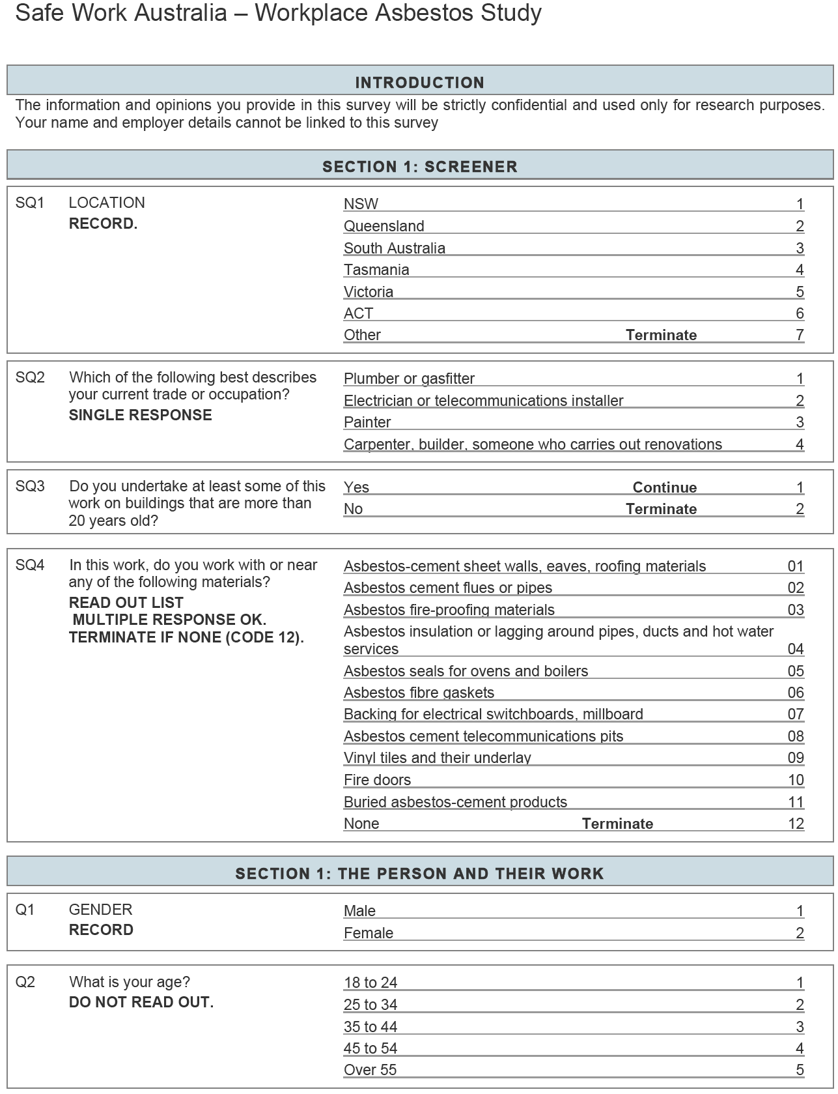
Survey questionnaire continued

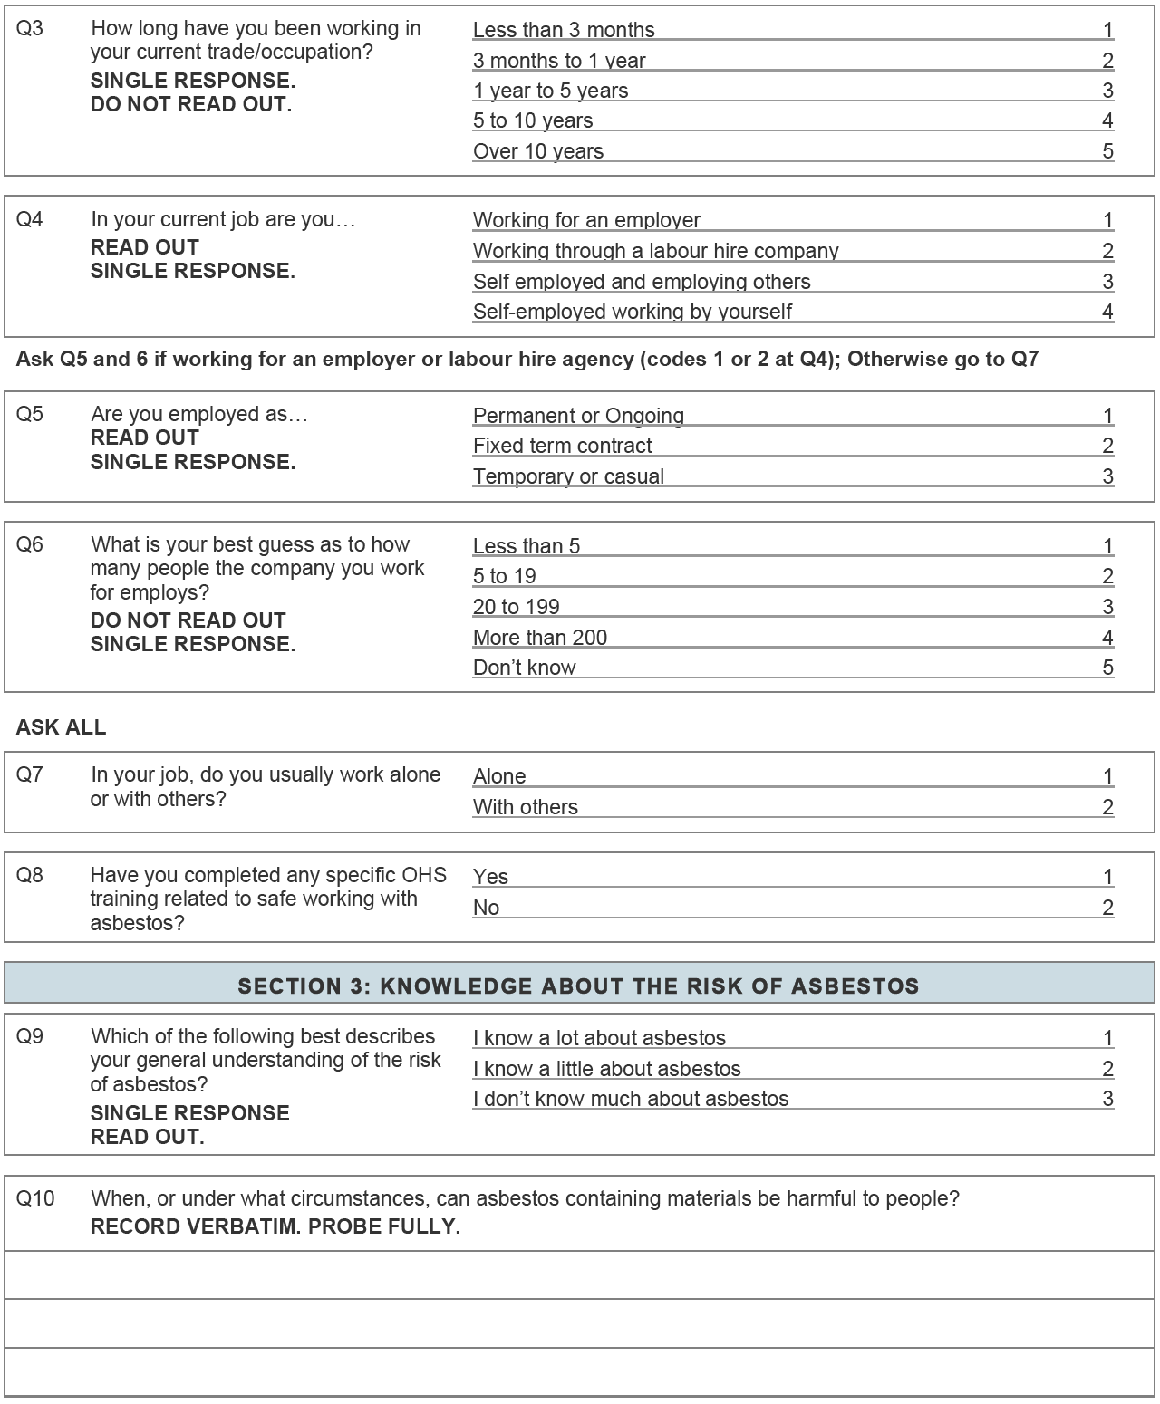
Survey questionnaire continued

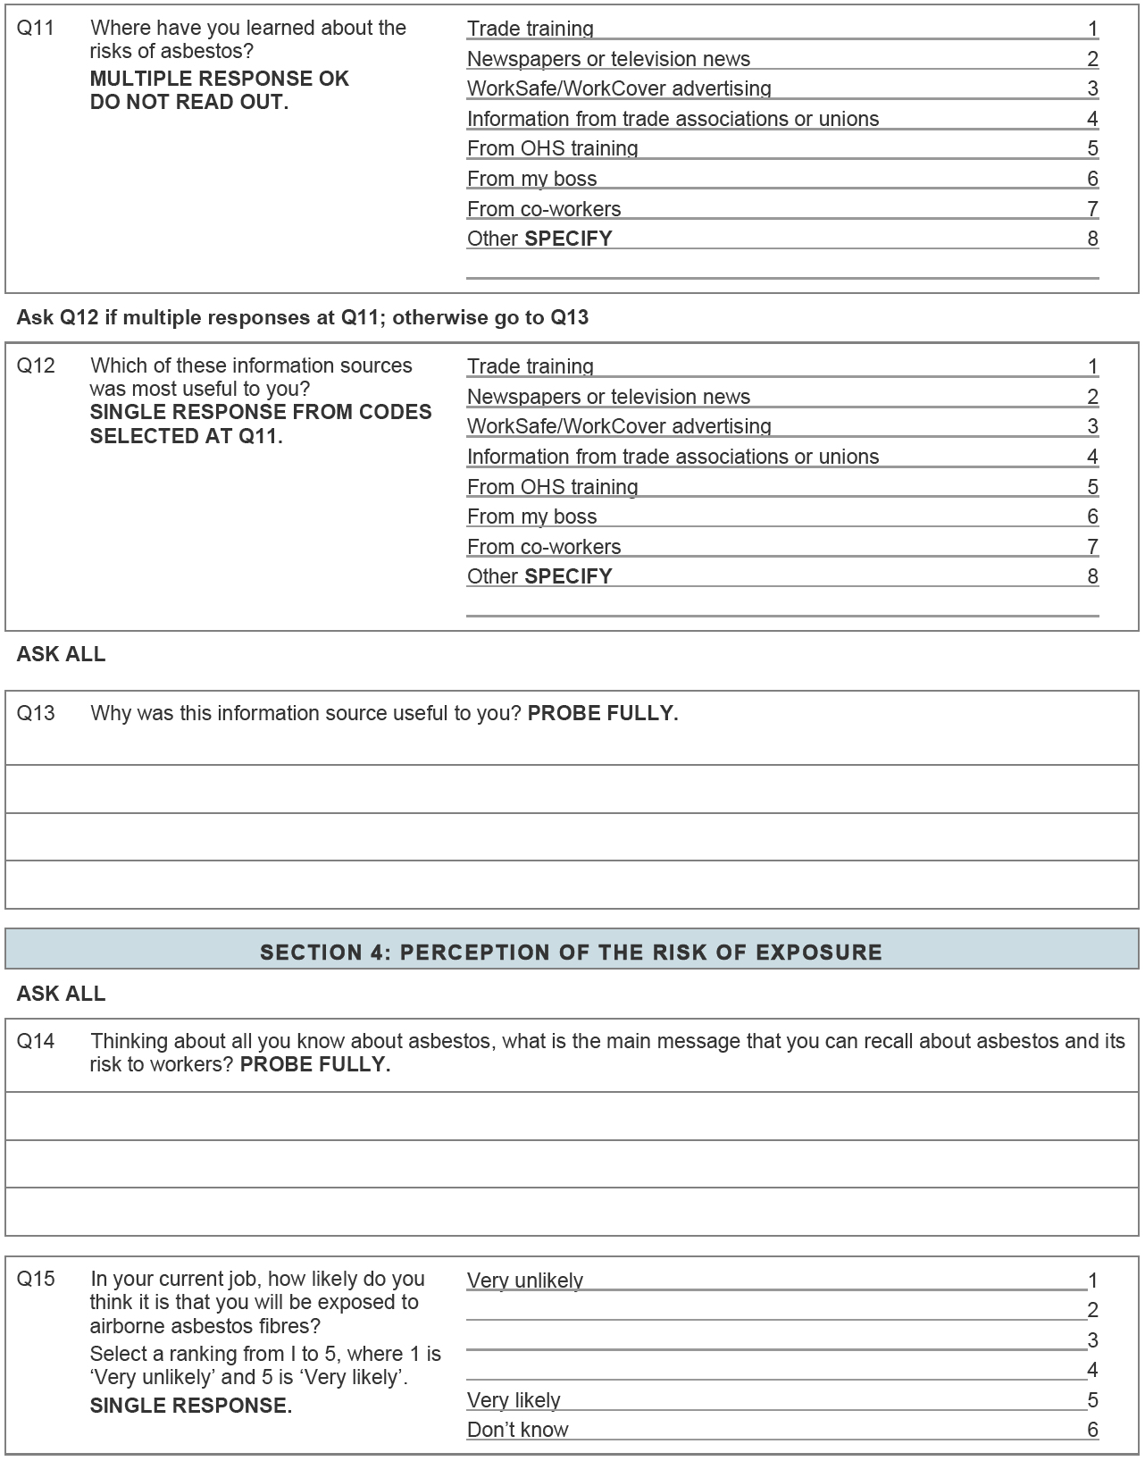
Survey questionnaire continued

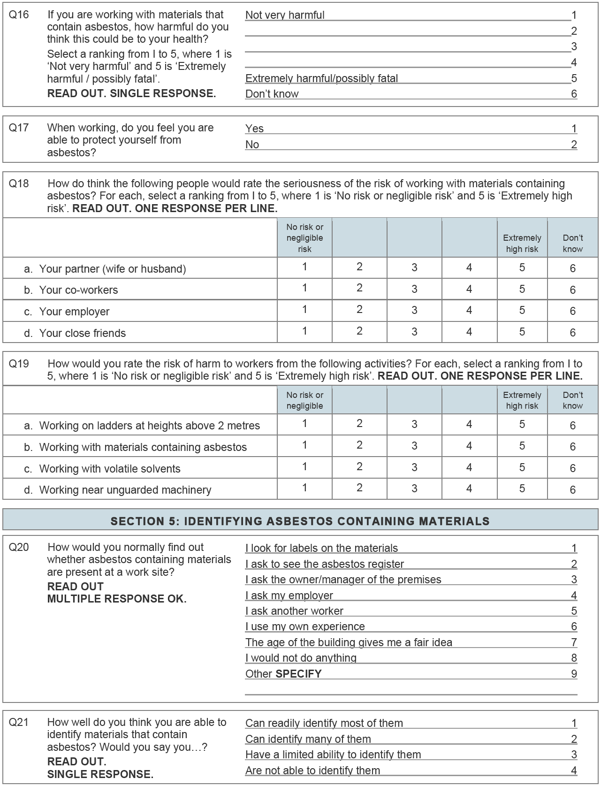
Survey questionnaire continued

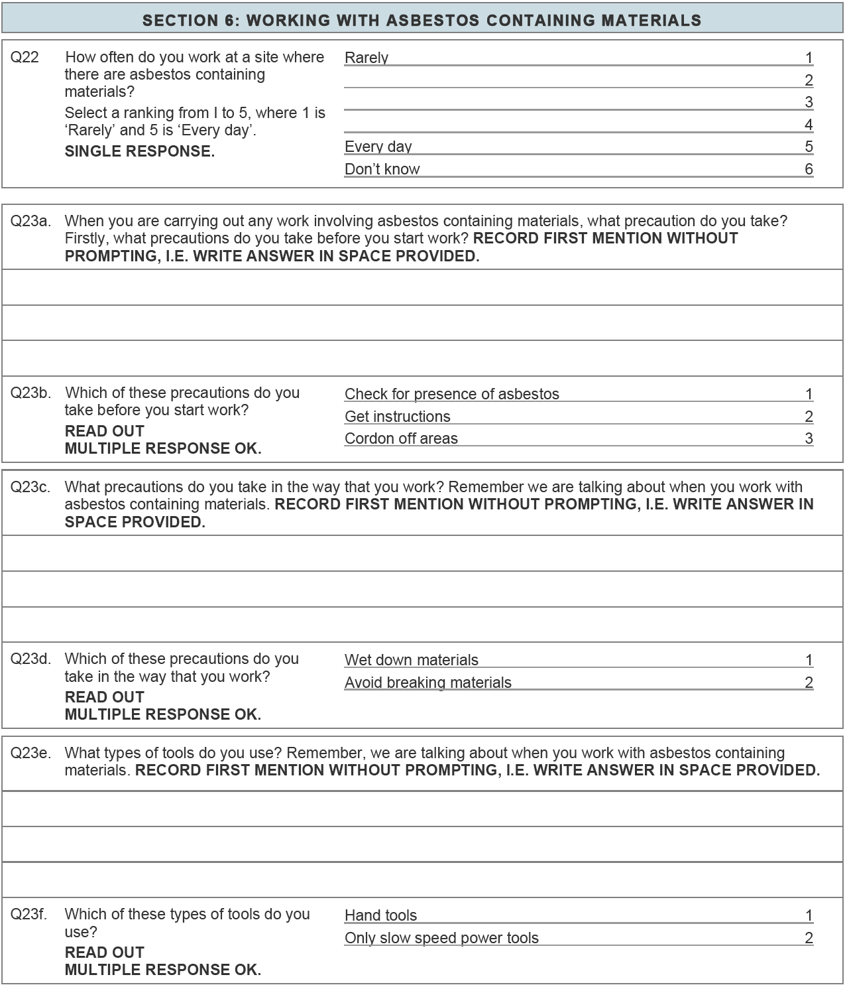
Survey questionnaire continued

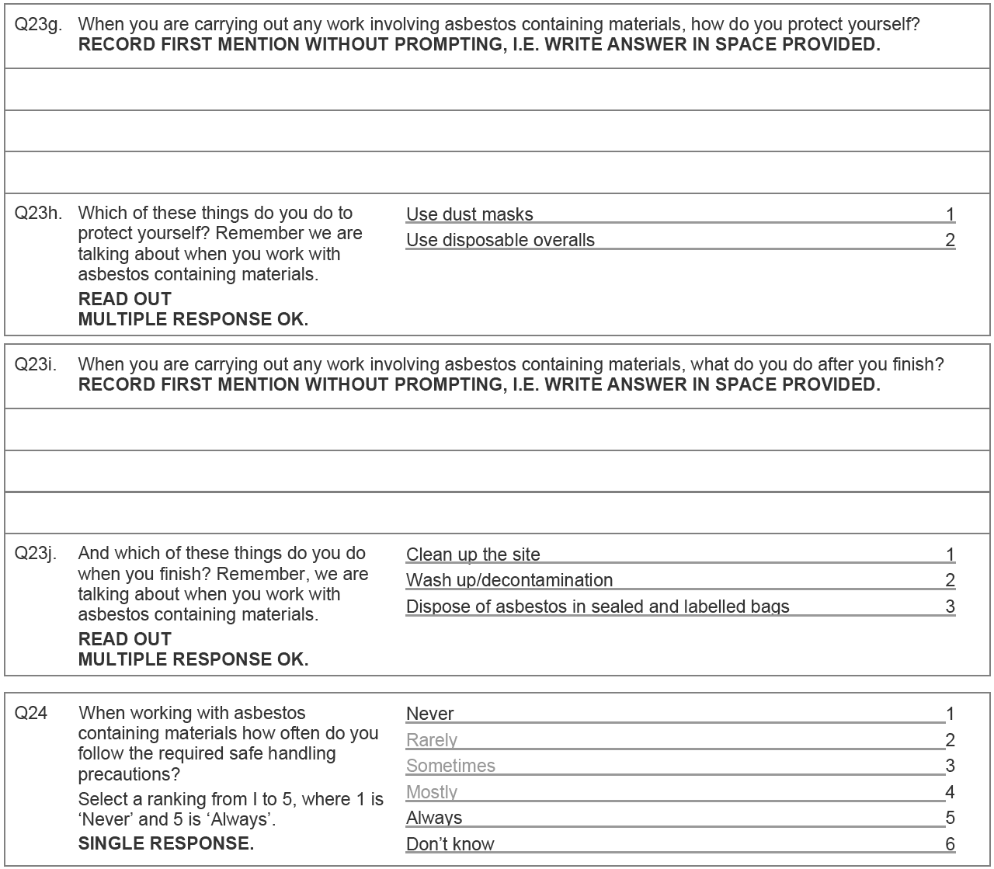
Survey questionnaire continued

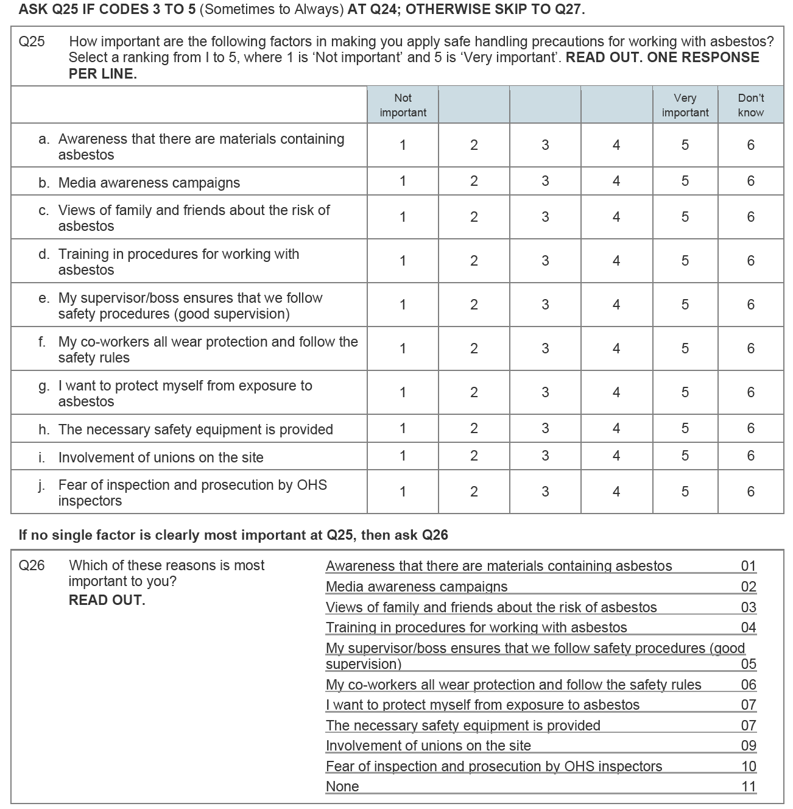
Survey questionnaire continued

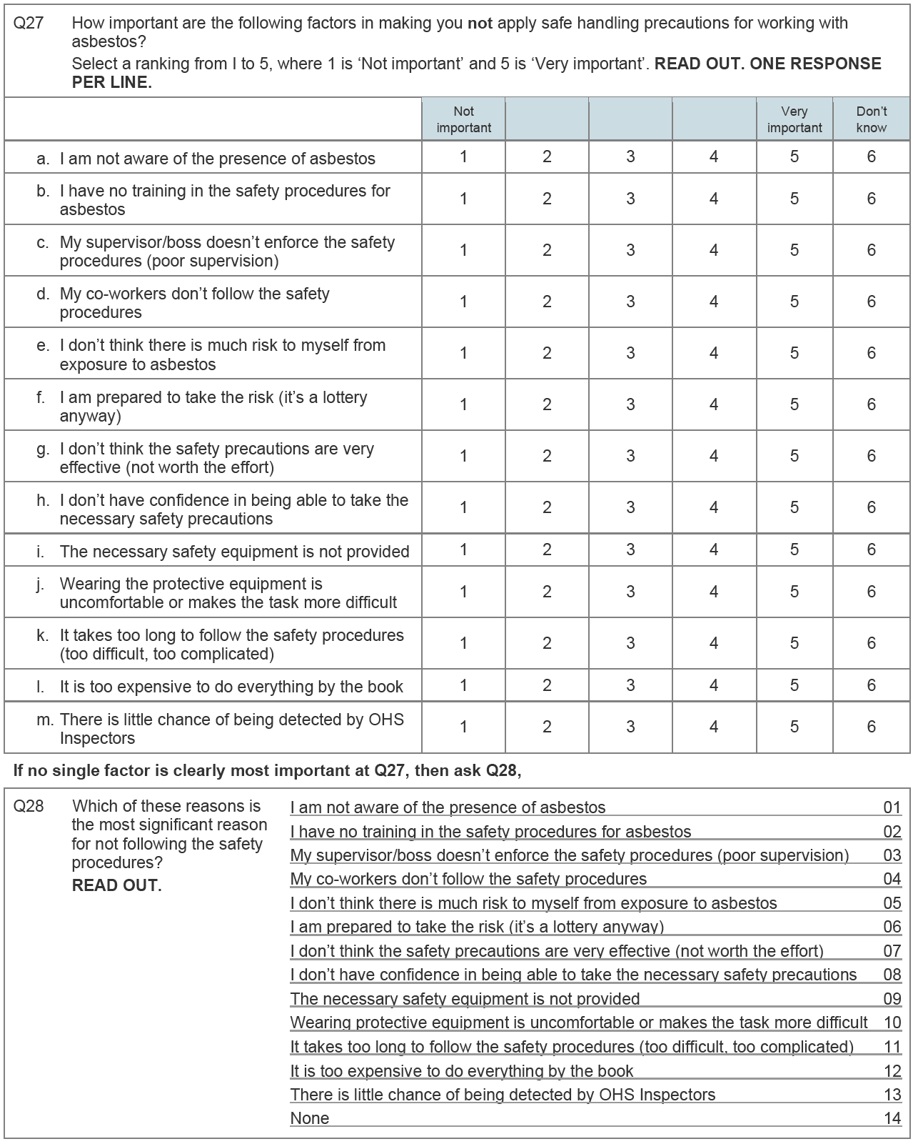

Additional questions asked during face-to-face interviews

Additional questions asked at face-to-face interviews continued

Additional questions asked at face-to-face interviews continued

List of Figures

Figure 6-1 The age distribution of the participants in the CATI survey participants 19
Figure 6-2 The percentage of survey participants by state / territory of residence 20
Figure 6-3 The percentage of the survey participants by trade 20
Figure 6-4 The percentage of survey participants by employment status 21
Figure 6-5 The percentage of workers who worked alone / with others within each trade 21
Figure 6-6 The percentage of workers who reported that they had completed specific OHS training relating to asbestos within each trade 22
Figure 6-7 The percentage of workers within each trade who reported they knew a lot, a little or not much about the risk of asbestos 22
Figure 6-8 The percentage of the survey participants who gave each response to the question: when or under what circumstances can asbestos containing materials be harmful to people. 23
Figure 6-9 The percentage of survey participants who gave each response to the question ‘where have you learned about the risks of asbestos?’. 24
Figure 6-10 The percentage of survey participants who thought the information sources were most useful. 25
Figure 6-11 The percentage of survey participants who provided each response to the question ‘why was this information source (about the risks of asbestos) useful to you?’ 26
Figure 6-12 The percentage of survey participants who gave each response to the question ‘thinking about all you know about asbestos, what is the main message that you can recall about asbestos and its risk to workers?’ 27
Figure 6-13 The percentage of workers within each trade by how they rated their likelihood of being exposed to airborne asbestos fibres in their current job 27
Figure 6-14 The percentage of workers within each trade by how they rated how harmful exposure to asbestos could be for their health 28
Figure 6-15 The percentage of workers in each trade who feel that they can protect themselves from asbestos 29
Figure 6-16 The percentage of workers who thought that the above people would rate the seriousness of the risk of working with materials containing asbestos 29
Figure 6-17 Risk rating of asbestos compared to other occupational hazards 30
Figure 6-18 The percentage of workers within each trade that said they would do these things to find out whether asbestos containing materials are present at a work site 31
Figure 6-19 The percentage of workers within each trade by how well participants think they are able to identify materials that contain asbestos 32
Figure 6-20 The percentage of workers within each trade by how they rated how often they work at a site where there are asbestos containing materials 32
Figure 6-21 The percentage of workers within each trade who reported they worked with or near these types of asbestos containing materials 33
Figure 6-22 The main spontaneous responses to the question what precautions do you take before you start work and the percentage of workers who gave each response. 34
Figure 6-23 The percentage of workers within each trade that would take these precautions before starting work with asbestos containing materials 34
Figure 6-24 The main spontaneous responses to the question what precautions do you take in the way that you work and the percentage of workers who gave each response. 35
Figure 6-25 The percentage of workers within each trade who said they would take these precautions when they work with asbestos 36
Figure 6-26 The percentage of workers within each trade who said they used hand tools and / or only slow speed power tools 36
Figure 6-27 The percentage of workers who gave each response to the question how do you protect yourself when carrying out any work involving asbestos containing materials? 37
Figure 6-28 The percentage of workers in each trade who reported they used dust masks and disposable overalls 37
Figure 6-29 The percentage of workers who gave each response to the question what do you do after you finish working with asbestos containing materials? 38
Figure 6-30 The percentage of workers within each trade who reported they cleaned up the site, disposed of asbestos appropriately and / or wash up / decontamination 39
Figure 6-31 The percentage of workers with in each trade (and for all workers – total) by how they rated how often they follow the required safe handling precautions for asbestos containing materials 39
Figure 6-32 The rating of importance of enabling / motivating factors by workers who sometimes, mostly or always follow the required safe handling precautions 40
Figure 6-33 The most important reason for following safe handling precautions 41
Figure 6-34 The rating of importance of barriers in following required safe handling precautions 42
Figure 6-35. The most important reason for NOT following safe handling precautions 43
Figure 6-36 Distribution of face-to-face interview participants by age 44
Figure 6-37 Distribution of participants by occupation 44
Figure 6-38 Distribution of face-to-face interviewees by state 44
Figure 6-39 Measures that would be the most helpful in identifying ACMs (single response) 45
Figure 6-40 Disposal action for respiratory protection (mask / cartridge) 46
Figure 6-41 Method of disposal of overalls among those who used disposable overalls / non-disposable overalls 47
Figure 6-42 Measures taken to clean up site after work with asbestos containing materials 48
Figure 6-43 Measures taken to decontaminate themselves after work with ACMs 48
Figure 6-44 Where asbestos waste is disposed 49
Figure 6-45. Reasons given as barriers to disposing asbestos at an approved site 50
Figure 6-46 Types of asbestos codes and guidance among those who has read a code of practice on asbestos 51

List of Tables

Table 6-1. Summary profile of telephone survey participants 19
Table 6-2. Selected characteristics of workers who participated in face-to-face interviews 43
Table 6-3. Types of respiratory protection used by face-to-face interviewees 46
Table 7-1. Summary of results: manual collection of asbestos debris 52
Table 7-2. Summary of results: trenching 53
Table 7-3. Summary of results: Drilling of asbestos cement sheet 53
Table 7-4 Summary of results: hole cutting of asbestos cement sheet 54
Table 7-5 Summary of results: sanding of asbestos cement sheet 54
Table 7-6 Summary of results: working with electrical switchboard backing material 55
Table 7-7 Summary of results: working with asbestos core fire doors 55
Table 7-8. Summary of results: Working in a ceiling space containing ACMs 56
Table 7-9. summary of atmospheric monitoring results 56

Victorian ‘Compliance Codes’ are similar in legislative effect to (approved) codes of practice in other jurisdictions.
If more than 10 square metres of AC sheet are to be removed a licensed asbestos removalist must be used.
The results of the first part of the face-to-face interviews are not presented in this report
For personal sampling air samples are collected at a sampling point on the workers collar – representing the atmosphere in the worker’s breathing zone.
Static monitoring collects samples in the vicinity in which work is being undertaken – represents the general work atmosphere for the area.

