THE SECOND Progress Report ON

The Australian Work Health and Safety Strategy 2012-2022

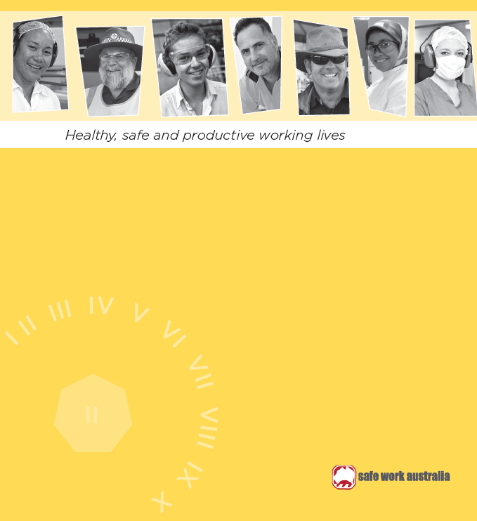

1 October 2013 – 31 October 2014

Creative commons logo

**Creative Commons**

978-1-74361-824-0 [PDF]

978-1-74361-825-7 [DOCX]

With the exception of the Safe Work Australia logo and all other images, this report is licensed by Safe Work Australia under a Creative Commons 3.0 Australia Licence.

To view a copy of this licence, visit http://creativecommons.org/licences/by/3.0/au/deed.en

In essence, you are free to copy, communicate and adapt the work, as long as you attribute the work to Safe Work Australia and abide by the other licensing terms. The report should be attributed as The second progress report on the Australian Work Health and Safety Strategy 2012-2022.

Enquiries regarding the licence and any use of this publication are welcome at:   
Safe Work Australia  
GPO Box 641 Canberra ACT 2601  
Email: copyrightrequests@swa.gov.au

# Executive summary Australian Strategy graphic wheel

During this second year of the Australian Work Health and Safety Strategy 2012-22 (Australian Strategy) Safe Work Australia and its Members have continued building a more responsive regulatory framework and provided guidance for the most serious hazards and risks. A robust data and research programme has provided evidence to inform national health and safety policies and programmes. The work health and safety regulators are engaging with the public through campaigns like “Getting home safely” and “Share Your Reason”. A stronger focus on responsive service delivery has provided business with advice to help them integrate work health and safety into their everyday business and reduce regulatory burden without compromising safety standards. The industry bodies and unions have continued to build the work health and safety skills of their members. The Australian Strategy Action Areas stimulate new conversations with a broader range of stakeholders. These highlight the importance of work design and the powerful role of leaders in influencing shareholders, boards and others to realise the benefits of improved work health and safety outcomes. In October 2014 the first Virtual Seminar Series on the Australian Strategy themes provided opportunities for participants to hear from leading experts, regulators and employee and employer representatives on how they are helping to create healthier, safer and more productive working lives.

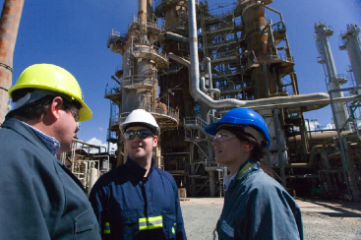

# Introduction

This is the second annual progress report of the Australian Work Health and Safety Strategy 2012-22 (Australian Strategy). It covers the period from 1 October 2013 to 31 October 2014.

This report provides a snapshot of some of the diverse and innovative activities undertaken by Safe Work Australia and its Members to improve work health and safety and achieve the vision of healthy safe and productive working lives for all Australians.

It builds on achievements reported in the inaugural progress report and notes some of the many initiatives undertaken in 2013-14.

BACKGROUND

The [Australian Strategy](http://www.safeworkaustralia.gov.au/sites/swa/about/publications/pages/australian-work-health-and-safety-strategy-2012-2022) builds on the work of [National OHS Strategy 2002-2012](http://www.safeworkaustralia.gov.au/sites/swa/about/publications/pages/sp200208nationalohsstrategy2002to2012) and is a framework to drive national and local activity to realise the vision of healthy, safe and productive working lives.

The Australian Strategy was formally endorsed by Workplace Relations Ministers, the Australian Council of Trade Unions (ACTU), Australian Chamber of Commerce and Industry (ACCI) and the Australian Industry Group (Ai Group) and launched by the Commonwealth Minister on 31 October 2012.

The Australian Strategy sets [four outcomes to be achieved by 2022](http://www.safeworkaustralia.gov.au/sites/swa/australian-strategy/outcomes/pages/2022-outcomes)

* reduced incidence of work-related death, injury and illness, achieved by
* reduced exposure to hazards and risks using
* improved hazard controls and supported by
* an improved work health and safety infrastructure.

Seven Action Areas focus national and local activity on areas which collectively are expected to result in the greatest improvement in workplace health and safety.

[Safe Work Australia Members](http://www.safeworkaustralia.gov.au/sites/swa/about/ourmembers/pages/members) — Commonwealth, state and territory governments, employer organisations and unions play an important role providing a responsive regulatory framework and practical advice and support to those with responsibility for health and safety to achieve these outcomes.

This report includes illustrative case studies on Safe Work Australia and Members’ activities. For more examples and case studies on national and local initiatives visit the Safe Work Australia website at www.swa.gov.au.

Figure 1: The Australian Strategy

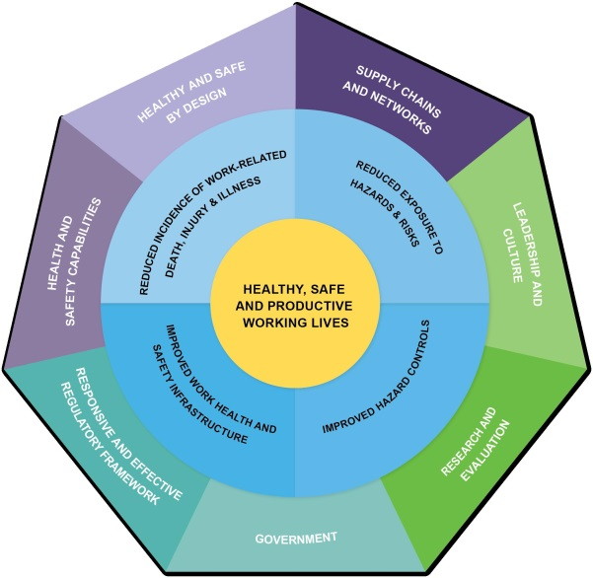

# Healthy and safe by design Health and safe by design graphic wheel

WHY IS THE DESIGN OF STRUCTURES, PLANT AND SUBSTANCES IMPORTANT?

The most effective and durable means of creating a healthy and safe working environment is to eliminate hazards and risks during the design of new plant, structures, substances and technology. Design processes need to take into account the hazards and risks that may be present at all stages of the lifecycle of structures, plant, products and substances.

It is important that designers, manufacturers, importers and suppliers better understand why safe designs are required, their legal obligations and how to comply with these.

WHAT IS BEING DONE?

Safe Work Australia and Members have and are undertaking activities to increase awareness and knowledge of the importance of safe design.

To supplement existing [codes and guidance](http://www.safeworkaustralia.gov.au/sites/swa/model-whs-laws/pages/model-whs-laws) in 2014, Safe Work Australia released the [Guide for the safe design of plant.](http://www.safeworkaustralia.gov.au/sites/swa/about/publications/pages/guidance-safe-design-manufacture-import-supply-plant) This provides duty holders with information on their obligations under the work health and safety (WHS) legislation and how they can help achieve safer designs of plant.

The high number of traumatic injuries from use of unsafe plant and structures has meant the WHS regulators have continued their strategic interventions to support compliance and enforcement.

[WorkSafe Victoria is eliminating risks at the source](http://www.safeworkaustralia.gov.au/sites/swa/australian-strategy/case-studies/pages/eliminating-risks) by targeting suppliers of non-compliant plant and machinery in an initiative to identify, trace and modify or remove dangerous machinery in the supply chain.

When purchasing new plant, small businesses may be unaware of the safety impacts of such decisions. As part of its Small Business Strategy, WorkCover NSW is helping small businesses make more informed choices through [its rebate scheme for the purchase of eligible safety equipment.](http://www.workcover.nsw.gov.au/health-and-safety/how-we-can-help/small-business-rebates)

The risks associated with quad bike use continue to be a major concern across Australia. WorkCover NSW has funded world-first research and testing of the dynamic handling of quad bikes through the [Quad Bike Crash Performance Safety Testing and Research Project.](http://www.tars.unsw.edu.au/research/Current/Quad-Bike_Safety/Performance_Project.html) The final report and recommendations of this $1.3 million project will be completed in 2015.

The research will be used to develop harm reduction strategies nationally. The strategies will aim to reduce the unacceptable level of on-farm quad bike fatalities and serious injuries.

**SAFE DESIGN OF PLANT AND MACHINERY SAVES LIVES**

The need for safer designs is raised by the findings of the 2014 Safe Work Australia report [Work-related fatalities associated with unsafe design of machinery, plant and powered tools, 2006 – 2011](http://www.safeworkaustralia.gov.au/sites/swa/about/publications/pages/work-related-fatalities-unsafe-design). It found between 2006 and 2011, 188 work-related deaths were definitely or possibly caused by unsafe design of plant or equipment.

**CASE STUDY**

Queensland: [Designing a lighter plasterboard to help reduce the load](http://www.safeworkaustralia.gov.au/sites/swa/australian-strategy/case-studies/pages/designing-lighter-plasterboard)

# Healthy and safe by design Health and safe by design graphic wheel

WHY IS THE DESIGN OF WORK IMPORTANT?

Despite a historically strong focus on preventing exposure to biomechanical, physical and psychosocial hazards, they continue to be the leading cause of work-related musculoskeletal and mental disorders.

Good design of work and work systems can eliminate or minimise these hazards and risks. Work design takes into account the task, job and organisational structure, as well as the individuals’ capabilities, relationships and responsibilities.

WHAT IS BEING DONE?

Safe Work Australia recognised that a major impediment to the good design of work was a lack of awareness of why it was important, what should be considered and how to do it.

The Safe Work Australia Members’ collaborative project [Good Work Through Effective Design project](http://www.safeworkaustralia.gov.au/sites/swa/about/publications/pages/good-work-design) has developed a [set of draft principles](http://www.comcare.gov.au/engage/scheme_consultations/closed_consultations/draft_principles_of_good_work_design) informed by research and refined through consultation with a tripartite panel and design professionals. These, along with an accompanying framework, will be available in 2015-16.

**WHAT DOES THE EVIDENCE SAY ABOUT HOW TO DESIGN GOOD WORK?**

Professor Sharon Parker’s report on [Principles and Evidence on Good Work Through Effective Design](http://www.comcare.gov.au/engage/scheme_consultations/closed_consultations/good_work_through_effective_design_project) (2014) reports on the empirical evidence for the best-practice approaches to the design of good work

**IMPROVING WORK ABILITY CAN EXTEND WORKING LIVES**

[Work Ability in Australia - Pilot Study](http://www.safeworkaustralia.gov.au/sites/swa/about/publications/pages/work-ability-in-australia-pilot-study)

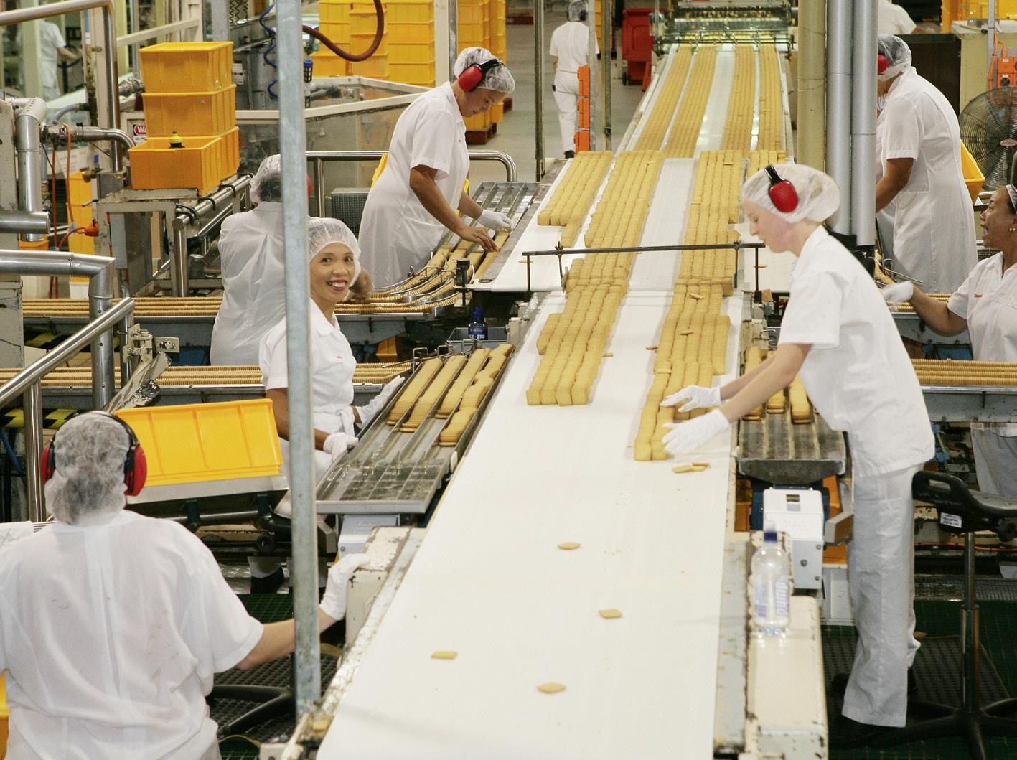

# Supply chains and networks Supply chains and networks graphic wheel

WHY ARE SUPPLY CHAINS AND NETWORKS IMPORTANT?

Supply chains and networks can involve formal or informal contractual arrangements that can have a significant influence— positively or negatively—on work health and safety practices.

Businesses when choosing contractors or purchasing goods and services can positively influence others’ behaviours by requiring they meet particular WHS standards.

The use of outsourcing creates an opportunity for business leaders to drive, model and support improved workplace practices.

WHAT IS BEING DONE?

In 2014 Safe Work Australia commenced national activities to encourage more organisations to improve work health and safety through their supply chains and networks, without imposing unnecessary requirements where small businesses are included.

Workplace Health and Safety Queensland continued its strong focus on actively working with industry through supply chains by:

* working with labour hire firms to increase their awareness of how they can improve health and safety
* working with the livestock transport industry to reduce risks of loading, unloading and transporting

livestock from farm gate to abattoir, and

* using the Zero Harm at Work Leadership program to encourage industry leaders to address hazards and risk within their own business and the supply chain.

[The Plastics and Chemicals Industries Association](http://www.safeworkaustralia.gov.au/sites/swa/australian-strategy/vss/pages/australian-chemical-industry) demonstrated in their video contribution to the 2014 Australian Strategy Virtual Seminar Series (VSS) that when companies actively work together along the supply chain, there can be more opportunities and positive outcomes for all of them— calling this “supply chain sustainability”.

**SUPPLY CHAINS AND NETWORKS**

The often-complex chain or web of commercial or business relationships designed to provide goods or services includes, for example, supplying agricultural produce to a supermarket or car components to vehicle manufacturers.

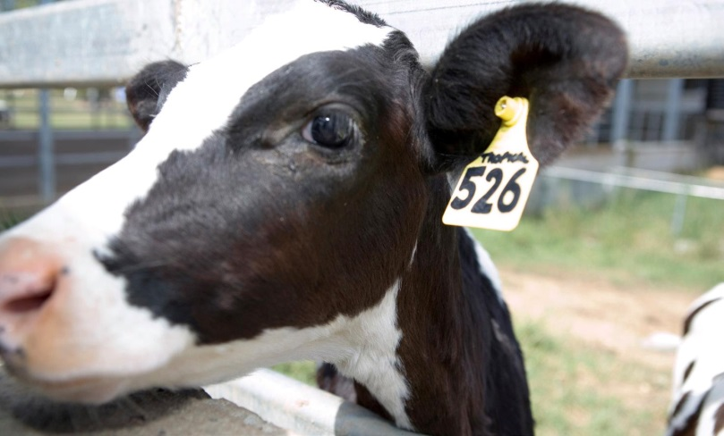

# Health and safety capabilities Health and safety capabilities graphic wheel

WHY ARE WORK HEALTH AND SAFETY CAPABILITIES SO IMPORTANT?

Those in control of work need to manage their business risks. They have to make informed decisions based on competent advice, whether from their own staff or external advisers.

Workers in turn need the education and training to be able to do their job safely.

Regulators are developing the capabilities of their own staff to better provide information and support compliance.

WHAT IS BEING DONE?

Attendance at training courses and conferences takes time and money: a challenge for small businesses or those located in regional or rural areas.

The [Australian Strategy Virtual Seminar Series (VSS)](http://www.safeworkaustralia.gov.au/sites/swa/australian-strategy/vss/pages/vss) is available online since its release during 2014 national Safe Work Australia Safety Month (safety month). Seminars feature national and international industry experts, academics and business leaders who share their experience and knowledge on a range of topics.

The VSS material was viewed over 70 000 times (October 2014-March 2015) from people around Australia and overseas. It remains on the Safe Work Australia web site as an ongoing resource.

Safe Work Australia continues to update and publish information and practical advice on obligations under the model WHS legislation.

[The Australian Chamber of Commerce and Industry website](https://www.youtube.com/channel/UCdfzxa39xge8Vu9Vi-ksWog) provides videos and webinars to improve understanding and support legislative compliance for their members.

In 2014, [Master Builders Association (MBA)](http://www.safeworkaustralia.gov.au/sites/swa/australian-strategy/case-studies/pages/qr-codes-construction) partnered with CodeSafe Solutions to deliver safety messages to construction workers via short engaging videos. Commenced in 2014, this project recognises some workers are more likely to pick up safety messages visually.

The work health and safety regulators continued to provide practical information and support for businesses through targeted rebates, worksite visits, and free coaching and mentoring. They published hazard and industry specific guidance – much of it designed especially for small to medium enterprises.

[The ACTU](http://www.safeatwork.org.au/) and unions through their Registered Training Organisations provided [Health and Safety Representative](http://training.gov.au/Training/Details/BSB41407) training and advice to their members.

Under the Australian Strategy there is recognition of the importance of building a skilled inspectorate. Heads of Workplace Safety Authorities’ (HWSA) collaboration on inspector training adopted nationally continues to work on improving their technical skills and supporting more consistent application of WHS laws.

# Health and safety capabilities Health and safety capabilities graphic wheel

**IMPROVED WHS AWARENESS CAN REDUCE EXPOSURE TO MULTIPLE DISEASE-CAUSING HAZARDS FOR YOUNG WORKERS**

A recent Safe Work Australia publication revealed young workers were more likely to be exposed to multiple disease-causing hazards. This was not limited to those in lower-skilled jobs. The research suggests younger workers may be assigned to tasks with higher exposures to hazards, highlighting the importance of equipping young workers with the skills and knowledge to protect themselves at work.

Source: [Exposure to Multiple Hazards among Australian Workers](http://www.safeworkaustralia.gov.au/sites/swa/about/publications/pages/exposure-multiple-hazards-australian-workers) (2014)

**TO SEE THE KEY NATIONAL ACTIVITIES**

Go to the [WHS Capabilities Activity Plan 2014-19](http://www.safeworkaustralia.gov.au/sites/swa/australian-strategy/related-activities)

WHY DO WE NEED AN EFFECTIVE EDUCATION SYSTEM?

An effective and robust education system responds to the changing nature of work and workplace hazards and risks.

Governments, regulators, education providers and industry need to work together to expand opportunities for learning and ensure continuous improvement of standards and quality of training and education. This is particularly important where work is high risk as specialist skills and knowledge are required.

Recent reviews of the tertiary and vocational sectors have revealed the challenges for them to provide high quality training and relevant education for contemporary Australian business.

WHAT IS BEING DONE?

Safe Work Australia and its Members are working with the Vocational Education and Training (VET) sector Industry Skills Councils (ISC) to improve the 29 high-risk work units of competency in the construction, transport, energy and manufacturing sectors—ensuring persons requiring high risk licences have the required skills and knowledge.

Safe Work Australia has continued its partnership with the OHS Education Accreditation Board— the custodian for the [OHS Body of Knowledge for Generalist OHS Professionals](http://www.ohsbok.org.au/) to strengthen the knowledge of WHS professionals. Three chapters have been published of the four funded by Safe Work Australia in 2013: WHS jurisprudence; organisational culture; risk and decision making, and user-centred and safe design. The chapter on risk and decision making will be published in 2015-16.

**2014 AUSTRALIAN STRATEGY VIRTUAL SEMINAR SERIES**

Free, accessible online information and resources: live panel discussions, video presentations, video transcripts, infographics, research reports, case studies and useful links.

**CASE STUDIES**

NSW: [The Safer Communities Safer Towns Initiative](http://www.safeworkaustralia.gov.au/sites/swa/australian-strategy/case-studies/pages/safer-towns)

NSW: [Recover @ Work Strategy](http://www.safeworkaustralia.gov.au/sites/swa/australian-strategy/case-studies/pages/recover-at-work)

Queensland: [Management Commitment: The key to safety and business improvement](http://www.safeworkaustralia.gov.au/sites/swa/australian-strategy/case-studies/pages/recover-at-work)

# Health and safety capabilities Health and safety capabilities graphic wheel

**KEY PRINCIPLES OF WHS CAPABILITIES**

Every person requires the capabilities—the knowledge, skills and resources—to fulfil their work health and safety role.



# Leadership and culture Leadership and Culture graphic wheel

WHY ARE LEADERS AND COMMUNITY ATTITUDES SO IMPORTANT?

Organisational cultures are strongly influenced by their internal leaders and the broader community values and attitudes. Community expectations are powerful drivers of change and collectively influence the nation’s health and safety culture. When the Australian community expects and demands work is free from harm, failure to do so will generate community pressure and calls for action.

WHAT IS BEING DONE?

Leadership and culture was a theme of the Australian Strategy [Virtual Seminar Series (VSS).](http://www.safeworkaustralia.gov.au/sites/swa/australian-strategy/vss/pages/vss) Nineteen programme items featured leaders who informed and inspired others to act to improve WHS in their sphere of influence.

In 2014 as in previous years the WHS regulators, and to a lesser extent employer associations and unions, ran multi-media campaigns to help raise community awareness of the serious impact of workplace incidents on individuals, businesses and society.

VSS programmes feature the ACTU highlighting the important role [Work Health and Safety Representatives](http://www.safeworkaustralia.gov.au/sites/swa/australian-strategy/vss/pages/hsr-workers-as-leaders) have as leaders. Employer associations Ai Group and ACCI illustrate how leaders can drive WHS improvements in their organisation.

The [Work Health and Safety Awards](http://www.safeworkaustralia.gov.au/sites/swa/media-events/awards/pages/awards) held by the Commonwealth, state and territory work health and safety regulators continue to recognise and promote innovative.

In 2014 the Safe Work Australia [Safety Month Workplace Participation Reward](http://www.safeworkaustralia.gov.au/sites/swa/media-events/safety-month/reward/pages/safety-month-workplace-participation-reward) was won by Howe Farming in Queensland. Howe Farming targeted known hazards at their work site with engaging activities for their workers each week during safety month.

The SafeWork SA initiative [Share your reason](http://www.safeworkaustralia.gov.au/sites/swa/australian-strategy/case-studies/pages/share-your-reason-sa) is helping to shape community attitudes that, impressively, has reached around 70 per cent of the South Australian population.

**AN UNSAFE BUSINESS IS NOT AN EFFECTIVE BUSINESS**

Jonathan Metcalfe, Chief Executive Officer of Transdev Australasia and Safe Work Australia 2013 Safety Ambassador knows the cost of poor work health and safety decisions. As a leader, Jonathan Metcalfe shares his vision of leadership in the transport industry in his conversation with Rod Maule, the Transdev Director of Safety, Quality and Risk Management, during the VSS.

**INVESTORS PREFER SAFE WORKPLACES**

Companies that accurately disclose their environmental and WHS information are considered more favourably by investors.

**Source**: [ACSI Report](http://www.safeworkaustralia.gov.au/sites/swa/australian-strategy/vss/pages/leadership-in-the-transport-industry)

# Leadership and culture Leadership and Culture graphic wheel

WHY ARE ORGANISATIONAL LEADERS IMPORTANT?

A positive organisational culture created by good leadership is fundamental to ensuring workplace health and safety. There is strong evidence performance is improved when organisations address WHS risks as a priority, together with other important business risks.

Organisations large and small know their reputation is essential for business resilience and sustainability. Internationally and in Australia interest is growing in corporate social responsibility indicators – which also include WHS.

It is important for organisations to have the tools to accurately measure their WHS performance and if desired benchmark themselves against others.

WHAT IS BEING DONE?

In 2014, Safe Work Australia Members commenced building tools to help business leaders and managers meet their legal obligations and to improve work health and safety in their workplaces. This Safe Work Australia national collaborative project will deliver an online system incorporating a set of principles and practical resources to support them. These are expected to be available in 2015-16.

Safe Work Australia is continuing to work with the Governance and Performance Research Centre at Macquarie University, the Safety Institute of Australia and [CPA Australia](http://www.cpaaustralia.com.au/about-us) on a long-term project to standardise and improve business and organisational [WHS reporting](http://www.safeworkaustralia.gov.au/sites/swa/about/publications/pages/issues-measurement-reporting-whs-performance-review). Three of the five reports from this project have been completed. The final two reports will be available in 2015-16.

Safe Work Australia has also continued its collaboration with Monash University to develop WHS indicators including one to measure organisational culture. This report will be available in 2015-16.

We know leaders pay particular attention to messages coming from their peers. Ann Sherry, the Safe Work Australia Chair, spoke with business leaders from large corporations about how to sustain focus on the most important business risks, and how to move from minimum compliance to strategic due diligence. See the panel discussion [Leadership and WHS in Challenging Working Environments](http://www.safeworkaustralia.gov.au/sites/swa/australian-strategy/vss/pages/leadership-whs-challenging-working-environment) programme of the VSS.

The [Sustainability Leadership Framework](http://www.safeworkaustralia.gov.au/sites/swa/australian-strategy/case-studies/pages/improving-safety-plastic-industry) is an exciting ongoing programme providing the platform for Plastics and Chemicals Industries Association (PACIA) members to turn environmental sustainability, security, product management and workplace health and safety into business opportunities.

# Leadership and culture Leadership and Culture graphic wheel

The Australian Construction Association (ACA) knows organisational culture is a compelling influence on safety performance. The ACA has collaborated with the Royal Melbourne Institute of Technology (RMIT) to develop a [culture maturity model and culture climate assessment survey tool](http://www.safeworkaustralia.gov.au/sites/swa/australian-strategy/case-studies/pages/design-and-culture-construction) to enable industry participants of any size to easily understand their existing culture and take steps to improve their culture and safety performance. Work on this project continues in 2015-16 with a validation process to ensure the effectiveness of the assessment survey tool.

Moving up the culture ladder

**MOVING UP THE CULTURE LADDER**

International expert, Professor Patrick Hudson, likens organisational culture to a game of snakes and ladders—we can climb up but also slide down. His [VSS presentation](http://www.safeworkaustralia.gov.au/sites/swa/australian-strategy/vss/pages/patrick-hudson-culture-ladder) gives suggestions on how organisations can use the concept of the ‘safety ladder’ to advance their safety.

**PACIA EXAMPLE**

PACIA [Surpasses National OHS Targets](http://www.safeworkaustralia.gov.au/sites/swa/australian-strategy/case-studies/pages/improving-safety-plastic-industry)

**CASE STUDY**

SA: [Focusing on Community engagement in South Australia](http://www.safeworkaustralia.gov.au/sites/swa/australian-strategy/case-studies/pages/community-engagement-sa)

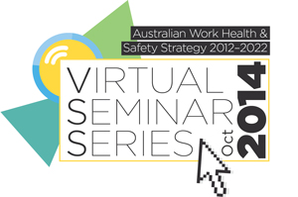

# Research and evaluation Research and Evaluation graphic wheel

WHY IS EVIDENCE IMPORTANT?

A coordinated and cooperative approach is being used to provide national information on how many, where and why workers have died, been injured or made ill by work. This directly informs the national priorities and helps shape a more effective and efficient use of prevention resources.

WHAT IS BEING DONE?

The Safe Work Australia Research, Evaluation and Data Strategy 2013–2017 has two distinct but complementary programmes of work.

* The Data Program collects and maintains accurate national outcomes data—including on the incidence of injuries, fatalities and illness and the associated economic costs, and
* The Research and Evaluation Program focuses on hazard surveillance and risk management, occupational illnesses, attitudes to WHS, and evaluation of interventions including the effectiveness of the Australian regulatory framework.

WHAT IS BEING DONE TO PROVIDE THE EVIDENCE TO INFORM POLICY   
AND PRACTICE?

Safe Work Australia in collaboration with the Commonwealth, states and territories has been improving the quality of the data on workplace deaths. Three main sources are being used:

1. [Notifiable Fatalities Monthly report](http://www.safeworkaustralia.gov.au/sites/swa/about/publications/pages/notifiedfatalitiesmonthlyreport)—the most timely data source.
2. [Work-related Traumatic Injury Fatalities report](http://www.safeworkaustralia.gov.au/sites/swa/statistics/work-related-fatalities/pages/workrelatedtraumaticinjuryfatalities)—the most comprehensive source using information from workers’ compensation data, coronial information, notifiable fatalities and the media.
3. [Compendium of Workers’ Compensation Statistics reports](http://www.safeworkaustralia.gov.au/sites/swa/statistics/workers-compensation-data/pages/compendiumofworkerscompensationstatistics)—provides information on the circumstances of injury claims, including those compensated for a disease-related fatality.

Safe Work Australia funds and oversees the [Australian Mesothelioma Registry](http://www.mesothelioma-australia.com/home/) which identifies the sources and likelihood of past exposure to asbestos of work-related and non-work-related origin among newly diagnosed patients.

During this reporting period the National Occupational Hazard and Risk Management Surveillance Research Program examined exposures to noise, dust and vibration in agriculture. This will be completed in 2015-16.

Research on the extent and effectiveness of the model WHS legislation reform agenda continued in 2014.

**THE SAFE WORK AUSTRALIA RESEARCH, EVALUATION AND DATA PROGRAMS**

Safe Work Australia collects and provides robust national information to meet the needs of governments, employer associations, unions, researchers and the wider community.

# Research and evaluation Research and Evaluation graphic wheel

**AUSTRALIA’S WORK-RELATED INJURIES AND ILLNESSES COSTS**

Work-related injuries and illnesses cost $60.6 billion dollars – 4.8 per cent of GDP.

**MESOTHELIOMA**

The incidence of mesothelioma is likely to peak in the next 10 to 15 years.

Projects included collection of baseline information on the:

* costs and benefits of compliance with the model WHS regulations from senior managers, and
* perceptions of work health and safety from business owners and representatives.

Safe Work Australia and its Members commenced a new Emerging Issues pilot programme in 2014. It will run for one year. The pilot will consider the emerging WHS issues associated with sedentary work and at-risk migrant/foreign workers. The pilot will be completed and evaluated in 2015-16.

WHS regulators continue to undertake important data and research programmes around key risk areas for their jurisdictions.

Work Health and Safety Queensland has used research data to develop a cost calculator tool that helps businesses estimate the uninsured costs of real and potential workplace injuries.

RESEARCH COLLABORATIONS

Due to the cost and need for highly specialised skills, research and data projects are often most effectively undertaken in collaboration with others.

In 2013-14 strategic research programmes were funded by two jurisdictions and are examples of recent collaborations between regulators, academic institutions and industry, often across jurisdictions.

* [SafeWork SA Grants programs](http://www.safework.sa.gov.au/show_page.jsp?id=8199#.VXfK5nLvqmQ) and
* [ISCRR research](http://www.worksafe.vic.gov.au/safety-and-prevention/health-and-wellbeing/research) programme by WorkSafe Victoria, the Transport Accident Commission and Monash University.

**CASE STUDIES**

[Model laws: What’s really happening in the Construction industry](http://www.safeworkaustralia.gov.au/sites/swa/australian-strategy/case-studies/pages/profile-manufacturing-industry) *and* [Profile of the Manufacturing industry](http://www.safeworkaustralia.gov.au/sites/swa/australian-strategy/case-studies/pages/profile-manufacturing-industry)

**FURTHER INFORMATION**

[Sources of information](http://www.safeworkaustralia.gov.au/sites/swa/australian-strategy/case-studies/pages/profile-manufacturing-industry)

[Risk awareness and perception of health and safety](http://www.safeworkaustralia.gov.au/sites/swa/australian-strategy/case-studies/pages/perception-of-health-safety)

# Government Government graphic wheel

HOW IS GOVERNMENT AN IMPORTANT DRIVER OF WORK HEALTH AND SAFETY?

Government at all levels directly and indirectly influences work health and safety within Australian businesses, organisations and the broader community, through policies, programmes and services.

Government bodies are major purchasers of products and services. By incorporating work health and safety into government investment, procurement arrangements and contracts, they can encourage suppliers to improve health and safety of products and services.

The community and the private sector expect that government bodies, as major employers, will exemplify good work health and safety practices.

WHAT IS BEING DONE?

Recently, the Commonwealth [Royal Commission into the Home Insulation Program](http://www.homeinsulationroyalcommission.gov.au/Pages/default.aspx) found poor identification and management of work health and safety risks at the programme’s design and implementation stages.

In response to the Royal Commission into the Home Insulation Program Safe Work Australia is examining better ways for government to incorporate WHS into policy and programme development, implementation and procurement processes.

Queensland undertook the Stay safe up there, switch off down here ceiling spaces advertising campaign aimed at improving electrical safety for homeowners and tradespeople.

In 2014, the ACT Government released a [suite of guidance to assist the ACT construction industry better manage WHS risks.](http://www.safeworkaustralia.gov.au/sites/swa/australian-strategy/case-studies/pages/government-construction-project) This was in response to the recommendations arising from the “Getting Home Safely”—Inquiry into Compliance with Work Health and Safety Requirements in the ACT Construction Industry.

The pivotal role of government to model good work health and safety practice is widely acknowledged. WHS regulators have continued to actively support government agencies to develop policies and programmes to improve health and safety outcomes. One example is WorkSafe Victoria’s one stop web page [*Your health and safety guide to Local Government.*](http://www.worksafe.vic.gov.au/safety-and-prevention/your-industry/local-government) More information about these programmes can be found at the WHS jurisdictions’ websites.

Governments collaborate to share information, policies and strategies to improve public sector performance. The National Work Health and Safety and Injury Management Forum collaborates informally to initiate activities that improve WHS outcomes for public sector workers.

**APSC AND COMCARE SUPPORT BETTER MENTAL HEALTH**

In 2014 the Australian Public Service Commission (APSC) and Comcare released the [Working Together: promoting mental health and wellbeing at work](http://www.apsc.gov.au/publications-and-media/current-publications/mental-health) guide. This aims to enable managers and workers to work together to build inclusive workplaces and effective systems for promoting mental health in the APS.

# Responsive and effective regulation Responsive and effective regulation graphic wheel

WHY IS GETTING THIS RIGHT IMPORTANT?

WHS regulators recognise the need for flexible, proactive and responsive options in their compliance and enforcement functions.

The community expects its members to arrive home safe and well, and workplaces that expose their workers to the risk of death or serious injury will be held to account.

WHAT IS BEING DONE?

Safe Work Australia is continuing to work with [jurisdictions to adopt the model WHS laws.](http://www.safeworkaustralia.gov.au/sites/swa/model-whs-laws/pages/jurisdictional-progress-whs-laws) In 2014 Western Australia introduced its version of the model WHS bill into its parliament.

Safe Work Australia assisted the Council of Australian Governments (COAG) in an examination of the model WHS laws to find ways to improve these and reduce unnecessary regulatory burden without compromising safety outcomes.

In 2014 Safe Work Australia developed a suite of 4 [model Codes of Practice](http://www.safeworkaustralia.gov.au/sites/swa/model-whs-laws/model-cop/pages/model-cop), 17 industry guidance and one fact sheet to assist compliance and provide further guidance. This information complements the extensive information already provided by the WHS regulators.

Safe Work Australia continues to develop and improve the information on its website to help businesses and organisations understand the legislative requirements. Ongoing effort will simplify material to make it easier to understand and allow it to be displayed on mobile devices.

In 2014-15 Safe Work Australia will continue its collaboration with the [Australian Forum of Explosives Regulators](http://www.safeworkaustralia.gov.au/sites/swa/about/who-we-work-with/afer/pages/afer) to achieve greater national consistency in explosives regulation. Reform will prioritise those areas where greatest benefits will be derived from improved consistency. A regulatory impact assessment will be undertaken in 2015, including public consultation. It aims to improve national security and safety, reduce regulatory burden and provide a more competitive marketplace in Australia and internationally.

WHS regulators are continuing to transform their business model by adapting their response to the particular business circumstances such as size, past history and commercial and working environment—for example, high-risk work and community expectations. Queensland has shared their journey through the publication [transforming the work health and safety regulator.](http://www.safeworkaustralia.gov.au/sites/swa/australian-strategy/vss/pages/a-safer-queensland)

The 2013-14 national compliance campaigns coordinated by HWSA were targeted at high risk industries including transport, agriculture and residential aged care, and fraudulent high-risk-work licences.

During this reporting period HWSA completed the Residential Aged Care Project. This set a baseline on industry performance to address manual task injuries. The residential aged care sector is expected to nearly triple in size by 2025, so HSWA is developing a national approach to help improve WHS outcomes.

Individual jurisdictions continue to review and improve their approaches to compliance and enforcement to ensure they respond to their local conditions and emerging issues.

# Responsive and effective regulation Responsive and effective regulation graphic wheel

**UNDERSTANDING REGULATORY EFFECTIVENESS**

The [Australian National University Regulatory Institutions Network (RegNet)](http://regnet.anu.edu.au/research/centres/national-research-centre-ohs-regulation-nrcohsr) research programme investigates and critiques selected domains of regulation.

RegNet receives funding from Safe Work Australia to assess the effectiveness of the model WHS laws. This work will be completed in 2016.

**VSS VIDEOS ON RESPONSIVE REGULATION**

Queensland: [Transformation of a responsive regulator](http://www.safeworkaustralia.gov.au/sites/swa/australian-strategy/vss/pages/a-safer-queensland) illustrates how the regulator is using   
up-to-date data to more effectively target their support activities.

Professor Richard Johnstone: [Rethinking Responsive Regulation](http://www.safeworkaustralia.gov.au/sites/swa/australian-strategy/vss/pages/richard-johnstone) outlines the theory and history of this approach in Australia.

**CASE STUDIES**

Queensland: [Partnering for Safety in Community Services](http://www.safeworkaustralia.gov.au/sites/swa/australian-strategy/case-studies/pages/partnering-safety-community-services)

ACT: [Accessing Legislation on the go](http://www.safeworkaustralia.gov.au/sites/swa/australian-strategy/case-studies/pages/accessing-legislation-on-the-go)

NT: [Safer beef cattle farming in the far north](http://www.safeworkaustralia.gov.au/sites/swa/australian-strategy/case-studies/pages/safer-beef-cattle-farming)

NSW: [Streamlining and simplifying how WorkCover NSW deals with clients](http://www.safeworkaustralia.gov.au/sites/swa/australian-strategy/case-studies/pages/workcover-nsw)

**FURTHER INFORMATION REPORTS**

[Comparative Performance Monitoring Report](http://www.safeworkaustralia.gov.au/sites/swa/about/publications/pages/comparative-performance-monitoring-report-15th-edition) for more information on regulators’ compliance and enforcement activity.

[Effectiveness of work health and safety interventions by regulators](http://www.safeworkaustralia.gov.au/sites/swa/about/publications/pages/the-effectiveness-of-whs-interventions)



# Supporting small business Australian Strategy graphic wheel

WHY IS THIS IMPORTANT?

Small businesses make a significant contribution to the Australian economy and employ 4.8 million workers. Owners know their business, know their risks and know their people. However, for a range of reasons they sometimes struggle with work health and safety issues.

WHS regulators and industry groups have developed programmes and resources to assist small businesses implement practical solutions.

WHAT IS BEING DONE?

In April 2014 government Ministers with responsibility for WHS asked Safe Work Australia to assist small business to have access to clear, concise, practical material, without compromising safety standards or imposing any further regulatory burden. This is a priority for all Australian governments and continues to be a major focus of all regulators.

In response to the Ministers’ request Safe Work Australia has redeveloped guidance and fact sheets to help small business owners and others understand the work health and safety obligations. These included a suite of guidance material and fact sheets on managing risks such as [Formwork and falsework](http://www.safeworkaustralia.gov.au/sites/swa/about/publications/pages/guidance-formwork-falsework) and [Amusement devices.](http://www.safeworkaustralia.gov.au/sites/swa/about/publications/pages/guidance-amusement-devices)

Small business owners often learn most effectively from hearing about the approaches used by other small businesses. Safe Work Australia has a suite of [case studies](http://www.safeworkaustralia.gov.au/sites/swa/australian-strategy/case-studies/pages/case-studies) from small business owners and regulators sharing their success stories achieving positive outcomes in WHS.

The 2014 VSS featured programme items and additional links targeted to small business owners. Of note were the examples highlighted by SafeWork SA from small-business owners on [seven steps](http://www.safeworkaustralia.gov.au/sites/swa/australian-strategy/vss/pages/seven-steps-for-small-business) they took to achieve good work health and safety outcomes and bottom-line improvements.

The VSS also featured information from the Australian Institute of Occupational Hygiene on how to reduce occupational noise for small business owners.

The WHS regulators have continued to develop resources to improve small business owners’ understanding of how to meet their obligations. Resources include access to free advisory services, information sessions, fact sheets and tool kits.

**Case study**

Queensland: [Partnering with industry to help electrical small businesses](http://www.safeworkaustralia.gov.au/sites/swa/australian-strategy/case-studies/pages/partnering-with-industry)

# Supporting small business Australian Strategy graphic wheel

Over this reporting period some innovative examples have included:

* WorkCover NSW: [Small Business rebate program](http://www.workcover.nsw.gov.au/health-and-safety/how-we-can-help/small-business-rebates)
* WorkSafe Victoria: [Small Business](http://www.worksafe.vic.gov.au/about-vwa/small-business)
* Workplace Health and Safety Queensland: [Small to medium enterprises program](https://www.worksafe.qld.gov.au/news/2013/whsq-free-workshops-for-small-to-medium-businesses)
* WorkSafe Tasmania: [Small business safety resources and advisors](http://worksafe.tas.gov.au/safety/safety_advisors)
* SafeWork SA: Small Business Strategy, Small Employer Incentives Package; and [Seven steps for small business](http://www.safework.sa.gov.au/show_page.jsp?id=113072#.Vd7DHHIcTX4)
* WorkSafe WA: [ThinkSafe small business program](http://www.commerce.wa.gov.au/worksafe/toolbox-and-essential-information-small-business)
* WorkSafe ACT: [Getting started – small business](http://www.worksafe.act.gov.au/page/view/1037%23Free%2520Information%2520Sessions)
* WorkSafe NT: [Business – rights and obligations](http://www.worksafe.nt.gov.au/Business/Pages/default.aspx)
* Ai Group: offered their members a series of business videos and webinars on the new WHS laws, and
* ACCI: provided WHS Introductory Information—assistance for small business videos and information.

**Case studies**

NSW: [Building safety in house construction](http://www.safeworkaustralia.gov.au/sites/swa/australian-strategy/case-studies/pages/building-safety)

NSW: [Safety coaches help small business](http://www.safeworkaustralia.gov.au/sites/swa/australian-strategy/case-studies/pages/safety-coaches-help-small-business)



# Priority industries—Agriculture Australian Strategy graphic wheel

The Australian Strategy identified seven industry groups with high numbers and rates of injury and/or fatalities or which were inherently hazardous:

* Agriculture*
* Road transport*
* Manufacturing*
* Construction*
* Accommodation and food services
* Public administration and safety, and
* Health care and social assistance*

Note: * indicates the same or similar group to the priority industries under the National OHS Strategy 2002-2012.

The 2013-14 data on performance in these industries is not yet available, so data used in this report reflects the impact of initiatives undertaken as part of the [National OHS Strategy 2002-2012](http://www.safeworkaustralia.gov.au/sites/swa/about/publications/pages/sp200208nationalohsstrategy2002to2012).

Government, industry and unions have continued to undertake significant work focusing on all the national priority industries.

Because of their poor work health and safety record, the agriculture and road transport industries are a specific focus for all jurisdictions during the first five years of the Australian Strategy. This second progress report builds on the work highlighted last year for these two priority industries.

WHY IS AGRICULTURE A PRIORITY INDUSTRY?

In 2013, the agricultural industry employed 276 100 workers. However agriculture (including support services) accounted for 21 per cent of all worker fatalities in Australia in 2013. This is more than eight times the fatality rate across all industries. This serious situation has resulted in increased Safe Work Australia and jurisdictional focus on the causes of these deaths.

Deaths in this industry were mainly from vehicle incidents including tractors, aircraft during mustering and quad bike use. Handling livestock, riding horses and contacting overhead electrical wires also caused a significant percentage of fatalities and injuries.

People in the agricultural sector tend to be older with rising numbers over 65 years and declining numbers of younger workers. This pattern has implications not only for the future sustainability of their businesses but also their injury and illness profiles.

The group most at risk were self-employed farmers over the age of 65 but those aged 55–64 years also experienced high fatality rates.

The preliminary data for 2012-13 on serious workers’ compensation claims indicated there were close to 3500 claims made by agricultural employees (including agriculture, forestry and fishing support services) for injuries or disorders requiring at least one week off work.

# Priority industries—Agriculture Australian Strategy graphic wheel

**FURTHER** **INFORMATION**

[Australian Strategy Priority Industries](http://www.safeworkaustralia.gov.au/sites/swa/australian-strategy/priority-industries/pages/priority-industries)

[Australian Strategy Priority Industry case studies](http://www.safeworkaustralia.gov.au/sites/swa/australian-strategy/case-studies/pages/case-studies)

[Serious injury and death Industry statistics](http://www.safeworkaustralia.gov.au/sites/swa/statistics/industry/pages/industry)

[Safe Work Australia Model Codes of Practice](http://www.safeworkaustralia.gov.au/sites/swa/model-whs-laws/model-cop/pages/model-cop)

[Safe Work Australia guides and factsheets](http://www.safeworkaustralia.gov.au/sites/swa/model-whs-laws/guidance/pages/guidance-material)

**FACT**

The Agriculture sector has increasing rates of self-employed farmers over the age of 55 who are most at risk of death or serious injury. [*(Preliminary data for 2012-13)* source](http://www.safeworkaustralia.gov.au/sites/swa/statistics/workers-compensation-data/pages/compendiumofworkerscompensationstatistics)

* Similar to the fatality data, serious injury rates were significantly above those in most other sectors recording a 2 per cent increase from the previous year.
* The majority of serious claims (26 per cent) were from body stressing, followed by being hit by moving objects other than an animal (19 per cent) and falls (on the same level – 11 per cent and from a height – 12 per cent). The main types of injuries or disorders were for: sprains and strains of joints and muscles (40 per cent), fractures (18 per cent) and open wounds (11 per cent).

WHAT IS BEING DONE?

The [National Agriculture Activity Plan 2014-2019](http://www.safeworkaustralia.gov.au/sites/swa/australian-strategy/priority-industries/pages/agriculture-activities) was released in this reporting period. It outlines key national activities undertaken by Safe Work Australia Members designed to improve WHS outcomes in this sector.

Up-to-date data helps focus national prevention activity. The report on [Work-related Injuries and Fatalities on Australian Farms](http://www.safeworkaustralia.gov.au/sites/swa/about/publications/pages/work-related-injuries-fatalities-australian-farms) released by Safe Work Australia during the first Australian Strategy reporting period remains current as a description of the profile of Australian farmers, with an in-depth examination of injuries and deaths on farms in 2010– 11. This report was used to further focus prevention activity.

In this second year of the Australian Strategy Safe Work Australia released a new two page fact sheet detailing the fatality and serious industry profile in the Agriculture industry in 2011-12. Annual editions will give Safe Work Australia and others the evidence needed to inform future interventions in this industry.

To support duty holders meeting their regulatory responsibilities Safe Work Australia finalised work on the guidance material [Guide to Managing Risks when New or Inexperienced Persons Interact with Horses.](http://www.safeworkaustralia.gov.au/sites/swa/about/publications/pages/guide-managing-risks-interact-horses)

**CASE STUDIES**

NSW: [Tragic death prompts action for commercial estuary fishing](http://www.safeworkaustralia.gov.au/sites/swa/australian-strategy/case-studies/pages/estuary-fishing)

NSW: [Alive and Well](http://www.safeworkaustralia.gov.au/sites/swa/australian-strategy/case-studies/pages/alive-and-well)

# Priority industries—Agriculture Australian Strategy graphic wheel

In 2014 Safe Work Australia highlighted work being done by Members and others to help businesses improve WHS outcomes in the Agriculture industry. The Agriculture industry was one of the themes of the 2014 VSS.

Some 2014 VSS items included:

* Northern Territory WorkSafe featured a segment on [Safety on outback stations—A snapshot of the Northern Territory’s cattle industry.](http://www.safeworkaustralia.gov.au/sites/swa/australian-strategy/vss/pages/safety-on-outback-stations)
* The National Farmers Federation spoke about the [importance of Farm safety,](http://www.safeworkaustralia.gov.au/sites/swa/australian-strategy/vss/pages/farm-safety-its-important) and
* NSW WorkCover shared the stories of farmers who survived near-fatal injury in their [Alive and Well](http://www.safeworkaustralia.gov.au/sites/swa/australian-strategy/vss/pages/alive-and-well) campaign.

# Priority industries— Road transport Australian Strategy graphic wheel

WHY IS ROAD TRANSPORT A PRIORITY INDUSTRY?

In 2013 the road transport industry fatality rate was more than ten times the national average. The road transport industry makes up only 2 per cent of the Australian workforce but accounted for 21 per cent of those killed while at work.

The main cause of deaths was vehicle incidents and 78 per cent of these were in single-vehicle incidents on public roads.

The preliminary data for 2012-13 on serious workers’ compensation claims indicate there were 4866 claims made by employees for injuries or disorders requiring at least one week off work, a 4 per cent decrease from the numbers of serious accepted claims in 2011-12. Nevertheless this was still significantly above the injury rate for other sectors.

Most serious claims in this sector resulted from body stressing, followed by falls, followed by vehicle accidents. The main types of injuries or disorders that resulted in serious workers’ compensation claims were for: sprains and strains of joints and muscles (45 per cent), fractures (12 per cent) and contusion with skin intact (7 per cent).

WHAT IS BEING DONE?

In this second year of reporting on the Australian Strategy, Safe Work Australia released two reports: [Work health and safety in the road freight transport industry and Work-related fatalities involving trucks, Australia, 2003 to 2012](http://www.safeworkaustralia.gov.au/sites/swa/about/publications/pages/work-related-fatalities-trucks-2003-2012) to draw national attention to the high rates of death and injury in this sector.

Six programme items of the 2014 VSS were dedicated to road freight transport. Forming a theme, these delivered key messages about WHS hazards in the industry and how leaders and others can address them. The [National Road Safety Partnership Program](http://www.nrspp.org.au/) delivered three powerful case studies highlighting the importance of national collaboration and action to save lives on Australian roads.

Work health and safety regulators continued targeting the transport sector with campaigns to address specific issues, for example:

* [NSW Road Freight Transport Industry Action Plan 2013-14](http://www.safeworkaustralia.gov.au/sites/swa/australian-strategy/case-studies/pages/nsw-road-freight-initiative) was aimed at short and long distance, and bulk freight transport. The action plan provided incentives, practical advice and coaching on onsite traffic management, manual loading / unloading, driver wellness and return to work / injury management.
* Comcare in partnership with state and territory heavy vehicle regulators and the [National Heavy Vehicle Regulator](https://www.nhvr.gov.au/safety-accreditation-compliance/on-road-compliance-and-enforcement) addressed poor heavy vehicle safety standards through proactive inspectorate activities as part of Operation Austrans.

**FACT**

Over the 11 years to 2013, 508 workers in the road transport sector were killed while at work.

**DID YOU KNOW?**

The average Toll NQX driver travels 220 000 km per year compared to the average Australian driver who does just 14 000 km per year. [See how in-vehicle cameras](http://www.safeworkaustralia.gov.au/sites/swa/australian-strategy/vss/pages/road-transport-case-study-toll-nqx) are contributing to better safety outcomes.

**CASE STUDY**:

Queensland: [Preventing workers falling from trucks](http://www.safeworkaustralia.gov.au/sites/swa/australian-strategy/case-studies/pages/preventing-workers-falling-from-trucks)

# Priority disorders Australian Strategy graphic wheel

The Australian Strategy identifies six disorders as national priorities for the first five years of the Australian Strategy. These were chosen based on the severity of consequences, the numbers of people estimated to be affected and the existence of known prevention options.

The priority disorders are work-related:

* musculoskeletal disorders (MSDs)
* mental disorders
* cancers (including skin cancer)
* asthma
* contact dermatitis, and
* noise-induced hearing loss.

For this second progress report three of the six priority disorders, MSDs, mental disorders and cancers are considered again. This report builds on the work detailed in the first progress report.

HOW IS PROGRESS BEING MEASURED?

Measuring the progress of reducing occupational disorders is challenging. For some diseases and disorders it is intrinsically difficult to determine the contribution of work to the onset of the condition.

The exceptions are diseases or disorders for which there are only a limited number of causes (e.g. mesothelioma), where the work-related cause is well established medically (e.g. noise-induced hearing loss) or where there is a short interval between the workplace exposure to the cause of the disease and the onset and diagnosis of the disease, such as asthma.

However, for the majority of occupational diseases and disorders there is a long latency period between the work-related exposure and diagnosis.

Typically, many factors contribute to the development of these diseases and disorders including lifestyle and non-work-related factors. Because of the difficulty proving work contribution (for the purposes of workers’ compensation claims) it is likely the available national data underestimates the true incidence and burden of work-related priority disorders.

The incidence data for long latency disorders reflect historical exposure patterns, which in many cases we know have since been improved.

With the exception of short-latency diseases, it is unlikely interventions and programmes undertaken as part of the Australian Strategy will have a measureable impact on the incidence of work-related diseases and disorders during the period of the Australian Strategy 2012–2022.

# Priority disorders Australian Strategy graphic wheel

Despite this, it is still worth monitoring occupational disorder statistics. Trends over time show the rate of progress. The statistics provide a tangible reminder of the hazards and risks associated with work and support motivation to reduce these risks.

The [Occupational disease indicators](http://www.safeworkaustralia.gov.au/sites/swa/about/publications/pages/occupational-disease-indicators-2014) report tracks health outcomes, especially for long-latency disorders. A better predictive measure of long-latency disorders is to monitor exposure to the disease-causing hazards along with the use and effectiveness of controls in Australian workplaces.

**RESEARCH**

The National Research Program is providing data on current exposures to disease causing hazards and the controls workplaces are using.

This will over time provide useful information to measure change.

# Priority disorders—Musculoskeletal disorders Australian Strategy graphic wheel

WHY ARE MSDs A NATIONAL PRIORITY?

MSDs are the most commonly compensated work-related condition. Muscular disorders include strains and sprains of joints and adjacent muscles; disorders of muscle, tendons and other soft tissues; and sometimes hernias. Skeletal disorders can include fractures, disorders of the bones, joints and cartilage.

Most claims for MSDs are from body stressing.

The incidence rate of workers’ compensation claims involving MSDs caused by body stressing decreased over the period 2000–01 to 2011–12 reflecting the interventions that occurred as part of the National OHS Strategy 2002-2012.

Over the period 2000–01 to 2010–12 there was an overall downward trend in the incidence of MSDs: the incidence rate for all claims involving MSDs that were caused by body stressing decreased by 26 per cent.

WHAT IS BEING DONE?

The Safe Work Australia and Curtin University project on Lost productivity due to musculoskeletal pain in young workers is helping to fill a current gap in understanding productivity loss associated with musculoskeletal pain in young adults. This will inform future national and local initiatives.

All the WHS regulators publish guidance on manual tasks; many of these providing very targeted industry advice. Because MSDs can lead to serious human and financial costs, all WHS regulators routinely invest significant inspectorate resources for compliance support and enforcement activities.

Queensland has implemented the [PErforMing and getting results project](http://www.safeworkaustralia.gov.au/sites/swa/australian-strategy/case-studies/pages/queensland-workplaces%27-performing), a simplified manual-tasks risk management programme. Workplace-based teams devise solutions for their high risk manual tasks.

**WHAT IS BODY STRESSING?**

Body stressing is muscular stress from manual handling: lifting, carrying, pushing, pulling objects; or stress from physical movements such as holding a posture or making repetitive movements.

**CASE STUDIES**

Queensland: [Reducing Injuries and hazards at McLean Farms](http://www.safeworkaustralia.gov.au/sites/swa/australian-strategy/case-studies/pages/reducing-injuries-mclean-farms)

Queensland: [Strong leadership critical for change](http://www.safeworkaustralia.gov.au/sites/swa/australian-strategy/case-studies/pages/strong-leadership-critical-for-change)

# Priority disorders—Mental disorders Australian Strategy graphic wheel

WHY ARE MENTAL DISORDERS A PRIORITY?

Mental stress is the leading cause of work-related and compensable mental disorders, causing significant personal distress to affected individuals and lost productivity for businesses.

Mental stress claims are also the most expensive form of workers’ compensation claims because they often cause lengthy absences from work.

The rate of workers’ compensation claims for mental disorders caused by mental stress increased between 2000–01 and 2003–04 and then decreased. However, the rate increased again between 2008–09 and 2010–11, to decrease again in 2011–12. The preliminary data for 2012–13 suggests a further decline in rates.

In 2012–13 there were more mental stress claims made for work pressure than any other sub-category. However the hazards that result in mental stress claims vary with the worker’s age and gender.

On average younger workers are more likely to make claims as a result of exposure to workplace or occupational violence, peaking for employees aged 40–44, whereas work pressure is the main cause of mental stress claims for older workers, peaking for those aged 50–54 years.

For the industries with the highest number/rate of mental stress claims, the majority of claims were for work pressure. This was particularly true in the Education sector. Claims for exposure to workplace or occupational violence were notable in the Retail trade industry, while the Transport and storage and Health and community services industries dominated claims for exposure to a traumatic event.

Women are three times more likely than men to make a workers’ compensation claim due to work-related harassment and/or workplace bullying.

WHAT IS BEING DONE?

The WHS laws recognise the importance of preventing mental disorders by explicitly defining ‘health’ to include psychological health.

In 2014, Safe Work Australia continued to address the ten recommendations made to Safe Work Australia in the Parliamentary Inquiry [Workplace Bullying We Just Want it to Stop](http://www.aph.gov.au/Parliamentary_Business/Committees/House_of_Representatives_committees?url=ee/bullying/report.htm) (the report). The publication [Psychological Health and Safety and Bullying in Australian Workplaces](http://www.safeworkaustralia.gov.au/sites/swa/about/publications/pages/psychosocial-health-and-safety-and-bullying-in-australian-workplaces) is an annual national statement which updates any emerging trends on psychosocial health and safety generally and workplace bullying.

Safe Work Australia released the fact sheet [Preventing psychological injury under work health and safety laws](http://www.safeworkaustralia.gov.au/sites/swa/about/publications/pages/preventing-psychological-injury-fact-sheet) to give duty holders information on how to address psychological health risks under the model WHS Act to ensure the health, safety and welfare of all persons at work.

**RESEARCH**

Recent analysis by Price Waterhouse Coopers estimates that untreated mental health conditions cost Australian employers nearly $11 billion a year through increased absenteeism, lower productivity and compensation claims.

**CASE** **STUDY**

Ai Group: [Getting psychological health and safety out of the too hard basket](http://www.safeworkaustralia.gov.au/sites/swa/australian-strategy/case-studies/pages/psychological-health)

# Priority disorders—Mental disorders Australian Strategy graphic wheel

Safe Work Australia was a member of the [Mentally Healthy Workplace Alliance](http://www.mentalhealthcommission.gov.au/our-work/mentally-healthy-workplace-alliance.aspx) and supported the [Heads Up initiative](http://www.safeworkaustralia.gov.au/sites/swa/media-events/media-releases/pages/mr10102014) which provides resources to enable leaders and their staff to improve workers’ mental health and promote a positive working environment.

The WHS regulators have identified the need for better tools to measure workers’ mental health, workplace risks and the effectiveness of controls.

In 2014, Workplace Health and Safety Queensland continued to work collaboratively with partners on the [People@ Work](http://www.peopleatworkproject.com.au/) project to develop a tool for business and inspectors. This project assists businesses and organisations to conduct a psychosocial risk assessment, measuring how different workplace characteristics influence worker health and wellbeing. It focuses particularly on risks to psychological health.

Comcare’s [Preventing psychological injuries in the workplace](http://www.safeworkaustralia.gov.au/sites/swa/australian-strategy/case-studies/pages/reducing-psychological-injury) campaign continues to promote better risk management and provide targeted compliance support including inspections, audits and best practice forums.

An increasing rate of work-related mental health disorders is taking a negative toll on individuals and businesses. [The Working Together: Promoting Mental Health and Wellbeing at Work Guide](http://www.apsc.gov.au/publications-and-media/current-publications/mental-health), developed by Comcare, the [APSC](http://www.apsc.gov.au/home) and Safe Work Australia, provides practical advice for managers and workers on this important issue.

Chronic diseases have a negative impact on worker health and business productivity. [The NSW Get Healthy at Work program](http://www.gethealthyatwork.com.au/) which commenced in 2014 is one of many workplace health initiatives introduced across Australia. Over 2 years, 15 000 workplaces in industries with a high prevalence of lifestyle-related chronic disease will participate in this innovative program. The program aims to support workers to improve their long-term eating, alcohol and smoking habits.

**VSS PRESENTING LEADERS: HEADS UP ON MENTAL HEALTH**

[Liz Tobin from beyondblue](http://www.safeworkaustralia.gov.au/sites/swa/australian-strategy/vss/pages/leaders-heads-up-on-mental-health) talks about the positive role leaders can have in creating mentally

healthy workplaces.

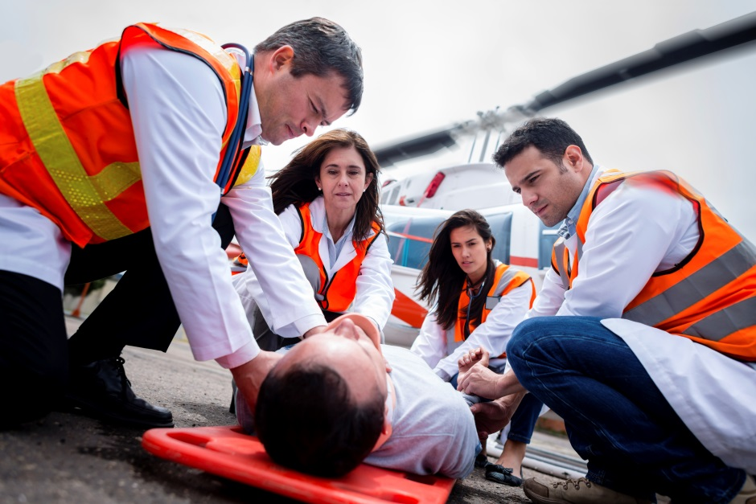

# Priority disorders—Cancers Australian Strategy graphic wheel

WHY ARE CANCERS A PRIORITY?

“Cancer” is a term for diseases in which abnormal cells multiply without control and includes mesothelioma, melanoma and lung cancer.

There is no available data on the real magnitude of occupational cancers in Australia. Very few cancers are reported to compensation authorities because of difficulties in proving causation, and the long lag time between occupational exposures and disease diagnosis. Therefore indirect methods are used to estimate the rates of occupational cancer which determine what proportion of known cancers might be due to occupational causes.

The [2006 report on occupational cancer](http://www.safeworkaustralia.gov.au/sites/swa/about/publications/pages/sr200604occupationalcancerinaustralia) in Australia estimated that occupation was responsible for about 11 per cent of incident cancers in males and 2 per cent in females. This equates to about 5000 cancers a year. It was also estimated approximately 1.5 million workers in Australia were potentially exposed to carcinogens at work.

The rate of workers’ compensation claims for all occupational cancers peaked at 66 claims per million employees in 2003–04 and declined to a low of 48 in 2008–09, remaining relatively stable thereafter. Between 2004–05 and 2010–11, the rate of claims for skin cancer remained relatively stable while mesothelioma declined slightly.

The latest data from the [occupational indicators report](http://www.safeworkaustralia.gov.au/sites/swa/about/publications/pages/occupational-disease-indicators-2014) found the occupations with the highest rates of workers’ compensation claims for cancers over the three-year period 2008–09 to 2010–11 include: freight and furniture handlers, railway labourers, electrical distribution tradespersons, carpentry and joinery tradespersons, gardeners, electricians and truck drivers.

WHAT IS BEING DONE?

Over the last few decades the WHS regulators have invested considerable efforts to increase workplace and community awareness of the need to prevent exposure to workplace carcinogens.

In 2014, Safe Work Australia collected evidence through its data and research activities and prepared three reports to inform future work on the exposure to priority carcinogens. These reports highlight work related exposures to lead, formaldehyde and polycyclic aromatic hydrocarbons in Australian workplaces. These reports will be available in 2015-16.

Safe Work Australia has been reviewing the guidance on minimising the risks of exposure to carcinogens in the workplace. This practical information is expected to be published in 2015-16 and will be of great interest to workplaces handling hazardous substances.

Safe Work Australia is also reviewing the health monitoring provisions in the model legislation to ensure these reflect up-to-date evidence and community expectations. This will allow workplaces to check their controls are effective and take prompt action if there appears to be a possible risk to workers’ health.

**REPORT**

Check out the full report on the Safe Work Australia website: [Occupational Disease Indicators 2014](http://www.safeworkaustralia.gov.au/sites/swa/about/publications/pages/occupational-disease-indicators-2014)

# Priority disorders—Cancers Australian Strategy graphic wheel

FOCUS ON MESOTHELIOMA

Mesothelioma is a cancer caused by exposure to asbestos; asbestosis is a chronic and incurable lung disease, also caused by asbestos exposure. Because Australia was previously a major producer and user of asbestos we have high rates of mesothelioma and asbestosis.

A person’s average life expectancy from the diagnosis of mesothelioma to death is nine months, and even with aggressive treatment, few people survive longer than two years.

The number of new mesothelioma cases has risen steadily in most years since 1982, when national data first became available, and peaked at 690 in 2011.

Safe Work Australia commenced funding the [Australian Mesothelioma Registry (AMR)](http://www.mesothelioma-australia.com/home/) managed by NSW Cancer Institute to provide better data on the incidence of mesothelioma. This Registry replaces the previous Australian Mesothelioma Register managed by the former National Occupational Health and Safety Commission (NOHSC).

The AMR measures and monitors the incidence of mesothelioma in Australia and the mortality associated with mesothelioma. The AMR also documents the likely asbestos exposure experience of people diagnosed with mesothelioma.

The preliminary number of mesothelioma cases for 2013 is 575. This preliminary figure is likely to increase because of delays in the reporting of new cases. Due to the long latency period between asbestos exposure and diagnosis of mesothelioma (typically 20 to 40 years), it is expected that the incidence of mesothelioma will not peak until sometime between 2014 and 2021.

All Australian WHS regulators are helping prevent exposure to asbestos by ensuring that everyone complies with the laws regulating it.

Activities in this area ranged from specific initiatives like the communication strategies on the WorkSafe ACT’s website about [asbestos awareness training](http://www.safeworkaustralia.gov.au/sites/swa/australian-strategy/case-studies/pages/asbestos-awareness-training), safe asbestos removal for home renovators and tradesmen, to SafeWork SA’s Open House target of 1000 workplace visits as part of its transitional educational programme on the implementation of harmonised WHS legislation.

**FACT**

In Australia, 575 people were diagnosed with mesothelioma in 2013.

By 31 May 2014, 218 of them were dead.

# Measuring progress against the targets Australian Strategy graphic wheel

The Australian Strategy sets three targets to measure the progress towards achieving the vision:

* a reduction of at least 20 per cent in the number of worker fatalities due to injury
* a reduction of at least 30 per cent in the incidence rate of claims resulting in one or more weeks off work, and
* a reduction of at least 30 per cent in the incidence rate of claims for musculoskeletal disorders resulting in one or more weeks off work.

In 2013 Safe Work Australia published the guide [Measuring progress towards targets – Reducing the incidence of work-related death, injury and illness.](http://www.safeworkaustralia.gov.au/sites/swa/about/publications/pages/measuring-progress-towards-targets) This explains how progress on the outcome to reduce the incidence of work-related death, injury and illness will be measured for the Australian Strategy from 2012–2022.

FATALITY TARGET

Worker fatalities will be reduced by at least 20 per cent.

The starting point for the fatality target is the average number of fatalities over the four year period 2007-2010, which equates to 268 fatalities. A 20 per cent reduction requires there to be no more than 214 fatalities by 2022.

A three year rolling average will be used to measure progress towards this target. This will restrict the impact of year to year volatility in fatality numbers on the outcome of this target. Measurement will be completed in 2023 when the 2022 data is finalised.

The Australian Strategy fatality target will be measured using the Traumatic Injury Fatality (TIF) data collection. This is different from the previous National OHS Strategy where the fatality target was restricted to compensated injury-fatalities.

The TIF collection provides a more complete and accurate catalogue of work-related injury-fatalities as it includes the deaths of workers who were not covered by workers’ compensation schemes (the self-employed) and those not eligible for compensation because they had no surviving dependents to make a claim.

Figure 2: Shows the three year rolling average number of fatalities 2003-05 to 2010-12 and reduction required to meet fatality target. 0 50 100 150 200 250 300 Three-year rolling average number of worker fatalities Three year rolling average target number

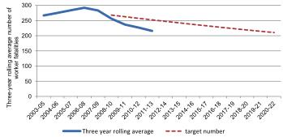

# Measuring progress against the targets Australian Strategy graphic wheel

**FOR** **INFORMATION**

Data to measure the progress for the new Australian Strategy won’t be available until 2015-16. Until then the metrics developed for the National OHS Strategy 2002–2012 will continue to be used.

**FOR** **INFORMATION**

As comparisons should be made using final rather than preliminary data, the first comparison data point for the year 2012-13 will not be available until 2015-16.

SERIOUS WORKERS’ COMPENSATION CLAIMS TARGETS

* Reduce the incidence rate of claims involving one or more weeks off work by at least 30 per cent, and
* Reduce the incidence rate of claims for musculoskeletal disorders resulting in one or more weeks off work by at least 30 per cent.

The starting (base period) and the end point incidence rates for these targets will be determined when the 2013-14 Workers’ Compensation National Data Set (NDS) data is finalised in 2015-16. Progress against these targets will be measured by comparing progressive annual incidence rates to the base period rate. The first reporting on this progress will be in the next progress report.

The preliminary data for 2012-13 indicate employees in Australia made:

* 117 817 serious workers’ compensation claims, which is equivalent to 11.1 serious claims per 1000 employees, and
* 70 608 serious workers’ compensation claims for musculoskeletal disorders, which is equivalent to 6.7 serious musculoskeletal disorder claims per 1000 employees.

Note: These figures are preliminary and expected to rise by about 3 per cent as claims are finalised.

The Australian Strategy defines serious claims as those non-fatal work-related injuries or illnesses that involve an employee requiring at least a week off work. The time off work does not need to be continuous. This is different to the definition of serious claims as applied under the previous National OHS Strategy and Comparative Performance Monitoring (CPM) reporting. Serious claims under the National OHS Strategy and CPM included fatalities, permanent incapacities and temporary incapacities that involved at least one week time lost from work.

The National OHS Strategy’s targets were to reduce the incidence of compensated work-related injury fatalities by at least 20 per cent and to reduce the incidence of serious compensated workplace injury (including musculoskeletal disorders) by at least 40 per cent, by 30 June 2012.

Achievements against the national targets for injuries and fatalities are measured using the NDS and are reported on annually in the CPM reports.

# Measuring progress against the targets Australian Strategy graphic wheel

The baseline for the national targets was calculated as the average incidence rate for the three-year period 2000–01 to 2002–03. Between the base period and 2011–12 there has been a 26 per cent reduction in the incidence rate of serious injury and musculoskeletal claims. The target of a 40 per cent reduction in serious compensated injury claims was not achieved.

In contrast, the incidence rate of compensated injury fatalities has fallen steadily over the past five years against a backdrop of rising employment. Since the base period there has been a 41 per cent decrease in the incidence rate of compensated injury fatalities. This is more than twice the decrease required to meet the target of a 20 per cent reduction by 30 June 2012.

Conclusion Australian Strategy graphic wheel


This report provided a snapshot of some of the diverse and innovative activities undertaken by Safe Work Australia and its Members to improve work health and safety and achieve the vision of healthy safe and productive working lives for all Australians.

The next progress reporting period from November 2014 to 31 October 2015 will focus on activity and progress in the manufacturing and construction industries. It will include more case studies and examples to showcase the work Safe Work Australia and its Members are doing under the themes of the Australian Strategy.

**COMING** **UP**

The second Australian Strategy Virtual Seminar Series will be held throughout October 2015. Its themes will be the Australian Strategy Action Areas: Healthy and safe by design and Supply chains and networks, and the national priority industries: manufacturing and construction. Items to show small business how improving work health and safety contributes to business success will again be a feature.

