GUIDE FOR MAJOR HAZARD FACILITIES: NOTIFICATION
AND DETERMINATION

MARCH 2014

Safe Work Australia is an Australian Government statutory agency established in 2009.
Safe Work Australia consists of representatives of the Commonwealth, state and territory
governments, the Australian Council of Trade Unions, the Australian Chamber of Commerce
and Industry and the Australian Industry Group.
Safe Work Australia works with the Commonwealth, state and territory governments
to improve work health and safety and workers’ compensation arrangements.
Safe Work Australia is a national policy body, not a regulator of work health and safety.
The Commonwealth, states and territories have responsibility for regulating and enforcing
work health and safety laws in their jurisdiction.
ISBN 978-0-642-33384-1 [PDF]
ISBN 978-0-642-33385-8 [RTF]


Creative Commons
Except for the logos of Safe Work Australia, SafeWork SA, WorkSafe Tasmania,
WorkSafe WA, Queensland Government, NT WorkSafe, WorkCover NSW, Comcare
and WorkSafe ACT, this copyright work is licensed under a Creative Commons
Attribution-Noncommercial 3.0 Australia licence. To view a copy of this licence, visit
http://creativecommons.org/licenses/by-nc/3.0/au/
In essence, you are free to copy, communicate and adapt the work for non commercial purposes,
as long as you attribute the work to Safe Work Australia and abide by the other licence terms.
Contact information
Safe Work Australia
Phone: 1300 551 832
Email: info@swa.gov.au
Website: www.swa.gov.au



TABLE OF CONTENTS

1. Introduction 4
2. notification PROCESS 6
2.1 When do I need to notify? 7
2.2 What information do I need to provide in the notification? 8
2.3 What happens after notification? 10
3. Calculation of the quantity of Schedule 15 chemicals 11
3.1 Identification of the operator and the facility 11
3.2 The threshold calculations 11
3.3 Identifying Schedule 15 chemicals and MHF threshold quantities 11
3.4 Maximum quantities present or likely to be present 14
3.5 When may quantities be excluded? 19
3.6 Excluding isolated quantities – the ‘less than 2 per cent’ rule 20
3.7 Example Calculations 24
4. Determination 25
Appendix A – WHS Regulations 26
Appendix B – Definitions 32
List of Amendments 34

Introduction
This Guide provides information to assist operators of facilities that are, or are likely to become, major hazard facilities (MHFs) to meet their obligations under the Work Health and Safety Act (the WHS Act) and the Work Health and Safety Regulations (the WHS Regulations) with respect to the processes for notification and determination of a MHF. It also explains how the MHF hazardous chemicals threshold quantities are used and provides practical examples.
The WHS Regulations require operators of facilities or proposed facilities to notify the regulator of Schedule 15 chemicals that are present or likely to be present at the facility. The regulator will then make a determination as to whether the facility is a MHF.
This Guide will assist operators to:
- provide prompt notification for an existing facility and timely notification for a new or proposed facility
- accurately calculate the quantity of Schedule 15 chemicals present or likely to be present at the facility
- supply all the required information in the notification to allow for correct identification of the MHF and to facilitate any determination inquiry, if necessary.
This Guide forms part of a set of guidance material for MHFs that includes information on:
- Safety Assessment
- Safety Management Systems
- Developing a Safety Case Outline
- Preparation of a Safety Case
- Safety Case: Demonstrating the Adequacy of Safety Management and Control Measures
- Information, Training and Instruction for Workers and Others at the Facility
- Providing Information to the Community
- Emergency Plans.

What do the WHS Regulations require?
Operators of certain facilities and proposed facilities must notify the regulator within prescribed timeframes and specify the required content of such notifications.
The WHS Regulations also:
- specify the circumstances in which the regulator may conduct an inquiry following notification (regulation 539)
- set out the procedure for such inquiry (regulation 540)
- specify when the regulator may make a determination following an inquiry (regulation 541)
- provide for the determination of facilities where the quantity of Schedule 15 chemicals exceeds their threshold quantity (regulation 542)
- provide for the regulator to determine that the operator of the facility is not a suitable person
to operate the facility (regulation 543)
- enable the regulator to impose conditions on a determination (regulation 544)
- require the regulator to give written notice of the determination and set out the effect of
a determination (regulation 545)
- set out the circumstances in which the regulator may:
- revoke a determination (regulation 546)
- require re-notification if the quantity of Schedule 15 chemicals increases (regulation 547)
- require re-notification if a new operator proposes to operate the facility (regulation 548)
- set out the timeframe in which a MHF licence must be applied for (regulation 549).
Further details of the WHS Regulations are set out in Appendix A.
Relevant definitions are set out in Appendix B.

notification PROCESS
Notification is when an organisation or person informs the regulator that they have Schedule 15 chemicals present or likely to be present at their facility in excess of 10 per cent of the threshold quantities. The facility may be an existing site, a modification to an existing site or a facility under construction. The threshold quantities are set out in Schedule 15 of the Regulations.
The intent of notification is to ensure that all potential major hazard facilities are made known to
the regulator. The process is illustrated in Figure 1 below.

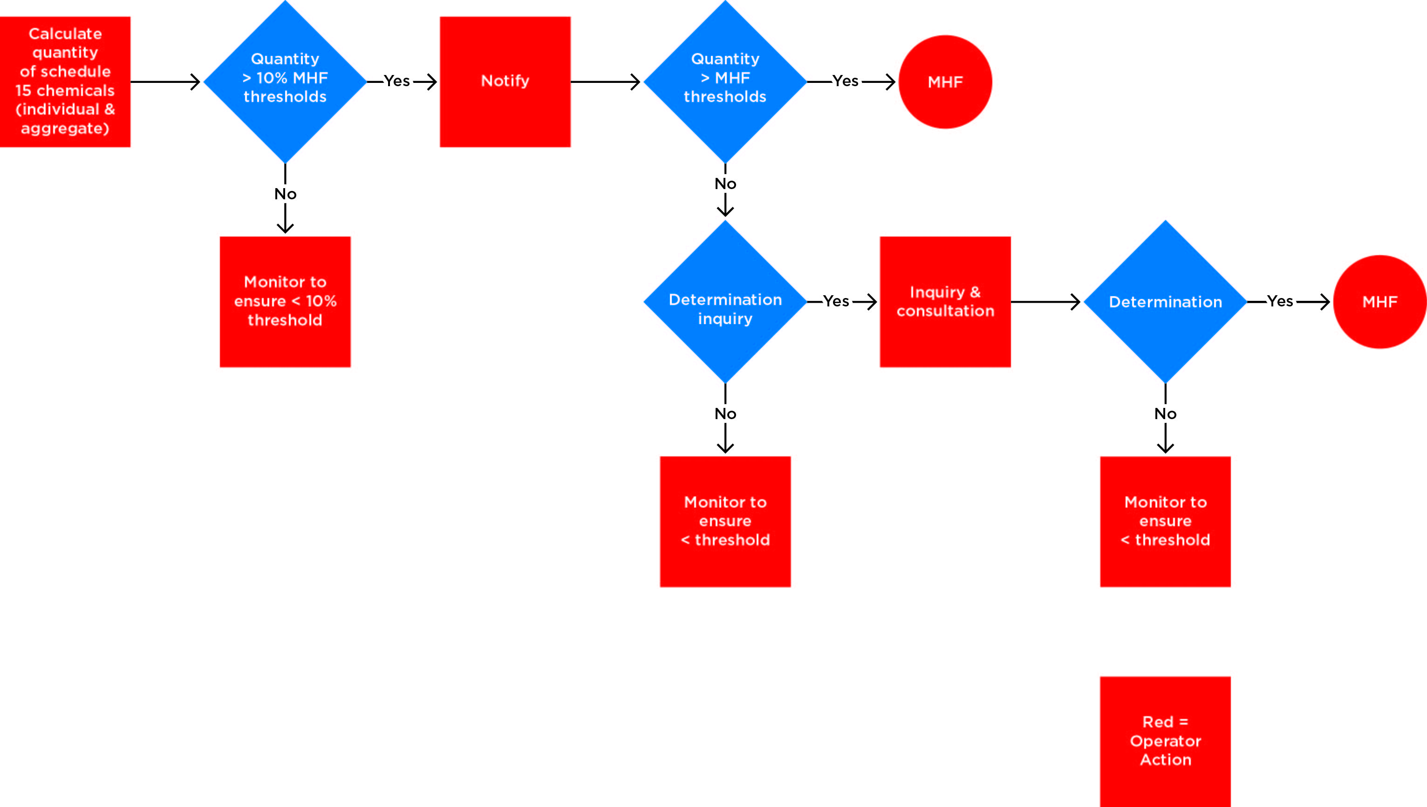

Figure 1 Flow diagram for notification and determination
Any workplace with Schedule 15 chemicals present or likely to be present above the MHF threshold values must be identified as a MHF unless subject to an exemption or otherwise excluded from application of the legislation. An operator who believes that a facility does not warrant designation as a MHF may apply for an exemption under regulation 688. Facilities with Schedule 15 chemicals present or likely to be present above 10 per cent but less than 100 per
cent of the MHF threshold quantities must notify and may be classified as a MHF if the regulator decides to hold a Determination Inquiry and, on inquiry, determines the facility to be a MHF.
The Determination Inquiry must be conducted in accordance with regulation 540.
The determination decision is based on the potential for a major incident to occur at the facility having regard to any relevant matter, including:
- the quantity and combination of Schedule 15 chemicals present or likely to be present
at the facility
- the type of activity at the facility that involves the Schedule 15 chemicals
- land use and other activities in the surrounding area.
The regulator may also hold an inquiry if a notification discloses, or if for some other reason
the regulator reasonably suspects, that the operator of the facility may not be a suitable person
to operate the facility.

When do I need to notify?

Existing facilities
Operators of existing licensed major hazard facilities do not need to notify.
Operators of previously notified facilities with Schedule 15 chemicals above 10 per cent but less than 100 per cent of the MHF threshold must notify as soon as practicable (but no more than three months) after becoming aware of the circumstances giving rise to the obligation to re-notify.
Re-notification is required if the quantity of Schedule 15 chemicals present, or likely to be present, at the facility increases or is likely to increase to a level that exceeds the level previously notified
to the regulator.
The regulator may agree to accept a delayed notification if the operator is able to satisfy the regulator that they have a reasonable explanation. However, this should not be taken for granted and should be discussed with the regulator prior to the expiry of the 3-month timeframe.
Operators of facilities storing or handling Schedule 15 chemicals should monitor the quantities
of Schedule 15 chemicals in relation to the MHF threshold quantities to ensure that they notify
the regulator in the time required by the Regulations.

Proposed facilities
The operator of a proposed facility at which Schedule 15 chemicals are likely to be present in
a quantity that exceeds 10 per cent of their threshold quantity may notify the regulator of this circumstance. A notification of a proposed facility must include the information required by regulation 538, with any necessary changes.
A facility that anticipates having chemicals in excess of the threshold quantity should notify in sufficient time to comply with the Regulations. For example, if the facility is at the early design stage, plans for the facility may not be available and the number of workers and the types/amounts of Schedule 15 chemicals may not be accurately known. The initial notification information may simply comprise design options under consideration, indications of the number of workers and estimates of the quantities of Schedule 15 chemicals likely to be present. Dates that should be included are the:
- earliest date for introduction of Schedule 15 chemicals
- earliest date for beneficial production
- earliest date that the facility may exceed the MHF threshold quantities.
Early notification facilitates the safety case and licensing processes.
Note that all MHF threshold quantities are in tonnes (t) and classifications are as per the ADG Code, not the GHS.

Example 1 – Example of notification for proposed facilities
A warehouse intends to increase the maximum quantity of very toxic materials. The threshold quantity for very toxic material is 20 t. If the facility intends to increase its maximum stock holdings above 2 t but below 20 t it will need to notify as soon as possible. If the facility intends to increase its maximum stock to above threshold quantities it will be a MHF and should be licensed before accepting the additional stock.
A proposed LPG terminal of 300 t capacity is a MHF. The LPG threshold is 200 t. The owner should notify with sufficient time to work through the determination and licensing process with
the regulator. It is in everybody’s interests that the facility be licensed before charging the
vessels with LPG.
A proposed chemical manufacturing facility should notify during the design phase of its development and keep the regulator informed of changes, as appropriate. These changes may include decisions on, for example, layout, inventory, number of personnel, organisational structure, etc. The date for determination should be agreed with the regulator.

What information do I need to provide in the notification?
Regulation 538 lists the information needed in a notification to the regulator. The amount of information required at notification will vary according to the facility. In general, more information
is required for a petroleum or chemical processing facility handling a wide range of chemicals
and less for a simple warehouse or other facility handling fewer chemicals.
While the Regulations do not specify the exact contents of a notification, the following table contains suggestions that would meet the intent of the Regulations. Operators should provide
this or similar information in the notification, as appropriate for their facility.

Information required  for Notification | Guidance
Part A: Contact Details and Declaration
Operator Details | Provide the Trading Name and ABN as per the ABN lookup at http://www.abr.business.gov.au.
Facility Details | Provide enough detail to locate the facility using a street-map  or Google maps.  The land title description is state-specific, but may include GPS coordinates, lot numbers or other real property description.  The ANZSIC code most applicable to your business may be found at www.abs.gov.au and search for “ANZSIC”.
Contact Details | Provide the phone number, etc. of a contact person with whom the regulator may communicate with regard to the information contained in the notification and any further queries.
Declaration | The declaration must contain the information required by regulation 538(2) and should be signed by the operator of the facility and, if the operator is a body corporate, each officer of the operator.
Part B: Business Description
Provide a brief description of the primary business activity at the site. Only the main activity should be listed (e.g. manufacture of pesticides; storage and distribution of LPG).
Provide a brief description of particular activities and processes that involve Schedule 15
chemicals (e.g. repackaging chlorine into 20 kg packs; loading and unloading 20 t trucks
and import from ship).
Indicate site staffing levels (including contractors) and indicate the maximum number of persons likely to be present at the facility on a normal working day. If the site operates on a shift roster,
then the shift arrangements should be provided. If there is significant seasonal variation,
or regular shutdown activity that significantly alters the workforce, this should also be explained.
Include information as an attachment if required.
Part C: Site and Surroundings
State the distance to the nearest sensitive land uses (e.g. residential, schools, hospitals, child
and aged care centres, etc.).
Attach a scaled map of the facility that includes the area outside the facility that is within 500 m
of the facility’s perimeter.
The location of storage tanks and vessels containing Schedule 15 chemicals should be clearly identified on the map and information supplied as to the maximum capacity, contents and storage conditions. Temporary storages should be included.
The location of the main processing units involving Schedule 15 chemicals should be clearly identified on the map and information supplied as to the maximum capacity, contents and process conditions.
The location of all loading and unloading facilities, administration areas and areas of high occupancy (control rooms, workshops, etc.) should be clearly identified and information supplied on the nature of the occupancy.
Attach information on the surrounding land use and planning zones available from the local area authority. If applicable, highlight major service utilities and transport corridors. If known, include
the location of other sites where hazardous substances may be present (in particular, if there are other MHFs).
Part D: Schedule 15 chemicals
Refer to the regulator for assistance. Any assumptions used in the calculation of quantities of Schedule 15 chemicals should be clearly stated.
Any special circumstances that may vary the quantity of Schedule 15 chemicals present should be explained. For example, pesticide manufacture is closely linked to the growing season, so more toxic chemicals will be stored and handled at these peak times. In another case, Schedule 15 chemicals may only produce notifiable levels under foreseeable abnormal conditions such as loss of cooling.
Part F: Other Hazardous Chemicals
Certain hazardous chemicals and other materials are not included in Schedule 15 but may contribute to a major incident. An example may be a combustible liquid that by itself would not lead to a major incident, but if involved in a fire caused by a more highly flammable substance may increase the consequences of that incident.

What happens after notification?
There are three situations following notification:

1. An operator intends to operate a facility where Schedule 15 chemicals will equal or exceed 100 per cent of the MHF threshold.
This would apply to:
- an existing facility that proposes to hold threshold quantities or above
- a facility currently in design/under construction that is expected to hold threshold quantities
or above.
In this scenario, the operator could seek an indication from the regulator as to when the facility will be determined.

2. Schedule 15 chemicals are present or likely to be present at an existing facility in quantities exceeding 10 per cent but less than 100 per cent of the threshold.
The notification is used by the regulator to identify facilities that could be determined at an inquiry to be a MHF. Determination inquiries are relatively rare, and most below-MHF threshold facilities are administered under Chapter 7 of the WHS Regulations.
The facility must re-notify if the quantity of Schedule 15 chemicals increases to a level that exceeds the level previously notified to the regulator.

3. A notification is not required because the quantities of Schedule 15 chemicals are less than or equal to 10 per cent of the MHF threshold.
The facility must continue to monitor the quantities of Schedule 15 chemicals and notify when the 10 per cent threshold is crossed or likely to be crossed.

Calculation of the quantity of Schedule 15 chemicals

Identification of the operator and the facility
It is necessary to identify the operator and the facility to determine where to start in identifying what must be included in the calculations e.g. the contents of one warehouse or two, all of the tanks in the tank-farm, or only those that are controlled by the business or undertaking.
In most cases the identities of the facility and the operator are apparent. The facility is the warehouse, the storage facility or the set of processing units and supporting infrastructure located on a particular parcel of land. The operator is the person conducting a business or undertaking that has management or control over the facility and has the power to direct that the whole facility be shut down.
In some cases, particular features such as joint ownership, satellite locations, sites separated by roads, site interdependency and legal site boundaries may complicate the identification of the operator and/or the facility. This complicates the calculation of the aggregate quantity of Schedule 15 chemicals and who holds the obligation. This can be discussed with the regulator.
A site must not be subdivided to avoid being determined as a MHF.
If more than one person has management or control of the facility and the power to direct the whole facility to be shut down, then an operator must be nominated in writing to the regulator.
This nomination must be included in the notification documentation.

The threshold calculations
The threshold calculations are described under clause 3 and clause 4 of Schedule 15.
If there is a single hazardous chemical q_{x}, with threshold quantity Q_{x} then the facility must notify
if the quantity of the Schedule 15 chemicals exceed 10 per cent of the threshold i.e. the ratio
q_{x}/Q_{x} > 0.1.
If there is more than one hazardous chemical present or likely to be present at the facility, the following aggregation formula must be used:
Aggregate ratio = (q_{x}/Q_{x}) + (q_{y}/Q_{y}) +….+ (q_{n}/Q_{n})
Where:
- q_{x}, q_{y},..q_{n} is the total quantity of each schedule 15 chemical present or likely to be present
- Q_{x},Q_{y}….Q_{n} is the relevant MHF threshold quantity for Schedule 15 chemical x,y…n
- x, y,…n are the different Schedule 15 chemicals present.
If the aggregate ratio is >0.1 the facility must notify. If the result is >1.0, the facility will be determined to be a MHF.
These steps are explained in the following sections.

Identifying Schedule 15 chemicals and MHF threshold quantities
The facility’s hazardous chemicals manifest compiled according to Schedule 12 is a starting point for identifying Schedule 15 chemicals on the site.
Schedule 15 divides chemicals into two groups—specific chemicals (Table 15.1) and general categories (Table 15.2)—and shows the major hazard threshold for each entry. Table 15.3 is used to refine the toxic class 6.1 into toxic and very toxic. Where a chemical listed in Table 15.1 also falls into one of the general categories in Table 15.2, the data in Table 15.1 takes precedence.

Example 1 – Table 15.1 precedence
Acetylene, UN number 1001 is a Table 15.1 substance with a threshold quantity of 50 t.
It is also a Division 2.1 dangerous good, which has a threshold of 200 t under Table 15.2.
The 50 t threshold value should be used.
Some chemicals may have properties corresponding to two or more of the categories in Table 15.2, in which case the lowest relevant threshold applies.
Example 2 – Two or more categories: lowest threshold applies
Butyronitrile, UN number 2411 is a Class 3, sub-risk 6.1 dangerous good, packing group II.
The listed LD50 (Oral, rat) is 50 mg/kg (toxic according to Table 3).
As a Class 3 flammable liquid PG II, there is a threshold of 50,000 t, but as a Division 6.1 toxic, there is a 200 t threshold. The 200 t threshold applies.
Some chemicals require knowledge of the flashpoint and the processing or storage conditions in order to determine the relevant threshold. The flashpoint is found in the safety data sheet. The storage conditions are site-specific.
Example 3 – Example of additional information required: flashpoint
Isopropylamine, UN number 1221, is a Class 3 dangerous good with sub-risk 8. It is a liquid at ambient conditions, but has a flashpoint of -38.9°C and a boiling point of 32.4°C. The applicable MHF threshold is 200 t.
Some chemicals require knowledge of the Hazchem codes in order to determine the relevant threshold. The Hazchem code is found in the safety data sheet.
Example 4 – Example of information required: Hazchem code
Phosphorous oxychloride, UN number 1810, is a Class 8 PG II substance with Hazchem code 4WE.
Class 8 dangerous goods are not considered in Schedule 15 unless they are also 4WE.
This chemical has a MHF threshold of 500 t.
Some chemicals require knowledge of the specific toxicity in order to determine the relevant threshold.
Example 5 – Differing types of toxicity
Sodium cyanide is not a named substance in Table 15.1. It is a dangerous good of Division 6.1 packing group 1, UN number 1689. It is not listed in Safe Work Australia’s Hazardous Substances Information System (see http://hsis.ascc.gov.au). The following toxicity data applies to sodium cyanide:
 | Table 3 Toxicity Criteria |  | Data for Sodium Cyanide | Source
 | Very Toxic | Toxic | Data for Sodium Cyanide | Source
Oral Toxicity LD50 (mg/kg) [in rats] | ≤5 | 5< LD50≤50 | 6.44 | Sax, Dangerous Properties of Industrial Materials
Dermal Toxicity LD50 (mg/kg) [rabbits] | ≤40 | 40<LD50≤200 | 10.4 | Sax, Dangerous Properties of Industrial Materials
Inhalation Toxicity LC50 (mg/L) | ≤ 0.5 | 0.5<LC50≤2 | Data not available
Conclusion
Sodium cyanide is very toxic based on the Dermal LD50, and toxic based on oral toxicity.
The 20 t threshold applies.
Care needs to be taken when interpreting the toxicity values quoted in the safety data sheet (SDS). Common mistakes include:
- using the packing group as the determinant of toxicity
- not using (or converting the data to) the same units and exposures as in Table 3
- not properly accounting for the properties of mixtures.
Example 6 – Errors induced by the use of the wrong units
The inhalation toxicity criterion in Table 15.3 is based on 4-hour exposures.
Other commonly used conversion factors are:
1 mg = 1000 µg
1 L = 0.001 m³
1000L = 1 t (for water) All MHF threshold calculations are in tonnes (t) (not Litres).

Example 7 – Errors induced by the use of the wrong units: Endosulfan
The SDS quotes the inhalation toxicity as Inhalation (rat) LC50 = 80 mg/m3/4hr.
The LC50 figure needs to be divided by 1,000 to convert m3 to L. Thus the inhalation LC50 value is 0.08 mg/L/4hr. The LC50 is less than 0.5mg/L and the material is classified as very toxic.

Example 8 – The dangers of using Packing Group for Toxicity
Packing group is used to indicate danger levels in transport. Some operators have tried to apply the packing group as an indication of hazard in storage. This should not be done, as some very toxic chemicals have a lower packing group, as illustrated below:

Name | Product Examples | ADG Packing Group
Aldicarb | Temik | I
Chlorothalonil | Bravo 500, Bravo 720 | I
Fenamiphos | Nemacur P | I
Lambda-cyhalothrin | Karate EC, Karate ULV, Karate Zeon | III
Methamidophos | Monitor | II
Paraquat Dichloride | Gramoxone, Spray.Seed, Tryquat, Shirquat | II
Parathion Methyl | Methyl Parathion 500, Folidol | III
Phorate | Thimet | I
Terbufos | Counter | I
Table 1: Very toxic Schedule 15 chemicals and ADG packing groups
The anomaly is due to rules in the ADG Code relating to Class 8 products with very toxic inhalation properties, but significantly lesser dermal and oral hazard.

Mixtures and solutions
Where Schedule 15 chemicals are present in solutions, formulations, mixtures or preparations, the relevant quantities of the chemical must be calculated from its concentration in the solution, formulation or mixture.
Example 9 – Table 15.1 - Solutions and formulations: component analysis
Allyl alcohol is a Schedule 15 chemical listed in Table 15.1. The MHF threshold is 20 t. A facility has 10 t of 20 per cent allyl alcohol - water solution. The quantity of allyl alcohol present or likely
to be present is 0.2 x 10 = 2 t. The aggregation formula result is 2/20 = 0.1.
Where the Schedule 15 chemical contained in Table 15.1 is itself a solution, then solutions of concentrations less than that specified need to be classified based on the characteristics of the solution.
Example 10 – Table 15.1 Solutions and formulations
Aqueous ammonia solutions with relative density < 0.880 at 15°C in water, with more than 50 per cent ammonia, have UN Number 3318 and are classified as Division 2.3 sub risk 8.
They are included, however, under the ammonia section in Table 15.1 with threshold quantity
of 200 t. The 200 t threshold applies.
Aqueous ammonia solutions with more than 35 per cent but less than 50 per cent ammonia have UN No 2073 and are a Division 2.2 dangerous good. They are not listed in Table 15.1 or Table 15.2 and are therefore not a Schedule 15 chemical. (It is a Division 2.2 dangerous good because
it has a vapour pressure above 300kPa at 50°C.) It should not be included in the calculations.
A 5 per cent ammonia solution is not classed as a dangerous good and is not a Schedule 15 chemical. It should not be included in the calculations.
Where mixtures, solutions or formulations containing Schedule 15 chemicals listed in Table 15.2 and/or Table 15.3 have not been characterised, the facility may either choose to characterise the mixture using the test methodologies in the ADG Code, or proportion the particular characteristic using component analysis.
Example 11 – Table 15.2 - Mixtures, solutions and formulations
A facility has a gas stream of 10 per cent carbon monoxide and 90 per cent nitrogen by mass. Carbon monoxide has UN number 1016 and is classified as class 2.3, sub-risk 2.1. The relevant MHF threshold in Table 15.2 is 200 t.
The facility needs to include the carbon monoxide component of the stream in its AQR calculation. If the total mass of gas in pipework and vessels is 100 t, then the quantity of carbon monoxide is 0.1x100t = 10t.

Maximum quantities present or likely to be present
The MHF regulations require the comparison of the maximum quantities of Schedule 15 chemicals present or likely to be present at the facility with the major hazard threshold quantity to determine
if a facility is a MHF. It must include all quantities at the facility, including materials in storage, materials in process vessels and interconnecting pipe work, materials in pipelines and materials
in internal site transport.

Maximum process vessel capacity
The quantity calculations should be based on the maximum capacity of the vessel unless there
is some failsafe mechanism that will prevent the volume in the vessel rising above a lower-than-maximum level. The densities of liquids and gases may vary according to temperature and pressure, and calculations should be based on the worst case combination of each equipment item within the plant’s safe operating envelope of parameters.
Where vapour spaces above the liquid in process equipment (e.g. in vacuum distillation columns, flash drums, condensers and refrigeration systems) and other such spaces cannot become filled with liquid, these spaces should be assessed on the quantity of vapour.

Maximum storage tank capacity
The maximum capacity for liquid storage in tanks is taken to be the tank volume, irrespective of the maximum fill level.
The maximum capacity of gas stored in cylinders or vessels is taken to be the water capacity of the cylinders or vessels. This is stamped on the collar or nameplate. The tonnage then needs to be calculated using the applicable density.
Careful consideration should be given to the potential contents of a tank.
Example 12 – Potential contents of a tank: mixed use
A tank terminal has four 15,000 t tanks that are able to contain class 3 PG II flammable liquids (50,000 t threshold) e.g. petrol. The terminal chooses to use three for petrol and one for diesel (which is not a Schedule 15 material). However, unless there is a permanent barrier in place to guarantee that petrol could not be put into the fourth tank, it must be assumed that at some time it might be used for petrol. The maximum storage capacity is therefore for all tanks full i.e. 60,000 t. This exceeds the major hazard threshold, making this facility a MHF even if only three tanks (45,000 t) normally have petrol in them at any time. This situation arises because the quantity used in the calculation needs to be consistent with any chemicals present or likely to be present at the site, so the fourth tank could also be filled with petrol at some point even though this may not be usual practice.
The terminal could consider modifying the arrangement to ensure that the fourth tank could not be used for petrol and therefore remove it from the calculation. This would require a combination of physical and administrative controls. It must not be possible to accidentally fill the tank via any connection to the other tanks.

Maximum storage area capacity
Basing the calculation on the maximum storage area capacity may be unrealistic where the facility has a large warehouse or open storage yard of which only small parts are used for the storage of Schedule 15 chemicals. In this case, the operators may choose to justify a maximum quantity present or likely to be present that is less than the theoretical capacity. The relevant MHF thresholds should be determined and the aggregate quantity calculated. If the aggregate quantity ratio is greater than 0.1, the facility must notify the regulator.
Example 13 – Example of a storage area partially used for Schedule 15 chemicals
A large agricultural warehouse stores pesticides, veterinary products, fertilisers and general merchandise. The warehouse operator must identify all Schedule 15 chemicals stored or likely to be stored at the warehouse, establish the maximum amount of each that may be stored at any one time, and compare them against the MHF thresholds both individually and in aggregate. If the ratio is >0.1, then the warehouse needs to notify the regulator.

Schedule 15 Chemical | Maximum Quantity Present | Threshold Quantity | Ratio
Paraquat dichloride  (very toxic) | 4 t | 20 t | 0.2
Lambda-cyhalothrin  (very toxic) | 4 t | 20 t | 0.2
Toxic pesticides | 100 t | 200 t | 0.5
Ammonium nitrate fertilisers | 500 t | 5,000 t | 0.1
 |  | Ratio | 1.0

If the aggregate quantity of Schedule 15 chemicals stocked is greater than 1.0 and the business
or undertaking is seasonal, the aggregate quantity should be calculated for each of the seasons.
If each seasonal aggregate is always less than 1.0, the business should explain how it manages
to ensure that stock quantities from one season are prevented from merging into the next season and thereby increasing the aggregate value. The regulator may consider this information in deciding whether the facility is a MHF.
Example 14 – Example of a seasonal facility
The facility in Example 13 calculates the aggregate quantity for each of the seasons.
Lambda cyhalothrin is used for insect control, whereas paraquat dichloride is used for weed control. The two chemicals are used at different times of the year. The “normal” ratio at any time
of the year would be in the order of 0.7.
The operator will need to include the seasonal information in the notification to the regulator.
The seasonality of storage is a relevant factor in determining if the warehouse is a MHF or not.

Example 15 – Example of restricted storage
A facility consists of two storage areas (A and B), which from time to time hold five Schedule 15 substances plus a range (up to 50 t) of other hazardous chemicals as follows:

Material | Storage areas (tonne) |  | Schedule 15 threshold (tonne) | Inventory/ threshold
Material | A | B | Schedule 15 threshold (tonne) | Inventory/ threshold
Acrolein | Up to 2 | Up to 2 | 200 | 0.02
Sodium chlorate | Up to 8 | Up to 8 | 200 | 0.08
Formaldehyde | Up to 2 | Up to 10 | 50 | 0.24
Methyl isocyanate | Up to 0.1 | None | 0.15 | 0.67
Other (not Schedule 15) | Up to 20 | Up to 30 | N/A | 0.0
Total | - | - | - | 1.01
Table 2: An example of calculating aggregates
This facility would automatically be a MHF because it has an aggregate greater than 1.0, unless some of the quantities are not present at the same time (e.g. sodium chlorate is only in one storage area at a time). Excluding one quantity reduces the aggregate to below 1.0, but the operator would need to demonstrate robust procedures to control risk.

Maximum capacity of pipelines and piping
The operator should consider the maximum quantity of chemicals that would, in the event of a failure, escape from a pipeline that is connected to the facility but is outside the facility boundary. This requires consideration of the maximum line pack for gases and the location of the nearest ESD devices to the boundary.
The operator should also consider quantities of material contained in piping within the facility when determining the maximum quantity present or likely to be present.

Maximum quantity of chemicals loaded or unloaded
The maximum quantity of chemicals loaded into or onto, or unloaded from, vehicles, trailers, rolling stock and ships that are from time to time present at the facility in the course of the facility’s operations needs to be included in the calculations unless the chemicals are in ‘intermediate temporary storage, while in transit by road or rail’. Note that chemicals subject to decanting, filling, picking and otherwise breaking of any load are not considered “in transit”.
If it is normal practice at a facility to have two or three tankers sitting overnight most days of the week, this should be considered normal storage rather than being intermediate temporary storage and should be included in the calculation.

Maximum quantity when loading or unloading ships
The maximum quantity for a wharf where ships are unloaded and loaded with chemicals is the maximum amount of chemicals that are present on the land-based facility at any one time, not the total amount unloaded/loaded over the entire shipping process.

Example 17 – Ship unloading
In the figure below, a ship is unloading 6,000 t of LPG into 20 t road tankers. The maximum quantity is the maximum amount loaded onto tankers that may be present within the facility at any time. Therefore, while tankers A and B are full and tanker C is empty (awaiting loading), the maximum quantity is 60 t. Tanker C would only be excluded if ‘gas free’. As the threshold for LPG is 200 t, this would mean the facility would have to notify.
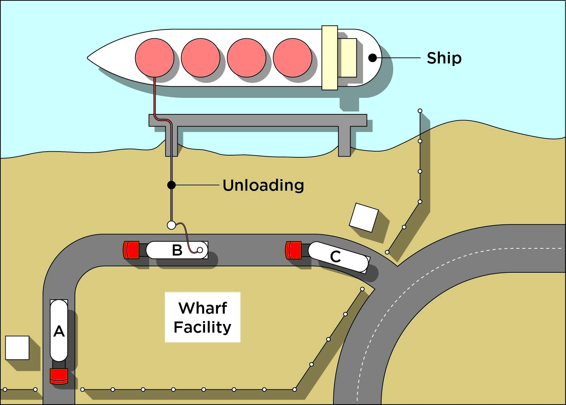

Figure 2 Ship unloading

Facilities holding a range of chemicals
Many facilities hold a range of Schedule 15 chemicals. The range of chemicals present may vary, with some chemicals in constant quantities, some present continuously (but in different quantities depending on the operation) and others present intermittently. In such cases, the calculation should be based on the highest aggregate quantity present or likely to be present at one time.
Example 18 – A range of chemicals
For example, long-term operating records show that a facility normally stores 500 t of X and 200 t of Y, but for short periods may store 500 t of X, 50 t of Y and 200 t of Z. The aggregate must be calculated for the two phases separately, and the higher value will apply. If a facility is above the 10 per cent level, then all of the Schedule 15 chemicals must be reported in the notification.

When may quantities be excluded?
Schedule 15 chemicals may be excluded from the assessment if they are held solely for ‘intermediate temporary storage, while in transit by road or rail’. This allows for situations where there is a roadside transport parking area (or similar) or road/rail terminal where goods may be held for short periods before loading or after unloading. Chemicals are also excluded if they are transiting a facility by road/rail while other goods are being loaded onto or unloaded from a vehicle.
This exclusion does not apply to facilities where the aggregate quantity of in-transit chemicals remains significant for extended periods e.g. a major warehouse acts as an intermediate store of 100 t of in-transit sodium cyanide (20 t threshold) every month. This facility must notify and will be classified as a MHF.
Another case that should be included is a facility where there are a number of tankers usually parked overnight. While any individual tanker may be in-transit, overall the inventory on-site usually has the equivalent of these tankers as well.
However, if, for example, the major warehouse described in Example 13 finds that it exceeds the MHF threshold quantities for a short period of time and the reason for exceeding the threshold is primarily the result of seasonal demand for the chemicals, the facility may apply for an exemption
if the chemicals are in intermediate temporary storage, the maximum package/container size is no more than 500 kg, and granting the exemption will result in a level of health and safety (in relation to the operation of the facility) that is at least equivalent to that which would be achieved by compliance with the relevant provisions of the WHS Regulations.
Schedule 15 chemicals present or likely to be present in the tailings dam of a mine are not to be considered in determining whether a mine is a MHF. The reason for this is that the chemical concentration is so low that, even if the total quantity of chemicals in a very large dam may be appreciable, at such a low concentration, tailings dam water would not contribute to a major incident.
The table below has examples of what particular inclusions/exclusions apply to the definition
of ‘present or likely to be present’.

Table 2 Inclusions and exclusions applying to ‘present or likely to be present
Inclusions | Exclusions
Chemicals that have been unloaded or waiting to be unloaded from ships, road or rail at a facility and where these or other Schedule 15 materials are present for extended periods. | Chemicals that have been unloaded or waiting to be unloaded from ships, road or rail at a facility and where Schedule 15 materials are only present occasionally and are for ‘intermediate temporary storage while in transit by road and rail’.  Materials on ships berthed alongside the facility.
Chemicals loaded on or will be unloaded from road/rail vehicles inside a facility and are not in ‘intermediate temporary storage while in transit by road or rail’. | -
Chemicals contained in a facility’s pipelines.  These chemicals could escape from pipelines connected to, terminating at or crossing a facility. This includes the contents at least up to the first off-site emergency isolation valve on each section, plus any contents that could flow out before isolation. Factors to take into consideration include detection time, flow rate and time to isolation. | Chemicals in pipelines that are connected to, terminate at or cross a facility and cannot escape onto the facility when relevant flow rate, detection and isolation factors are taken into account.

Excluding isolated quantities – the ‘less than 2 per cent’ rule
‘Isolated quantities of less than 2 per cent of the individual threshold’ of a Schedule 15 chemical may be excluded from the aggregate quantity threshold. This allows chemicals to be excluded if held in quantities sufficiently small and separated from other more significant quantities so that it
is very unlikely, on its own, to act as an initiator of a major incident i.e. any incident involving the isolated quantity cannot affect other quantities and escalate into a significant major incident.
To be excluded, the quantity must be less than 2 per cent of the individual threshold quantity.
In effect this means that it must also be isolated such that:
- the maximum effect radius of an incident involving the material cannot impact other material and cause a major incident (e.g. knock-on effect)
- its location means that a loss of containment of the chemical is unlikely to expose a person
to serious risk to health or safety
- it can be isolated sufficiently during process shutdown so that the release is limited to that isolated quantity at that location. This requires that the shutdown be automatic, rapid and isolate the equipment from other chemicals in the system.
Depending on the nature of the chemical, storage may be sufficiently isolated if in a separate compound, behind a fire-rated barrier or in a transport container. During notification, operators should justify why isolated quantities have been excluded from aggregation. Compliance with
a relevant Australian Standard is generally acceptable, but needs to be reviewed in the context
of potentially initiating a major incident.
Exclusions apply only to the evaluation of the aggregate quantity. If a facility is a MHF despite these exclusions, then the requirements of the MHF Regulations apply to ALL Schedule 15 chemicals that can cause or contribute to a major incident, including those excluded from the threshold calculations.

Example 19 – First example of isolated small quantities
A facility has two large tanks containing a total of 195 t of LPG and two small tanks each containing 4 t of LPG (see Figure 3).
Both small tanks can be excluded under the 2 per cent rule because each tank is:
- 2 per cent of the LPG threshold quantity (200 t)
- segregated from each other such that a loss of containment at one vessel will not affect any other
- located where it is very unlikely to expose a person to risk to health and safety.
The result is that, even though the total quantity of LPG is 203 t, the relevant quantity is only 195 t. Therefore, the facility is not automatically a MHF. The operator must still notify the regulator because the quantity is greater than 10 per cent of the threshold and the regulator may determine the facility to be a MHF. In the notification, the operator should justify exclusion of the two small tanks from the aggregation.
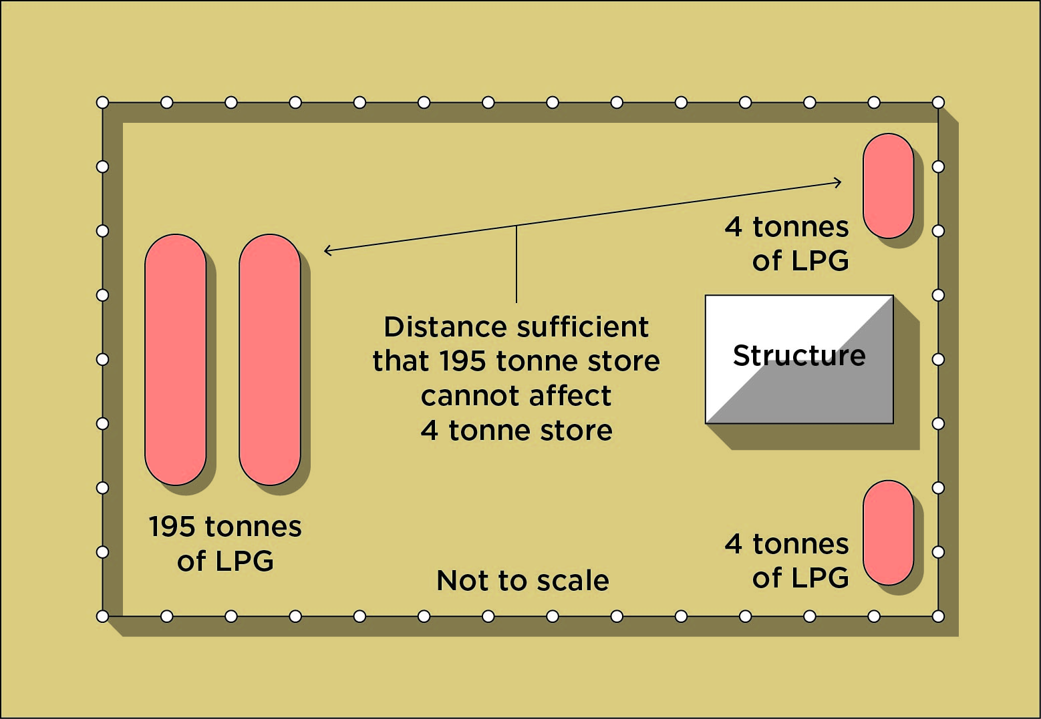

Figure 3 Example 1 of a facility with isolated small quantities
Note that the remaining quantity of 195 t is sufficiently close to the threshold quantity that the regulator could decide to determine the facility if other factors, for example being located near another MHF, apply.

Example 20 – Second example of isolated small quantities
A facility has a tank containing 18 t of LPG and a small tank containing four t of LPG
(see Figure 4).
The small tank comprises 2 per cent of the threshold quantity (200 t) but its location means that
an incident at the small tank cannot escalate. The 2 per cent rule applies. The result is that even though the total quantity of LPG is 22 t, the relevant quantity is only 18 t. The facility does not
need to notify the regulator since the aggregate quantity is less than 10 per cent of the threshold quantity.
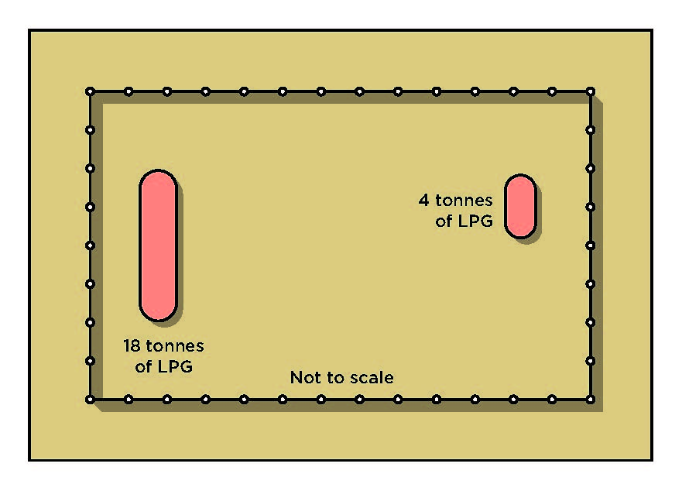

Figure 4 Example 2 of a facility with isolated small quantities

Example 21 – Third example of isolated small quantities
A facility has two large tanks containing 198 t of LPG and a small tank containing 4 t of LPG
(see Figure 5).
While the small tank is 2 per cent of the facility’s threshold (200 t), it is located where it may initiate a major incident involving the large tanks. The 2 per cent rule does not apply and the 4 t tank must be included in the threshold. Since the total amount of LPG is 202 t, compared to the threshold of 200 t, the facility is a MHF. The operator must notify the regulator and the facility will be registered as an MHF.
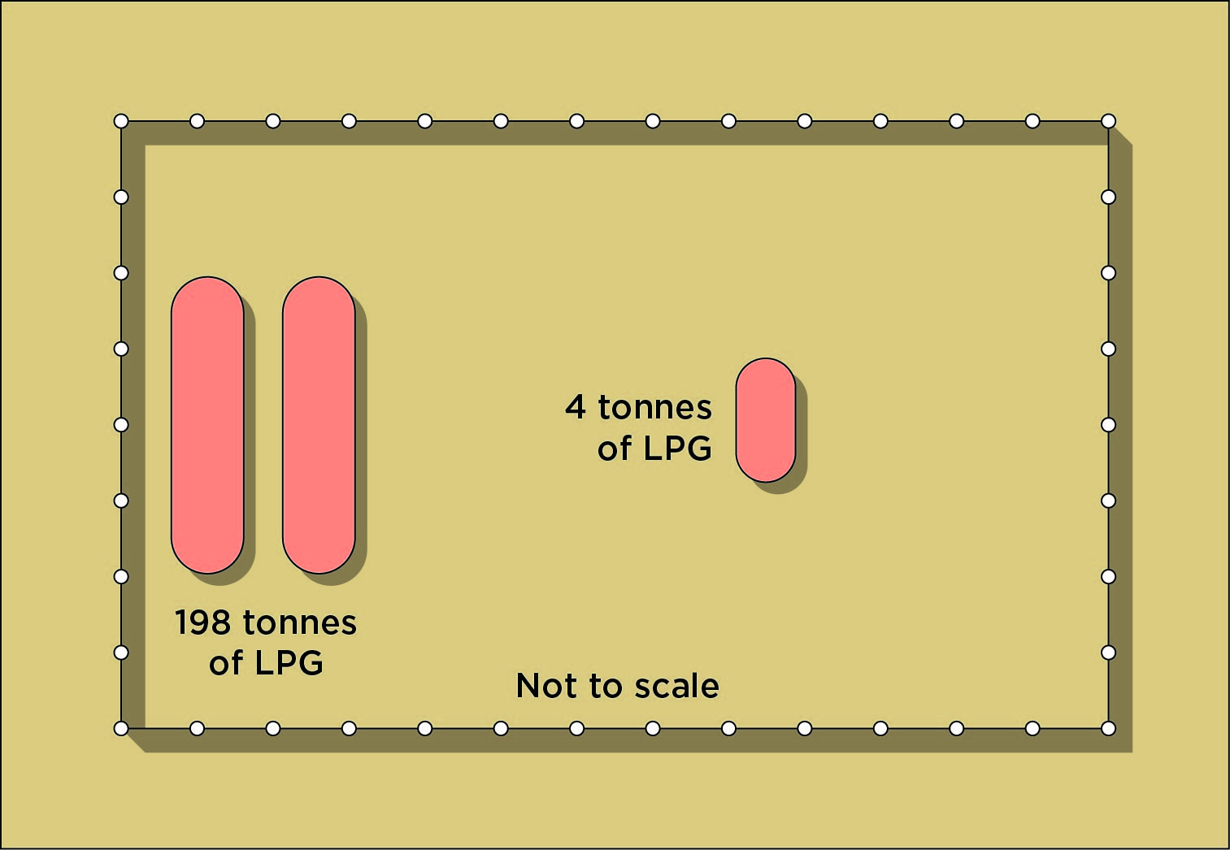

Figure 5 Example 3 of a facility with isolated small quantities

Example Calculations
Example 22 – Single storage (LPG)
The facility has a single 100 t LPG bullet. It is loaded and unloaded by 20 t tankers. The tankers do not “layover” overnight.
The MHF threshold for LPG (refer to Table 1) is 200 t.
The ratio for the facility is 100/200 = 0.5
The facility must notify.

Example 23 – Aggregate quantity calculations
A facility stores 10 t of hydrogen and 180 t of flammable liquids (class 3 PG I). The major hazard threshold quantities for the two chemicals are 50 t and 200 t respectively. Because the facility stores two types of material but each is below the corresponding threshold, the aggregation formula must be applied:
10 / 50 | + | 180 / 200 | = | 0.2 + 0.9 = 1.1
Since the ratio is more than 1.0, the facility is a MHF. The operator must notify the regulator.

Example 24 – Aggregate quantity calculations
A facility handles 10 t of acrylonitrile (threshold 200 t) and 40 t of ethylene oxide (threshold 50 t). The aggregation formula is:
10 / 200 | + | 40 / 50 | = | 0.05 + 0.8 = 0.85
Since the total ratio is less than 1.0, the facility is not automatically classified as a MHF. The operator still needs to notify the regulator because the total exceeds 0.1 (10 per cent), and the regulator may determine the facility to be an MHF.

Determination
If the notification discloses that the quantity of Schedule 15 chemicals present or likely to be present at a facility exceeds their threshold quantity, the regulator must make a determination confirming the facility to be a MHF.
A facility which holds more than 10 per cent of the MHF threshold quantity but less than the threshold quantity may be the subject of an inquiry to determine whether the facility should be regulated as a MHF.
The inquiry is usually triggered by information supplied during notification, but may also be conducted if the regulator has reasonable grounds to believe that the facility should have notified, but did not, or that the operator of the facility may not be a suitable person to operate the facility. Examples of sources of information that might alert the regulator to this possibility include applications for planning permits or amendments, reports of an incident involving Schedule 15 chemicals at a facility or direct communication by independent parties.
Regulation 540 sets out the inquiry procedure that must be followed. The regulator must give
a written notice to the nominated contact person (or operator, if notification has not occurred) outlining the reasons for the inquiry and inviting the operator to make a submission. The operator has 28 days to make this submission.
The factors that must be considered during the determination inquiry are specified in regulation 541, namely whether the regulator considers that there is potential for a major incident to occur at the facility or proposed facility having regard to any relevant matter, including:
- the quantity or combination of Schedule 15 chemicals present or likely to be present at the facility. The likelihood that an inquiry will be held will be greater for those facilities where the quantity of Schedule 15 chemicals is close to the MHF threshold, or, for example, if inherently unstable or mutually incompatible chemicals are present in significant quantities.
- the type of activities within the facility involving the Schedule 15 chemicals. Where the activities conducted at the facility are in some way intrinsically of higher hazard, then the likelihood of the facility being determined to be a MHF will be greater. Examples include: if chemicals are stored in relatively large closely grouped tanks; if the process has the potential
to generate by-products of extreme toxicity; if the process involves extremes of temperature and/or pressure; and if the process is complex, requiring advanced engineering controls to ensure safety.
- the land use and other activities in the area surrounding the facility. The potential consequences of an incident at a facility in a high-density residential area would be higher than if the facility were in a remote non-residential area. Similar concerns exist where there is the potential for escalation of any major incident to neighbouring facilities.
During the inquiry, the regulator must consider the operator’s submission and consult with interested parties, for example health and safety representatives at the facility, local emergency services, and any government department or agency with a regulatory role in relation to MHFs. The decision on determining whether the facility must be regulated as an MHF will be made at the conclusion of the inquiry and following consideration of any submissions and consultation.
If the regulator determines the facility to be a MHF, the regulator may also make a determination that the operator is not a suitable person to operate the facility. If no such determination is made, the operator is taken to be a suitable person to operate the MHF and to apply for a MHF licence.
The operator of a facility that has been determined to be a MHF must be given a written notice explaining the reasons for the determination and the date on which the determination takes effect. The notice must be given within 14 days of making the determination. The determination date must be at least 28 days after the date of the notice.

Appendix A – WHS Regulations

Regulation | Requirement
536 | Operators of certain facilities must notify regulator  (1) The operator of a facility at which Schedule 15 chemicals are present or likely to be present in a quantity that exceeds 10 per cent of their threshold quantity must notify the regulator of this circumstance in accordance with this Part.  (2) Notification must be given:  (a) as soon as practicable (but no more than 3 months) after the operator becomes aware, or ought reasonably to have become aware, of the circumstance giving rise to the requirement to notify; or  (b) within any longer period that the regulator determines if satisfied on application by the operator that there is a reasonable excuse for the delayed notification.
537 | Notification—proposed facilities  (1) The operator of a proposed facility at which Schedule 15 chemicals are likely to be present in a quantity that exceeds 10 per cent of their threshold quantity may notify the regulator of this circumstance.  (2) Any notification under this regulation must include the information required by regulation 538 (with any necessary changes).
538 | Content of notification  (1) A notification under regulation 536 must be made in the manner and form required by the regulator.  (2) The notification must include the following:  (a) information about the facility, including the nature of its operations;  (b) information about the operator, including the matters specified in subregulation (2);  (c) information about the Schedule 15 chemicals present or likely to be present at the facility;  (d) the nomination of a contact person with whom the regulator can communicate for the purposes of:  (i) this Part; and  (ii) the licensing process;  (e) any additional information required by the regulator.  (3) The information given under subregulation (2)(b) must include:  (a) if the operator is an individual:  (i) a declaration as to whether or not the operator has ever been convicted or found guilty of any offence under the Act or these Regulations or under any corresponding WHS law; and  (ii) details of any conviction or finding of guilt declared under subparagraph (i); and  (iii) a declaration as to whether or not the operator has entered into an enforceable undertaking under the Act or under any corresponding WHS law; and  (iv) details of any enforceable undertaking declared under paragraph (iii); and  (v) if the operator has previously been refused an equivalent licence under a corresponding WHS law, a declaration giving details of that refusal;  (vi) if the operator has previously held an equivalent licence under a corresponding WHS law, a declaration:  (A) describing any condition imposed on that licence; and  (B) stating whether or not that licence had been suspended or cancelled and, if so, whether or not the operator had been disqualified from applying for an equivalent licence; and  (C) giving details of any suspension, cancellation or disqualification;  (vii) a declaration that the information contained in the application is, to the best of the operator's knowledge, true and correct;  (viii) any additional information required by the regulator; or  (b) if the operator is a body corporate, the information specified in paragraph (a) in relation to:  (i) the operator; and  (ii) each officer of the operator.
539 | When regulator may conduct inquiry  The regulator may conduct an inquiry under this Division if a notification under regulation 536 or 537 discloses, or if for some other reason the regulator reasonably suspects, that:  (a) the quantity of Schedule 15 chemicals present or likely to be present at a facility (or proposed facility) exceeds 10 per cent of their threshold quantity but does not exceed their threshold quantity; or  (b) the operator of the facility (or proposed facility) may not be a suitable person to operate the facility (or proposed facility).
540 | Inquiry procedure  (1) This regulation sets out the procedure for an inquiry.  (2) The regulator must give a written notice to the person referred to in subregulation (3):  (a) informing the person of the reasons for the inquiry; and  (b) advising the person that the person may, by a specified date (being not less than 28 days after the notice is given), make a submission to the regulator in relation to the inquiry.  (3) Notice under subregulation (2) must be provided:  (a) for an inquiry about a facility in relation to which a notification has been given under regulation 536 or 537—to the contact person identified in the notification; and  (b) in any other case—to the operator of the facility.  (4) The regulator must:  (a) if the recipient of the notice has made a submission in relation to the inquiry— consider that submission; and  (b) consult with interested persons including:  (i) health and safety representatives at the facility; and  (ii) the emergency service organisations that have responsibility for the area in which the facility is located; and  (iii) any government department or agency with a regulatory role in relation to major hazard facilities; and  (c) decide whether or not to make a determination under regulation 541 or 542; and  (d) if it decides to make a determination under regulation 541 or 542—decide whether or not to make a determination in relation to the operator under regulation 543.
541 | Determination in relation to facility, on inquiry  (1) This regulation applies if an inquiry discloses that the quantity of Schedule 15 chemicals present or likely to be present at a facility or proposed facility exceeds 10 per cent of their threshold quantity, but does not exceed their threshold quantity.  (2) The regulator may determine the facility or proposed facility to be a major hazard facility if the regulator considers that there is a potential for a major incident to occur at the facility or proposed facility having regard to any relevant matter, including:  (a) the quantity and combination of Schedule 15 chemicals present or likely to be present at the facility; and  (b) the type of activity at the facility that involves the Schedule 15 chemicals; and  (c) land use and other activities in the surrounding area.
542 | Determination in relation to over-threshold facility  (1) This regulation applies if a notification under regulation 536 or 537 discloses that the quantity of Schedule 15 chemicals present or likely to be present at a facility (or proposed facility) exceeds their threshold quantity.  (2) The regulator must make a determination confirming the facility (or proposed facility) to be a major hazard facility.
543 | Suitability of facility operator  (1) This regulation applies if the regulator determines a facility or a proposed facility to be a major hazard facility under regulation 541 or 542.  (2) The regulator may determine that the operator of the major hazard facility or proposed major hazard facility is not a suitable person to operate the major hazard facility if the regulator:  (a) has conducted an inquiry under regulation 540 into the suitability of the operator; and  (b) is satisfied on reasonable grounds that the operator is not a suitable person to operate the major hazard facility or proposed major hazard facility.  (3) If no determination is made under this regulation, the operator of the major hazard facility or proposed major hazard facility is taken to be a suitable person to operate the major hazard facility and to apply for a major hazard facility licence.
544 | Conditions on determination of major hazard facility  (1) The regulator may impose conditions on a determination made under regulation 541 or 542.  (2) Without limiting subregulation (1), the regulator may impose conditions in relation to any of the following matters:  (a) additional control measures that must be implemented in relation to the carrying out of work or activities at the determined major hazard facility;  (b) the recording or keeping of additional information;  (c) the provision of additional information, training and instruction or the provision of specified information, training and instruction to additional persons or classes of persons;  (d) the provision of additional information to the regulator;  (e) if the operator is a person conducting a business or undertaking, the additional class of persons who may carry out work or activities on the operator's behalf.  (3) The operator of a determined major hazard facility, in relation to which conditions are imposed under this regulation, must ensure that the conditions are complied with.
545 | Notice and effect of determinations  (1) If the regulator makes a determination under this Part, the regulator must give the operator of the determined major hazard facility a written notice of the determination, stating:  (a) the reasons for the determination; and  (b) the date on which the determination takes effect, which must be at least 28 days after the date of the notice; and  (c) any conditions imposed on the determination under regulation 544.  (2) The notice must be given within 14 days of the making of the determination.  (3) The effect of a determination under regulation 543 is that:  (a) the operator is not taken to be a suitable person to operate the determined major hazard facility;  (b) the exemption provided by regulation 535(3) does not apply to the determined major hazard facility.  (4) A determination takes effect on the date specified in the notice.  (5) A determination is of unlimited duration unless it is revoked.
546 | When regulator may revoke a determination  The regulator may revoke a determination under this Part if, after consultation with the major hazard facility's contact person or operator (as applicable), the regulator is satisfied that the reasons for the determination no longer apply.
547 | Re-notification if quantity of Schedule 15 chemicals increases  (1) This regulation applies to a facility or proposed facility:  (a) at which the quantity of Schedule 15 chemicals present or likely to be present exceeds 10% of their threshold quantity but does not exceed their threshold quantity; and  (b) in relation to which notification was given under regulation 536 or 537; and  (c) that is not determined to be a major hazard facility under regulation 541.  (2) The operator of the facility or proposed facility must re-notify the regulator in accordance with this Part if the quantity of Schedule 15 chemicals present or likely to be present at the facility or proposed facility increases, or is likely to increase, to a level that exceeds the level previously notified to the regulator.  (3) The provisions of this Part apply, to the extent that they relate to a re-notification under this regulation, as if the re-notification were a notification under regulation 536.
548 | Notification by new operator  (1) This regulation applies:  (a) in relation to a determined major hazard facility that is proposed to be operated by a new operator;  (b) whether or not a determination under regulation 543 was made in relation to the current operator.  (2) A proposed new operator of the determined major hazard facility must give the regulator a notification that contains the information specified in regulation 538(2) in relation to the proposed new operator.  (3) The provision of this Part apply, to the extent that they relate to the suitability of an operator, as if the notification under subregulation (2) were a notification under regulation 536.
549 | Time in which major hazard facility licence must be applied for  (1) Subject to this regulation, the operator of a determined major hazard facility must apply for a major hazard facility licence within 24 months after the determination of the facility.  (2) The regulator may extend the time in which the operator of a determined major hazard facility must apply for a licence if satisfied, on application by the operator, that there has not been sufficient time to comply with Part 9.3.

Appendix B – Definitions
ADG Code means the Australian Code for the Transport of Dangerous Goods by Road and Rail, 7th edition, approved by the Australian Transport Council.
Component analysis means where the quantity of chemical is calculated based on the fraction
of chemical in the mixture or solution using the equation:
a x b = c
Where a = mass fraction of chemical
b = mass of mixture of solution
c = quantity of chemical present
GHS means the Globally Harmonised System of Classification and Labelling of Chemicals, Third revised edition, published by the United Nations, as modified under Schedule 6.
In transit, in relation to a thing, means that the thing:
- is supplied to, or stored at, a workplace in containers that are not opened at the workplace
- is not used at the workplace
- is kept at the workplace for not more than five consecutive days.
Isolated quantity is a quantity of Schedule 15 chemical where its location at the facility is such that it cannot on its own initiate a major incident.
Major hazard facility (MHF) means a facility:
- at which Schedule 15 chemicals are present or likely to be present in a quantity that exceeds their threshold quantity
- that is determined by the regulator under Part 9.2 to be a MHF.
Modification is a reference to a change at the facility that has or would have the effect of:
- creating a major incident hazard that has not previously been identified
- significantly increasing the likelihood of a major incident occurring
- in relation to a major incident that may occur, significantly increasing:
- its magnitude
- the severity of its health and safety consequences.
Operator
- in relation to a facility, means the person conducting the business or undertaking of operating the facility, who has:
- management or control of the facility
- the power to direct that the whole facility be shut down
- in relation to a proposed facility, means:
- the operator of a proposed facility that is an existing workplace
- the person who is to be the operator of a proposed facility that is being designed or constructed.
National security information is information held at the facility the disclosure of which is likely to prejudice Australia’s national security. Such information may include the disclosure of the location, type and quantity of Schedule 15 chemicals.
Present or likely to be present is a reference to the quantity of hazardous chemicals that would meet the maximum capacity of the facility, including:
- the maximum capacity of process vessels and interconnecting pipe systems that contain the hazardous chemicals
- the maximum capacity of storage tanks and vessels used for the hazardous chemicals
- the maximum capacity of other storage areas at the facility that could contain the hazardous chemicals
- the maximum capacity of pipe work outside process areas to contain the hazardous chemicals
- the maximum quantity of hazardous chemicals that would, in the event of failure, escape into the facility from pipe work that is situated off the premises but is connected to the facility
- the maximum quantity of hazardous chemicals loaded into or onto, or unloaded from, vehicles, trailers, rolling stock and ships that are from time to time present at the facility in the course of the facility's operations.
Note: Schedule 15 chemicals present or likely to be present in the tailings dam of a mine are not to be considered in determining whether a mine is a facility or a MHF.
Quantity, as referred to in Schedule 15, means a mass in tonnes (t) (i.e. the same units as the threshold value).
Schedule 15 chemical means a hazardous chemical that:
- is specified in Schedule 15, table 15.1 of the WHS Regulations
- belongs to a class, type or category of hazardous chemicals specified in Schedule 15,
table 15.2 of the Regulations.
Threshold quantity, in relation to a Schedule 15 chemical, means:
- the threshold quantity of a specific hazardous chemical as determined under clause 3
of Schedule 15
- the aggregate threshold quantity of 2 or more hazardous chemicals as determined under clause 4 of Schedule 15 (regulation 5).

List of Amendments
Date | Page Number | Amendments
7 March 2014 | Front Cover | Publication date added March 2014, first published in March 2012.
7 March 2014 | Whole document | Introduction of 15 to all table numbers i.e. Table 15.1 instead of Table 1.
7 March 2014 | Whole document | Editorial changes for consistency - tonnes (t) and major hazard facility (MHF).
7 March 2014 | Whole document | Formatting has been reviewed.
7 March 2014 | Pages 7 and 11 | Relocation of statement from pg 11 to pg7 – ‘Note that  all MHF threshold quantities are in tonnes (t) and classifications are as per the ADG Code, not the GHS’.
7 March 2014 | Page 12 | Corrections to LD50 Dermal toxicity and LC50 Inhalation toxicity in Example 5 to match changes to Table 15.3 in the WHS Regulations.
7 March 2014 | Page 13 | Example 6 and 7 corrected to account for changes to LD50 and LC50 concentrations in Example 5.

