WORKING IN THE VICINITY OF OVERHEAD AND UNDERGROUND ELECTRIC LINES

INFORMATION SHEET

Overview

This Information Sheet provides advice for small businesses and workers on managing the risks associated with working in the vicinity of overhead and underground electric lines.

More information is in the [*General guide   
for working in the vicinity of overhead and underground electric lines*](http://www.safeworkaustralia.gov.au/sites/SWA/about/Publications/Documents/859/Overhead-Underground-Electric-Lines-General-Guide.docx) and associated material for:

* operating cranes and mobile plant
* tree and vegetation management
* scaffolding work
* agricultural work
* low voltage overhead electric lines near structures, and
* transporting high loads.

What are the risks?

Contact with energised electric lines can cause death, electric shock or other injury caused directly or indirectly by electricity. An electric shock can also occur without contact with overhead electric lines. A close approach to   
line conductors may allow a ‘flashover’ to occur. The risk of flashover increases as the line voltage increases.

What do I need to do?

You must manage the risks associated with working in the vicinity of overhead and underground electric lines and associated electrical equipment by:

* identifying potential hazards
* consulting workers and asset owners e.g. the Electricity Supply Authority or the person with management or control of the electric line or premises, and
* deciding what approach distances and work zones are required for safe operations.

How do I do it?

When assessing the risks consider:

* the location, height, arrangement and visibility of overhead electric lines and supporting structures e.g. poles, towers   
  and stay wires
* the voltage of electric lines and exposed energised parts and whether they are insulated or bare
* possible sway or sag of the electric lines
* environmental conditions e.g. storm activity, heavy rain, hail and lightning
* site conditions e.g. wind strength and direction, terrain, ground surface and vehicular traffic
* type of plant and machinery required –design envelope, stability, dimensions and operating characteristics, minimum clearance distances and manoeuvrability
* the nature, size and shape of loads to be moved e.g. load stability, whether loads are conductive and how loads are secured
* the type of work activities required and the frequency of work tasks
* qualifications, competency, skill and experience of people doing the work
* the setting up and packing up processes, and
* safe work practices and procedures   
  e.g. a safety observer and ‘permit to work.’

How do I control the risks?

The best way to eliminate the hazard is by preventing people, plant, equipment and materials from coming close enough to energised overhead electric lines for direct contact or ‘flashover’ to occur. Consider:

* de-energising the electric line, or
* isolating and earthing the line for the duration of the work, or
* re-routing the electric line away from the work area.

Where elimination is not reasonably practicable, minimise the risks by substituting the hazard or work practice with something safer for example by:

* using alternative plant that cannot enter   
  an unsafe zone
* using non-conductive tools, or
* using ultrasonic measuring devices to measure the height of overhead lines.

Consider isolating the hazard from people by erecting a physical barrier to prevent any part   
of the plant or equipment or a person, or anything held by a person, or attached to   
a person entering Zone B or:

Use engineering controls like:

* limiting movement of plant with mechanical stops
* fitting plant with programmable zone limiting devices, and
* mechanically limiting the slew speed   
  of a crane to slow using electrically insulated plant and equipment.

If a risk still remains use administrative controlslike:

* fitting proximity sensors and a warning device to plant to alert operators when they are about to enter Zone B.
* making hazards more visible e.g.   
  use warning signs or tiger tails
* managing and supervising the work
* defining areas where plant should not enter e.g. rigid tape barriers or use high visibility bunting and

Use suitable PPE like:

* electrically tested insulating gloves
* rubber soled boots
* safety helmets
* stand on a rubber insulating mat or on   
  an equipotential conductive mat, and
* wear dry clothes especially in wet or humid conditions, or
* wear fire retardant clothing.

A combination of the above controls can   
be used if a single control is not enough   
to minimise the risks.

### Safe work method statements (SWMS)

A SWMS is required for energised electrical work and high risk construction work carried   
out on or near energised electrical installations or services. A written SWMS should be based on a risk assessment.

The SWMS and risk assessment should be available to workers on site for the duration   
of the work.

Approach distances

Approach distances are one way of separating people from hazards. The approach distance   
for each work zone will vary depending on the voltage of the overhead electric line and the level of authorisation of each person doing the work. As the risk increases a greater approach distance is required. There are three work zones shown in Figure 1:

**Zone C** is a No Go Zone where electricity supply authority approval is required. A ‘permit to work’ may be required. If a SWMS is not required a written safe system of work based on a risk assessment is required.

**Zone B** is for authorised persons only who   
must be trained in overhead electric line hazards. A written safe system of work based   
on a risk assessment is required.

**Zone A** is for unauthorised persons who   
do not have sufficient training or experience   
to be able to avoid electrical dangers.

Electric lines should always be treated as energised unless you have:

* an access authority confirming the electric lines have been de-energised, or
* another written document from the Electricity Supply Authority which allows people to work in the No Go Zone.

**Figure 1** Work zones in the vicinity of overhead electric lines

Diagram shows three work zones near an electric line pole.
Zone C is a No Go Zone where Electricity Supply Authority approval is required.
Zone B is for an authorised person.
Zone A is for an unauthorised person.

Approach distances for vehicles

Specific approach distances apply to vehicles and mobile plant stowed for transit and driven under overhead electric lines. Consider the voltage of the electric line and:

* the design and transit envelope
* the work activities e.g. person working from the top of the vehicle
* where the distance between the overhead electric line and ground may decrease, and
* the risk assessment factors for operating   
  the vehicle.

Approach distances and work zones in each state and territory vary for people, plant and vehicles depending on the voltage of the overhead electric line, whether the electric lines are insulated or bare, and in some states with or without consultation with the person in control of the energised overhead electric line or exposed part.

For more information contact your state or territory [Electricity Supply Authority](http://www.safeworkaustralia.gov.au/sites/SWA/about/Publications/Documents/859/Electricity-Supply-Authorities.docx) or [Electricity Regulator](http://www.safeworkaustralia.gov.au/sites/SWA/about/Publications/Documents/859/Electricity-Regulators.docx).

Training and competence

Authorised persons who work closer than Zone B and safety observers who observe the work should have successfully completed a relevant training course provided by a registered training authority. They should be assessed as competent to carry out their work tasks in the vicinity of energised electric lines and exposed parts. Written certification should be verified.

Safety observers must be competent to implement control measures in an emergency and to rescue and resuscitate   
a worker if necessary. Authorised persons and safety observers must be re-assessed annually.

### Safety observer

A safety observer should be used whenever the work activity is done in Zone B or the work activity in Zone A can enter Zone B.

The safety observer should alert workers and crane or plant operators when approach distances are likely to be breached or other unsafe conditions arise.

A safety observer must be able to communicate effectively at all times with crane and mobile plant operators and warn them about an approach to Zone B.

Safety observers should monitor the work activity and have the authority to stop the work at any time.

## UNDERGROUND ELECTRIC CABLES

What are the risks?

Damage to energised electric cables can cause electric shock. The explosive effects of arcing current and fire or flames can occur when a sheath of cable is crushed or individual phases of the cable make contact.

Gas leaking in the ground or in a trench can be ignited by an electric charge or electrical arc causing a fire or explosion. Gas can be introduced by work activities like oxy-acetylene cutting creating a further risk.

What do I need to do?

You must manage the risks associated with people working in the vicinity of energised underground electric cables involving potential contact with exposed parts by:

* identifying potential risks e.g.:
* digging holes with metal hand tools   
  e.g. spades, shovels, picks or forks
* excavating trenches with earth moving machinery using a metal toothed bucket
* driving implements into the ground   
  e.g. star pickets, and
* consulting asset owners

How do I do it?

When assessing the risks consider:

* tools damaging cables or equipment, and
* electric cables or equipment being concealed in a work location.

You should assume electrical risks exist or have a qualified person investigate and provide a report.

If excavating in a public place you can find out where underground assets are located at your work site by contacting:

* [Dial-before-you-Dig](http://www.1100.com.au/) on 1100 or submit an on-line enquiry at www.1100.com.au.
* Relevant authorities e.g. [Electricity Supply Authority](http://www.safeworkaustralia.gov.au/sites/SWA/about/Publications/Documents/859/Electricity-Supply-Authorities.docx), communication company, local government authority and water authority.

If excavating on private property contact the owner or occupier of the premises about the location of buried cables.

How do I control the risks?

If you cannot find out exactly where an underground cable is, use pot-holing to carefully identify the cable location. This involves digging with hand tools to a pre-determined depth to verify if assets exist in the immediate location. Use insulated tools suitable for the voltage concerned or use vacuum pumping to locate   
the cable.

The best way to eliminate these hazards is   
by preventing people, plant, equipment and materials from coming close enough to energised underground electric cables   
for direct contact or arcing to occur.

Consider:

* de-energising the electricity supply, or
* isolating the electricity supply for the duration of the work.

Where elimination is not reasonably practicable, minimise the risks by substituting the hazard or work practice with something safer for example by:

* using insulated hand tools
* using non-powered hand tools, or
* hiring a person with relevant electrical qualifications to do the job.

Consider isolating the hazard from people by installing a physical barrier to prevent accidental contact between the hand held tool and underground electric cable.

If a risk still remains consider the following controls in the order below.

Administrative controls like:

* authorisation to do the work e.g. a permit   
  to work, and
* training workers to identify hazards   
  and perform the work safely, and

Suitable PPE like:

* insulated gloves
* rubber soled boots, and
* safety helmets.

A combination of the above controls can   
be used if a single control is not enough   
to minimise the risks.

Emergency and rescue procedures

You must ensure an emergency plan for contact with energised electric lines is developed and maintained so it is effective for each workplace or site.

Consider potential emergency situations resulting from mobile plant, equipment   
or people contacting energised electric lines.

Emergency rescue procedures must be developed, tested and practiced so everyone knows what to do. Include:

* breaking contact with electricity source   
  if possible
* isolating the electricity supply
* warning people to keep at least 8 metres clear from crane or plant (see Figure 2), and
* ensuring unauthorised, unequipped people do not attempt a rescue until the electricity supply is isolated and the site is made safe.

All workers must be trained and be familiar with emergency and rescue procedures.

**Figure 2** Affected area surrounding mobile plant when in contact with energised overhead electric line

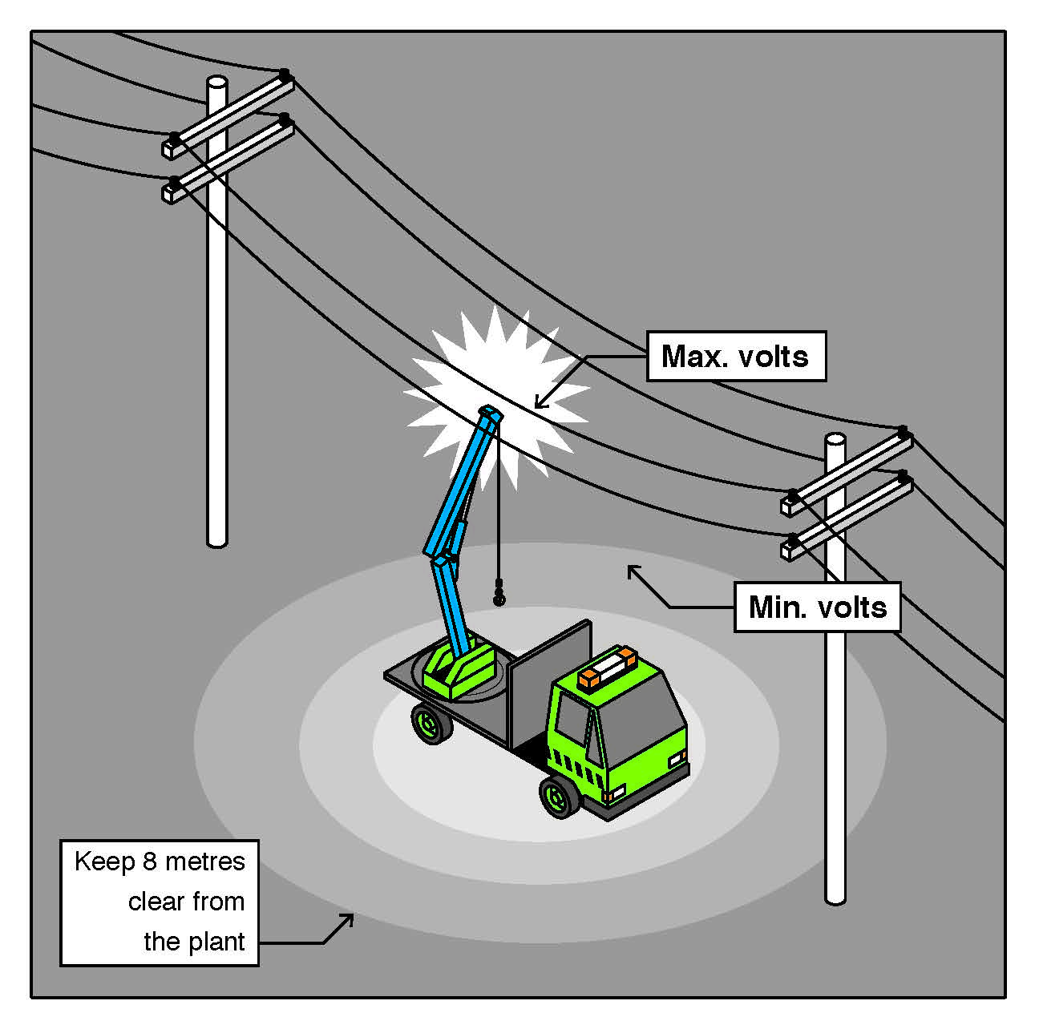

For further information see the [Safe Work Australia](http://www.swa.gov.au/) website (www.swa.gov.au).