USING OTHER POWERED   
MOBILE PLANT AS A CRANE  
INFORMATION SHEET

## Overview

This information sheet provides advice on managing the risks associated with using other powered mobile plant like earthmoving machinery as a crane.

For further information see the [*General guide for cranes*](http://www.safeworkaustralia.gov.au/sites/swa/about/publications/pages/guidance-cranes)*.*

## Powered mobile plant used as a crane

Powered mobile plant may be used to lift, lower and transport freely suspended loads—that is, the load is not pinned to the boom or on tynes but is suspended by slings or chains from a purpose designed lifting point, jib attachment or quick‑hitch.

Powered mobile plant used in this way includes forklifts and earthmoving machinery like backhoes, front-end loaders and excavators (see Figure 1).

**Figure 1** An excavator lifting a load

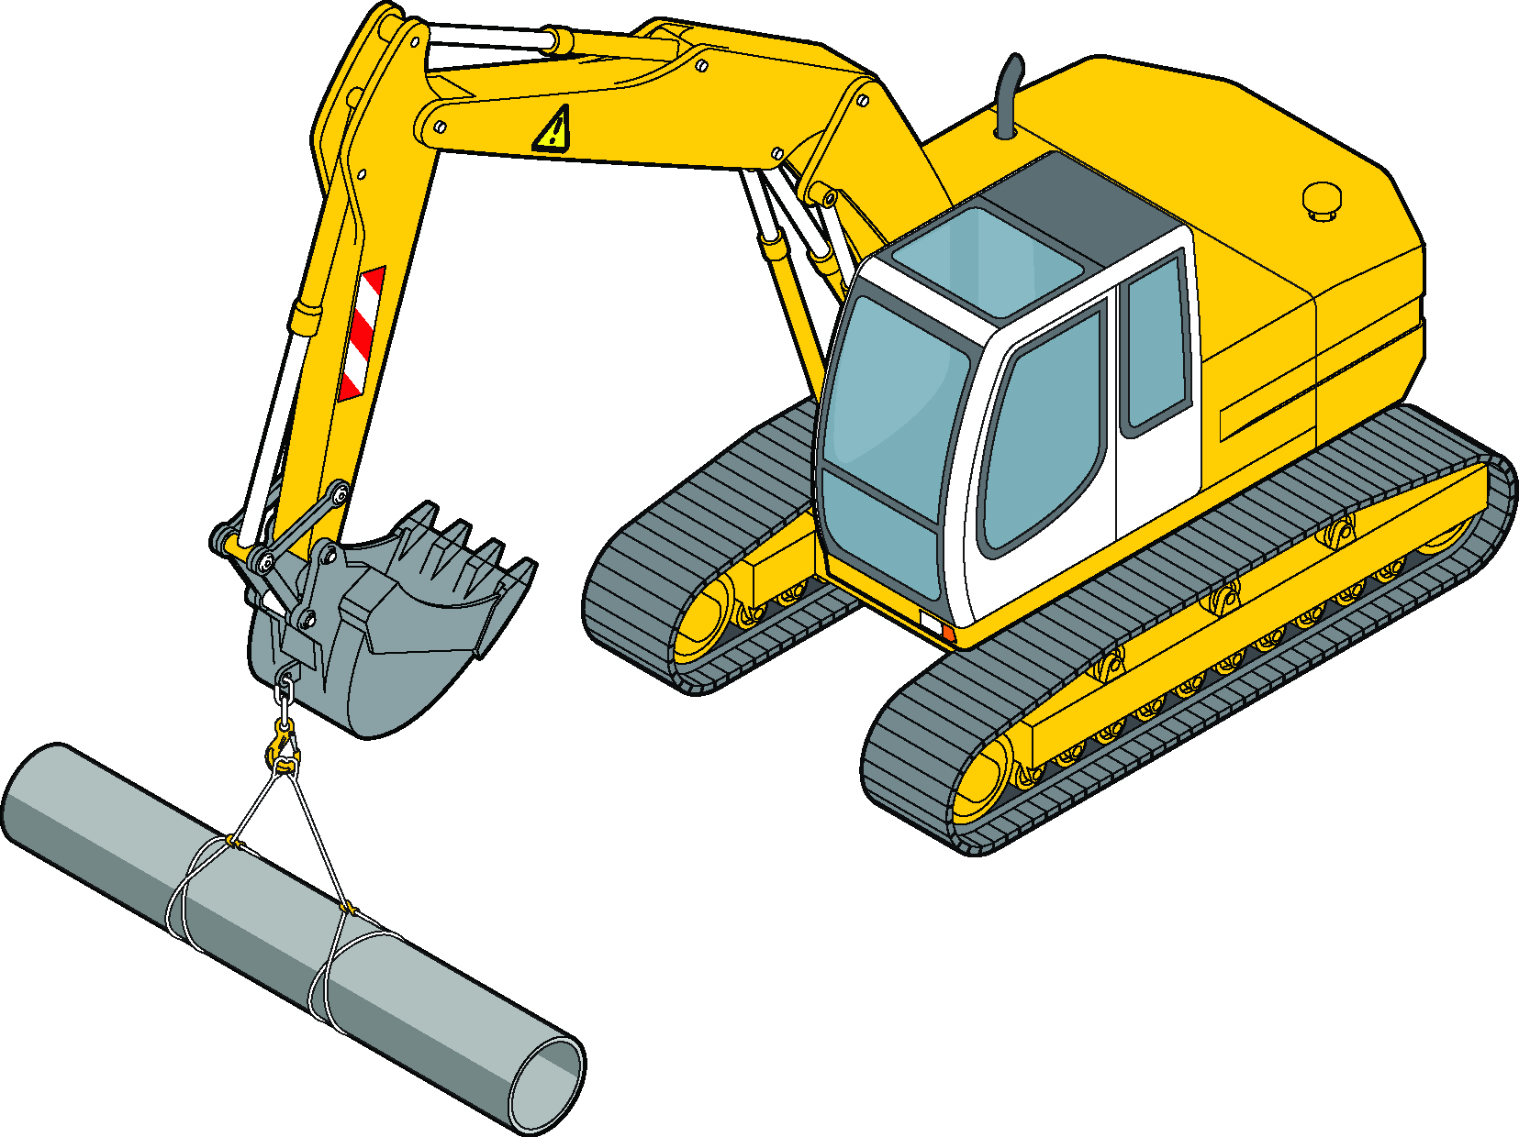

These types of powered mobile plant do not generally provide the same level of safety found in common types of cranes for precision lifting and placement.

Using powered mobile plant as a crane for construction work is classified as high risk construction work and a safe work method statement must be prepared before the work starts.

## Operator competency and licensing

Operators of powered mobile plant must be trained and competent to operate the plant safely. When mobile plant is used to lift freely suspended loads, the operator of the mobile plant may require more specific training for this task including how to estimate loads.

For example, if a jib attachment is used the operator will require additional training for safe operation. This could include the completion of non-slewing mobile crane training (see Figure 2).

**Figure 2** Forklift jib attachment

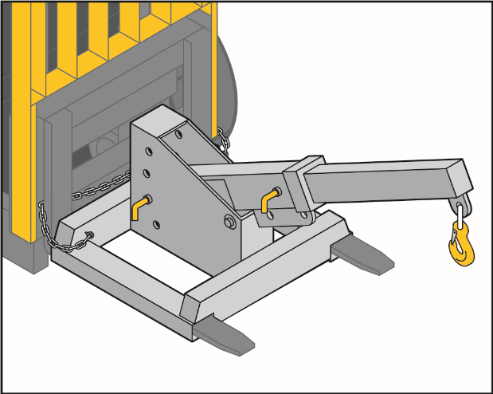

Powered mobile plant may be set up like a mobile crane, for example, where a winch with ropes is fitted. The operator of the mobile plant may also need to hold a relevant mobile crane high risk work (HRW) licence. Operators should contact the regulator for advice on whether a HRW licence is required.

## Dogging

The operator of the mobile plant must be able to see the load at all times during the lift. If the load is out of the operator’s view at any time, the lifting process must be directed by a worker with a dogging or rigging HRW licence and the operator must understand dogging signals.

For more information see the [Information Sheet: *High risk work licensing for dogging*](http://www.safeworkaustralia.gov.au/sites/swa/about/publications/pages/guidance-high-risk-work-licensing).

## Rated capacity

The rated capacity of powered mobile plant is the maximum load that can be attached and handled in its current configuration. When determining the load to be lifted, the mass of any attachments, such as buckets or quick-hitch devices, must be included, unless the rated capacity chart (load chart) allows otherwise.

The rated capacity or working load limit should be clearly marked near the lifting point.

A rated capacity limiter can be fitted to prevent overloading of the plant by stopping relevant functions when an overload is detected.

## Load chart

Load charts, also called rated capacity charts, identify what load a crane or other plant is able to lift safely. The load chart should be available for the operator to ensure the plant will not be overloaded.

For some items of powered mobile plant used as a crane, there may be more than one load chart for different boom and counterweight configurations. These load charts may be complex and include many conditions that should be complied with to ensure the plant can safely lift a load.

The load chart for the mobile plant should identify each lift point location and the corresponding rated capacity for each position.

The load chart should show the:

* manufacturer’s name, plant model and date of manufacture
* lifting point locations and their rated capacity
* boom configuration—particularly where different boom configurations may be used
* the maximum load that can be lifted for each lifting point and boom configuration
* stabiliser requirements—where applicable
* side slope allowance, and
* deductions for attachments e.g. bucket or quick‑hitch devices—where applicable.

## Lifting points

Loads should only be suspended from the manufacturer’s designated lift point or quick-hitch if fitted unless another designated lifting point has been designed and fitted.

Designated lifting points and lifting attachments for powered mobile plant can be supplied by the plant manufacturer or designed by an engineer. Lifting attachments often consist of a welded assembly that fits onto the end of the dipper arm when the bucket is removed.

Lifting points should form a closed eye where a load rated shackle may be attached (see Figure 3).

**Figure 3** Closed eye lifting points on an excavator

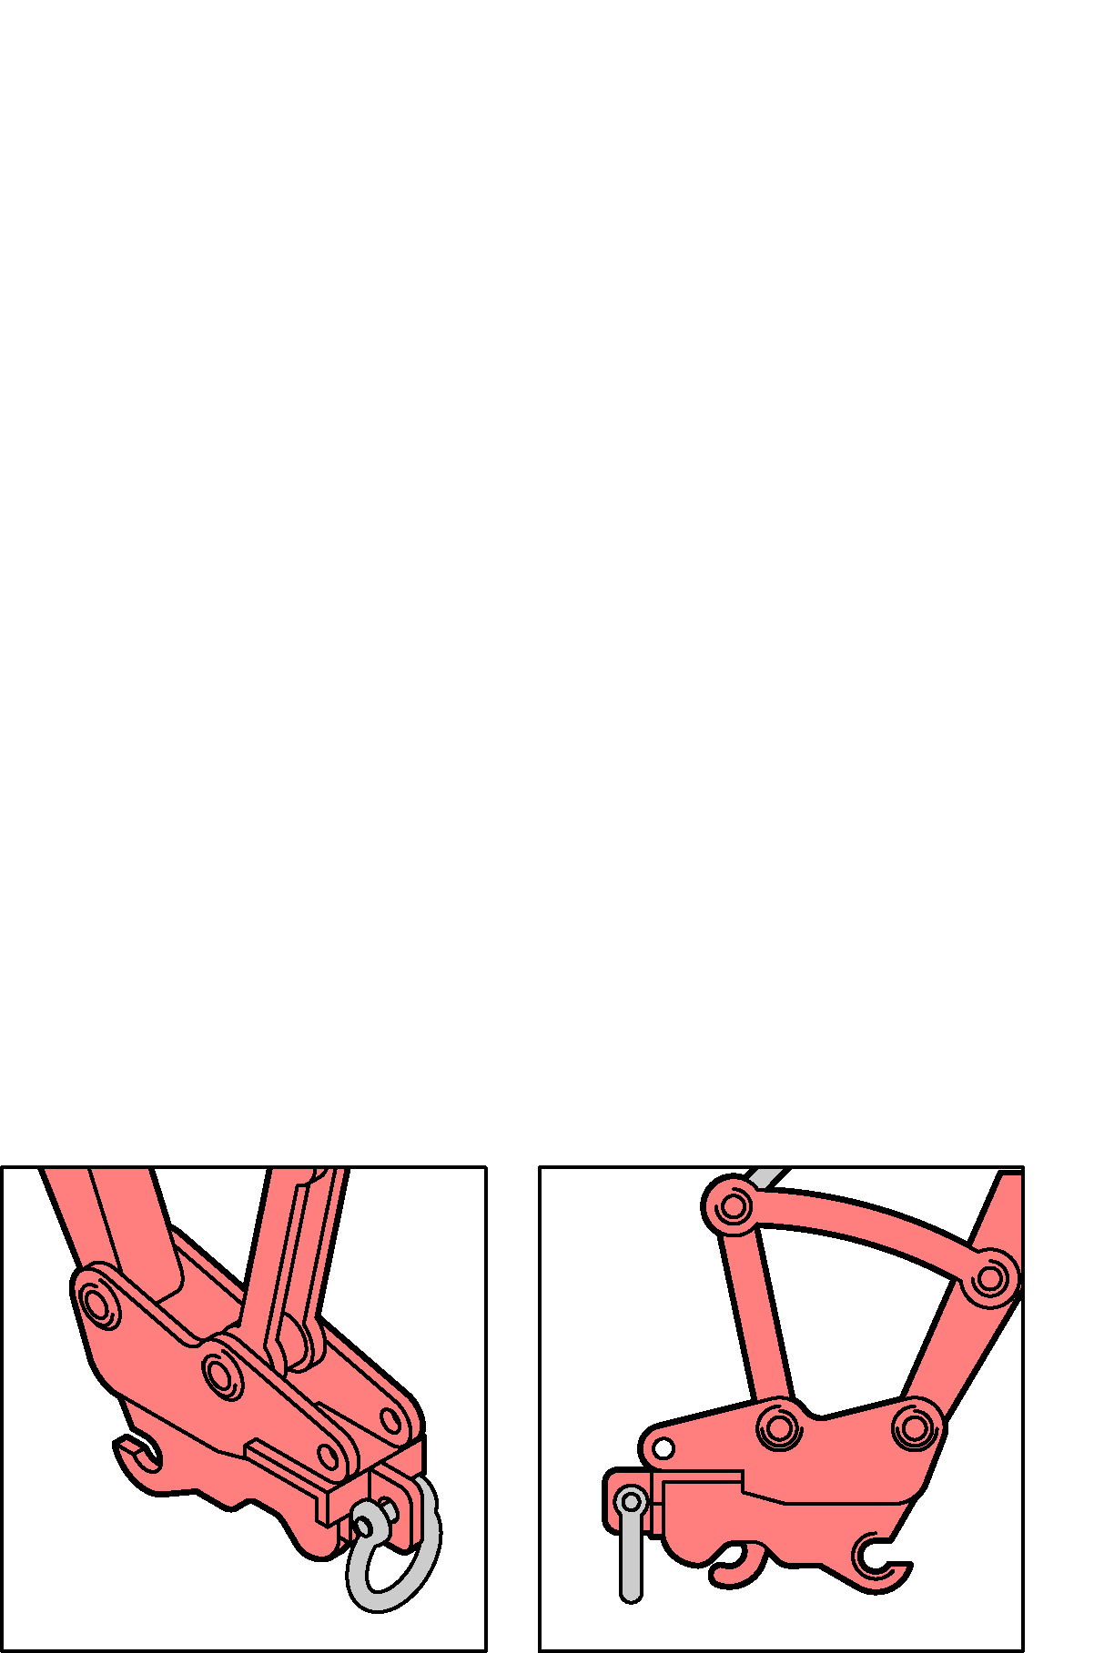

The lifting point should be designed so that:

* accidental unhooking of the load cannot occur
* the sling cannot become detached from the lifting point, and
* slings will hang clear of the boom or boom attachment.

Hooks should not be used on the dipper arm or other attachments of earthmoving plant because the load may unhook as the arm rotates. This can even occur when the hook is fitted with a latch because the latch may become damaged. For example, on a mobile crane the hook always hangs vertically—an excavator lifting point rotates.

Lifting points should not be attached to quick-hitch buckets or buckets generally as:

* the application of a load to the outside of the bucket can load the pins and linkages in ways other than the designer intended
* it is easier for the operator to overload the plant by not allowing for the dead weight of the bucket or because the bucket still has material inside it
* the sling can be damaged because it may pass over the front edge of the bucket, and
* they may be damaged when the bucket is used for excavation activity.

## Quick-hitches

A quick-hitch is a device that is fitted to an excavator or backhoe arm for the purpose of rapidly mounting and dismounting attachments and they require appropriate risk controls.

For more information see the [Information Sheet: *Quick-hitches for earthmoving machinery*](http://www.safeworkaustralia.gov.au/sites/swa/about/publications/pages/guidance-cranes)*.*

## Burst protection

Burst protection should be fitted on earthmoving equipment used as a crane where the rated capacity exceeds 1 tonne. Information on fitting burst protection should be obtained from the original manufacturer of the plant.

Where the rated capacity of the plant is 1 tonne or more and burst protection is not fitted, the plant should not be used to lift loads near workers.

Burst protection should be fitted on critical hydraulic cylinders to prevent boom or dipper arm collapse. The following conditions should be applied when considering burst protection:

* Obtain information on fitting burst protection devices from the plant manufacturer.
* The plant’s maximum rated capacity is as per the manufacturer’s specifications for the plant, and includes:
  + *Single rated capacity*: the lifting capacity of the plant at its maximum lifting radius is the rated capacity and is to be marked on the boom or dipper arm.
  + *Variable rated capacities*: Where the plant has variable lifting capacities, the lifting capacity at the minimum radius should be used to decide whether burst protection is required. The plant should also be fully compliant with the design requirements for mobile cranes.
* The operator should not be able to switch off burst protection devices.

## Further information

The following technical standards provide further information on powered mobile plant used as a crane:

* AS 1418.8-2008: *Cranes, hoists and winches-Part 8-Special purpose appliances*
* ISO 8643:1997: *Earthmoving machinery–Hydraulic excavator and backhoe loader boom-lowering control device–Requirements and tests*.

For further information see the Safe Work Australia website [www.swa.gov.au](http://www.swa.gov.au)*.*