Work-related

Traumatic Injury Fatalities,

Australia

2017



Disclaimer

Safe Work Australia provides the information in this publication to raise awareness of work health and safety. This information is general guidance only and does not replace any statutory requirement contained in any relevant state, territory or Commonwealth legislation. It is not a substitute for independent professional advice. Users should exercise their own skill and care to evaluate the accuracy, currency, completeness and relevance for their purposes of any information contained in the publication. Users should obtain appropriate advice relevant to their particular circumstances.

While Safe Work Australia makes every effort to ensure information is accurate and up-to-date, Safe Work Australia does not provide any warranty regarding the accuracy, currency or completeness of the information contained in this publication and will not be held liable for any loss, damage, cost or expense incurred or arising by reason of any person using or relying on the information in this publication.

This publication may incorporate views or information from third parties, which do not necessarily reflect the views of Safe Work Australia. The inclusion of such material does not indicate an endorsement of that material or a commitment to any particular course of action. The views in this publication should not be taken to represent the views of Safe Work Australia unless otherwise expressly stated.

ISSN 2209-9190

Creative Commons

This copyright work is licensed under a Creative Commons Attribution-Noncommercial 4.0 International licence. To view a copy of this licence, visit creativecommons.org/licenses In essence, you are free to copy, communicate and adapt the work for non-commercial purposes, as long as you attribute the work to Safe Work Australia and abide by the other licence terms.

Contact information

Safe Work Australia | <mailto:info@swa.gov.au> | www.swa.gov.au

Important Notice

Safe Work Australia provides the information given in this document to improve public access to information about work health and safety information generally. The vision of Safe Work Australia is Australian workplaces free from injury and disease. Its mission is to lead and coordinate national efforts to prevent workplace death, injury and disease in Australia.

Contents

Work-related 1

Traumatic Injury Fatalities, 1

Australia 1

Foreword 4

Section 1: Worker fatalities 7

1. Worker fatalities 8

1.1. Worker fatalities by sex 8

1.2. Worker fatalities by age 9

1.3. Industry 10

1.4. Priority industries 13

1.4.1. Agriculture 15

1.4.2. Road transport 17

1.4.3. Construction 18

1.5. Occupation 21

1.6. Worker fatalities by State/Territory 23

1.7. Mechanism of incident 24

1.8. Breakdown agency 25

1.9. Being hit by moving objects 26

1.10. Falls from a height 27

1.11. Being hit by falling objects 28

1.12. Vehicle involvement and collisions 29

Section 2: Bystander Fatalities 31

2. Bystander fatalities by mechanism of incident 32

2.1 Bystander fatalities by age group 32

Section 3: Data sources & Glossary 33

3. Data sources 34

3.1 Glossary 34

Foreword

The aim of this report is to provide statistics about people who traumatically die each year from injuries that arose through work-related activity. This includes traumatic fatalities resulting from an injury sustained in the course of a work activity (worker fatalities) and as a result of someone else’s work activity (bystander fatalities).

Earlier reports have included fatalities that occurred while the worker was commuting to or from work (commuter fatalities), however, these fatalities have always been difficult to distinguish from other road fatalities and this report relies partly on workers’ compensation data. As fewer jurisdictions are now providing compensation coverage for commuting, the integrity of the commuter fatality collection has diminished and has therefore been ceased.

Injury is defined as a condition coded to ‘External causes of morbidity and mortality’ and ‘Injury, poisoning and certain other consequences of external causes’ in the International Statistical Classification of Diseases and Related Health Problems, Tenth Revision, Australian Modification (ICD–10–AM).

The scope of this collection includes all persons:

* who were traumatically fatally injured, and
* whose injuries resulted from work activity or exposures, and
* whose injuries occurred in an incident that took place in Australian territories or territorial waters.

The report includes all persons who died:

* while working including unpaid volunteers and family workers, persons undertaking work experience and defence force personnel killed within Australian territories or territorial waters or travelling for work (worker fatalities), or
* as a result of someone else’s work activity (bystander fatalities).

The collection specifically excludes those who died:

* of iatrogenic injuries—those where the worker died due to medical intervention
* due to natural causes such as heart attacks and strokes, except where a work-related injury was the direct cause of the heart attack or stroke
* as a result of diseases, such as cancers, and
* by self-inflicted injuries (suicide).

Changes from previous publications may also be evident due to the availability of additional information from finalised coroners' reports and additional workers’ compensation claims. The Data presented in this report is based on the information available about the fatalities as at June 2018 when the 2017 data set was finalised.

For explanatory notes on the data for this publication, refer to <https://www.safeworkaustralia.gov.au/doc/explanatory-notes-safe-work-australia-datasets>

Key Findings

- 190 workers were fatally injured at work
- Fatality rate 1.5 per 100,000 workers
- Decreased by 48 per cent from a peak of 3.0 per 100,000 in 2007
- 176 of 190 fatalities involved male workers
- 93 per cent male
- 7 per cent female

Industry fatalities in 2017

- 72 per cent of fatalities were in three industries:
- 54 transport, postal and warehousing
- 52 agriculture, forestry and fishing
- 30 construction

Causes of worker fatalities in 2017

- 32 per cent (60 workers) vehicle collision
- 15 per cent (28 workers) falling from height
- 18 per cent (35 workers) hit by moving objects
- 119 of 190 fatalities (63 per cent) were related to vehicles

Causes of bystander fatalities in 2017

- 61 per cent (41 bystanders) of bystander fatalities were due to a vehicle collision
- 24 per cent (16 bystanders) hit by moving objects

Worker fatalities in 2017 by state/territory

- Western Australia: 20 fatalities (1.5 per 100,000 workers)
- Northern Territory: 7 fatalities (5.1 per 100,000 workers)
-  Queensland: 45 fatalities (1.9 per 100,000 workers)
- South Australia: 14 Fatalities (1.7 per 100,000 workers)
- New South Wales: 62 fatalities (1.6 per 100,000 workers)
- Australian Capital Territory: 1 fatality (0.4 per 100,000 workers)
- Victoria: 36 fatalities ( 1.1 per 100,000 workers)
- Tasmania: 5 fatalities (2.0 per 100,000 workers)

Total 190 fatalities (1.5 per 100,000 workers)

Section 1: Worker fatalities

1. Worker fatalities

Figure 1 shows that both the number of fatalities and the fatality rate have been trending downward since 2007. Injuries at work resulted in the deaths of 190 workers in 2017, three more than in 2016. The highest number of work‑related injury fatalities was recorded in 2007 when there were 310 deaths.

Similarly, the fatality rate was 1.5 fatalities per 100,000 workers in 2017, which is 6 per cent less than the rate in 2016. The fatality rate in 2017 is the lowest since the series began and is around half the rate recorded at the peak in 2007 when there were 3.0 fatalities per 100,000 workers.

Figure 1: Worker fatalities: number of fatalities and fatality rate, 2003 to 2017

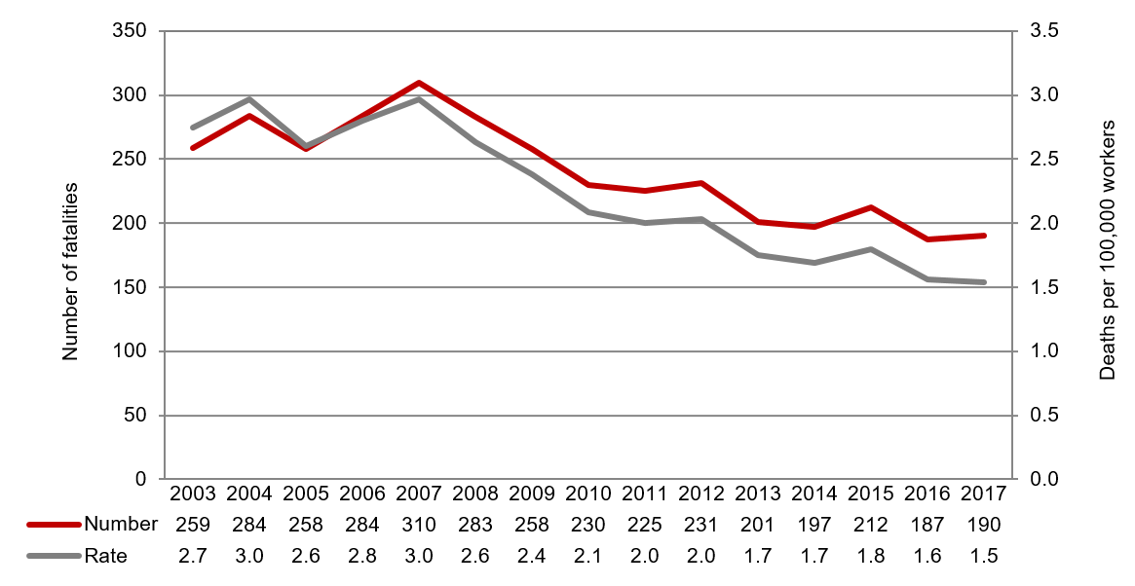

* 1. Worker fatalities by sex

In 2017, 93 per cent (176 of the 190 fatalities) of workers killed were men. Figure 2 shows that the fatality rate for male workers has been declining over the last 10 years, down from 5.0 fatalities per 100,000 workers in 2007 to 2.7 in 2017. Over the same period the fatality rate for female workers has remained relatively constant at or around 0.3 fatalities per 100,000 workers.

Figure 2: Worker fatalities: fatality rate by sex, 2003 to 2017

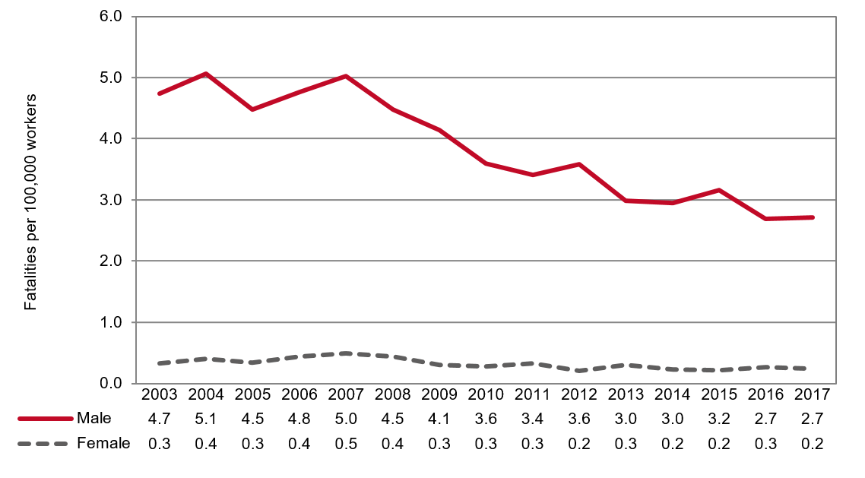

* 1. Worker fatalities by age

Tables 1 and 2 show the distribution of fatalities by age group. This distribution shows that there were fewer fatalities in the youngest and oldest age groups, which reflects the lower workforce participation of these age groups compared with other age groups.

The fatality distribution by age for 2017 was broadly similar to previous years, with fatalities among workers under 25 and those aged 65 and over remaining at a similar low point to 2016.

Despite this, while only accounting for 40 per cent of the workforce in 2017, older workers aged 45 and over accounted for the majority (57 per cent) of worker fatalities. This disproportionate share is also evident in Table 3 which shows that the fatality rates for the older age groups of 45–54, 55–64 and 65 and over were higher than younger age group rates.

Table 1: Worker fatalities: number by age group, 2013 to 2017

|  |  |  |  |  |  |  |
| --- | --- | --- | --- | --- | --- | --- |
| **Age group** | **2013** | **2014** | **2015** | **2016** | **2017** | **Total** |
| **Under 25** | 17 | 22 | 17 | 16 | 16 | 88 |
| **25–34** | 30 | 33 | 39 | 33 | 32 | 167 |
| **35–44** | 37 | 28 | 28 | 24 | 33 | 150 |
| **45–54** | 44 | 45 | 50 | 40 | 35 | 214 |
| **55–64** | 39 | 38 | 42 | 48 | 49 | 216 |
| **65 & over** | 34 | 31 | 36 | 26 | 25 | 152 |
| **Total** | **201** | **197** | **212** | **187** | **190** | **987** |

Table 2: Worker fatalities: proportion by age group, 2013 to 2017

|  |  |  |  |  |  |  |
| --- | --- | --- | --- | --- | --- | --- |
| **Age group** | **2013** | **2014** | **2015** | **2016** | **2017** | **5 year average** |
| **Under 25** | 8% | 11% | 8% | 9% | 8% | **9%** |
| **25–34** | 15% | 17% | 18% | 18% | 17% | **17%** |
| **35–44** | 18% | 14% | 13% | 13% | 17% | **15%** |
| **45–54** | 22% | 23% | 24% | 21% | 18% | **22%** |
| **55–64** | 19% | 19% | 20% | 26% | 26% | **22%** |
| **65 & over** | 17% | 16% | 17% | 14% | 13% | **15%** |
| **Total** | **100%** | **100%** | **100%** | **100%** | **100%** | **100%** |

Table 3: Worker fatalities: fatality rates by age group, 2013 to 2017

|  |  |  |  |  |  |  |
| --- | --- | --- | --- | --- | --- | --- |
| **Age group** | **2013** | **2014** | **2015** | **2016** | **2017** | **5 year average** |
| **Under 25** | 0.9 | 1.2 | 0.9 | 0.9 | 0.9 | **1.0** |
| **25–34** | 1.1 | 1.2 | 1.4 | 1.2 | 1.1 | **1.2** |
| **35–44** | 1.5 | 1.1 | 1.1 | 0.9 | 1.2 | **1.2** |
| **45–54** | 1.8 | 1.8 | 2.0 | 1.6 | 1.4 | **1.7** |
| **55–64** | 2.4 | 2.3 | 2.5 | 2.7 | 2.7 | **2.5** |
| **65 & over** | 8.6 | 7.3 | 8.3 | 5.7 | 5.1 | **7.0** |
| **Total** | **1.7** | **1.7** | **1.8** | **1.6** | **1.5** | **1.7** |

* 1. Industry

Figure 3 shows in 2017, the vast majority (72 per cent) of fatalities occurred in three industries.

Transport, postal and warehousing (54 fatalities) accounted for more than a quarter of fatalities in 2017 (28 per cent), followed closely by Agriculture, forestry and fishing (52 fatalities, 27 per cent) and Construction (30 fatalities, 16 per cent).

Figure 3: Worker fatalities: proportion by industry of employer, 2017 and five year average (2013 to 2017)

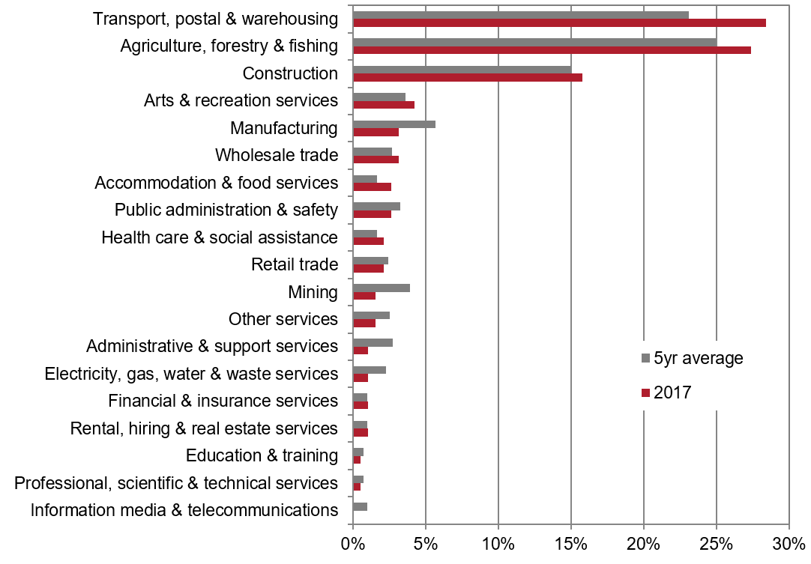

Fatality rates, expressed as the number of fatalities per 100,000 workers, are best used when comparing data across industries. Figure 4 shows that in 2017 the Agriculture, forestry and fishing industry recorded the highest fatality rate with 16.5 fatalities per 100,000 workers, more than 10 times the all industries average of 1.5. The Transport, postal and warehousing industry recorded the second highest fatality rate in 2017 with 8.6 fatalities per 100,000 workers, followed by the Arts and recreation services industry (3.5 fatalities per 100,000 workers).

Figure 4: Worker fatalities: fatality rates by industry of employer, 2017 and five year average (2013 to 2017)

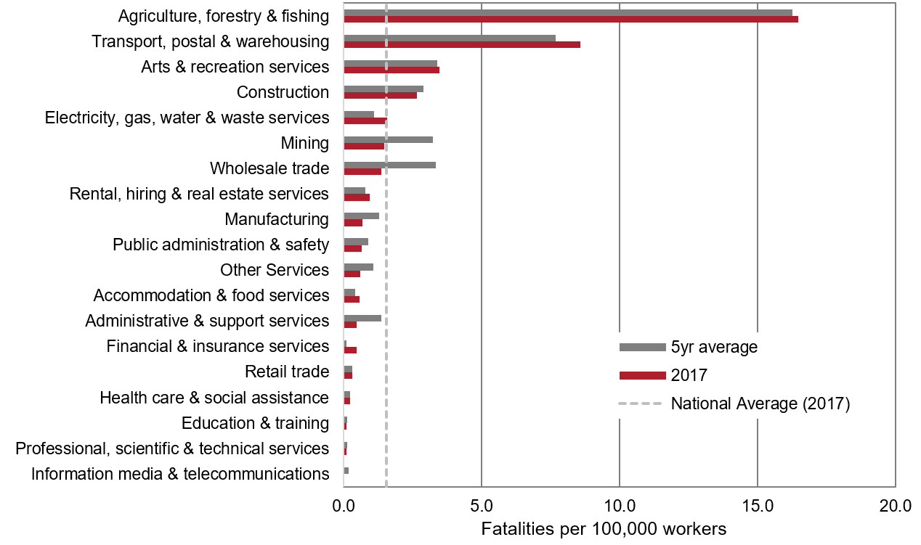

It should be noted, however, that fatality rates are sensitive to the number of workers employed in each industry. Industries which employ the fewest workers (such as the Electricity, gas, water and waste services industry) may show volatility even when small variations in the number of fatalities are recorded. Therefore, the actual number of fatalities should also be considered when interpreting the fatality rates for smaller industries (see Table 4 for a comparison).

Table 4: Worker fatalities: number of fatalities and fatality rates by industry of employer, 2016, 2017 and five year average (2013 to 2017)

|  |  |  |  |  |  |  |
| --- | --- | --- | --- | --- | --- | --- |
| **Industry of employer** | **Number of fatalities** | | | **Fatality rates** | | |
| **2016** | **2017** | **5yr average** | **2016** | **2017** | **5yr average** |
| **Agriculture, forestry & fishing** | 45 | 52 | 51 | 14.3 | 16.5 | 16.3 |
| **Transport, postal & warehousing** | 46 | 54 | 47 | 7.4 | 8.6 | 7.7 |
| **Arts & recreation services** | 5 | 8 | 7 | 2.2 | 3.5 | 3.4 |
| **Construction** | 36 | 30 | 31 | 3.4 | 2.7 | 2.9 |
| **Electricity, gas, water & waste services** | 8 | 2 | 5 | 5.8 | 1.5 | 3.2 |
| **Mining** | 6 | 3 | 8 | 2.7 | 1.4 | 3.3 |
| **Wholesale trade** | 0 | 6 | 4 | 0.0 | 1.6 | 1.1 |
| **Rental, hiring & real estate services** | 2 | 2 | 2 | 0.9 | 1.0 | 0.8 |
| **Manufacturing** | 7 | 6 | 12 | 0.8 | 0.7 | 1.3 |
| **Public administration & safety** | 5 | 5 | 7 | 0.7 | 0.6 | 0.9 |
| **Other Services** | 4 | 3 | 5 | 0.8 | 0.6 | 1.1 |
| **Accommodation & food services** | 1 | 5 | 3 | 0.1 | 0.6 | 0.4 |
| **Administrative & support services** | 9 | 2 | 6 | 2.1 | 0.5 | 1.4 |
| **Financial & insurance services** | 0 | 2 | 0 | 0.0 | 0.5 | 0.1 |
| **Retail trade** | 4 | 4 | 4 | 0.3 | 0.3 | 0.3 |
| **Health care & social assistance** | 4 | 4 | 3 | 0.3 | 0.2 | 0.2 |
| **Education & training** | 2 | 1 | 1 | 0.2 | 0.1 | 0.1 |
| **Professional, scientific & technical services** | 1 | 1 | 1 | 0.1 | 0.1 | 0.1 |
| **Information media & telecommunications** | 2 | .. | .. | 1.0 | 0.0 | 0.2 |
| **Total** | **187** | **190** | **197** | **1.6** | **1.5** | **1.7** |

When considering numbers and rates of fatalities in 2017, one should also consider the five year average (2013 to 2017) as figures can fluctuate year-on-year. For example, there were three fatalities in the Mining industry in 2017, while in previous years there were significantly more with six fatalities in 2016 (11 in both 2015 and 2014, and nine in 2013). This higher incidence in earlier years is evident with the Mining five year average rate being more than double the 2017 rate (3.3 to 1.4 fatalities per 100,000 workers, respectively).

* 1. Priority industries

The *Australian Work Health and Safety Strategy 2012–2022* (Australian Strategy) provides a framework to drive improvements in work health and safety (WHS) in Australia. It promotes a collaborative approach between the Commonwealth, state and territory governments, industry and unions and other organisations to achieve the vision of healthy, safe and productive working lives. The Australian Strategy identifies national priority industries and disorders to help direct prevention activities to where they are needed the most.

The following priority industries have high numbers and rates of fatalities and/or injuries, or are by their nature hazardous:

* Agriculture
* Road transport
* Manufacturing
* Construction
* Accommodation and food services
* Public administration and safety, and
* Health care and social assistance.

Figure 5 shows that three priority industries—Agriculture, Construction and Road transport—accounted for 55 per cent of worker fatalities between 2013 and 2017.

Figure 5: Worker fatalities: proportion of fatalities by priority industry of employer, 2013–2017 (combined)

This pie chart shows proportion of fatalities by priority industry of employer, 2013-2017 (combined):
- Road transport 19 per cent
- Agriculture 20 per cent
- Construction 16 per cent
- Other priority industries 13 per cent
- All other industries 32 per cent.

* Includes: Manufacturing, Accommodation and food services, Public administration and safety, and Health care and social assistance

Agriculture, Construction and Road transport’s large share of fatalities is not due to industry size, but due to disproportionately high fatality rates for these industries. As Figure 6 shows, the 5-year average fatality rates for Road Transport (14.9), Agriculture (14.8) and Construction (2.9) sit above the rates for the remaining other priority industries and all other industries (1.7). Given these significantly higher rates, this report examines these three priority industries in further detail.

Figure 6: Worker fatalities: fatality rates by priority industry of employer, 2013–2017 (combined)

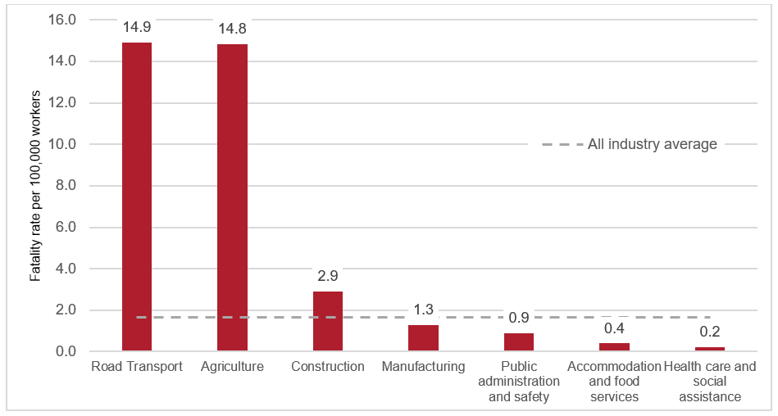

Industries such as Manufacturing, Accommodation and food services, Health care and social assistance and Public administration and safety have low fatality rates but are included as priority industries due to high non-fatal injury rates. For information on non-fatal injuries in these industries, refer to the latest [*Australian Workers’ Compensation Statistics*](https://www.safeworkaustralia.gov.au/collection/australian-workers-compensation-statistics)report*.*

* + 1. Agriculture

Table 5 shows the number of worker fatalities in the Agriculture industry sub-division and related groups, by age group for 2013 to 2017. Over the five year period, workers aged 65 and over accounted for a third (33 per cent) of fatalities in the Agriculture industry. This is more than double the proportion (15 per cent) of fatalities across all industries over the same period and age group.

Within the Agriculture industry, the Sheep, beef cattle and grain farming industry group accounted for 59 per cent of fatalities over the five year period (118 out of 199 fatalities).

Table 5: Worker fatalities: Agriculture industry groups by age group, 2013 to 2017 (combined)

|  |  |  |  |  |  |
| --- | --- | --- | --- | --- | --- |
| **Industry group** | **Under 25** | **25–44** | **45–64** | **65 & over** | **Total** |
| **Sheep, beef cattle & grain farming** | 9 | 20 | 49 | 40 | 118 |
| **Fruit & tree nut growing** | .. | 4 | 10 | 4 | 18 |
| **Other livestock farming** | .. | 3 | 9 | 6 | 18 |
| **Other crop growing** | 3 | 4 | 2 | 7 | 16 |
| **Dairy cattle farming** | 2 | 1 | 7 | 3 | 13 |
| **Mushroom & vegetable growing** | 2 | 2 | 3 | 2 | 9 |
| **Poultry farming** | .. | 1 | 1 | 3 | 5 |
| **Deer farming** | .. | .. | 1 | .. | 1 |
| **Nursery & floriculture production** | 1 | .. | .. | .. | 1 |
| **Grand Total** | **17** | **35** | **82** | **65** | **199** |

Table 6 shows the most common mechanisms of incident[1] causing worker fatalities in the Agriculture industry. A quarter of the fatalities in the Agriculture industry were due to vehicle collisions over the five years to 2017. This was followed by the rollover of non-road vehicles (34 fatalities or 17 per cent) and being hit by moving objects (27 fatalities or 14 per cent).

Table 6: Worker fatalities: Agriculture by mechanism of incident, 2013 to 2017 (combined)

|  |  |  |
| --- | --- | --- |
| **Mechanism of incident** | **No. of fatalities** | **% of fatalities** |
| **Vehicle collision** | 50 | 25% |
| **Rollover of non-road vehicle** | 34 | 17% |
| **Being hit by moving objects** | 27 | 14% |
| **Falls from a height** | 19 | 10% |
| **Being trapped by moving machinery** | 16 | 8% |
| **Being hit by falling objects** | 10 | 5% |
| **Contact with hot objects** | 8 | 4% |
| **Being trapped between stationary and moving objects** | 7 | 4% |
| **Contact with electricity** | 7 | 4% |
| **Being hit by an animal** | 7 | 4% |
| **Other mechanisms** | 14 | 7% |
| **Total** | **199** | **100%** |

* The percentages shown in this table have been rounded to the nearest whole number; therefore the sum of percentage figures for each column may not equal the total.

Table 7 shows whether vehicles were involved[2] in an agricultural worker fatality, and what types of vehicles. Over the five years to 2017 the majority (72 per cent) of fatalities in the Agriculture industry involved a vehicle. Of these fatalities, 40 (20 per cent) involved a tractor and 37 (19 per cent) involved a quad bike.

Table 7: Worker fatalities: Agriculture by vehicle involvement and type of vehicle, 2013 to 2017 (combined)

|  |  |  |
| --- | --- | --- |
| **Vehicle involvement and type of vehicle** | **No. of fatalities** | **% of fatalities** |
| **Vehicle involved** | **144** | **72%** |
| Tractor | 40 | 20% |
| Quad bike | 37 | 19% |
| Ute or car | 13 | 7% |
| Worker on foot | 12 | 6% |
| Aircraft | 11 | 6% |
| Motorbike | 6 | 3% |
| Forklift | 5 | 3% |
| Truck | 4 | 2% |
| Other vehicles | 16 | 8% |
| **No vehicle involved** | **55** | **28%** |
| **Total** | **199** | **100%** |

* The percentages shown in this table have been rounded to the nearest whole number; therefore the sum of percentage figures for each column may not equal the total.

* + 1. Road transport

Over the period from 2013 to 2017, there were 190 worker fatalities in the Road transport industry. Of these, the vast majority (93 per cent) occurred in the Road freight transport sub-division. The remaining 13 fatalities occurred in the Road passenger transport industry.

As shown in Table 8, the majority of fatalities in the Road transport industry over the five years to 2017 were due to vehicle collisions—137 in the Road freight transport industry and 9 in the Road passenger transport industry. Being hit by moving objects (14 fatalities) was the next highest mechanism for the Road freight transport industry, compared with being trapped by moving machinery (3 fatalities) for the Road passenger transport industry.

Table 8: Worker fatalities in Road transport industry groups by mechanism of incident, 2013 to 2017 (combined)

|  |  |  |
| --- | --- | --- |
| **Industry group and mechanism of incident** | **No. of fatalities** | **% of fatalities** |
| **Road freight transport** | **177** | **93%** |
| Vehicle collision | 137 | 72% |
| Being hit by moving objects | 14 | 7% |
| Being hit by falling objects | 8 | 4% |
| Being trapped between stationary and moving objects | 6 | 3% |
| Falls from a height | 4 | 2% |
| Other mechanisms | 8 | 4% |
| **Road passenger transport** | **13** | **7%** |
| Vehicle collision | 9 | 5% |
| Being trapped by moving machinery | 3 | 2% |
| Being assaulted by a person or persons | 1 | 1% |
| **Total** | **190** | **100%** |

* The percentages shown in this table have been rounded to the nearest whole number; therefore the sum of percentage figures for each column may not equal the total.

Table 9 shows that 176 work fatalities (or 93 per cent) in the Road transport industry involved a vehicle, and of these, the majority (149 fatalities) occurred while the deceased worker was driving. A further 10 fatalities occurred while the worker was loading or unloading a vehicle and 6 occurred while the worker was conducting repairs or maintenance on a vehicle.

Table 9: Worker fatalities: Road transport by vehicle involvement and activity of the deceased, 2013 to 2017 (combined)

|  |  |  |
| --- | --- | --- |
| **Vehicle involvement/Deceased activity** | **No. of fatalities** | **% of fatalities** |
| **Vehicle involved** | **176** | **93%** |
| Driving/moving freight/people | 149 | 78% |
| Loading/unloading | 10 | 5% |
| Repair/maintenance | 6 | 3% |
| Entering/exiting vehicle | 1 | 1% |
| Other | 10 | 5% |
| **No vehicle involved** | **14** | **7%** |
| Loading/unloading | 2 | 1% |
| Repair/maintenance | 1 | 1% |
| Other | 11 | 6% |
| **Total** | **190** | **100%** |

* The percentages shown in this table have been rounded to the nearest whole number; therefore the sum of percentage figures for each column may not equal the total.

* + 1. Construction

Over the five year period from 2013 to 2017, there were 153 worker fatalities in the Construction industry in Australia. Figure 7 below shows that almost two-thirds (90 fatalities or 59 per cent) occurred in the Construction services industry sub-division. As Table 10 highlights, these 90 fatalities were relatively evenly spread across the industry groups within the Construction services sub-division.

Figure 7: Worker fatalities: Fatality proportions by construction industry divisions, 2013 to 2017 (combined)

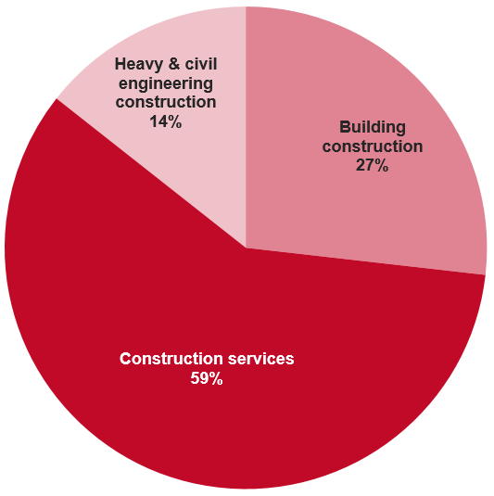

As outlined in Table 10, younger construction workers aged under 25 accounted for 13 per cent of fatalities, compared with only 9 per cent of fatalities across all industries.

Table 10: Worker fatalities: Construction industry sub-divisions and groups by age group, 2013 to 2017 (combined)

|  |  |  |  |  |  |
| --- | --- | --- | --- | --- | --- |
| **Industry sub-divisions and groups** | **Under 25** | **25–44** | **45–64** | **65 & over** | **Total** |
| **Building Construction** | **6** | **12** | **18** | **5** | **41** |
| Residential building construction | 2 | 7 | 9 | 3 | 21 |
| Non-residential building construction | 4 | 5 | 9 | 2 | 20 |
| **Construction Services** | **12** | **27** | **39** | **12** | **90** |
| Other construction services | 5 | 4 | 6 | 5 | 20 |
| Building structure services | 1 | 6 | 12 | 1 | 20 |
| Land development & site preparation services | 1 | 7 | 8 | 2 | 18 |
| Building installation services | 4 | 7 | 6 | .. | 17 |
| Building completion services | 1 | 3 | 7 | 4 | 15 |
| **Heavy & Civil Engineering Construction** | **2** | **7** | **9** | **4** | **22** |
| **Construction Total** | **20** | **46** | **66** | **21** | **153** |

With regard to occupations within the Construction industry, Table 11 shows Labourers (both Construction & mining and Miscellaneous) accounted for 34 per cent of fatalities from 2013 to 2017. This was followed by Electricians accounting for 10 per cent and Bricklayers, carpenters and joiners accounting for 9 per cent of Construction industry fatalities.

Table 11: Worker fatalities: Construction industry occupations, 2013 to 2017 (combined)

|  |  |  |
| --- | --- | --- |
| **Occupation minor groups** | **No. of fatalities** | **% of fatalities** |
| Construction and mining labourers | 37 | 24% |
| Miscellaneous labourers | 15 | 10% |
| Electricians | 15 | 10% |
| Bricklayers, carpenters and joiners | 14 | 9% |
| Mobile plant operators | 10 | 7% |
| Glaziers, plasterers and tilers | 9 | 6% |
| Floor finishers and painting trades workers | 9 | 6% |
| Truck drivers | 7 | 5% |
| Plumbers | 7 | 5% |
| Construction, distribution and production managers | 7 | 5% |
| Stationary plant operators | 6 | 4% |
| Electronics and telecommunications trades workers | 3 | 2% |
| Other occupations | 14 | 9% |
| **Construction Total** | **153** | **100%** |

* The percentages shown in this table have been rounded to the nearest whole number; therefore the sum of percentage figures for each column may not equal the total.

In terms of mechanism of the fatalities, Table 12 shows that between 2013 and 2017, falls from a height were the main cause of fatalities in both the Building construction and Construction services industry sub-divisions. By contrast, being hit by moving objects caused the most fatalities in the Heavy and civil engineering construction industry sub-division.

Fatalities arising from vehicle collisions were most common in the Construction services industry sub-division, causing 13 deaths. Being hit by falling objects was a common cause of fatality across Building construction and Construction services, totalling 22 fatalities. Lastly, contact with electricity was a significant cause of fatalities in Construction services (12 fatalities).

Table 12: Worker fatalities: Construction industry sub-divisions by mechanism of incident, 2013 to 2017 (combined)

|  |  |  |
| --- | --- | --- |
| **Construction sub-division and mechanism** | **No. of fatalities** | **% of fatalities** |
| **Building construction** | **41** | **27%** |
| Falls from a height | 17 | 41% |
| Being hit by falling objects | 10 | 24% |
| Being hit by moving objects | 5 | 12% |
| Contact with electricity | 3 | 7% |
| Vehicle collision | 2 | 5% |
| Being trapped between stationary and moving objects | 2 | 5% |
| Other mechanisms | 2 | 5% |
| **Construction services** | **90** | **59%** |
| Falls from a height | 28 | 31% |
| Vehicle collision | 13 | 14% |
| Being hit by falling objects | 12 | 13% |
| Contact with electricity | 12 | 13% |
| Being trapped between stationary and moving objects | 8 | 9% |
| Being hit by moving objects | 5 | 6% |
| Being trapped by moving machinery | 4 | 4% |
| Rollover of non-road vehicle | 3 | 3% |
| Slide or cave-in | 2 | 2% |
| Other mechanisms | 3 | 3% |
| **Heavy & civil engineering construction** | **22** | **14%** |
| Being hit by moving objects | 9 | 41% |
| Vehicle collision | 5 | 23% |
| Being trapped between stationary and moving objects | 3 | 14% |
| Falls from a height | 1 | 5% |
| Other mechanisms | 4 | 18% |
| **Construction Total** | **153** | **100%** |

* The percentages shown in this table have been rounded to the nearest whole number; therefore the sum of percentage figures for each column may not equal the total.

Across the Construction industry, falls from a height caused 46 fatalities (or 30 per cent) over the five years to 2017. As shown in Table 13 below, over a third (35 per cent) of these involved falls from a building or other type of structure, and almost a quarter (22 per cent) involved a fall from a ladder.

Table 13: Worker fatalities: Construction industry, falls from a height fatalities by breakdown agency, 2013 to 2017 (combined)

|  |  |  |
| --- | --- | --- |
| **Breakdown agency** | **No. of fatalities** | **% of fatalities** |
| **Buildings and other structures** | 16 | 35% |
| **Ladders** | 10 | 22% |
| **Openings in floors, walls or ceilings** | 4 | 9% |
| **Scaffolding** | 3 | 7% |
| **Doors and windows** | 3 | 7% |
| **Cranes** | 2 | 4% |
| **Other agencies** | 8 | 17% |
| **Falls from a height – Total** | **46** | **100%** |

* The percentages shown in this table have been rounded to the nearest whole number; therefore the sum of percentage figures for each column may not equal the total.

* 1. Occupation

In 2017, 56 Labourers were killed, accounting for the largest proportion (29 per cent) of all worker fatalities. Table 14 below shows Machinery operators and drivers accounted for a further 29 per cent (55 fatalities) of fatalities, the majority of which (80 per cent) were Road and rail drivers. Managers accounted for a further 14 per cent (26 fatalities) and Technicians and trades workers 9 per cent (17 fatalities).

Table 14: Worker fatalities: number of fatalities by major and sub-major occupation groups, 2016, 2017 and five year average (2013 to 2017)

|  |  |  |  |
| --- | --- | --- | --- |
| **Occupation** | **Number of fatalities** | | |
| **2016** | **2017** | **5yr average** |
| **Machinery operators and drivers** | **66** | **55** | **64** |
| Road and rail drivers | 53 | 44 | 48 |
| Machine and stationary plant operators | 5 | 7 | 8 |
| Mobile plant operators | 8 | 3 | 8 |
| **Labourers** | **44** | **56** | **47** |
| Farm, forestry and garden workers | 15 | 18 | 17 |
| Construction and mining labourers | 13 | 13 | 11 |
| **Managers** | **27** | **26** | **29** |
| Farmers and farm managers | 23 | 21 | 24 |
| **Technicians and trades workers** | **28** | **17** | **28** |
| Construction trades workers | 12 | 7 | 9 |
| Electrotechnology and telecommunications trades workers | 7 | 2 | 7 |
| Automotive and engineering trades workers | 3 | 3 | 7 |
| **Professionals** | **14** | **18** | **14** |
| Design, engineering, science and transport professionals | 8 | 14 | 9 |
| **Community and personal service workers** | **5** | **14** | **11** |
| Sports and personal service workers | 1 | 7 | 5 |
| Protective service workers | 3 | 4 | 4 |
| **Clerical & administrative workers** | **2** | **1** | **3** |
| **Sales workers** | **1** | **3** | **2** |
| **Total** | **187** | **190** | **197** |

Figure 8 below presents 2017 and five year average (2013 to 2017) fatality rates for the ‘sub-major’ classification tier of occupations. Only sub-major occupations with a 2017 fatality rate over the national 2017 average fatality rate of 1.5 fatalities per 100,000 workers are shown. Farm, forestry and garden workers had the highest 2017 rate of 14.9 fatalities per 100,000 workers, followed by Farmers and farm managers (13.5) and Road and rail drivers (12.4).

Figure 8: Worker fatalities: occupations with 2017 fatality rates over the 2017 national average, 2017 and 5 year average (2013 to 2017) rates

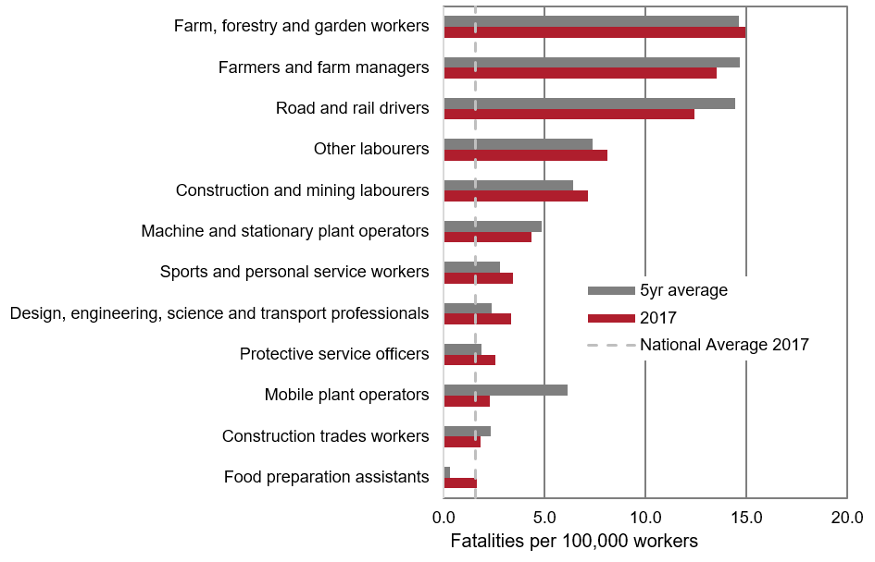

* 1. Worker fatalities by State/Territory

The data presented in this section relates to the state or territory where the fatality occurred and not necessarily the jurisdiction. Table 15 shows that in 2017, the vast majority of worker fatalities occurred in in New South Wales (62 fatalities), Queensland (45 fatalities), and Victoria (36 fatalities).

Table 15: Worker fatalities: number by State/Territory of death, 2016, 2017 and five year average (2013 to 2017)

|  |  |  |  |  |  |  |
| --- | --- | --- | --- | --- | --- | --- |
| **State/Territory** | **Number of fatalities** | | | **Fatality rates** | | |
| **2016** | **2017** | **5yr average (2013–2017)** | **2016** | **2017** | **5yr average (2013–2017)** |
| **New South Wales** | 54 | 62 | 58 | 1.4 | 1.6 | 1.6 |
| **Queensland** | 45 | 45 | 49 | 1.9 | 1.9 | 2.1 |
| **Victoria** | 36 | 36 | 37 | 1.2 | 1.1 | 1.2 |
| **Western Australia** | 20 | 20 | 28 | 1.5 | 1.5 | 2.1 |
| **South Australia** | 21 | 14 | 14 | 2.6 | 1.7 | 1.7 |
| **Northern Territory** | 4 | 7 | 4 | 3.0 | 5.1 | 3.2 |
| **Tasmania** | 6 | 5 | 7 | 2.5 | 2.0 | 2.8 |
| **Australian Capital Territory** | 1 | 1 | 1 | 0.5 | 0.4 | 0.3 |
| **Total** | **187** | **190** | **197** | **1.6** | **1.5** | **1.7** |

Table 16 shows the industries that had the highest numbers of fatalities occurring in each state or territory over the 5 years from 2013 to 2017. As seen in the national overview of industries, Agriculture, forestry and fishing, Transport, postal and warehousing and Construction account for most worker fatalities across all the states and territories (65 per cent nationally from 2013 to 2017).

Table 16: Worker fatalities: number by State/Territory of death and industries with the highest number of fatalities, 2013 to 2017 (combined)

|  |  |  |  |  |  |  |  |  |
| --- | --- | --- | --- | --- | --- | --- | --- | --- |
| **Industry** | **New South Wales** | **Queensland** | **Victoria** | **Western Australia** | **South Australia** | **Tasmania** | **Northern Territory** | **National total (2013–2017)** |
| **Agriculture, forestry & fishing** | 65 | 68 | 64 | 25 | 19 | 9 | 4 | 254 |
| **Transport, postal & warehousing** | 71 | 54 | 39 | 35 | 22 | 6 | 8 | 235 |
| **Construction** | 52 | 37 | 29 | 21 | 9 | 3 | 1 | 153 |
| **Manufacturing** | 23 | 13 | 3 | 15 | .. | 4 | .. | 58 |
| **Mining** | 8 | 10 | 1 | 14 | 2 | 3 | 2 | 40 |
| **Arts & recreation services** | 9 | 14 | 6 | 4 | 2 | .. | 1 | 37 |
| **Public administration & safety** | 7 | 9 | 5 | 4 | 4 | 1 | 2 | 33 |
| **Administrative & support services** | 4 | 8 | 6 | 5 | 4 | 1 | .. | 28 |
| **Other services** | 5 | 7 | 3 | 6 | 3 | 2 | .. | 26 |
| **Electricity, gas, water & waste services** | 5 | 4 | 8 | 5 | 1 | .. | .. | 23 |
| **Other industries** | 41 | 21 | 21 | 6 | 4 | 4 | 3 | 100 |
| **Total** | **290** | **245** | **185** | **140** | **70** | **33** | **21** | **987** |

* The Australian Capital Territory was not included separately due to the low number of fatalities, however, the total includes the Australian Capital Territory.

* 1. Mechanism of incident

The mechanism of incident refers to the overall action, exposure or event that describes the circumstances that resulted in a worker fatality.

Table 17 below shows that 60 worker fatalities (31 per cent) were due to a vehicle collision in 2017, 17 less than in 2016 and 8 below the five year average (2013 to 2017). This includes incidents where an occupant of a vehicle is killed following a collision with another vehicle or a stationary object.

Being hit by moving objects accounted for the next highest proportion of worker fatalities (18 per cent, 35 fatalities) in 2017, which was higher than its proportion of 10 per cent (18 fatalities) in 2016. Falls from a height accounted for the third highest proportion in 2017 at 15 per cent (28 fatalities), followed by being hit by falling objects (8 per cent, 15 fatalities).

These top four mechanisms accounted for almost three-quarters of worker fatalities in 2017 (73 per cent).

Table 17: Worker fatalities: number by mechanism of incident, 2013 to 2017 (sorted by five year average)

|  |  |  |  |  |  |  |
| --- | --- | --- | --- | --- | --- | --- |
| **Mechanism of incident** | **Number of fatalities** | | | **% of fatalities** | | |
| **2016** | **2017** | **5 yr**  **average (2013–2017)** | **2016** | **2017** | **5 yr**  **average (2013–2017)** |
| **Vehicle incident** | 77 | 60 | 68 | 41% | 32% | 34% |
| **Falls from a height** | 25 | 28 | 26 | 13% | 15% | 13% |
| **Being hit by moving objects** | 18 | 35 | 26 | 10% | 18% | 13% |
| **Being hit by falling objects** | 17 | 15 | 19 | 9% | 8% | 10% |
| **Rollover of non-road vehicle** | 4 | 10 | 10 | 2% | 5% | 5% |
| **Being trapped between stationary and moving objects** | 4 | 10 | 9 | 2% | 5% | 4% |
| **Being trapped by moving machinery** | 8 | 3 | 8 | 4% | 2% | 4% |
| **Contact with electricity** | 7 | 4 | 6 | 4% | 2% | 3% |
| **Drowning** | 7 | 8 | 5 | 4% | 4% | 2% |
| **Being assaulted by a person or persons** | 4 | 2 | 4 | 2% | 1% | 2% |
| **Contact with hot objects** | 3 | 3 | 3 | 2% | 2% | 2% |
| **Explosion** | 2 |  | 4 | 1% | 0% | 2% |
| **Being hit by an animal** | 3 | 3 | 2 | 2% | 2% | 1% |
| **Slide or cave-in** | 1 | 2 | 2 | 1% | 1% | 1% |
| **Other mechanisms** | 7 | 7 | 7 | 4% | 4% | 3% |
| **Grand Total** | **187** | **190** | **197** | **100%** | **100%** | **100%** |

* The percentages shown in this table have been rounded to the nearest whole number; therefore the sum of percentage figures for each column may not equal the total.

* 1. Breakdown agency

The breakdown agency identifies the object, substance or circumstance principally involved at the point at which things started to go wrong and ultimately led to a worker fatality.

Figure 9 shows that the breakdown agency of mobile plant and transport accounted for over half (56 per cent) of fatalities over the five years to 2017. Mobile plant and transport includes objects such as cars, tractors and excavators. Environmental agencies accounted for the second most common breakdown agency (14 per cent of fatalities), which includes objects such as buildings and vegetation.

Figure 9: Worker fatalities: proportion by breakdown agencies, 2013 to 2017 (combined)

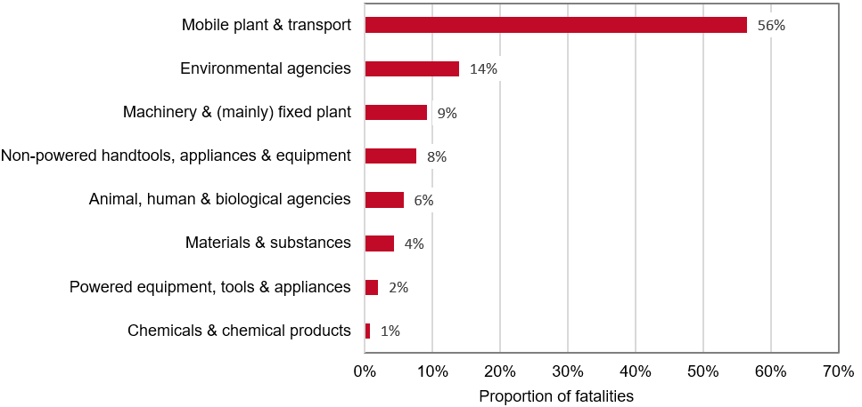

The following sections analyse selected mechanisms of incidents in conjunction with breakdown agencies, providing an overview of types of high-risk work that can result in worker fatalities. For a comprehensive overview of breakdown agency coding, see the [Type of Occurrence Classification System (TOOCS), 3rd Edition](https://www.safeworkaustralia.gov.au/doc/type-occurrence-classification-system-3rd-edition-revision-1).

* 1. Being hit by moving objects

In 2017, 35 workers were killed as a result of being hit by moving objects. This is almost double the number in 2016 (18 fatalities).

As shown in Table 18, 54 per cent of these fatalities were caused by mobile plant and transport in 2017. Within the mobile plant and transport category, being hit by heavy vehicles (trucks, semi-trailers and lorries) accounted for the highest proportion (20 per cent), followed by light vehicles such as cars, station wagons, vans and utilities (11 per cent). These fatalities are of workers who were not occupants in a vehicle – vehicle occupant fatalities are analysed further in section 1.12.

With mobile plant and transport accounting for the majority of 2017 fatalities due to being hit by moving objects, the remaining fatalities were evenly spread across breakdown agencies. The next most common breakdown agency was machinery & (mainly) fixed plant (11 per cent), which involves plant such as cranes and forklifts.

Table 18: Worker fatalities due to being hit by moving objects: number by breakdown agency, 2013 to 2017 (sorted by five year average)

|  |  |  |  |  |  |  |  |
| --- | --- | --- | --- | --- | --- | --- | --- |
| **Breakdown agency** | **2013** | **2014** | **2015** | **2016** | **2017** | **% of 2017** | **% of 5 yr average (2013–2017)** |
| **Mobile plant & transport** | **16** | **17** | **18** | **11** | **19** | **54%** | **63%** |
| Trucks, semi-trailers, lorries | 5 | 5 | 3 | 2 | 7 | 20% | 17% |
| Cars, station wagons, vans, utilities | 5 | 2 | 3 | .. | 4 | 11% | 11% |
| Tractors, agricultural or otherwise | 1 | 5 | 3 | 3 | 4 | 11% | 13% |
| Self-propelled plant | 3 | 2 | 6 | 5 | 1 | 3% | 13% |
| Other mobile plant and transport | 2 | 3 | 3 | 1 | 3 | 9% | 9% |
| **Machinery & (mainly) fixed plant** | **5** | **1** | **3** | **2** | **4** | **11%** | **12%** |
| **Powered equipment, tools & appliances** | **..** | **..** | **3** | **2** | **3** | **9%** | **7%** |
| **Non-powered handtools, appliances & equipment** | **2** | **2** | **2** | **..** | **3** | **9%** | **7%** |
| **Animal, human & biological agencies** | **..** | **1** | **1** | **1** | **2** | **6%** | **4%** |
| **Environmental agencies** | **..** | **1** | **2** | **..** | **1** | **3%** | **3%** |
| **Materials & substances** | **..** | **..** | **..** | **1** | **3** | **9%** | **3%** |
| **Chemicals & chemical products** | **1** | **..** | **..** | **..** | **..** | **..** | **1%** |
| **Total – being hit by moving objects** | **24** | **22** | **29** | **18** | **35** | **100%** | **100%** |

* The percentages shown in this table have been rounded to the nearest whole number; therefore the sum of percentage figures for each column may not equal the total.

* 1. Falls from a height

In 2017, 28 workers died as a result of a fall from a height.

Table 19 shows that over the 5 years to 2017, falls from a height most commonly involved falls from a roof (15 per cent of fatalities), ladder (14 per cent), horses, donkeys and mules (11 per cent) and trucks, semi-trailers and lorries (7 per cent).

Table 19: Worker fatalities due to falls from a height: number by selected breakdown agencies, 2013 to 2017 (sorted by five year average)

|  |  |  |  |  |  |  |  |
| --- | --- | --- | --- | --- | --- | --- | --- |
| **Breakdown agency** | **2013** | **2014** | **2015** | **2016** | **2017** | **% of 2017** | **% of 5yr average (2013–2017)** |
| **Environmental agencies** | **7** | **10** | **12** | **9** | **11** | **39%** | **38%** |
| Roof | 2 | 5 | 6 | 4 | 3 | 11% | 15% |
| Openings in floors, walls or ceilings | **..** | 1 | 1 | 2 | 3 | 11% | 5% |
| **Non-powered handtools, appliances & equipment** | **4** | **4** | **7** | **10** | **6** | **21%** | **24%** |
| Ladders | 3 | 2 | 3 | 6 | 4 | 14% | 14% |
| Scaffolding | .. | .. | 2 | 2 | .. | 0% | 3% |
| **Mobile plant & transport** | **7** | **2** | **5** | **3** | **6** | **21%** | **18%** |
| Trucks, semi-trailers, lorries | 3 | .. | 3 | 1 | 2 | 7% | 7% |
| Tractors, agricultural or otherwise | 1 | .. | .. | .. | 3 | 11% | 3% |
| **Animal, human & biological agencies** | **5** | **3** | **3** | **1** | **3** | **11%** | **12%** |
| Horses, donkeys, mules | 4 | 3 | 3 | 1 | 3 | 11% | 11% |
| **Machinery & (mainly) fixed plant** | **3** | **3** | **2** | **1** | **1** | **4%** | **8%** |
| Elevating work platforms | 1 | .. | 2 | .. | .. | 0% | 2% |
| **Total – Falls from a height** | **26** | **22** | **29** | **25** | **28** | **100%** | **100%** |

* The sum of the number of fatalities and percentage figures for each column may not equal the total due to rounding and the inclusion of selected subcategories in some breakdown agencies. The total also includes fatalities where the breakdown agency was unknown.

* 1. Being hit by falling objects

In 2017, 15 workers died due to being hit by falling objects.

Table 20 provides more detail on the object (agency) which hit the worker. Over the five years up to 2017, 15 per cent of fatalities occurred as a result of a worker being hit by falling vegetation. This was followed by trucks, semi-trailers and lorries (12 per cent) and ferrous and non-ferrous metal (9 per cent).

Table 20: Worker fatalities due to being hit by falling objects: number by selected breakdown agencies, 2013 to 2017 (sorted by five year average)

|  |  |  |  |  |  |  |  |
| --- | --- | --- | --- | --- | --- | --- | --- |
| **Breakdown agency** | **2013** | **2014** | **2015** | **2016** | **2017** | **% of 2017** | **% of 5yr average (2013–2017)** |
| **Environmental agencies** | **8** | **6** | **3** | **6** | **3** | **20%** | **27%** |
| Vegetation | 6 | 2 | 2 | 3 | 1 | 7% | 15% |
| Buildings and other structures | 2 | 3 | .. | 1 | 1 | 7% | 7% |
| **Mobile plant & transport** | **6** | **4** | **10** | **3** | **1** | **7%** | **25%** |
| Trucks, semi-trailers, lorries | 4 | 3 | 1 | 2 | 1 | 7% | 12% |
| Tractors, agricultural or otherwise | 1 | .. | 1 | 1 | .. | .. | 3% |
| **Materials & substances** | **5** | **3** | **5** | **5** | **4** | **27%** | **23%** |
| Ferrous and non-ferrous metal | 3 | 3 | .. | 2 | 1 | 7% | 9% |
| Sawn or dressed timber | .. | .. | 2 | 1 | 1 | 7% | 4% |
| Bricks and tiles and concrete, cement and clay products, not elsewhere classified | .. | .. | 2 | 1 | 1 | 7% | 4% |
| **Machinery & (mainly) fixed plant** | **2** | **2** | **1** | **3** | **3** | **20%** | **12%** |
| Cranes | 1 | .. | .. | 1 | 1 | 7% | 3% |
| Forklift trucks | .. | 1 | .. | 1 | 1 | 7% | 3% |
| **Non-powered handtools, appliances & equipment** | **3** | **2** | **2** | **..** | **4** | **27%** | **12%** |
| Storage equipment | 2 | .. | 1 | .. | 1 | 7% | 4% |
| Doors and windows | 1 | 2 | .. | .. | .. | .. | 3% |
| **Total – Being hit by falling objects** | **25** | **17** | **21** | **17** | **15** | **100%** | **100%** |

* Only selected agency subgroups are included. Therefore the number of fatalities in the selected subcategories will not add to the category total. The percentage figures are also rounded to the nearest whole number.

* 1. Vehicle involvement and collisions

Safe Work Australia’s work-related fatalities database collects two sources of information relating to vehicles:

* Whether a vehicle was principally involved in the incident leading to a worker fatality, referred to as ‘vehicle involvement’
* ‘Vehicle collisions’, where a vehicle crash occurred and the occupant of the vehicle was killed[3]

Over the five year period from 2013 to 2017, 60 per cent of worker fatalities (597 fatalities) involved vehicles. Of these, just under half (291 fatalities) occurred on a public road.

Table 21 shows that the vast majority (85 per cent) of worker fatalities involving vehicles on public roads were the result of a vehicle collision. This was followed by being hit by moving objects, which accounted for a further 8 per cent of fatalities.

By contrast, less than a third (30 per cent) of fatalities involving a vehicle not on a public road were due to a vehicle collision. A further 20 per cent were caused by being hit by a moving object and 15 per cent due to the rollover of a non-road vehicle.

Table 21: Worker fatalities by vehicle involvement: percentage by public road status and mechanism of incident, 2013 to 2017 combined (sorted by vehicle involved fatalities)

|  |  |  |  |  |  |
| --- | --- | --- | --- | --- | --- |
| **Mechanism of fatality** | **Vehicle involved: On a public road** | **Vehicle involved: Not on a public road** | **Vehicle involved: Total** | **No vehicle involved** | **Total** |
| **Vehicle collision** | 85% | 30% | 57% | .. | **34%** |
| **Being hit by moving objects** | 8% | 20% | 14% | 11% | **13%** |
| **Rollover of non-road vehicle** | 2% | 15% | 8% | .. | **5%** |
| **Being hit by falling objects** | 0% | 8% | 4% | 18% | **10%** |
| **Being trapped between stationary and moving objects** | 1% | 8% | 5% | 4% | **4%** |
| **Being trapped by moving machinery** | 1% | 6% | 3% | 5% | **4%** |
| **Falls from a height** | 0% | 7% | 4% | 28% | **13%** |
| **Other mechanisms** | 2% | 8% | 5% | 33% | **16%** |
| **Total** | **29%** | **31%** | **60%** | **40%** | **100%** |

* The percentages shown in this table have been rounded to the nearest whole number; therefore the sum of percentage figures for each column may not equal the total.

Table 22 shows in 2017, of the 60 workers who died in a vehicle collision, over two thirds (68 per cent) involved single vehicle collisions and just under half of these involved heavy vehicles (19 fatalities). A further 13 fatalities were as a result of an aircraft crash.

Table 22: Worker fatalities due to vehicle collision: number by type of collision and breakdown agency, 2013 to 2017

|  |  |  |  |  |  |  |  |
| --- | --- | --- | --- | --- | --- | --- | --- |
| **Type of collision** | **2013** | **2014** | **2015** | **2016** | **2017** | **% of 2017** | **% of 5yr average** |
| **Single vehicle collision** | **42** | **51** | **35** | **46** | **41** | **68%** | **64%** |
| Heavy vehicle | 18 | 24 | 17 | 21 | 19 | 46% | 46% |
| Aircraft | 10 | 9 | 5 | 7 | 13 | 32% | 21% |
| Light vehicle | 5 | 9 | 6 | 13 | 3 | 7% | 17% |
| Quad bike | 4 | 5 | 5 | .. | 2 | 5% | 7% |
| Motorbike | 2 | 3 | .. | .. | 3 | 7% | 4% |
| Agriculture vehicle | 2 | .. | .. | 3 | .. | 0% | 2% |
| Other single vehicle | 1 | 1 | 2 | 2 | 1 | 2% | 3% |
| **Multi vehicle collision** | **25** | **23** | **25** | **31** | **19** | **32%** | **36%** |
| Two heavy vehicles | 7 | 8 | 6 | 10 | 6 | 32% | 30% |
| Occupant in a light vehicle killed in collision with a heavy vehicle | 7 | 5 | 6 | 5 | 5 | 26% | 23% |
| Two light vehicles | 4 | 4 | 7 | 9 | 4 | 21% | 23% |
| Occupant in a heavy vehicle killed in collision with a light vehicle | 4 | 3 | 2 | 4 | 1 | 5% | 11% |
| Other multi-vehicle collision | 3 | 3 | 4 | 3 | 3 | 16% | 13% |
| **Total – vehicle collision** | **67** | **74** | **60** | **77** | **60** | **100%** | **100%** |

* The percentages shown in this table have been rounded to the nearest whole number; therefore the sum of percentage figures for each column may not equal the total.

The remaining 19 fatalities in 2017 due to a vehicle collision involved a multi-vehicle collision. One third (32 per cent) of these involved two heavy vehicles and a further 26 per cent involved an occupant in a light vehicle killed in collision with a heavy vehicle.



Section 2: Bystander Fatalities

1. Bystander fatalities by mechanism of incident

The actions of a worker or a fault in a workplace resulted in the deaths of 67 members of the public (referred to as bystanders) in 2017.

Table 23 shows over the five year period from 2013 to 2017, 58 per cent of the bystander fatalities were due to a vehicle collision, with being hit by moving objects accounting for a further 18 per cent.

Drowning and falls from a height each accounted for 6 per cent of fatalities over the same period, and being hit by falling objects accounted for 5 per cent.

Table 23: Bystander fatalities: number by mechanism of incident, 2013 to 2017 (sorted by five year average)

|  |  |  |  |  |  |  |  |
| --- | --- | --- | --- | --- | --- | --- | --- |
| **Mechanism of fatality** | **2013** | **2014** | **2015** | **2016** | **2017** | **% of 2017** | **% of 5yr average (2013–2017)** |
| **Vehicle collision** | 43 | 42 | 30 | 25 | 41 | 61% | 58% |
| **Being hit by moving objects** | 8 | 10 | 9 | 12 | 16 | 24% | 18% |
| **Drowning** | .. | 5 | 5 | 7 | 1 | 1% | 6% |
| **Being hit by falling objects** | 6 | 3 | 2 | 3 | .. | 0% | 5% |
| **Falls from a height** | 4 | 6 | 3 | 1 | 4 | 6% | 6% |
| **Other mechanisms** | 6 | 6 | 2 | 5 | 5 | 7% | 8% |
| **Total** | **67** | **72** | **51** | **53** | **67** | **100%** | **100%** |

* The percentages shown in this table have been rounded to the nearest whole number; therefore the sum of percentage figures for each column may not equal the total.

* 1. Bystander fatalities by age group

Table 24 shows that for the period of 2013 to 2017, children under 14 years of age and those aged 65 years or older accounted for 13 per cent (41 fatalities) and 22 per cent (69 fatalities) of fatalities, respectively.

Bystander fatalities caused by a vehicle collision accounted for the highest number of fatalities across all age groups. This was followed by being hit by moving objects, where children aged 14 and under accounted for 22 per cent (12 fatalities) and bystanders aged 65 and over accounted for 27 per cent (15 fatalities). Bystanders 65 and over accounted for 44 per cent of falls from a height, the majority (5 fatalities) of which occurred in a health care setting.

Table 24: Bystander fatalities: number by age group, 2013 to 2017

|  |  |  |  |  |  |
| --- | --- | --- | --- | --- | --- |
| **Mechanism of fatality** | **14 & under** | **15–24** | **25–44** | **45–64** | **65 & over** |
| **Vehicle collision** | 16 | 24 | 57 | 58 | 26 |
| **Being hit by moving objects** | 12 | 2 | 8 | 18 | 15 |
| **Drowning** | 1 | 3 | 3 | 4 | 7 |
| **Falls from a height** | 4 | 2 | 2 | 2 | 8 |
| **Being hit by falling objects** | 5 | 2 | 2 | 2 | 3 |
| **Other mechanisms** | 3 | 1 | 7 | 3 | 10 |
| **Total** | **41** | **34** | **79** | **87** | **69** |

Section 3:   
Data sources & Glossary

1. Data sources

The Traumatic Injury Fatalities dataset uses information from four datasets:

* National Data Set for Compensation-based Statistics (NDS), constructed using accepted workers’ compensation claims
* Notifiable Fatalities Collection (NFC), constructed using work-related fatalities that are notified to Australian work health and safety authorities
* National Coronial Information System (NCIS), constructed using deaths reported to Australian coroners
* Labour Force Survey data, conducted by the Australian Bureau of Statistics (ABS category number 6202.0) to provide the number of workers to calculate fatality rates

These four datasets are also supplemented by monitoring of work-related fatalities through Australian media by Safe Work Australia.

For more information on Safe Work Australia datasets, refer to <https://www.safeworkaustralia.gov.au/doc/explanatory-notes-safe-work-australia-datasets>.

* 1. Glossary

**Being hit by moving objects**

Part of the Mechanism classification used to describe the action of an object hitting a person. This includes pedestrians hit by vehicles as well as being hit by other moving equipment or objects.

**Breakdown agency**

A part of the TOOCS classification which identified the object, substance or circumstance principally involved at the point at which things started to go wrong and ultimately led to a worker fatality.

**Bystander fatality**

The death of a person who dies from injuries sustained as a result of another person’s work activity and who was not engaged in a work activity of their own at the time of the injury. A traffic incident death is only classified as a bystander fatality when attributable to someone else’s work activity. Typically, this means the driver of a work vehicle is at fault. Cases where fault could not be determined with sufficient confidence are excluded.

**Employed person**

The denominators used in calculating fatality rates in this report are based on ABS estimates of Employed persons, as defined in Labour force, Australia (ABS cat no 6202.0). This population includes Employees (who work for an employer); self-employed persons (regardless of whether they employ others or not); and those who work without pay for a family business or farm. It excludes persons whose only work is voluntary.

**Employee**

A person who works for a public or private employer and receives remuneration in wages, salary, a retainer fee from their employer while working on a commission basis, tips, piece-rates, or payment in kind; or a person who operates his or her own incorporated enterprise with or without hiring employees.

**Fatality rate**

The number killed as a result of work-related injury expressed as a per-capita rate against the population at risk of work-related injury. In this report the rate is expressed as the number of fatalities per 100,000 Employed persons: for brevity this is usually expressed as ‘fatalities per 100,000 workers’. See Paragraph 4 of the Explanatory notes for further details.

**Industry**

A grouping of businesses that carry out similar economic activities. Fatalities data in this publication have been coded to the Australian and New Zealand Standard Industrial Classification (ANZSIC) 2006 (ABS cat. no. 1292.0). ANZSIC utilises four levels of industry classification—division, subdivision, group and class—and unless specified in this report, industries are presented at the division level.

**Injury**

A condition coded to ‘External causes of morbidity and mortality’ and ‘Injury, poisoning and certain other consequences of external causes’ in the International Statistical Classification of Diseases and Related Health Problems, Tenth Revision, Australian Modification (ICD–10–AM).

**Job**

A set of tasks designed to be performed by one person for an employer (including self-employment) in return for payment or profit.

**Mechanism of incident**

The action, exposure or event that best describes the circumstances that resulted in the most serious injury.

**Non-public road incident**

An incident involving a vehicle that occurred at a worksite, on a private road or a public area that is not a public road. These incidents include plane crashes and incidents involving watercraft as well as vehicle crashes on farming properties.

**Occupation**

A set of jobs with similar sets of tasks. Fatalities data in this publication have been coded to the Australian and New Zealand Standard Classification of Occupations (ANZSCO) (ABS cat. no. 1220.0) First edition. ANZSCO utilises four levels of occupational classification—major, sub-major, minor and unit groups—and unless specified in this report, occupations are presented at the major group level.

**Public road incident**

A collision on a public road between any vehicle or self-propelled plant and anything else including a pedestrian. Incidents involving vehicles at worksites or on private roads are excluded. Public road incidents can be due to a Vehicle collision or being hit by a vehicle (which is included in the Mechanism of Being hit by moving objects).

**Rollover of non-road vehicle**

Part of the Mechanism classification used to identify when a vehicle that is not normally a road vehicle overturns. This includes tractors and quad bikes being used on farm properties.

**Type of occurrence classification system (TOOCS)**

A suite of four classifications to code the way an injury occurred, comprising the Nature of injury/disease classification, the Bodily location of injury/disease classification, Mechanism of incident classification, and the Agency of injury/disease classification. Version 3.1 is used for coding the data presented in this report. Fatalities are only coded by Mechanism and Agency.

**Vehicle collision**

Part of the Mechanism of incident classification that identifies fatalities that occurred due to a vehicle crash and where the occupant of the vehicle was killed. In the classification, this category is called Vehicle Incident but has been renamed to assist with reader understanding. Vehicle collisions that occur on public roads are further classified as a public road incidents and do not include people hit by a vehicle, which are coded to Being hit by moving objects. Vehicles not only include cars and trucks but also include other motorised equipment such as aircraft, boats, loaders, tractors and quad bikes.

**Volunteer**

Persons who undertake voluntary work through or for an organisation or group are included in the worker counts where that organisation or group is a business enterprise. It does not include sporting organisations or caring activities.

**Worker fatality**

The death of a person who dies from injuries sustained while at work, including those workers whose injury was caused by another’s work activity. Workers include employees, self-employed persons, volunteers and contributing family workers.

1. See Glossary for explanation of ‘mechanism of incident’
2. See Glossary for explanation of ‘vehicle involvement’
3. Refer to the Glossary for more detail on Vehicle collisions