Guide to managing risk in construction: Prefabricated Concrete

Guidance material

september 2019

**Disclaimer**

Safe Work Australia is an Australian Government statutory agency established in 2009. Safe Work Australia includes Members from the Commonwealth, and each state and territory, Members representing the interests of workers and Members representing the interests of employers.

Safe Work Australia works with the Commonwealth, state and territory governments to improve work health and safety and workers’ compensation arrangements. Safe Work Australia is a national policy body, not a regulator of work health and safety. The Commonwealth, states and territories have responsibility for regulating and enforcing work health and safety laws in their jurisdiction.

ISBN 978-1-76051-834-9 (Online DOCX)

ISBN 978-1-76051-833-2 (Online PDF)

**Creative Commons**

This copyright work is licensed under a Creative Commons Attribution-Noncommercial 4.0 International licence. To view a copy of this licence, visit creativecommons.org/licenses In essence, you are free to copy, communicate and adapt the work for non-commercial purposes, as long as you attribute the work to Safe Work Australia and abide by the other licence terms.

**Contact information**

Safe Work Australia | <mailto:info@swa.gov.au> | [www.swa.gov.au](http://swa.hosts.application.enet/business-support/Communication/Documents/www.swa.gov.au)

# Contents

Contents 3

1. Introduction 5

1.1. What is prefabricated concrete? 5

1.2. Who should use this guide 5

1.3. Scope 5

2. Duties under WHS laws 6

2.1. Who has health and safety duties at the workplace? 6

2.2. Managing risks to health and safety associated with prefabricated concrete 8

2.3. Training, instruction and supervision 10

2.4. Information 11

2.5. Consultation 11

3. Planning and safe design 13

3.1. Roles and functions 13

3.2. Safe structural design 14

3.3. Safe erection design 15

3.4. Proprietary documentation 16

4. Element manufacture 19

4.1. Pre-pour inspection 19

4.2. Casting concrete 19

4.3. Post manufacture 21

5. Transport and storage 22

5.1. Planning on-site movement 22

5.2. Loading 22

5.3. Transport 23

5.4. Unloading 24

5.5. Storage 24

6. Erection process 26

6.1. Pre-erection 26

6.2. Crane setup and operation 27

6.3. During erection 28

6.4. When temporarily erected 33

6.5. Post-erection 33

Appendix A – Technical standards and other references 35

Appendix B – Template: Assigning roles and functions 36

Appendix C – Template: Manufacture certificate of compliance 37

Appendix D – Template: Qualification register 38

Appendix E – Pre-erection checklist 39

Erection planning 39

Site 39

Erection crew 39

Element quality 39

Cranes and rigging 40

# Introduction

## What is prefabricated concrete?

Prefabricated concrete is a concrete element that is manufactured somewhere other than its final place of installation. Examples of prefabricated concrete elements used in construction include wall elements, columns, beams, flooring and façade units, concrete pipes, bridge beams or culverts.

Prefabricated concrete construction is a method of prefabricating concrete in discrete elements and erecting and incorporating them by crane into their final position in the building structure.

## Who should use this guide

This guide provides practical guidance to assist persons conducting a business or undertaking (PCBU) to manage risks to health and safety associated with prefabricated concrete elements in construction. It is aimed primarily at the principal contractor of a construction project that involves the use of prefabricated concrete elements, but contains information that is relevant to a range of people who work with prefabricated concrete elements and have duties under Work Health and Safety (WHS) laws.

## Scope

The guide contains information on how to eliminate or minimise the health and safety risks associated with using prefabricated concrete in construction. It outlines relevant duties under WHS laws and provides information on best practice when working with prefabricated concrete elements, including guidance on how to:

* plan, design and document the work to be undertaken
* make sure prefabricated concrete elements are manufactured in accordance with the design criteria
* move and lift prefabricated concrete elements safely
* manage risks when transporting and storing prefabricated concrete elements, and
* appropriately install and remove temporary support.

The guide covers working with both tilt-up concrete elements (which are manufactured immediately adjacent to their final place of installation at the construction site) and precast concrete elements (which are manufactured at an off-site manufacturing facility, or at a different location on the construction site). It does not include information about the use of small individual concrete elements that can be handled manually, such as house stumps, bricks, pavers, fence posts, garden edging, planter boxes or parts of modular retaining walls.

The guide has been developed with a focus on building construction work using prefabricated concrete elements, and is designed to complement existing guidance material (see Appendix A). The emphasis is on ensuring a safe working environment whenever these concrete elements are used. It is not intended to be an all-encompassing design, manufacture and erection manual. Prefabricated concrete elements for civil construction are not included in this guide.

# Duties under WHS laws

## Who has health and safety duties at the workplace?

Everyone involved in construction work that uses prefabricated concrete elements has health and safety duties when carrying out the work.

### Persons conducting a business or undertaking

WHS Act section 19

Primary duty of care

A PCBU must ensure, so far as is reasonably practicable, that workers and other people are not exposed to health and safety risks arising from the business or undertaking.

This duty requires the person to manage risks by eliminating health and safety risks so far as reasonably practicable, and if it is not reasonably practicable to eliminate the risks, by minimising those risks so far as is reasonably practicable.

A PCBU also has a number of more specific obligations, which are set out in the WHS Regulations.

### Principal contractor

WHS Regulation 308

Specific control measure—signage identifying principal contractor

WHS Regulation 309

WHS management plan—preparation

WHS Regulation 310

WHS management plan—duty to inform

WHS Regulation 311

WHS management plan—review

WHS Regulation 312

High risk construction work—safe work method statements

WHS Regulation 313

Copy of WHS management plan must be kept

WHS Regulation 314

Further health and safety duties—specific regulations

WHS Regulation 315

Further health and safety duties—specific risks

Projects involving construction work that costs $250,000 or more are classified as ‘construction projects’ under the model WHS laws. Each construction project has a ‘principal contractor’. A principal contractor is also a PCBU. The principal contractor for a construction project is:

* the PCBU that commissions a construction project
* if the PCBU that commissions the project engages another PCBU to be the principal contractor and authorises the person to have management or control of the workplace and to discharge the duties of the principal contractor, the PCBU so engaged, or
* if the owner of residential premises is an individual who directly or indirectly engaged a PCBU to undertake a construction project in relation to the premises, the PCBU so engaged provided the PCBU has management or control of the workplace.

A construction project only has one principal contractor at any specific time.

In addition to the duties imposed on a principal contractor as a PCBU, the principal contractor has duties relating to the WHS management plan, ensuring general compliance, and managing specific risks.

### Designers, manufacturers, importers, suppliers and installers

WHS Act section 22

Duties of persons conducting businesses or undertakings that design plant, substances or structures

WHS Act section 23

Duties of persons conducting businesses or undertakings that manufacture plant, substances or structures

WHS Act section 24

Duties of persons conducting businesses or undertakings that import plant, substances or structures

WHS Act section 25

Duties of persons conducting businesses or undertakings that supply plant, substances or structures

WHS Act section 26

Duties of persons conducting businesses or undertakings that install, construct or commission plant or structures

WHS Regulation 295

Designers must give safety report to person who commissions design

A designer, manufacturer, importer, supplier or installer of plant, substances or structures must ensure, so far as is reasonably practicable, that the plant, substance or structure they design, manufacture, import, supply or install is without risks to health and safety. This includes undertaking necessary associated testing and providing adequate information about the plant, substance or structure.

### Officers

WHS Act section 27

Duties of officers

An officer (for example a company director) must exercise due diligence to ensure the business or undertaking complies with the WHS Act and WHS Regulations. This includes taking reasonable steps to ensure the business or undertaking has and uses appropriate resources and processes to eliminate or minimise risks to health and safety.

### Workers

WHS Act section 28

Duties of workers

Workers have a duty to take reasonable care for their own health and safety and to not adversely affect the health and safety of other persons. Workers must comply with reasonable instructions, as far as they are reasonably able, and cooperate with reasonable health and safety policies or procedures that have been notified to workers. If personal protective equipment (PPE) is provided by the business or undertaking, the worker must, so far as they are reasonably able, use or wear it in accordance with the information, instruction and training provided.

### Other persons at the workplace

WHS Act section 29

Duties of other persons at the workplace

Other persons at the workplace, like visitors, must take reasonable care for their own health and safety and must take care not to adversely affect other people’s health and safety. They must comply, so far as they are reasonably able, with reasonable instructions given by the PCBU to allow that person to comply with the WHS Act. If PPE is provided by the business or undertaking, other persons at the workplace must, so far as they are reasonably able, use or wear it in accordance with the information, instruction and training provided.

## Managing risks to health and safety associated with prefabricated concrete

Due to their size and mass, prefabricated concrete elements can be vulnerable to uncontrolled collapse. This can cause workers and others to be seriously injured or even killed. Uncontrolled collapse can occur for a range of reasons including:

* faulty concrete element design
* inadequate crane capacity and placement
* inadequate concrete strength for lifting and bracing inserts
* quality control issues during manufacture
* incorrect components, or
* inadequate or incorrectly designed or installed temporary support systems.

All duty holders involved in the use of prefabricated concrete in construction have a role in managing the associated risks to health and safety. To determine whether health and safety risks are being adequately managed, identify hazards, assess risks and monitor controls. Where a risk is not being adequately managed, a PCBU must take action to eliminate or minimise the risk, so far as is reasonably practicable.

### Identify the hazards

First, identify the hazards. Many things can pose a hazard in a construction project using prefabricated concrete elements, such as deficient design of prefabricated concrete elements, faulty prefabricated concrete components, unauthorised modifications to prefabricated concrete elements, poor lifting practices and inadequate temporary support.

Consider each stage of the project lifecycle and identify potential hazards. For example:

* Review proprietary documentation such as designer’s safety reports, design drawings, shop drawings and erection instructions to identify hazardous tasks and the sequence of work.
* Observe work locations and look for interactions with other activities, vehicles, pedestrians, structures or underground essential services.
* Consider the environment and check for features such as sloping ground, rough surfaces, holes, excavations, trees, underground watercourses or other structures.
* Ask workers and other duty holders about any problems they encounter or anticipate when working with prefabricated concrete elements.
* Review any inspection, maintenance, incident and injury records, including information on near misses.
* Review high risk construction work needs.

Information about hazards should be recorded and given to those involved in later stages of the structure’s lifecycle to enable effective consultation and risk management.

### Assess the risks

If a hazard has been identified, the PCBU should use a risk assessment to determine how large the risk posed by the hazard is, what action is necessary to control the risk, how urgently the action needs to be taken and who is responsible for implementing the control measure. In some cases the risks and related control measures will be well known, but in other cases a more comprehensive assessment will be required.

### Take action to control the risk

A PCBU must eliminate risks, so far as is reasonably practicable. Eliminating a risk means removing it from the workplace. For example, installing braces onto panels at ground level prior to lifting to eliminate work at height is an elimination control measure.

If elimination is not reasonably practicable, consider options in accordance with the hierarchy of risk control. The hierarchy of controls requires the highest level of controls to be implemented first, so far as is reasonably practicable:

* Substitute a high risk activity with a low risk activity – for example use an element connection system instead of relying on welding.
* Isolate the hazard – for example use an exclusion zone to separate workers from mobile plant that is erecting prefabricated concrete elements.
* Implement engineering controls – for example provide overhead protective structures to prevent objects falling and hitting people below the work area.

If it is not reasonably practicable to minimise the risk through substitution, isolation or engineering controls, the risks must be minimised through lower level controls:

* Introduce administrative controls – for example stop construction work at designated hold points until engineering approval is obtained to progress to the next step of the process.
* Use PPE – for example wear high visibility clothing, hard hats, protective hand and footwear. Use PPE in addition to higher level controls when some risk still remains.

### Maintain and review the control measures

The PCBU should review control measures regularly to ensure they are working as planned and that risks are managed so far as is reasonably practicable. Consider any changes, the nature and duration of work and whether the system is working as planned. When reviewing control measures, review and revise any Safe Work Method Statements (SWMS) that have been prepared in relation to high risk construction work.

Further information on the risk management process is available in the model Code of Practice: [*How to manage work health and safety risks*](https://www.safeworkaustralia.gov.au/book/model-code-practice-how-manage-work-health-and-safety-risks) and the model Code of Practice: [*Construction work*](https://www.safeworkaustralia.gov.au/doc/model-code-practice-construction-work).

## Training, instruction and supervision

Duty holders must provide training and instruction to workers in a way that is easily understood. It should include information on:

* the hazards and risks associated with the work
* the control measures implemented and how to use and maintain them correctly
* how to identify when control measures have deteriorated
* how to report hazards to the people who can take action to control the associated risks, and
* the arrangements in place to deal with emergencies, including first aid instructions.

All workers on the construction site must have completed general construction induction (White Card) training before starting work. Other licences, such as a high risk work licence, may also be required depending on the work being undertaken.

A person with relevant training and experience should also supervise prefabricated concrete construction work and ensure safety procedures are being followed, particularly where administrative control measures are used to minimise risks.

Further information on general construction induction training and other training is available in the model Code of Practice:[*Construction work*](https://www.safeworkaustralia.gov.au/doc/model-code-practice-construction-work).

Further information on high risk work licensing is available in the [High risk work licensing information sheets](https://www.safeworkaustralia.gov.au/collection/high-risk-work-licensing-information-sheets) or by contacting the [WHS regulator](https://www.safeworkaustralia.gov.au/licences) in the state or territory the work is being performed.

## Information

In addition to the above duties, the PCBU and principal contractor also have duties in regard to information.

WHS Regulation 43

Duty to prepare, maintain and implement emergency plan

WHS Regulation 237

Records of plant

WHS Regulation 291

Meaning of high risk construction work

WHS Regulation 299

Safe work method statement required for high risk construction work

WHS Regulation 309

WHS management plan—preparation

The PCBU and principal contractor must consult with workers, prepare information and make it available to workers. This includes SWMS for high risk construction work, emergency plans, WHS management plans, and plant design and item registration.

Further information on emergency plans is available in the model Code of Practice: [*Managing the work environment and facilities*](https://www.safeworkaustralia.gov.au/doc/model-code-practice-managing-work-environment-and-facilities) and [Fact sheet: Emergency plans](https://www.safeworkaustralia.gov.au/doc/emergency-plans-fact-sheet).

Further information on plant design and item registration is available in the model Code of Practice: [*Managing risks of plant in the workplace*](https://www.safeworkaustralia.gov.au/doc/model-code-practice-managing-risks-plant-workplace).

Further information on SWMS is available in the model Code of Practice: [*Construction work*](https://www.safeworkaustralia.gov.au/doc/model-code-practice-construction-work) and in the [Construction information sheets](https://www.safeworkaustralia.gov.au/collection/construction-information-sheets).

Further information on principal contractor duties and WHS management plans is available in the model Code of Practice: [Construction work](https://www.safeworkaustralia.gov.au/doc/model-code-practice-construction-work) and in the [Construction information sheets](https://www.safeworkaustralia.gov.au/collection/construction-information-sheets).

## Consultation

Managing risks is a shared responsibility, and duty holders have obligations in regard to consultation. It is important to ensure that everyone involved in a construction project that uses prefabricated concrete works together to ensure risks are being managed in the most effective way.

### Consulting with workers

A PCBU must consult, so far as is reasonably practicable, with workers who carry out work for the business or undertaking who are (or are likely to be) directly affected by a health and safety matter.

Consultation involves sharing information, giving workers a reasonable opportunity to express views and taking those views into account before making decisions about health and safety matters. Workers and their health and safety representatives (HSRs), if any, designers, engineers, prefabricators, transporters and erectors must all be consulted. Consultation with workers and their HSRs is required at each step of the risk management process.

Workers are entitled to be represented by an HSR who has been elected to represent their work group. If workers are represented by an HSR, consultation must include that representative. Any health and safety committees should also be engaged throughout the process.

Further information on consultation is available in the model Code of Practice: [*Work health and safety consultation, cooperation and coordination*](https://www.safeworkaustralia.gov.au/doc/model-code-practice-work-health-and-safety-consultation-cooperation-and-coordination).

### Coordinating activities with other duty holders

When there is more than one business or undertaking involved in a construction project that involves the use of prefabricated concrete elements, the duty holders must share information about the hazards and work together to eliminate or minimise the risks.

Each duty holder should exchange information and find out who is doing what and work together in a cooperative and coordinated way so risks are eliminated or minimised so far as is reasonably practicable.

This includes when there is more than one designer (or engineer) involved. Designers must consult with each other about the health and safety implications of their designs and include safety-critical design tasks in the scope of work documentation.

Further information on working with other duty holders is available in the model Code of Practice: [*Work health and safety consultation, co-operation and co-ordination*](https://www.safeworkaustralia.gov.au/doc/model-code-practice-work-health-and-safety-consultation-cooperation-and-coordination).

Further information on the importance of consultation between designers is available in AS 3850.2: *Prefabricated concrete elements – Part 2: Building construction* and the model Code of Practice: [*Safe design of structures*](https://www.safeworkaustralia.gov.au/doc/model-code-practice-safe-design-structures).

# Planning and safe design

The best way to manage risks to health and safety arising from work is to prevent them from happening in the first place. Safe design integrates hazard identification and risk assessment early in the design process to eliminate or minimise risks of injury throughout the life of a product. Undertake thorough planning as the first step of any construction project to support safe design, and communicate the plan to help ensure that it is implemented as intended.

## Roles and functions

Before accepting the work, the precaster should ensure they have the capacity, capability and facilities to safely complete the job. The PCBU or principal contractor should identify key roles and assign key functions to ensure that everyone involved in the construction project is aware of their responsibilities and understands what tasks are to be completed by whom. To assist with this process use the template provided at Appendix B.

The case study below illustrates the key roles and functions of participants in an example construction project. Note that contractual arrangements and the specific roles and functions of each participant in a construction project will vary from project to project.

### Illustrative example: Roles and functions

A residential apartment block, valued at $5 million, is to be constructed. Prefabricated concrete elements such as wall panels and floor slabs will be used in the project. The elements will be manufactured off-site.

The developer commissions the project and engages an architect to be the building designer. The building designer engages an in-service design engineer (also known as a structural design engineer or project design engineer) who is responsible for producing and issuing structural drawings. The developer is responsible for making sure that the developing company fulfils its WHS duties. The building designer and in-service design engineer are both responsible for ensuring that the structure will not pose a risk to health and safety, so far as is reasonably practicable.

Because the value of the project is greater than $250,000, the developer also engages a builder who acts as the principal contractor. The principal contractor has overarching responsibility for managing the health and safety risks arising from the work, and for monitoring and liaising with all other parties involved in the project.

The principal contractor engages an erection design engineer who is responsible for the erection design and sequence. They both work with the prefabricator and erector to agree on the erection sequence. The erection design engineer is responsible for completing the erection design so that it will not pose a risk to health and safety, so far as is reasonably practicable. This includes providing the prefabricator with drawings showing element features that are necessary for the erection sequence.

The prefabricator engages a shop detailer who is responsible for developing the shop drawings according to the information provided by the in-service design engineer and erection design engineer. The prefabricator is responsible for providing the shop drawings to the erection design engineer for approval and for manufacturing the prefabricated concrete elements to the approved specifications. The prefabricator is also responsible for providing information to the transporter. The transporter takes the manufacture certificate of compliance and is responsible for giving them to the erector. The erector is responsible for making sure they receive the certificate and for checking it.

Once the prefabricated concrete element is received at site, the erector erects, temporarily braces and grouts the prefabricated concrete element in position.

Once the prefabricated concrete elements are incorporated into the final structure, the in‑service engineer must inspect and provide written confirmation that it is safe for the temporary bracing to be removed.

In addition to the principal contractor, in-service engineer and erection design engineer, the prefabricator, shop detailer, transporter and erector also have a responsibility to ensure the design, manufacture, transport and erection of elements does not pose a risk to health and safety, so far as is reasonably practicable. Changes must not be made to the prefabricated concrete elements or erection sequence without the written approval of the in-service engineer and erection design engineer.

## Safe structural design

The in-service design is usually responsible for the design of the final structure.

The in-service design engineer must think about the practical implications of their design, and how risks to health and safety can be eliminated or minimised during construction.

The in-service design engineer, prefabricator, principal contractor or builder, erection design engineer and erector should work collaboratively to plan out and agree on the manufacture and erection sequences in a way that eliminates and minimises risks. Relevant considerations include:

* where the manufacture will take place
* how the elements will be lifted for transport
* the movement of materials and equipment
* the required vehicle load capacity
* where the elements will be stored
* the clearance to adjacent structures
* whether assembly can take place on ground, or if working at height will be necessary, and
* the allowances required for cranes and other lifting devices.

Although typically the responsibility of the erection design engineer, the in-service engineer should also consider the following:

* the structural connections, braces and temporary supports that will be needed
* whether additional reinforcements, such as strongbacks (Figure 1), will be required
* potential wind loads, construction loads and impact loads, and
* how to ensure structural stability while the structure is temporarily erected.

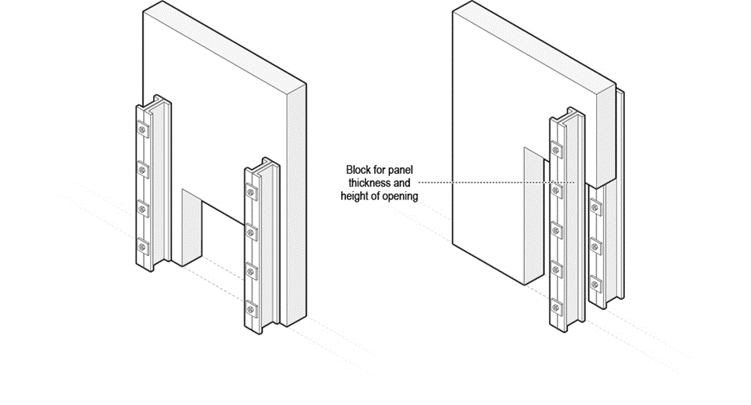

Figure 1: Examples of strongbacks for prefabricated concrete wall panels.

Once the erection design has been prepared and the shop drawings have been drafted, the in-service design engineer should review these documents to ensure that the prefabricated concrete elements and structure still achieve the original structural design intent.

Further information on the design of structures is available in the model Code of Practice: [*Safe design of structures*](https://www.safeworkaustralia.gov.au/doc/model-code-practice-safe-design-structures).

Further information on in-service design is available in AS 3600: *Concrete structures* and AS 4100: *Steel structures*.

## Safe erection design

Erection design covers all aspects of the erection of prefabricated concrete elements, including lifting and rotation of the panels, storage, transportation, erection, construction loads and temporary bracing of the elements.

A suitably competent person, such as an engineer with experience in such matters, should be engaged to develop a safe system of work for the erection of precast or tilt-up concrete or panels. This person is referred to as the erection design engineer.

The erection design engineer is usually responsible for the erection design phase. The erection design engineer is responsible for developing a safe system of work for the erection of prefabricated concrete elements and for ensuring the prefabricated concrete elements, inserts, temporary supports and supporting structures can resist all handling, transport, erection, wind and construction loads.

Similar to the in-service design engineer, the erection design engineer must think about the practical implications of their design and how risks to health and safety can be eliminated or minimised. In preparing the erection design, the erection design engineer should consider all of the factors that are relevant for the in-service design engineer to consider during the structural design. In addition, the erection design engineer should consider the impact of the assumptions made in the structural design (for example in relation to wind loading during the construction phase).

Whilst the builder or principle contractor may not always directly engage the erection design engineer, both builder and erector should ensure that a suitably competent person(s) is engaged and has undertaken the relevant functions of the erection design engineer before erection work commences.

The erection design should be detailed in the shop drawings and erection documentation. Guidance on what these should contain is provided in Section 3.5 of this guide.

As part of the erection design, the erection design engineer is also responsible for considering the transport and on-site storage of elements. In doing so, the erection design engineer should:

* proportion the prefabricated concrete elements so they can be transported on standard vehicles during normal working hours
* design the storage racking systems, frames and supports in accordance with the shape, size and weight of the prefabricated concrete elements
* structure the storage process and sorting order to minimise multiple handling and provide safe access, and
* require prefabricated concrete elements to be stored in a designated area where they are stable (even in windy conditions) and vehicles are not used.

Further information on the working load limit for braces is available in AS 3850.1: *Prefabricated concrete elements – Part 1: General requirements*.

Further information on erection design is available in AS 3850.2: *Prefabricated concrete elements – Part 2: Building construction*.

Further information on temporary bracing and propping systems, and design to resist all expected loads, is available in AS/NZS 1170.2: *Structural design actions – Wind actions*.

Further information on the working load limit for props is available in AS 3610: *Formwork for concrete*.

## Proprietary documentation

In addition to the information outlined in Section 2.4 of this guide, clear and complete proprietary documentation will help to ensure work is completed safely.

### Design safe report

WHS Regulation 295

Designer must give safety report to person who commissions design

The in-service design engineer must prepare a written safety report that specifies any design features that create a risk to the health and safety of those carrying out construction work, and any hazards associated with any specific or unusual designs, such as designs including large cantilevers or voids. The PCBU should request a copy of the safety report if they do not receive it. The PCBU should also give a copy to the principal contractor, if there is one.

Further information on the written safety report provided by the designer is available in the model Code of Practice: [*Safe design of structures*](https://www.safeworkaustralia.gov.au/doc/model-code-practice-safe-design-structures).

### Structural drawings

Structural drawings consider the prefabricated concrete element as part of the final structure. The in-service design engineer normally prepares the structural drawings. The drawings should include:

* plans and elevations for element layout (layout plan)
* structurally critical dimensions
* any required reinforcements
* framing connection locations and type and fixing insert capacity
* concrete specifications, and
* base connection details.

Further information on structural drawings is available in AS 3850.2: *Prefabricated concrete elements – Part 2: Building construction*.

### Shop drawings

Shop drawings provide information that is used in the manufacture of a prefabricated concrete element. The shop detailer should prepare the shop drawings in accordance with the structural drawings, with the in-service design engineer and the erection design engineer. The shop drawings should include:

* drawing date, issue number and project location
* element number and centre of gravity
* dimensions and mass of the element
* details on the structural reinforcement
* specifications of the lifting and fixing inserts, strongback inserts, and bracing inserts and fixings
* location of the lifting and fixing/bracing inserts and specification of any safety critical component reinforcement
* details on the reinforcement for element transport and lifting
* details on levelling pads
* details about welding and bolted connections
* required compressive strength for the element and brace footing/foundations
* required compressive strength at the time of the initial lift
* bracing requirements
* orientation of elements, and
* rigging details.

Further information on shop drawings is available in AS 3850.2: *Prefabricated concrete elements – Part 2: Building construction*.

### Manufacture certificate of compliance

The manufacture certificate of compliance assures the principal contractor and erector that the prefabricated concrete elements have been manufactured in accordance with the specifications outlined by the in-service design engineer. There is usually one certificate per delivery of prefabricated concrete elements.

The prefabricator should prepare the manufacture certificate of compliance. A template for the manufacture certificate of compliance is available at Appendix C.

### Erection documentation

The erection documentation describes all aspects of the construction work involving the use of the prefabricated concrete elements.

The erection design engineer normally prepares the erection documentation. It should include:

* erection sequence and orientation (marking/layout plan)
* lifting details, including lifting points, clutches and rigging
* rigging details and configurations
* bracing details including type, required capacity, angle and fixings
* levelling shims details and grouting requirements
* engineering certificates for lifting, in situ loads, bracing and wind-loading
* the on-site storage plan
* required compressive strength of the brace footing concrete at the time of erection
* specification of the wind loads the temporary bracing has been designed to resist, and
* any other safety critical information that is required to ensure risks to health and safety are controlled.

Where multiple parties contribute to the erection documentation, the erection design engineer should provide written advice to indicate that they have reviewed and are satisfied with all components of the documentation.

Further information on erection documentation is available in AS 3850.2: *Prefabricated concrete elements – Part 2: Building construction*.

# Element manufacture

Prefabricated concrete elements need to have the required structural integrity to allow for safe storage, movement and erection. A competent person should confirm that the prefabricated concrete elements have been manufactured in accordance with approved shop drawings to ensure that the required integrity has been achieved.

The information in this section is focused on on-site manufacture of prefabricated concrete elements, but it may also be relevant to off-site manufacture.

## Pre-pour inspection

Before casting, someone who can accurately read and understand the approved shop drawings for the prefabricated concrete elements should inspect the form arrangement and set-up to ensure any errors are identified and fixed. Check that:

* the formwork dimensions match those in the shop drawings
* the formwork is stable
* insert and connection details are correct
* reinforcement size, location, concrete cover and fixing is correct
* all component reinforcement is in place as per the manufacturer’s specifications.
* inserts have not been welded (without the written consent of the component manufacturer), and
* concrete element edge details and penetrations match the shop drawings.

Digital photography may be used after the inspection, but before casting, to confirm the placement of cast-in components and reinforcements. These photographs should be retained until completion of the construction project.

## Casting concrete

When casting concrete, consider the manufacture site, concrete specification, casting bed, and any hazardous chemicals to be used.

Remember that only the erection design engineer should vary the design of the prefabricated concrete elements, and only after consulting the in-service design engineer.

### Manufacture location

The PCBU should establish a safe system of work at the manufacture location. When manufacturing prefabricated concrete elements on-site, toolbox sessions should be held each morning to allow workers to discuss and understand the planned sequence of work. The PCBU or principal contractor must communicate the SWMS and emergency plan and make sure both are understood by everyone.

Verify that workers and subcontractors have the appropriate training, qualifications and authorisations to ensure they have the knowledge and experience to perform the work safely. PPE must be provided and worn for all work activities where a risk remains after implementing engineering, substitution or isolation controls risks.

Place casting beds in a position where they do not interfere with other activities on the construction site.

### Concrete specifications

The prefabricator should advise the concrete supplier of:

* the specified characteristic concrete compressive strength
* the concrete strength required at the time of the initial lift
* the required maximum aggregate size
* the required slump and special design requirements (if any), and
* details of the site access.

### Casting

When setting up the casting bed and formwork, they should be positioned and secured in accordance with the supplier’s recommendations and as detailed in the shop drawings, to prevent dislodgement during concrete placement. Casting beds should be capable of supporting construction loads and the effectiveness of the release agent should be verified in accordance with the manufacturer’s recommendations.

If stack casting, it is best practice to cast the prefabricated concrete elements in the reverse order of erection to avoid multiple handling: i.e. the top element will be cast last and erected first.

The prefabricator should permanently mark prefabricated concrete elements during or immediately after casting with a unique identification designation. This is usually the concrete element number and date of casting.

Consider the impact of suction loads when lifting the element from the casting bed or panel stack. The correct rigging should be used, in accordance with the erection design, to limit stresses on the element and prevent damage or catastrophic failure of the element. Seek advice from the erection design engineer if necessary.

Further information on eliminating or minimising the WHS risk to workers and others associated with formwork is available in the General guide: [Formwork and falsework](https://www.safeworkaustralia.gov.au/collection/formwork-and-falsework-guidance-material).

Further information on safely manufacturing prefabricated concrete elements is available in AS 3850.2: *Prefabricated concrete elements – Part 2: Building construction* and AS 1012: *Methods of testing concrete*.

Further information on formwork is available in AS 3610: *Formwork for concrete*.

### Hazardous chemicals

Curing and release agents can be hazardous chemicals. When using curing and release agents:

* check the compatibility of release agents with the curing compound and other applied finishes and joint sealants - the supplier can provide specialist advice
* obtain the Safety Data Sheet (SDS) and make it available to anyone who may be exposed to any hazardous chemicals used on-site
* consult with all people who might be exposed to the substance about the intention to use the substance and the safest method of use
* train anyone likely to be exposed to hazardous chemicals on health risks, control measures and correct use, and inform them about health surveillance, and
* consider whether any other risk controls, such as providing PPE, are necessary.

Further information on the use of hazardous chemicals and safety data sheets is available in the model Code of Practice: [*Managing the risks of hazardous chemicals in the workplace*](https://www.safeworkaustralia.gov.au/doc/model-code-practice-managing-risks-hazardous-chemicals-workplace) and the [Fact sheet: Understanding safety data sheets for hazardous chemicals](https://www.safeworkaustralia.gov.au/doc/understanding-safety-data-sheets-hazardous-chemicals).

Further information on curing compounds and release agents is available in AS 3799: *Liquid membrane-forming curing compounds for concrete*.

## Post manufacture

Once manufacture is complete, the person who conducted the pre-pour inspection should check that the prefabricated concrete element meets quality and strength requirements. Prior to being lifted from the casting bed, concrete compressive strength tests should be performed to confirm the concrete strength of the element has achieved the minimum required strength at initial lift as specified on the shop drawings. Once satisfied, this person should complete a manufacture certificate of compliance for the prefabricated concrete elements. Where prefabricated concrete elements are manufactured off-site, the manufacture certificate of compliance should be provided to the transporter prior to the prefabricated concrete elements being moved from the manufacture site. A template of a manufacture certificate of compliance is at Appendix C.

Further information on inspecting concrete elements is available in AS 3850.1: *Prefabricated concrete elements – Part 1: General requirements*.

# Transport and storage

There are risks to be managed in transporting and storing prefabricated concrete elements. Consider the details of the loading, transport, unloading and storage of elements to continually assess risks and implement appropriate controls.

## Planning on-site movement

The principal contractor or builder is responsible for planning the on-site movement of prefabricated concrete elements. This should be done taking into account the WHS management plan and erection design to eliminate or, if elimination is not reasonably practicable, minimise risks to health and safety. Relevant considerations include:

* whether the work area will be appropriately secured
* where safe entry and exit points will be
* whether exclusion zones are required
* if a construction zone will be established on a public street
* if the erection crew will be competent and suitably qualified
* what emergency arrangements are
* whether working at height will be necessary, and if safe systems are required
* how plant will be operated safely, especially near overhead electric lines, and
* required inspections and maintenance for all equipment.

Circumstances may change as the work progresses, so plans should be updated with information about new risks at regular intervals.

Further information on planning to eliminating and minimising risks in construction is available in the model Code of Practice: [*Construction work*](https://www.safeworkaustralia.gov.au/doc/model-code-practice-construction-work) and in the [Construction information sheets](https://www.safeworkaustralia.gov.au/collection/construction-information-sheets).

Further information on working at heights is available in the model Code of Practice: [*Managing the risk of falls at workplaces*](https://www.safeworkaustralia.gov.au/doc/model-code-practice-managing-risk-falls-workplaces).

Further information on working near overhead electricity lines is available in the [*General guide for working in the vicinity of overhead and underground electric lines*](https://www.safeworkaustralia.gov.au/doc/overhead-underground-electric-lines-general-guide) and [*Guide for operating cranes and mobile plant near overhead electricity lines*](https://www.safeworkaustralia.gov.au/doc/guide-operating-cranes-mobile-plant-ohel).

## Loading

To minimise the need for handling prefabricated concrete elements, load them in a sequence compatible with the unloading sequence on the erection documentation and make sure that the individual identification marks are visible. Establishing an exclusion zone minimises the risk of collisions with other objects or people. Before loading, check all prefabricated concrete elements have reached the required strength for lifting the elements from the delivery vehicle.

Frames used to support prefabricated concrete elements during transport should be designed to withstand loads and forces acting on the system during loading, transportation and unloading. The support frames should be certified by a qualified engineer.

A frame that is not an integral part of the trailer must be separately and individually secured. The fixing method must be capable of withstanding any forces applied during loading, transportation and unloading.

Incorrectly restrained prefabricated concrete elements can move unexpectedly, posing a risk to workers and others in the vicinity of the load. Engineer approval must also be sought where extra support is added whilst on the trailer (e.g. vertical strongbacks or extra timbers).

Each prefabricated concrete element should be individually restrained with chains from the sides and front to prevent movement. If long prefabricated concrete elements are being transported, it is best practice to use special restraints suitable for the load. Clearly identifying lifting inserts will also help during the unloading stage.

Semi-trailers should be stabilised by lowering the support legs onto a firm base during loading activities.

Further information on restraining loads and the certification of a load restraint system is available in the National Transport Commission *Load restraint guide 2018*.

## Transport

Everyone involved in transporting prefabricated concrete elements should do so in accordance with the relevant legislation and erection documentation, and plan the transport to minimise the need to relocate the elements once they reach the worksite.

Precast components should not be transported within three days (72 hours) of casting unless concrete in the specific components is tested to confirm that design strength for erection has been attained. These test results must be available on site prior to erecting the element.

The prefabricator should provide the transporter with information on the shape, size and details of the prefabricated concrete elements in advance, so they can select the most appropriate method for stabilising and securing the load. Before transporting prefabricated concrete elements, the transporter should consult with the principal contractor or builder and consider site specific factors such as:

* local traffic regulations and required permits (as well as national heavy vehicle laws)
* existing infrastructure such as low bridges, power lines and roundabouts
* transport of prefabricated concrete elements to and around the site
* access for transport vehicles, including cranes, and
* unloading on-site using all-weather roads onto and across the site.

The transporter should ensure that drivers are adequately trained and experienced in the transport of prefabricated concrete elements.

The prefabricator should provide the transporter with the manufacture certificate of compliance before transporting the prefabricated concrete elements. Upon delivery of the prefabricated concrete elements, the transporter should give the certificate to the erector. This should be available on-site at all times.

Before commencing the journey, drivers should check the loads and restraints. If possible drivers should also stop to check the load and restraints shortly after commencing the journey. Restraints may loosen due to settling of the load and stretching of the restraints.

Prior to entering the construction site the driver should, under the direction of the site supervisor, inspect the traffic management plan and relevant areas of the construction site to verify there are no dangers.

## Unloading

Unload prefabricated concrete elements in accordance with the erection documentation. Before unloading, check the:

Element quality

* the manufacture certificate of compliance matches the prefabricated concrete elements
* confirm that the concrete strength for lifting has been achieved, and
* no damage has occurred during transport.

Site

* an exclusion zone has been established
* the delivery vehicle and crane are stable and on level ground, and
* the wheels of the delivery vehicle are chocked and the park brake is applied.

Lifting equipment

* the lifting inserts are not damaged, and are compatible with the lifting system clutches being used
* the nominated brace fixing bolts are available on-site, and
* any strongbacks have been correctly placed.

Only people who are involved in unloading the prefabricated concrete elements should be within the vicinity of the delivery vehicle. Do not stand near the vehicle in an area where an element would fall if the vehicle was knocked or moved, or if rigging was to fail.

Particular care should be taken when unloading elements to ensure the load and frame remains stable. Semi-trailers should be stabilised by lowering the support legs onto a firm base. Where unloading cannot take place on a firm level surface, the loading configuration must be checked to ensure that removing individual elements does not result in instability of the load or the vehicle.

Check any identified hold points and witness points have been met before unloading prefabricated concrete elements.

If a prefabricated concrete panel has been damaged during transport, the in-service design engineer and erection design engineer should provide approval before the panel is unloaded from the delivery vehicle.

When unloading, only release each prefabricated concrete element once the crane has taken the initial load, to minimise the risks of dropping the element. Individually secure each element, as the unloading sequence can lead to load instability.

## Storage

Store prefabricated concrete elements in accordance with the SWMS and the erection documentation. The way prefabricated concrete elements are stored will depend on the type of prefabricated concrete element.

If the erection documentation requires prefabricated concrete elements to be stored in a location where vehicles are used, erect bollards or other physical barriers and appropriate warning signs to minimise the risk of a collision.

If prefabricated concrete elements cannot be stored in accordance with the erection documentation (for example due to poor weather impacting planned erection), the erection design engineer should provide instructions about how to store the prefabricated concrete elements safely.

Prefabricated concrete elements should not be stored horizontally or on a suspended floor slab or beam unless approval and written instructions have been provided by the erection design engineer. If the erection design engineer has not provided their approval, prefabricated concrete elements should be stored at ground level.

When prefabricated concrete elements are stored off-site (for example at a manufacturing facility), store them in a way that will not compromise their quality.

# Erection process

Erecting prefabricated concrete elements is a complex process. Manage risks by undertaking checks pre-erection, implementing controls during erection, and inspecting and maintaining temporary supports.

## Pre-erection

Before erection commences, consider the qualifications of the erection crew, set up an exclusion zone, and complete the pre-erection checklist.

### Erection crew

All members of the erection crew should be selected in accordance with relevant Commonwealth, state and territory regulations. A qualification register may be used to list qualified persons in the erection crew. A template for a qualification register is at Appendix D. The crane operator must hold a licence appropriate for the type and capacity of the crane in use.

The erector should nominate one person in the erection crew to be responsible for the implementation and coordination of the erection process. This person should hold an intermediate or advanced rigging licence.

Make sure that all members of the erection crew have access to the erection documentation and PPE that functions according to the relevant standard. Ensure that the erection crew understand the engineering assumptions that have been made, such as for wind loads and when work should be stopped.

### Exclusion zone

Set up exclusion zones to minimise the risk of prefabricated concrete elements and cranes striking people, or people being caught between a prefabricated concrete element and another hard surface. The size of the exclusion zone will depend on the associated risk assessment. Only allow people directly involved with the lifting of prefabricated concrete elements to access an area where lifting is taking place, and plan the zone so that loads will not be suspended over, or travel over, a person.

Depending on the construction site and local regulations, the principal contractor or builder should consider installing appropriate signage, barriers and perimeter fencing to establish an exclusion zone. The principal contractor or builder should consider whether any common boundaries or public footpaths, roads or access ways will interact with the exclusion zone, and take this into account in planning how to communicate the exclusion zone.

Where a footpath, road or other access way is located in an exclusion zone, ensure members of the public and traffic will be prevented from passing through the zone while prefabricated concrete element construction work is being undertaken.

### Pre-erection checks

The erection sequence will be different for each project because different factors will impact each construction site. Before commencing erection, review the SWMS, WHS management plan and erection documentation, check the site is prepared appropriately and that the prefabricated concrete elements are not affected by deficiencies. A checklist is at Appendix E.

Elements should not be erected on site within three (72 hours) days of casting unless the concrete in the specific elements has been tested to confirm that the design strength for erection has been attained. Test results must be available on site prior to erecting the element.

Further information on pre-erection checks is available in AS 3850.1: Prefabricated concrete elements – Part 1: General requirements and AS 3850.2: Prefabricated concrete elements – Part 2: Building construction.

## Crane setup and operation

Crane and rigging equipment will be needed to move prefabricated concrete elements. This will often involve working at height. Under the model WHS Regulations, these activities are high risk construction work and there are specific precautions that must be taken to manage risks to health and safety.

### Preparation

The principal contractor or builder should check that riggers and crane operators are experienced and have the correct high risk work licence for the work to be undertaken.

To choose the most appropriate crane, identify hazards and conduct a risk assessment. Consider:

* the construction site, including any overhead power lines
* where on the site the crane will be located
* the necessary clearance for the crane
* the required lifting capacity of the crane
* the rigging system that will be used, and
* the potential impact of wind.

The erection documentation should outline the wind speed that the prefabricated concrete elements have been designed to withstand.

The crane and rigging should be designed to lift the prefabricated concrete elements. Do not use a crane that does not have the required capacity or is not designed to lift prefabricated concrete elements.

If the crane will be set up on the ground, obtain written certification of the ground bearing capacity from an engineer with specific experience in soil engineering. The engineer should identify and assess backfilled excavations, trenches and soak wells, make any necessary recommendations, and assess their implementation. For example, timber mats may be needed to ensure any backfilling can support the crane and load.

Choose lifting manoeuvres based on the type of crane being used, the construction site and the specific elements. Make sure that cranes are operated, inspected and maintained by a competent person in accordance with the manufacturer’s directions

Further information on rigging and lifting prefabricated concrete elements is available in AS 3850.2: *Prefabricated concrete elements – Part 2: Building construction* and AS 2550: *Cranes, hoists and winches*.

Further information on lifting clutches is available in AS 3850.1: *Prefabricated concrete elements – Part 1: General requirements*.

Further information on tower cranes is available in AS 1418.4: *Cranes, hoists and winches – Tower cranes*.

Further information on managing the risks associated with the use of cranes is available in the [cranes guidance material](https://www.safeworkaustralia.gov.au/collection/cranes-guidance-material).

### Operating cranes

Prefabricated concrete elements must be lifted in accordance with the SWMS. The erection documentation and the plan developed by the principal contractor or builder should also be followed. Cranes should only be operated in accordance with the manufacturer’s instructions.

When a prefabricated concrete element is required to be rotated about an edge, such as when tilting up a panel that has been cast on-site, the prefabricated concrete element should not lean towards the crane. If part of the lifting system fails while a suspended prefabricated concrete element is leaning toward a crane, the element can fall against the crane and may cause the crane to overturn.

When a prefabricated concrete element is required to be rotated mid-air, such as when a prefabricated concrete panel is being lifted from a vehicle, multiple cranes or a single crane with two hoists should be used.

When multiple cranes are used, the load is shared between both cranes. The load on each crane changes as the element is rotated. Before commencing any lifts, the maximum load share on each crane should be calculated and a lift procedure developed to ensure each crane remains within rated capacity throughout the lift.

When the main and auxiliary hoists of a single mobile crane are used simultaneously, the load is shared between the two hoists. The load on each hoist changes as the element is rotated. The auxiliary hoist should be able to take 70­‑75 per cent of the weight of the panel during a rotation. A lift procedure should be developed to ensure the crane remains within rated capacity throughout the lift. The procedure should ensure the element is supported by the main hoist after its rotation.

During any mid-air rotation, at least one of the crane ropes will deviate from the vertical. Take care to ensure any resulting fleet angle does not exceed any limits specified by the crane manufacturer. Cranes should be orientated relative to the element in a manner that prevents side loading of sheave booms.

Further information on managing the risks associated with the use of cranes is available in the [cranes guidance material](https://www.safeworkaustralia.gov.au/collection/cranes-guidance-material).

Further information on lifting clutches is available in AS 3850.1: *Prefabricated concrete elements – Part 1: General requirements* and AS 3850.2: *Prefabricated concrete elements – Part 2: Building construction*.

## During erection

Everyone involved in the erection of prefabricated concrete elements should be aware that it is a potentially hazardous activity. Handle each prefabricated concrete element in accordance with the erection documentation.

Double-check the erection documentation with the erection design engineer when:

* precast concrete is supported on formwork or even cantilevered formwork (e.g. balcony panel so the slab can tie into panel)
* vertical propping is expected to take weight of the panel (e.g. accrow prop could dislodge)
* if there are less than 2 dowell bars (method of restraint at the base of the panel), or
* there is no strongback over a door, opening or thin section.

Grouting should occur as soon as possible after erection to lock in the base and prevent movement.

### Movement of workers and loads

Prefabricated concrete elements should not travel over a person while suspended.

People permitted within the exclusion zone should avoid being in a position where they can be struck in the event of a prefabricated concrete element falling, a crane collapsing, or being caught between a prefabricated concrete element and any other hard surface.

Where the need to carry out work at height has not been eliminated during planning and design, the PCBU must minimise the risk of falls and maintain a safe system of work. This should include providing a fall prevention device (such as secure fencing, elevating work platforms or scaffolding), or if that is not reasonably practicable, a work positioning system or a fall arrest system. Ensure that no one works on a prefabricated concrete element that is leaning towards them and no one is placed between a concrete element being lifted and another wall or object.

### Modifying prefabricated concrete elements

Prefabricated concrete elements should not be modified in any way during erection without the express approval of the erection design engineer, in consultation with the in-service design engineer. This includes physical modifications to the concrete element as well as modifications to the erection process such as using different lifting points, different erection sequence or changing rigging configurations. Approval should be provided in writing to the principal contractor or builder before modification takes place. Relevant documentation such as shop drawings, should be updated and re-numbered where necessary, and previous versions clearly labelled that they are no longer valid. Alterations or additions to the prefabricated concrete element should be communicated to all persons involved in the erection and installation processes.

### Installation of temporary supports

Ensure temporary supports and braces are installed in accordance with the erection documentation. Double-check the erection documentation with the erection design engineer, when:

* fewer than two or three or more temporary supports are to be used for a prefabricated concrete element
* braces are to be installed at an angle of less than 45 degrees or more than 60 degrees (Figure 2)
* braces are skewed more than five degrees and are not perpendicular to the prefabricated concrete element (Figure 2)
* a brace already connected to one prefabricated concrete element is to be connected to another braced prefabricated concrete element for support, or
* levelling shims are more than 40 millimetres high or are located less than 200 millimetres from the end of the prefabricated concrete element (Figure 3).

Do not deviate from the erection documentation unless prior written approval is obtained from the erection design engineer.

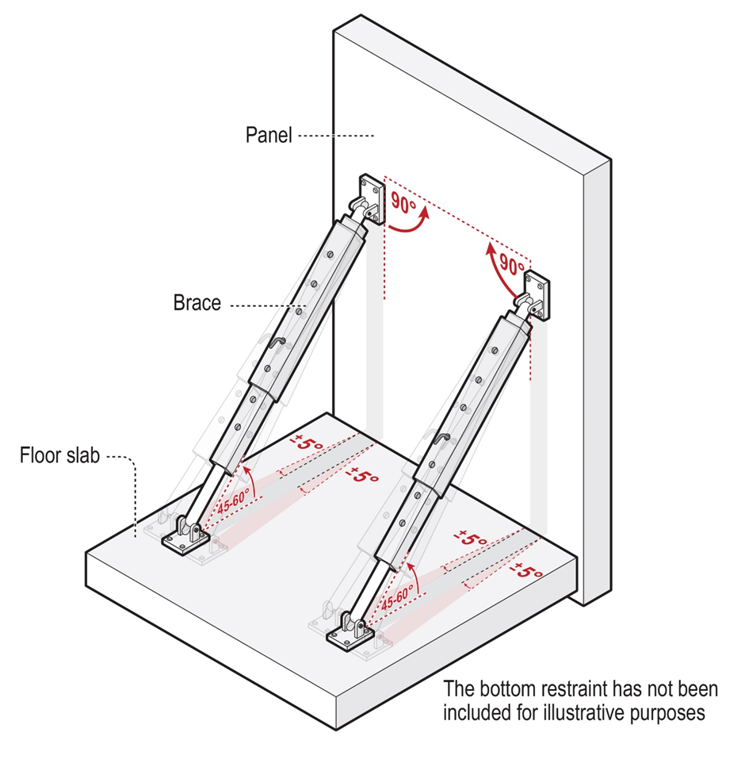

Figure 2: Standard bracing arrangements for a prefabricated concrete wall panel

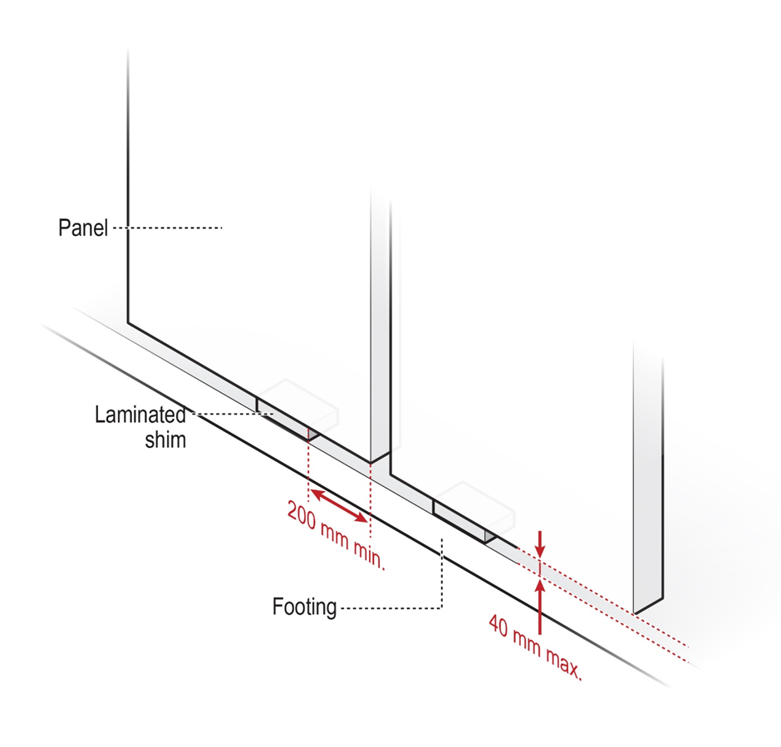

Figure 3: Standard shim arrangements for prefabricated concrete wall panels.

When bracing thin prefabricated concrete elements, it may only be possible to use one brace in each direction. Implement additional precautions to protect those braces from impacts (Figure 4).

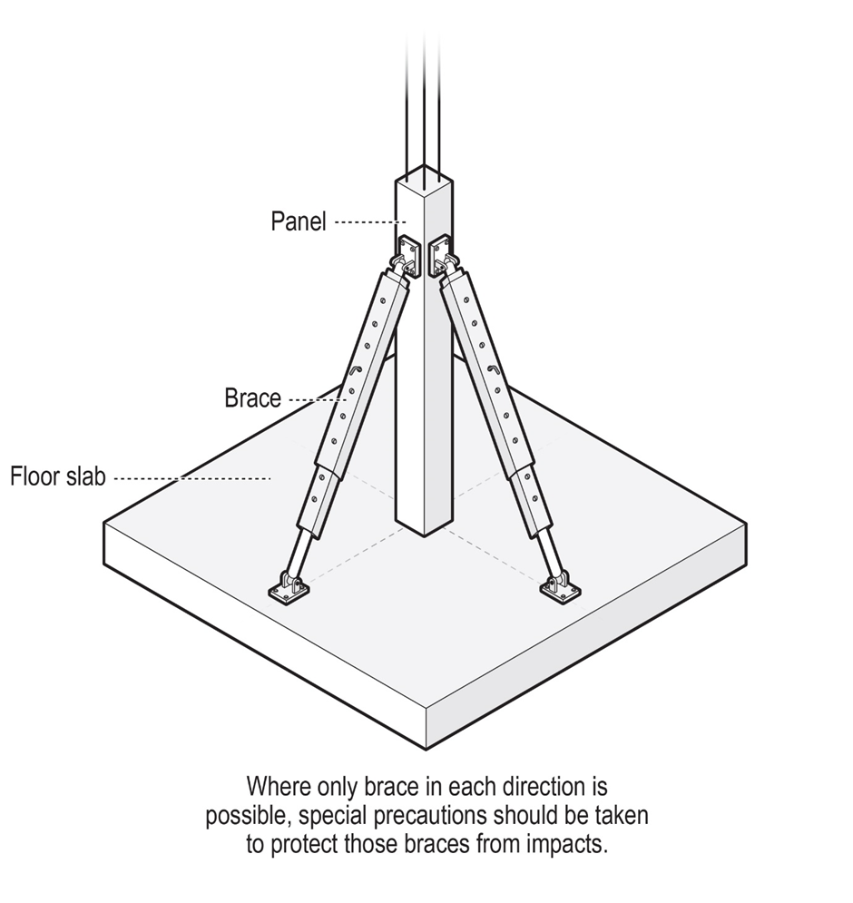

Figure 4: Example bracing of thin prefabricated concrete elements.

In the event of adverse weather conditions it may be necessary to stabilise incomplete structures using measures considered as part of the initial design and forming part of the designed erection sequence. This should not be an ad-hoc means of stabilisation. Where a prefabricated concrete element cannot be stabilised overnight, it should be stored at ground level, unless the erection design engineer approves an alternative storage method.

Further information on temporary supports and braces is available in AS 3850.2: *Prefabricated concrete elements – Part 2: Building construction*.

Further information on the safe design of temporary structures is available in the [model Code of Practice: *Safe design of structures*](https://www.safeworkaustralia.gov.au/doc/model-code-practice-safe-design-structures)

## When temporarily erected

Prefabricated concrete element structures are susceptible to progressive collapse, so it is essential that the failure of a single prefabricated concrete element does not lead to the complete collapse of the structure. Manage risks when using temporary supports by inspecting regularly, removing support safely and only storing verified loads.

### Inspection of temporary supports

The erection design engineer and principal contractor should establish a plan to ensure the stability of the structure is monitored and maintained while temporarily erected. Braces and bracing inserts, propping, fixings and connections should be verified weekly and after major weather events to ensure the stability of the structure is maintained. The stability of the whole structure should also be checked at each stage of the erection process. Confirm the correct setting torque for all cast-in components with the supplier and ensure brace anchor installations are completed with a calibrated torque wrench to ensure the correct torque is achieved.

Further information on temporary supports and braces is available in AS 3850.2: *Prefabricated concrete elements – Part 2: Building construction*.

### Storing objects

Objects, including prefabricated concrete elements, should only be stored on the structure if the erection design engineer has verified the loads can be supported. Consult the erection documentation for information on where materials and mobile plant can be stored or operated, the maximum allowable loads, the relative locations of the storage areas, and any additional temporary supports required to carry these loads.

## Post-erection

### Incorporation into final structure

Follow the structural drawings and the instructions of the in-service design engineer when attaching prefabricated concrete elements to other structural elements. The erection design engineer should also approve any variations to the design specifications.

Prior to incorporating prefabricated concrete elements into the final structure, consider site specific safety factors such as how the prefabricated concrete elements will be fixed to the structure, the effect of impact loads on the existing structure when positioning the elements, and the effect of wind loading on the structure in its partially completed state.

### Removal of temporary supports

Only remove temporary supports in accordance with the instructions provided by the in‑service design engineer.

Ensure all hold points have been met before removing any temporary supports. Before removing temporary supports, a competent welding inspector should confirm any structural welds have been completed in accordance with the structural drawings and the relevant technical standards. The in-service design engineer should provide written confirmation that the temporary supports can be removed.

Further information on the safe removal of temporary supports is available in AS 3850.2: *Prefabricated concrete elements – Part 2: Building construction*.

Further information on the removal of props is available in AS 3610: *Formwork for concrete*.

# Appendix A – Technical standards and other references

This guide complements the following technical standards and provides further guidance on the use of prefabricated concrete elements and supporting materials. These technical standards provide guidance only and compliance with them does not guarantee compliance with the WHS Act and WHS Regulations. This list is not exhaustive:

* AS 3850.1: *Prefabricated concrete elements – Part 1: General requirements*
* AS 3850.2: *Prefabricated concrete elements – Part 2: Building construction*
* AS 3610: *Formwork for concrete*
* AS 3600: *Concrete structures*
* AS 4100: *Steel structures*
* AS 2550: *Cranes, hoists and winches*
* AS 1012: *Methods of testing concrete*
* AS/NZS 1170.2: *Structural design actions – Wind actions*

The following Safe Work Australia model Codes of Practice provide in-depth practical guidance about issues raised in this guide:

* [model Code of Practice: *Construction work*](https://www.safeworkaustralia.gov.au/doc/model-code-practice-construction-work)
* [model Code of Practice: *How to manage work health and safety risks*](https://www.safeworkaustralia.gov.au/doc/model-code-practice-how-manage-work-health-and-safety-risks)
* [model Code of Practice: *Managing risks of plant in the workplace*](https://www.safeworkaustralia.gov.au/doc/model-code-practice-managing-risks-plant-workplace)
* [model Code of Practice: *Managing the risk of falls at workplaces*](https://www.safeworkaustralia.gov.au/doc/model-code-practice-managing-risk-falls-workplaces)
* [model Code of Practice: *Managing the risks of hazardous chemicals in the workplace*](https://www.safeworkaustralia.gov.au/doc/model-code-practice-managing-risks-hazardous-chemicals-workplace)
* [model Code of Practice: *Managing the work environment and facilities*](https://www.safeworkaustralia.gov.au/doc/model-code-practice-managing-work-environment-and-facilities)
* [model Code of Practice: *Safe design of structures*](https://www.safeworkaustralia.gov.au/doc/model-code-practice-safe-design-structures)
* [model Code of Practice: *Work health and safety consultation, cooperation and coordination*](https://www.safeworkaustralia.gov.au/doc/model-code-practice-work-health-and-safety-consultation-co-operation-and-co-ordination)

This guide is supported by the following Safe Work Australia guidance material:

* [Construction information sheets](https://www.safeworkaustralia.gov.au/collection/construction-information-sheets)
* [Fact sheet: Emergency plans](https://www.safeworkaustralia.gov.au/doc/emergency-plans-fact-sheet)
* [High risk work licensing information sheets](https://www.safeworkaustralia.gov.au/collection/high-risk-work-licensing-information-sheets)
* [Fact sheet: Understanding safety data sheets for hazardous chemicals](https://www.safeworkaustralia.gov.au/doc/understanding-safety-data-sheets-hazardous-chemicals)
* [General guide: Formwork and falsework](https://www.safeworkaustralia.gov.au/collection/formwork-and-falsework-guidance-material)
* [Cranes guidance material](https://www.safeworkaustralia.gov.au/collection/cranes-guidance-material)

# Appendix B – Template: Assigning roles and functions

The principal contractor should work with persons who have key roles or functions to complete this template, filling in one document per person. List the responsibilities of the person at each stage of the construction work, noting if the person does not have a responsibility for a given stage.

| Prefabricated concrete elements construction work: Roles and functions | |
| --- | --- |
| **Project details** | |
| Project name | |
| Site address | |
| **Project phase** | **Functions** |
| Position |  |
| Full name |  |
| Signature |  |
| **Concept** |  |
| **Building design** |  |
| **Erection design responsibility** |  |
| **Manufacture** |  |
| **Storage** |  |
| **Handling, moving and transport** |  |
| **Erection** |  |

# Appendix C – Template: Manufacture certificate of compliance

| Prefabricated concrete elements: Manufacture certificate of compliance | | | | | | | |
| --- | --- | --- | --- | --- | --- | --- | --- |
| **Project details** | | | | | | | |
| Project name |  | | | | | | |
| Site address |  | | | | | | |
| **Responsible parties** | | | | | | | |
| Prefabricator | | |  | |  | | |
| Principal contractor | | |  | |  | | |
| **Schedule of elements** | | | | | | | |
| Identification number | | | | Unit weight | | Casting date | Notes |
|  | | | |  | |  |  |
|  | | | |  | |  |  |
|  | | | |  | |  |  |
|  | | | |  | |  |  |
|  | | | |  | |  |  |
| This is to certify that:   * + - * the above listed prefabricated concrete elements have been manufactured in accordance with the shop drawings * the above listed prefabricated concrete elements have achieved the strength required for lifting, and * all lifting, fixing and bracing inserts are the correct size, in the correct location, and marked with the manufacturer’s identification. | | | | | | | |
| Full name | |  | | | | | |
| Position | |  | | | | | |
| Signature | |  | | | | | |
| Date | |  | | | | | |

# Appendix D – Template: Qualification register

| Prefabricated concrete elements construction work: Qualification register  Refer to Section 6.1 of this guide for minimum erection crew qualification requirements. | | | | | | |
| --- | --- | --- | --- | --- | --- | --- |
| **Project details** | | | | | | |
| Project name | |  | | | | |
| Site address | |  | | | | |
|  | **Full name** | | **Certificate type** | **Certificate number** | **Activity on site** |  |
|  |  | |  |  |  |  |
|  |  | |  |  |  |  |
|  |  | |  |  |  |  |
|  |  | |  |  |  |  |
|  |  | |  |  |  |  |
|  |  | |  |  |  |  |
|  |  | |  |  |  |  |
|  |  | |  |  |  |  |
|  | | | | | |  |

# Appendix E – Pre-erection checklist

## Erection planning

* The erection documentation has been completed by the erection design engineer
* Any changes to the erection design are approved by the erection design engineer and recorded in the erection documentation
* The erection platform can carry the erection loads at the time of erection
* The erection documentation matches sequencing and load restraint requirements
* The erection design engineer has approved lifting
* Load distribution on lifting points is appropriate
* Measure the final element position to confirm that the element will fit and to avoid double handling
* There are enough prefabricated concrete element braces of suitable length and safe working load to meet the requirements of the erection documentation
* There are appropriate brace fixings on-site that meet the minimum specifications provided in the erection documentation
* The installation procedure and setting torques for fixings are available to the erection crew
* Grouting requirements are available to the erection crew

## Site

* Clearance is sufficient for crane access and mobility
* Advice on working near overhead powerlines has been sought from the local WHS regulatory authority and electricity supply authority
* Any required approvals for work near overhead powerlines have been obtained
* Underground powerlines, utilities, tanks or soak wells, and backfilled trenches have been identified and appropriate measures have been put in place
* An exclusion zone has been established
* Weather conditions are appropriate for erection

## Erection crew

* Members are suitably qualified and competent
* Crew members have been briefed on the task and engineering assumptions
* Communication systems are known and understood
* Emergency procedures are known and understood
* Hold and witness points are known
* Required height access equipment is available

## Element quality

* The manufacture certificate of compliance is available on-site
* The prefabricated concrete elements match the manufacture certificate of compliance
* The in-service design engineer and erection design engineer have confirmed that any damaged or repaired panels can be used
* Check concrete around lifting inserts for compaction/cracking issue
* The manufacture certificate of compliance has been checked to ensure the concrete in the element has attained the specified strength for lifting
* The concrete in the bracing supports has attained the specified strength
* A calibrated torque wrench is available on-site for the installation of brace anchors

## Cranes and rigging

* Compaction of site surface areas has been considered
* The lift plan has been completed
* Written certification from an engineer to say that the proposed crane standing areas can safely carry loads has been received
* The rigging system should be in accordance with the erection design documentation
* Load distribution on lifting points is appropriate
* Lifting will occur in the direction specified in the erection documentation
* Braces do not interfere with the rigging
* Lifting inserts are compatible with lifting clutches, are in the correct locations and marked with the manufacturer’s identification
* Lifting gear and slings are visually inspected for damage and have been tested and tagged as being safe for use
* Lifting recesses are cleaned out so that lifting clutches can correctly engage
* A calibrated torque wrench is available on-site for the installation of brace anchors