Comparative performance monitoring report
Part 2 - Work health and safety compliance and enforcement activities
21st Edition - December 2019

Comparison of work health and safety and workers' compensation schemes in Australia and New Zealand.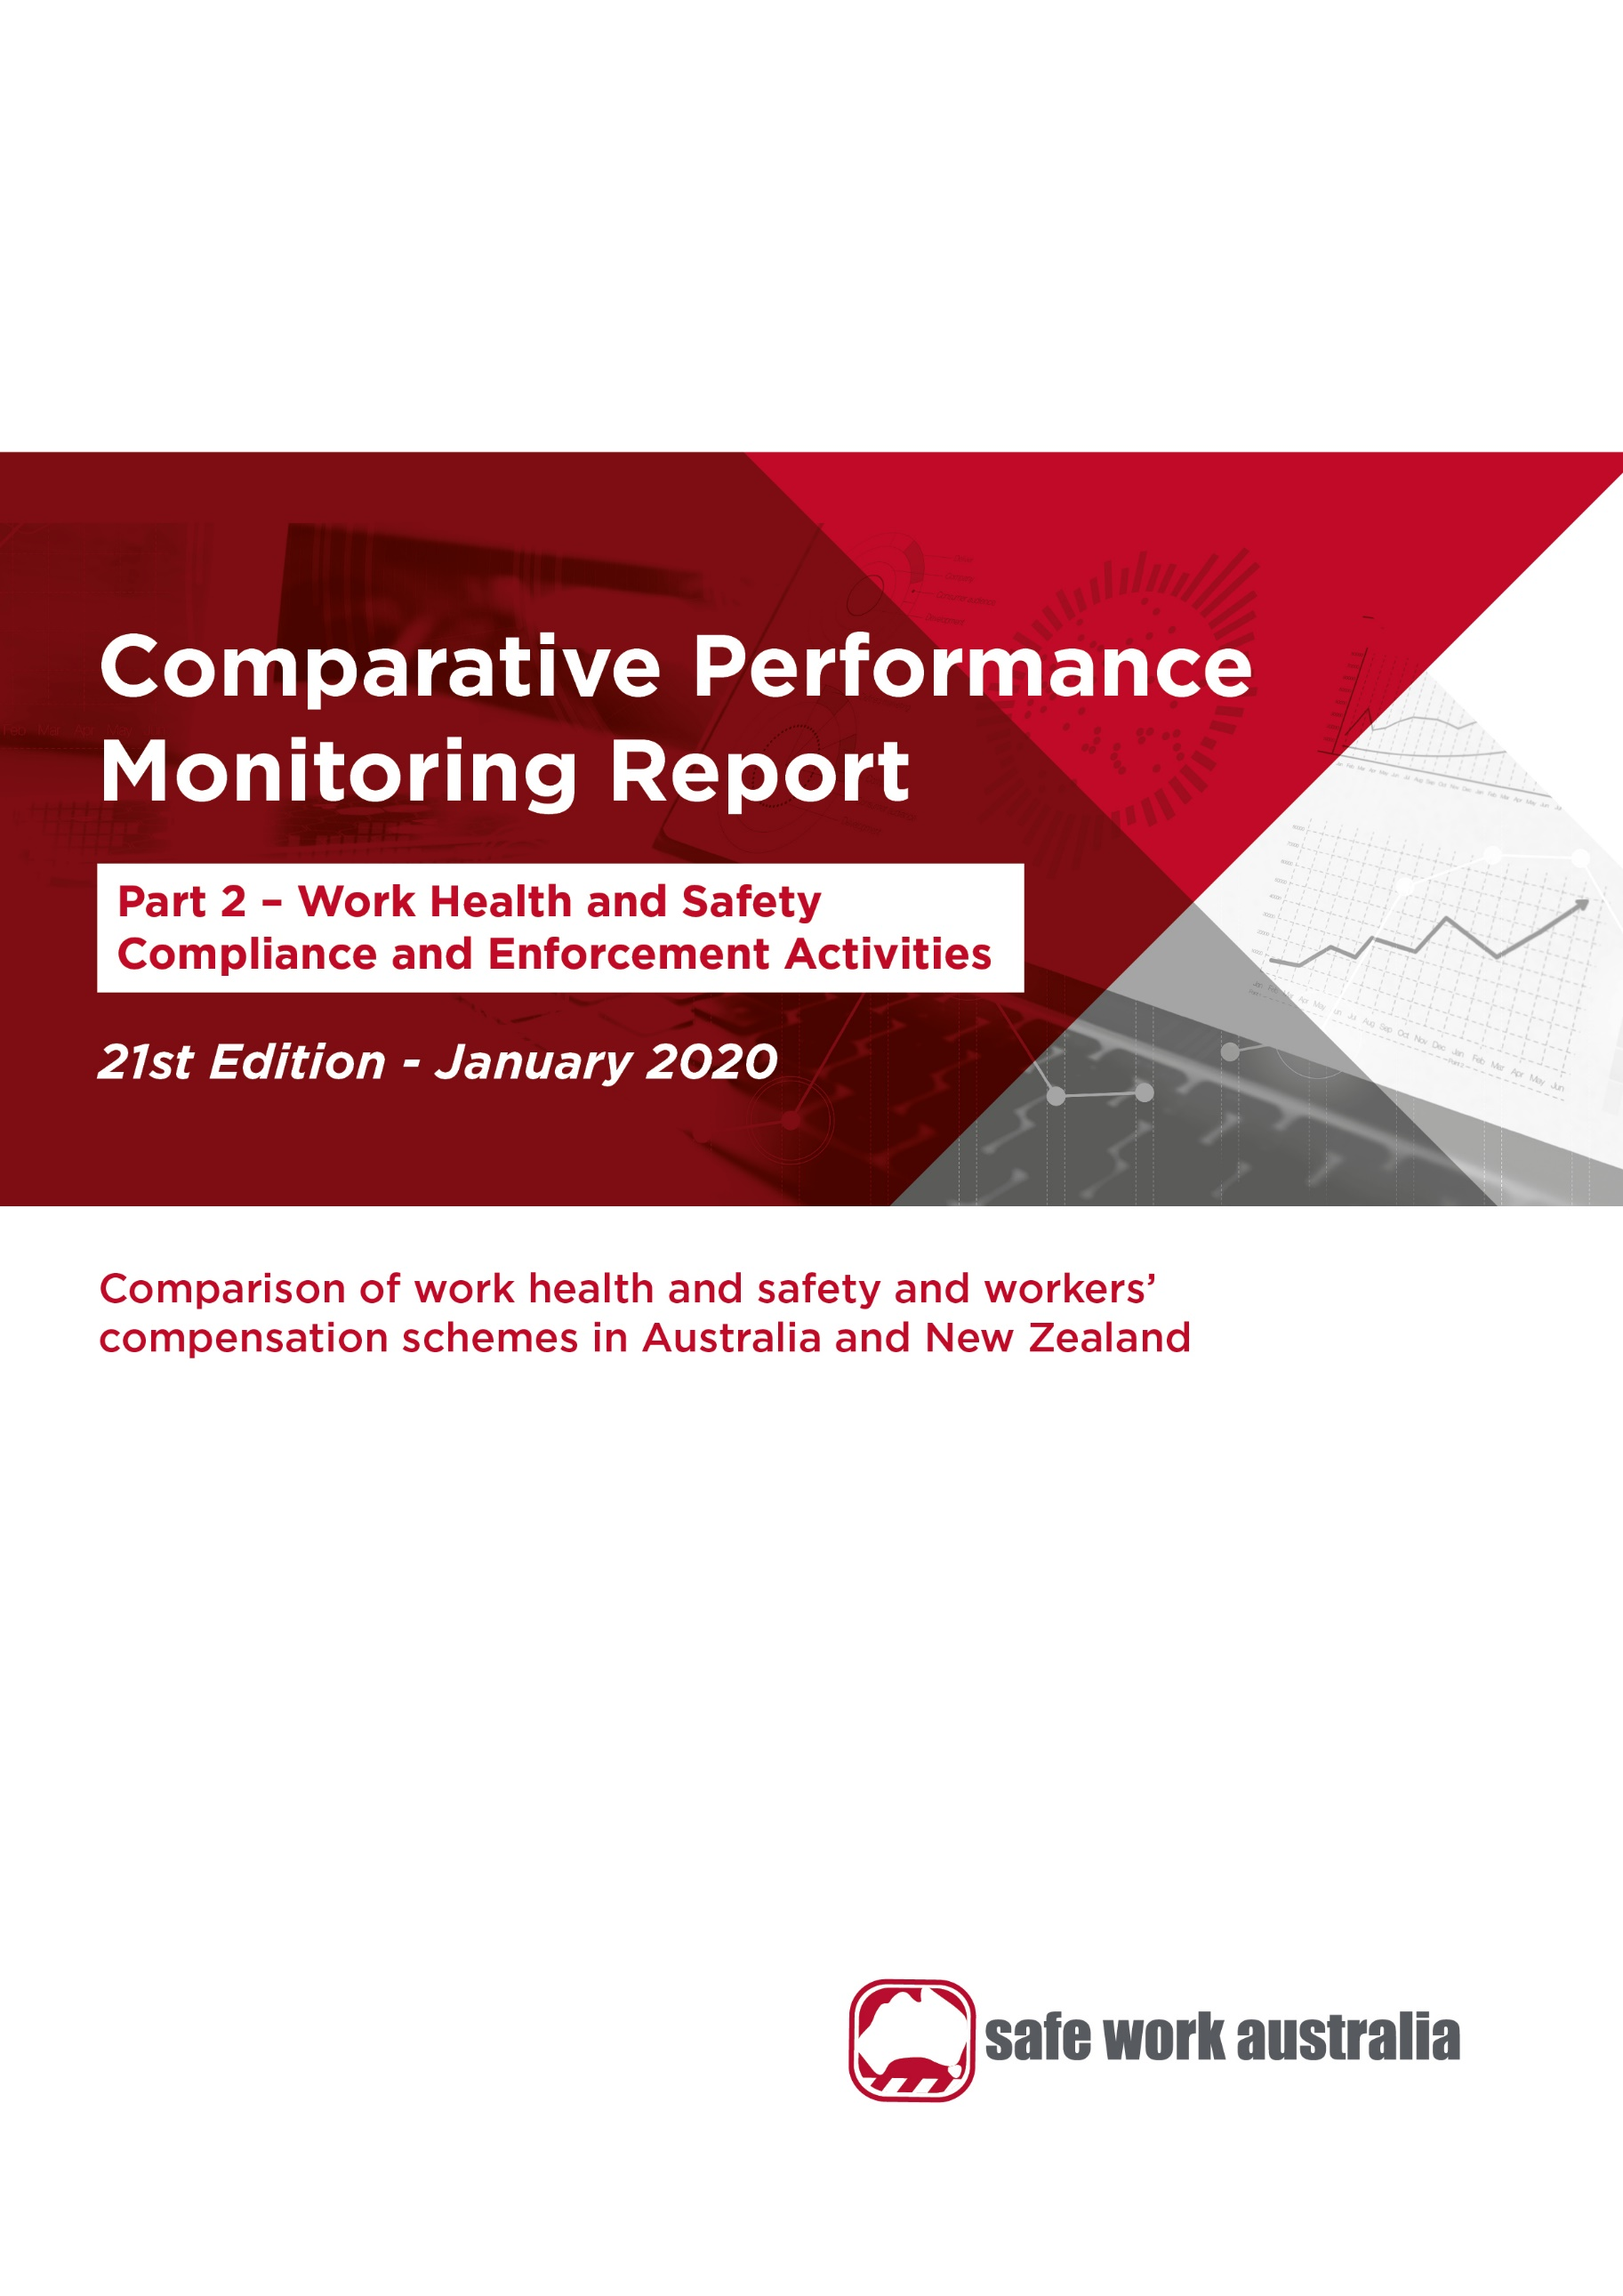

Disclaimer

Safe Work Australia provides the information in this publication to raise awareness of work health and safety.

While Safe Work Australia makes every effort to ensure information is accurate and up-to-date, Safe Work Australia does not provide any warranty regarding the accuracy, currency or completeness of the information contained in this publication and will not be held liable for any loss, damage, cost or expense incurred or arising by reason of any person using or relying on the information in this publication.

This publication may incorporate views or information from third parties, which do not necessarily reflect the views of Safe Work Australia. The inclusion of such material does not indicate an endorsement of that material or a commitment to any particular course of action. The views in this publication should not be taken to represent the views of Safe Work Australia unless otherwise expressly stated.

**ISSN 2209-9174**



Creative Commons

This copyright report is licensed under a Creative Commons Attribution-Noncommercial 4.0 International licence. To view a copy of this licence, visit <https://creativecommons.org/licenses/by-nc/4.0/>. In essence, you are free to copy, communicate and adapt the work for non-commercial purposes, as long as you attribute the work to Safe Work Australia and abide by the other licence terms.

Enquiries regarding the licence and any use of the report are welcome at:

Copyright Officer  
Safe Work Australia   
GPO Box 641 Canberra ACT 2601

Email: [info@swa.gov.au](mailto:info@swa.gov.au)

Important Notice

Safe Work Australia provides the information given in this document to improve public access to information about work health and safety information generally. The vision of Safe Work Australia is Australian workplaces free from injury and disease. Its mission is to lead and coordinate national efforts to prevent workplace death, injury and disease in Australia.

Contents

**Foreword** 4

**1. Work health and safety compliance and enforcement activities** 8

1.1 Interventions 8

1.2 Inspectors 11

1.3 Notices 13

1.4 Enforceable undertakings 13

1.5 Legal proceedings 15

1.6 Fines 15

**Appendix 1 –– Explanatory notes** 17

**Appendix 2 – Jurisdictional contact information** 18

Foreword

The Labour Ministers’ Council released the first Comparative Performance Monitoring (CPM) report in December 1998. The CPM project was transferred to Safe Work Australia when it was established in 2009. The CPM reports provide trend analysis on the work health and safety and workers’ compensation schemes operating in Australia and New Zealand. This is the 21st annual report of the CPM project.

The CPM is complemented by the [*Australian Workers’ Compensation Statistics*](https://www.safeworkaustralia.gov.au/collection/australian-workers-compensation-statistics) report, which provides more detailed analysis of national workers’ compensation data using key variables such as occupation, industry, age and sex with supporting information on the circumstances surrounding work-related injury and disease occurrences. The CPM is also complemented by the [*Comparison of Workers’ Compensation Arrangements in Australia and New Zealand*](https://www.safeworkaustralia.gov.au/doc/comparison-workers-compensation-arrangements-australia-and-new-zealand-2016), which discusses the way that each scheme deals with key aspects such as coverage, benefits, self-insurance, common law and dispute resolution. The publications can be found on the Safe Work Australia website.

# Statement of purpose

The role of the CPM report is to facilitate improving work health and safety, workers’ compensation and related service outcomes in Australian and New Zealand schemes through an accessible report that:

1. monitors the comparative performance of jurisdictions over time, and
2. enables benchmarking across jurisdictions and the identification of best practice to support policy making.

# Data

The data used in this report were supplied by jurisdictions for the 2017–18 financial year and data updates back to 2013–14.

Readers should be aware that the data presented here may differ from jurisdictional annual reports due to the use of different definitions and the application of adjustment factors to aid in the comparability of data. Explanatory commentary on the data items is contained within each chapter with additional information included in Appendix 1 – Explanatory Notes, at the end of this publication.

The data in this report were collected from:

* workers’ compensation schemes and work health and safety authorities as follows:
  + New South Wales — State Insurance Regulatory Authority and SafeWork NSW
  + Victoria — WorkSafe Victoria
  + Queensland — Workplace Health and Safety Queensland, Office of Industrial Relations – Education Queensland , Queensland Workers’ Compensation Regulator and WorkCover Queensland
  + Western Australia — Department of Mines, Industry Regulation and Safety – WorkSafe
  + South Australia — Return to Work South Australia and SafeWork SA
  + Tasmania — WorkSafe Tasmania
  + Northern Territory — NT WorkSafe, Department of Attorney-General and Justice
  + Australian Capital Territory — Access Canberra, Worksafe ACT within Chief Minister Treasury and Economic Development Directorate
  + Australian Government — Comcare
  + Seacare — Seacare Authority (Seafarers Safety, Rehabilitation and Compensation Authority), and
  + New Zealand — Accident Compensation Corporation and WorkSafe New Zealand
* the National Data Set for Compensation-based Statistics and the Work-related Traumatic Injury Fatalities data set compiled by Safe Work Australia. Further information on these data sets can be found on the [Safe Work Australia](https://www.safeworkaustralia.gov.au/statistics-and-research/statistics/statistics) website, and
* the Australian Bureau of Statistics (ABS) which provides estimates of the number of employees and hours worked based on the Labour Force Survey, the Survey of Employment and Earnings and data provided by Comcare. Further adjustments are made using data from the Census, the Forms of Employment Survey and the Survey of Employment Arrangements, Retirement and Superannuation.

The CPM report does not currently include any information on compliance and enforcement activities relating to the mining industry, including the offshore petroleum industry. This is to ensure jurisdictional data are comparable, as not all jurisdictions’ work health and safety authorities conduct these activities. Rather they are in some cases conducted by separate specific agencies.

The CPM also does not currently include information or data from a range of other industry‑specific regulators that have responsibilities with respect to work health and safety and workers’ compensation. These include national industry based regulators with compliance and enforcement roles such as the National Heavy Vehicle Regulator, the National Rail Safety Regulator and the National Offshore Petroleum Safety and Environmental Management Authority, and other agencies with responsibility for industry-specific compensation claims. Further information on these regulators can be found at their respective websites.

# Coordination

This report has been compiled and coordinated by Safe Work Australia with assistance from representatives of work health and safety and workers’ compensation authorities in Australia and New Zealand. Through a partnership of governments, employers and employees, Safe Work Australia leads the development of national policy to improve work health and safety and workers’ compensation arrangements across Australia.

In this report the name ‘Australian Government’ is used for indicators relating to the Australian Government jurisdiction in work health and safety and workers’ compensation matters, while ‘Comcare’ is used to describe Comcare — the entity for indicators relating to scheme performance.

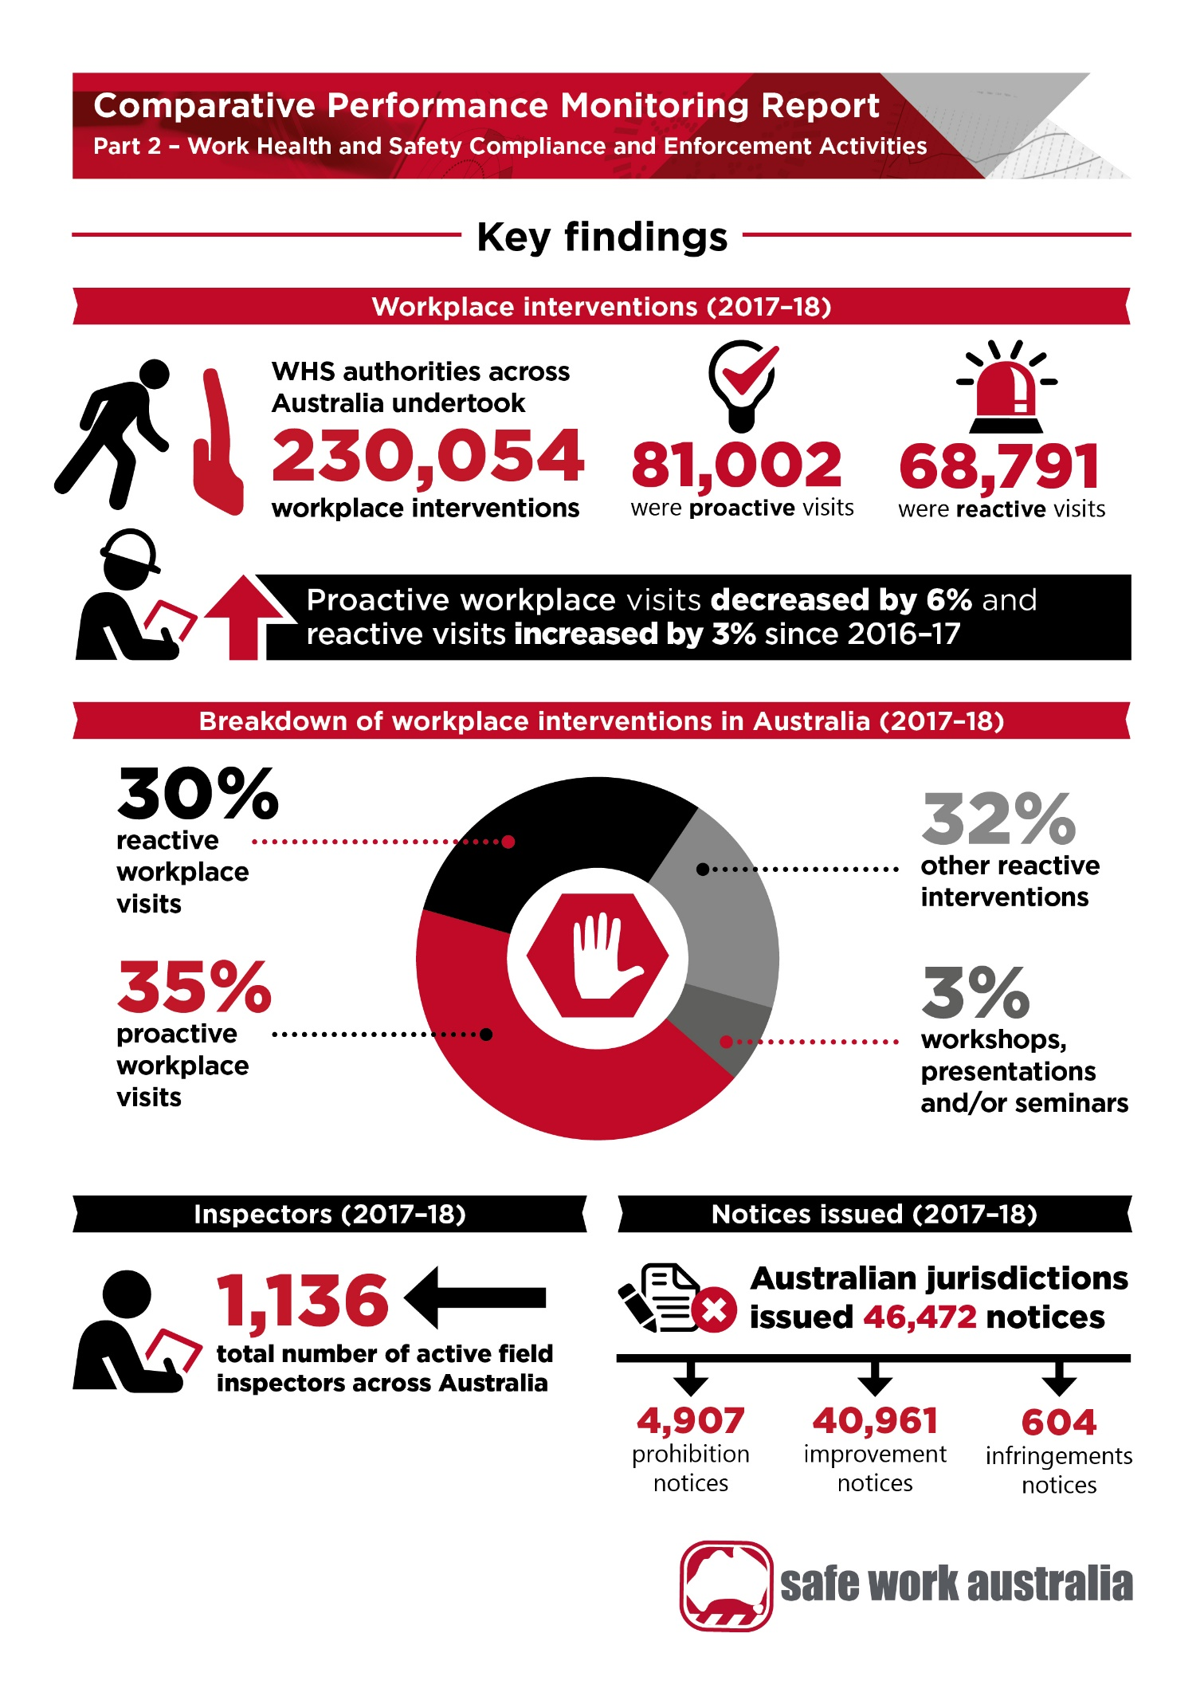

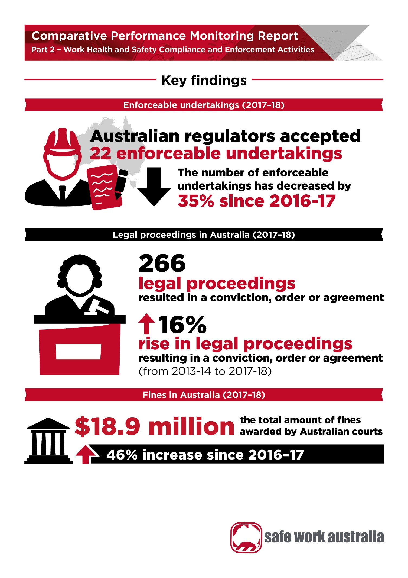

1. Work health and safety compliance and enforcement activities

Jurisdictional work health and safety authorities play a critical role in reducing workplace deaths and injuries by encouraging, monitoring and enforcing compliance with relevant WHS laws. The activity of authorities ranges from educational activities, such as providing information, presentations, training and advice, to enforcement actions such as fines and court proceedings. All Australian and New Zealand WHS authorities take a risk-based approach to compliance activity, applying interventions that are proportionate to the identified risk of workplace harm.

Indicators 12a to 12d provide details on specific work health and safety compliance and enforcement activities undertaken by jurisdictions each year from 2013–14 to 2017–18. The reader should note that the compliance and enforcement data for Indicator 12 do not include the mining sector. Mine inspectors have a different mechanism for enforcement measures and have been excluded from the data due to different legislations operating across the jurisdictions. Due to this exclusion, it is possible that the number of field active inspectors shown in this report may differ from inspectorate numbers shown in jurisdictional reports.

A summary of the compliance and enforcement activities in 2017–18 shows that there were:

* 81,002 proactive workplace visits around Australia
* 68,791 reactive workplace visits around Australia
* 1,136 field active inspectors employed around Australia
* 46,472 notices issued by Australian jurisdictions
* 22 enforceable undertakings accepted by Australian jurisdictions
* 289 legal proceedings against duty holders finalised
* 266 legal proceedings resulting in a conviction, order or agreement, and
* $18.9 million in fines issued by Australian courts.

Each of these activities is discussed in more detail in the sections below.

Interventions

In 2017–18, overall jurisdictional work health and safety authorities undertook 230,054 workplace interventions. Of these, there were 81,002 proactive workplace visits and 68,791 reactive workplace visits. In addition, there were 5,789 proactive workshops, presentations or seminars and 74,472 other reactive intervention activities, such as desk based audits, meetings, telephone advice and written correspondence that are directly involved in the resolution of an incident or complaint.

Indicator 12a shows that the number of proactive workplace visits decreased by 6 per cent and the number of proactive workshops, presentations and seminars decreased by 29 per cent in 2017–18 compared to the previous year. The number of reactive workplace visits increased by 3 per cent, while the number of other reactive intervention activities recorded an 8 per cent increase in 2017–18 compared to the previous year.

A high proportion of intervention activities in New South Wales seek to resolve issues through workplace visits, office-based follow up and stakeholder engagement. New South Wales integrates its proactive prevention programs with reactive activities to ensure greater coverage. The number of proactive and reactive workplace visits increased in New South Wales in 2017–18 compared with the previous year (up by 3 per cent and 28 per cent respectively).

In Victoria the number of proactive workplace visits increased by 1 per cent in 2017–18, while the number of reactive workplace visits increased by 13 per cent compared to the previous year.

Since the model laws came into effect, Queensland started to apply a triaging framework ‘WHSQ Response Activity Process (WRAP)’ to all incident notifications, complaints and statutory requests resulting in a better reporting system for categorising matters between reactive and proactive interventions. Before the introduction of WRAP a proportion of reactive work (namely response assessments) was obscured in proactive work within the Queensland inspectorate activity database due to limitations of the system at the time. This resulted in considerably lower reporting of reactive workplace visits prior to 2013–14. Queensland has developed a new, more contemporary methodology and has provided Safe Work Australia with updated inspectorate data since 2013–14 based on this new methodology. In 2017–18, Queensland recorded a decrease in the number of proactive workplace visits (down 7 per cent), while the number of reactive workplace visits increased by 12 per cent compared to the previous year.

Western Australia recorded a decrease in the number of proactive workplace visits (down 17 per cent), while the number of reactive workplace visits recorded an increase (up 7 per cent) in 2017–18 compared to the previous year.

South Australia recorded a substantial decrease in both the number of proactive and reactive workplace visits (down 36 per cent and 34 per cent respectively). The number of proactive workshops, presentations and seminars decreased by 8 per cent in 2017–18 compared to the previous year. SafeWork SA attributes the decrease of workplace visits, seminars and presentations to the Agency wide Reform Program, which incorporated an organisational restructure resulting in vacant positions extended across the business. The restructure coincided with a whole of Government saving strategy, reducing a proportion of non-Inspector roles, predominantly from the Educator function.

Tasmania recorded a substantial decrease in the number of proactive workplace visits (down 50 per cent), and in proactive workshops, presentations, seminars (down 69 per cent) in 2017–18 compared to the previous year. The number of reactive workplace visits in Tasmania also decreased in 2017–18 (down 24 per cent) compared to the previous year. This trend is on the back of an increase in the number of complex and on-going investigations and an increase in the number of issues and disputes referred to the Regulator for resolution.

The Australian Capital Territory recorded a substantial increase in the number of proactive workplace visits (up 25 per cent) in 2017–18 compared to the previous year. This was due to the continuation of increased levels of engagement and education activities combined with the inspection of retail spaces and visits to events since last year. It was also due to a targeted proactive program conducted by WorkSafe ACT with automotive workshops. However, the number of reactive workplace visits recorded a substantial decrease (down 43 per cent) in 2017–18 compared to the previous year.

The Northern Territory recorded a substantial decrease in the number of proactive workplace visits (down 41 per cent) in 2017–18 compared to the previous year due to an increase in investigations and prosecutions. The introduction of harmonised laws has resulted in a greater focus on education and advice activities that is reflected in increased number of education sessions and the establishment of a Small Business Advisory Team in 2016.

The Australian Government recorded a substantial increase in both the number of proactive workplace visits (up 49 per cent) and reactive workplace visits (up 357 per cent) in 2017-18 compared with the previous year. The number of proactive workshops, presentations and seminars also increased over the year (up 27 per cent), however, the number of other reactive intervention declined, down by 25 per cent.

New Zealand provides combined number of proactive and reactive workplace visits, as they are unable to separate them. New Zealand recoded a 6 per cent increase in the number of proactive workplace visits in 2017–18 compared to the previous year.

Indicator 12a – Work health and safety intervention activity by jurisdiction

| Activity | Financial year | NSW | Vic | Qld | WA | SA | Tas | NT | ACT | Aus Gov | Seacare | aTotal Aus | NZ |
| --- | --- | --- | --- | --- | --- | --- | --- | --- | --- | --- | --- | --- | --- |
| Number of workplace visits: Proactive | 2013–14 | 19,505 | b 22,721 | c 16,561 | d 5,664 | 8,915 | 3,439 | 1,514 | 490 | 2,856 | 57 | 81,722 | f 13,022 |
|  | 2014–15 | 25,164 | b 22,403 | c 16,896 | d 5,116 | 6,157 | 2,823 | 1,793 | 442 | 2,953 | 97 | 83,844 | f 17,320 |
|  | 2015–16 | 23,089 | b 24,369 | c 22,029 | d 5,847 | 5,157 | 2,185 | 2,166 | 1,430 | 1,697 | 93 | 88,062 | f 17,611 |
|  | 2016–17 | 22,139 | b 23,669 | c 17,303 | d 5,169 | 8,815 | 3,826 | 1,477 | 1,933 | 2,000 | 72 | 86,403 | f 13,405 |
|  | 2017–18 | 22,765 | b 23,997 | c 16,031 | d 4,268 | 5,680 | 1,913 | 872 | 2,424 | 2,981 | 71 | 81,002 | f 14,270 |
| Number of workshops/ presentations / seminars: | 2013–14 | 644 | u/a | 2,515 | e 311 | 279 | 125 | 51 | 159 | 2,001 | u/a | 6,085 | u/a |
| Proactive | 2014–15 | 649 | u/a | 4,607 | e 336 | 539 | n/a | 157 | 100 | 2,000 | u/a | 8,388 | u/a |
|  | 2015–16 | 826 | u/a | 3,992 | e 315 | 414 | 878 | 271 | 173 | 1,125 | u/a | 7,994 | u/a |
|  | 2016–17 | 706 | u/a | 4,006 | e 275 | 358 | 1,126 | 240 | 191 | 1,198 | u/a | 8,100 | u/a |
|  | 2017–18 | 818 | u/a | 2,090 | e 264 | 329 | 351 | 240 | 176 | 1,521 | u/a | 5,789 | u/a |
| Number of workplace visits: Reactive | 2013–14 | 10,403 | 18,845 | 10,577 | d 4,149 | 9,338 | 3,623 | 3,514 | 2,384 | 384 | u/a | 63,217 | f u/a |
|  | 2014–15 | 10,818 | 18,317 | 9,350 | d 3,264 | 7,988 | 2,717 | 3,499 | 2,247 | 308 | u/a | 58,508 | f u/a |
|  | 2015–16 | 10,937 | 21,897 | 9,521 | d 3,184 | 10,512 | 1,668 | 3,850 | 2,861 | 226 | u/a | 64,656 | f u/a |
|  | 2016–17 | 9,917 | 22,141 | 9,484 | d 2,951 | 12,525 | 2,028 | 4,429 | 2,990 | 342 | u/a | 66,807 | f u/a |
|  | 2017–18 | 12,739 | 24,921 | 10,605 | d 3,157 | 8,261 | 1,533 | 4,299 | 1,710 | 1,566 | u/a | 68,791 | f u/a |
| Other reactive interventions | 2013–14 | 17,019 | u/a | 34,845 | 14,968 | 9,278 | 0 | 259 | 0 | 2,372 | 0 | 78,741 | g 1,224 |
|  | 2014–15 | 13,227 | u/a | 34,588 | 14,248 | * 3,684 | 0 | u/a | 0 | 3,323 | 0 | 69,070 | h 773 |
|  | 2015–16 | 7,269 | u/a | 36,743 | 13,276 | 4,317 | 0 | u/a | 0 | 3,304 | 0 | 64,909 | h 556 |
|  | 2016–17 | 5,020 | u/a | 41,694 | 15,249 | 4,107 | 0 | u/a | 0 | 2,925 | 0 | 68,995 | h 354 |
|  | 2017–18 | 7,651 | u/a | 44,019 | 16,066 | 4,538 | 0 | u/a | 0 | 2,198 | 0 | 74,472 | h 242 |

u/a – Data unavailable as some jurisdictions do not collect this information. For rest of footnotes, please refer to Appendix 1 – Explanatory Notes.

Inspectors

Indicator 12b shows the numbers and activities of field active inspectors across Australia. Field active inspectors are defined as gazetted inspectors whose role is to spend the majority of their time ensuring compliance with the provisions of work health and safety legislation. In some jurisdictions inspectors engage in other activities to improve the work health and safety capabilities of businesses and workplaces (i.e. a compliance field role). They include investigators (where applicable) who are appointed to work with the enforcement provisions by doing worksite visits, gathering evidence and drawing conclusions. Field active inspectors also include current vacancies and staff on extended leave, managers of the inspectorate regardless of whether undertaking field active work, and auditors (who are gazetted as inspectors) who are responsible for creating an audit template, completing the auditing process and providing feedback. Staff involved in giving advice and information packs from the office, and business advisory officers and community education officers, have been excluded.

Although repeat visits and the number of inspectors in attendance are counted separately for both proactive and reactive workplace intervention measures, this is not the case in Western Australia where inspectors in attendance are not counted separately. Please refer to the Explanatory notes for more details.

Over the five years from 2013–14 to 2017–18, the number of field active inspectors employed around Australia has remained relatively stable. In 2017–18, however, the overall number of field active inspectors in Australia increased slightly (up 3 per cent) compared to the previous year. The number of inspectors grew for Victoria (up 7 per cent), Queensland (up 5 per cent), Tasmania (up 4 per cent), and the Australian Government (up 4 per cent), and remained the same for New South Wales, Western Australia, South Australia, the Northern Territory and Seacare. The Australian Capital Territory was the only jurisdiction to record a fall in inspector numbers (down 7 per cent, or two inspectors).

In 2017–18, the total number of field active inspectors in New Zealand was 183; which is slightly higher (up 1 per cent) compared to the previous year.

Indicator 12b – Work health and safety inspectorate activity by jurisdiction

| Activity | Financial year | NSW | Vic | Qld | WA | SA | Tas | NT | ACT | Aus Gov | Seacare | aTotal Aus | NZ |
| --- | --- | --- | --- | --- | --- | --- | --- | --- | --- | --- | --- | --- | --- |
| Number of field active  inspectors | 2013–14 | 315 | i 261 | 211 | 103 | 93 | 31 | 17 | 30 | 46 | 0 | 1,107 | h, k 160 |
|  | 2014–15 | 315 | i 261 | 210 | 103 | 93 | 23 | 25 | 30 | 46 | 2 | 1,108 | k 181 |
|  | 2015–16 | 315 | i 264 | 217 | 93 | 96 | 25 | 26 | 30 | 46 | 2 | 1,114 | k 181 |
|  | 2016–17 | 315 | i 253 | 217 | 93 | 96 | 25 | 26 | 30 | 50 | 2 | 1,107 | k 181 |
|  | 2017–18 | 315 | i 271 | 227 | 93 | 96 | 26 | 26 | 28 | 52 | 2 | 1,136 | k 183 |
| Number of field active inspectors per 10 000 | 2013–14 | 1.0 | 1.0 | 1.0 | 0.9 | 1.3 | 1.5 | 1.4 | 2.4 | 1.2 | 1.3 | 1.1 | 0.9 |
| employees | 2014–15 | 1.0 | 1.0 | 1.0 | 0.9 | 1.3 | 1.1 | 2.0 | 2.3 | 1.2 | 2.9 | 1.0 | 1.0 |
|  | 2015–16 | 0.9 | 1.0 | 1.0 | 0.8 | 1.3 | 1.2 | 2.0 | 2.2 | 1.2 | 3.3 | 1.0 | 1.0 |
|  | 2016–17 | 0.9 | 0.9 | 1.0 | 0.8 | 1.3 | 1.2 | 2.0 | 2.1 | 1.3 | 2.2 | 1.0 | 1.0 |
|  | 2017–18 | 0.9 | 0.9 | 1.0 | 0.8 | 1.3 | 1.2 | 1.9 | 1.9 | 1.3 | 3.9 | 1.0 | 1.0 |
| Number of other staff undertaking non- | 2013–14 | 0 | u/a | 81 | j 5 | 12 | 0 | 0 | 4 | 36 | 2 | 140 | 0 |
| inspectorate activities | 2014–15 | 0 | u/a | 86 | 3 | 13 | 0 | 0 | 3 | 41 | 2 | 148 | 0 |
|  | 2015–16 | 0 | u/a | 67 | 3 | 11 | 9 | 0 | 4 | 49 | 2 | 145 | 0 |
|  | 2016–17 | 0 | u/a | 68 | 3 | 11 | 9 | 2 | 4 | 49 | 2 | 148 | 0 |
|  | 2017–18 | 0 | u/a | 82 | 4 | 11 | 9 | 2 | 7 | 22 | 2 | 139 | 0 |

u/a – Data unavailable as some jurisdictions do not collect this information. For rest of footnotes, please refer to Appendix 1 – Explanatory Notes.

Notices

In line with the requirements under the model work health and safety laws, some jurisdictions have created infringement notice schemes for certain offences. Where inspectors identify a breach under their work health and safety legislation, a notice may be issued. Data on notices cannot be compared directly across jurisdictions as notices are issued differently in each jurisdiction. In some instances a single notice may be issued for multiple breaches of the legislation, while in other instances separate notices are issued for each breach identified.

Indicator 12c shows that in 2017–18 there was a significant increase in the number of infringement and prohibition notices issued compared to the previous year. Australian jurisdictions issued 46,472 notices in 2017–18, comprising 604 infringement notices (up 103 per cent), 4,907 prohibition notices (up 40 per cent) and 40,961 improvement notices (up 2 per cent) compared to 43,938 notices in the previous year.

In 2017–18, there was a substantial increase from the previous year in the number of notices issued by the Australian Government (up 141 per cent), Queensland (up 95 per cent), the Australian Capital Territory (up 69 per cent), New South Wales (up 30 per cent), Tasmania (up 10 per cent) and South Australia (up 9 per cent). The number of notices issued decreased in Western Australia (down 25 per cent), the Northern Territory (down 9 per cent) and Victoria (down 5 per cent).

Comcare’s Inspectorate has revised its internal processes to align with its Compliance and Enforcement Policy and Risk Model to ensure activities are targeted using a risk-based approach. As a result the Inspectorate is delivering a higher volume of regulatory activity and increasing the use of statutory notices as tools to improve compliance across the Australian Government jurisdiction.

For infringement notices alone, the Australian Capital Territory issued 37 infringement notices in 2017–18 compared to just one in the previous year. The significant increase in the Australian Capital Territory infringement and improvement notices was due to a targeted proactive program conducted by WorkSafe ACT with automotive workshops. In New South Wales there was also a large increase with the number of infringement notices issued more than doubling.

New Zealand recorded a 47 per cent increase in the number of notices issued in 2017–18 compared to the previous year, with a 70 per cent rise in improvement notices alone. These increases were likely due to changes under New Zealand’s new *Health and Safety at Work Act 2015,* whichentered into force on 4 April 2016.

Enforceable undertakings

An enforceable undertaking is a legally binding agreement made in response to the contravention of a work health and safety law, which is entered into as an alternative to legal proceedings. An enforceable undertaking provides an opportunity for significant work health and safety remediation to be undertaken, while avoiding the costs and time burden associated with court actions. Typically the activities associated with an undertaking are substantial and must aim to deliver tangible benefits to the workplace, industry or the broader community.

Enforceable undertakings are an important compliance tool under the model work health and safety legislation. An enforceable undertaking will generally not be accepted where the offence relates to reckless conduct or where an infringement notice has been issued for the contravention.

There were 22 enforceable undertakings accepted by regulators in 2017–18, compared to 34 in the previous year, as shown in Indicator 12c. The number of enforceable undertakings accepted by regulators varies from one year to another depending on specific cases.

The New Zealand *Health and Safety at Work Act 2015* came into effect on 4 April 2016. This introduced a broader suite of enforcement tools such as enforceable undertakings. As a result there were 2 enforceable undertakings accepted by the regulators in New Zealand in 2016–17 and 14 in 2017–18 as shown in Indicator 12c.

Indicator 12c – Work health and safety notices and enforceable undertakings by jurisdiction

| Activity | Financial year | NSW | Vic | Qld | WA | SA | Tas | NT | ACT | Aus Gov | Seacare | aTotal Aus | NZ |
| --- | --- | --- | --- | --- | --- | --- | --- | --- | --- | --- | --- | --- | --- |
| Number of infringement notices issued | 2013–14 | 55 | l u/a | 58 | l n/a | 2 | 22 | 0 | 43 | l n/a | l n/a | 180 | 101 |
|  | 2014–15 | 92 | l u/a | 29 | l n/a | 2 | 14 | 1 | 13 | l n/a | l n/a | 151 | 100 |
|  | 2015–16 | 88 | l u/a | 57 | l n/a | 1 | 14 | 3 | 0 | l n/a | l n/a | 163 | 35 |
|  | 2016–17 | 160 | l u/a | 123 | l n/a | 1 | 12 | 1 | 1 | l n/a | l n/a | 298 | 12 |
|  | 2017–18 | 324 | l u/a | 221 | l n/a | 0 | 20 | 2 | 37 | l n/a | l n/a | 604 | 10 |
| Number of improvement notices issued | 2013–14 | 5,098 | 15,834 | 4,424 | 12,568 | 1,347 | 160 | 108 | 832 | 20 | 32 | 40,423 | 4,947 |
|  | 2014–15 | 6,545 | 15,730 | 1,749 | 12,039 | 1,728 | 241 | 74 | 369 | 8 | 43 | 38,526 | 5,809 |
|  | 2015–16 | 7,266 | 16,733 | 1,755 | 11,893 | 1,575 | 308 | 103 | 130 | 18 | 51 | 39,832 | 3,683 |
|  | 2016–17 | 7,513 | 15,912 | 2,485 | 11,341 | 2,342 | 212 | 169 | 141 | 8 | 3 | 40,126 | 2,117 |
|  | 2017–18 | 9,210 | 15,170 | 4,899 | 8,526 | 2,468 | 251 | 208 | 205 | 24 | 0 | 40,961 | 3,595 |
| Number of prohibition notices issued | 2013–14 | 498 | 499 | 1,222 | 550 | 629 | 121 | 122 | 195 | 14 | 0 | 3,850 | 2,423 |
|  | 2014–15 | 673 | 542 | 760 | 427 | 832 | 106 | 131 | 133 | 7 | 0 | 3,611 | 2,048 |
|  | 2015–16 | 718 | 527 | 542 | 279 | 688 | 85 | 117 | 71 | 8 | 3 | 3,038 | 1,304 |
|  | 2016–17 | 1,041 | 576 | 659 | 278 | 650 | 95 | 148 | 58 | 9 | 0 | 3,514 | 1,131 |
|  | 2017–18 | 1,810 | 555 | 1,247 | 233 | 791 | 79 | 80 | 95 | 17 | 0 | 4,907 | 1,194 |
| Number of enforceable undertakings | 2013–14 | 1 | 13 | 10 | m n/a | 0 | 0 | 0 | 0 | 0 | n/a | 24 | m n/a |
|  | 2014–15 | 5 | 8 | 7 | m n/a | 1 | 0 | 0 | 2 | 0 | n/a | 23 | m n/a |
|  | 2015–16 | 12 | 5 | 10 | m n/a | 4 | 0 | 3 | 1 | 0 | n/a | 35 | m n/a |
|  | 2016–17 | 10 | 12 | 5 | m n/a | 3 | 0 | 2 | 2 | 0 | n/a | 34 | m 2 |
|  | 2017–18 | 7 | 5 | 3 | m n/a | 2 | 0 | 3 | 2 | 0 | n/a | 22 | m 14 |

u/a – Data unavailable as some jurisdictions do not collect this information. For rest of footnotes, please refer to Appendix 1 – Explanatory Notes.

Legal proceedings

A legal proceeding is defined as any investigation activity where a complaint has been laid or a summons issued against a company or individual. This data item is designed to collect the number of companies or individuals against which a legal proceeding has been either finalised, or resulted in a conviction, order or agreement. A conviction order or agreement is defined (with or without penalty) once it has been recorded against a company or individual, in the judicial system. All legal proceedings recorded in the reference year are counted regardless of when the initial legal action commenced. Data for Victoria and the Australian Capital Territory is limited to the number of successful prosecutions resulting in a conviction, fine or both.

Indicator 12d shows that, in 2017–18, there was a 16 per cent increase in the overall number of legal proceedings finalised compared to the previous year – although this was mostly driven by relatively large increases New South Wales (up 79 per cent) and Victoria (up 23 per cent). However most jurisdictions recorded an increase in the number of proceedings that resulted in a conviction, order or agreement, with a total rise in these proceedings of 20 per cent in 2017–18 compared to the previous year.

Across Australia, the Northern Territory recorded an increase from one finalised legal proceeding in 2016-17 to three in 2017-18. New South Wales (up 79 per cent) and Victoria (up 23 per cent) both recorded substantial increases in the number of legal proceeding finalised in 2017-18 compared with the previous year. The Australian Capital Territory recorded the largest decrease (down 67 per cent) in the number of legal proceedings finalised, followed by Western Australia (down 21 per cent), Tasmania (down 20 per cent) and Queensland (down 6 per cent). The Australian Government did not record any legal proceedings finalised in 2017–18, compared to two cases recorded in the previous year.

Tasmania recorded a substantial increases in the number of legal proceedings resulting in a conviction, order or agreement increases from only one in 2016-17 to four in 2017-18. Of the larger jurisdictions, New South Wales (up 79 per cent), and Victoria and South Australia (up 25 per cent each) recorded the largest yearly increase in the number of legal proceedings resulting in a conviction, order or agreement.

In New Zealand, there was a 9 per cent increase in the number of legal proceedings finalised in   
2017–18 compared to the previous year. However, the number of legal proceedings resulting in a conviction, order or agreement decreased by 16 per cent in 2017–18 compared to the previous year.

Fines

Indicator 12d shows that the total amount of fines awarded by the courts in 2017–18 was $18.9 million, a 46 per cent increase from the previous year. In some instances the courts declare that penalty amounts are to remain confidential. Therefore the data recorded in Indicator 12d are only those amounts known publicly. Individual cases can impact the total amount of fines awarded by the courts as fines are recorded in the year the court makes a judgement. There may therefore be variability year‑to-year and a lag between an action being initiated and a fine awarded.

In 2017–18, the Northern Territory recorded the largest increase (up 626 per cent) in the amount of fines awarded by the courts compared to the previous year, followed by Victoria (up 174 per cent), South Australia (up 93 per cent), Western Australia (up 90 per cent) and Tasmania (up 49 per cent).

The Australian Capital Territory recorded the largest decrease (down 56 per cent) in the amount of fines awarded in 2017–18 compared to the previous year, followed by New South Wales (down 8 per cent) and Queensland (down 1 per cent). The Australian Government did not record any fines in 2017–18 compared to $908,000 in the previous year.

The total amount of fines ordered by the courts in New Zealand was $4.3 million during 2017–18, which was 139 per cent higher than that reported in 2016–17.

Indicator 12d – Work health and safety legal proceedings and fines by jurisdiction

| Activity | Financial year | NSW | Vic | Qld | WA | SA | Tas | NT | ACT | Aus Gov | Seacare | a Total Aus | NZ |
| --- | --- | --- | --- | --- | --- | --- | --- | --- | --- | --- | --- | --- | --- |
| Number of legal proceedings finalised | 2013–14 | n 46 | 109 | 53 | 20 | 27 | 5 | 1 | 4 | 0 | 0 | 265 | 97 |
|  | 2014–15 | n 91 | 113 | 54 | 19 | 19 | 0 | 0 | 5 | 5 | 0 | 306 | 98 |
|  | 2015–16 | n 61 | 105 | 48 | 18 | 23 | 6 | 3 | 7 | 3 | 0 | 274 | 96 |
|  | 2016–17 | n 34 | 103 | 69 | 14 | 16 | 5 | 1 | 6 | 2 | 0 | 250 | 65 |
|  | 2017–18 | n 61 | 127 | 65 | 11 | 16 | 4 | 3 | 2 | o 0 | 0 | 289 | 71 |
| Number of legal proceedings resulting in | 2013–14 | n 41 | 94 | 47 | 16 | 21 | 5 | 1 | 4 | 0 | 0 | 229 | 83 |
| a conviction, order or agreement | 2014–15 | n 88 | 104 | 42 | 13 | 17 | 0 | 0 | 4 | 5 | 0 | 273 | 90 |
|  | 2015–16 | n 55 | 98 | 42 | 17 | 19 | 2 | 1 | 4 | 3 | 0 | 241 | 88 |
|  | 2016–17 | n 33 | 93 | 64 | 13 | 12 | 1 | 2 | 1 | 2 | 0 | 221 | 58 |
|  | 2017–18 | n 59 | 116 | 56 | 11 | 15 | 4 | 3 | 2 | 0 | 0 | 266 | 49 |
| Total amount of fines ordered by the courts | 2013–14 | $2,481 | $3,673 | $1,910 | $485 | $956 | $33 | $5 | $58 | $0 | $0 | $9,601 | $3,529 |
| ($’000) | 2014–15 | $7,012 | $4,097 | $1,800 | $547 | $737 | $0 | $0 | $311 | $1,033 | $0 | $15,537 | $2,857 |
|  | 2015–16 | $4,063 | $4,451 | $1,104 | $640 | $778 | $75 | $152 | $238 | $460 | $0 | $11,961 | $3,521 |
|  | 2016–17 | $4,464 | $3,460 | $2,594 | $415 | $721 | $225 | $27 | $140 | $908 | $0 | $12,954 | $1,823 |
|  | 2017–18 | $4,112 | $9,467 | $2,569 | $788 | $1,395 | $335 | $196 | $61 | $0 | $0 | $18,923 | $4,348 |

u/a – Data unavailable as some jurisdictions do not collect this information. For rest of footnotes, please refer to Appendix 1 – Explanatory Notes.

Appendix 1 –– Explanatory notes

## Indicator 12 – Footnotes

### Footnotes for Indicator 12a

* In 2014–15, SafeWork SA reassessed what it counts as a reactive intervention. SafeWork SA recalculated previous figures (2012–13 to 2017–18) to align with reassessed reactive intervention data.

1. Totals only include jurisdictions that supplied the relevant data.
2. Does not include industry forums/ presentations where an inspection also occurs.
3. Queensland provided updated enforcement data following a major review of inspectorate data collection during 2016–17. The updated data provided goes back to the 2013–14 financial year.
4. The number of inspectors in attendance in Western Australia is not counted separately.
5. Western Australia figures may be inflated when inspectors and community education officers, on occasions, present at or attend the same event. These figures cannot currently be identified or separated. In addition, the ThinkSafe Small Business Program officially ceased in March 2014. Program data is included in figures up to 2013–14 for this activity, and as such, data reported in 2014–15 and beyond is not directly comparable to previous years.
6. The numbers provided were the number of total workplace assessments.
7. Other reactive intervention activities are interpreted as investigation activity.
8. The drop is due to budget cuts.

### Footnotes for Indicator 12b

1. The drop is due to budget cuts.
2. Amended to include managers of inspectorate.
3. Data provided up to 2013–14 include FTE figures for external consultants, the ThinkSafe Small Business Manager, and Community Education Officers. The ThinkSafe Small Business Program officially ceased in March 2014. Therefore, data reported in 2014–15 and beyond is not comparable to previous years.
4. The number of field active inspectors for New Zealand excludes field active inspectors operating in Maritime, Aviation and High Hazard areas.

### Footnotes for Indicator 12c

1. There is no legislative requirement for infringement notices in Western Australia, Victoria and the Australian Government, while in South Australia it commenced in January 2013 under its WHS legislation. There is no provision under the OHS(MI) Act for issuing of infringement notices in the Seacare scheme*.*
2. Enforceable undertakings are included in Western Australia under Section 55H of the *Occupational Safety and Health Act 1984;* however none have been finalised since that time. New Zealand introduced enforceable undertakings in 2016, and the first full year of data for this is 2017–18.

### Footnote for Indicator 12d

1. Data shows the number of defendants in successful work health and safety prosecutions.
2. Four criminal proceedings were commenced during the 2017–18 financial year but none were finalised.

Appendix 2 – Jurisdictional contact information

| Jurisdiction | Organisation | Contact details |
| --- | --- | --- |
| New South Wales | State Insurance Regulatory Authority  SafeWork NSW  Customer Service Centre | [www.sira.nsw.gov.au](http://www.sira.nsw.gov.au/)  [www.safework.nsw.gov.au](http://www.safework.nsw.gov.au/)  13 10 50 |
| Victoria | WorkSafe Victoria | Advisory Service  1800 136 089  [info@worksafe.vic.gov.au](mailto:info@worksafe.vic.gov.au)  [www.worksafe.vic.gov.au](http://www.worksafe.vic.gov.au/) |
| Queensland | Workplace Health and Safety Queensland – Office of Industrial Relations – Education Queensland | Infoline  1300 362 128  [www.worksafe.qld.gov.au](https://www.worksafe.qld.gov.au/) |
| Western Australia | WorkCover WA  Department of Mines, Industry Regulation and Safety – WorkSafe | (08) 9388 5555  [www.workcover.wa.gov.au](http://www.workcover.wa.gov.au/)  1300 307 877  [www.dmirs.wa.gov.au](http://www.dmirs.wa.gov.au/) |
| South Australia | Return to WorkSA (rtwsa)  SafeWork SA | 13 18 55  [www.rtwsa.com](http://www.rtwsa.com/)  1300 365 255  [www.safework.sa.gov.au](http://www.safework.sa.gov.au/) |
| Tasmania | WorkSafe Tasmania | Helpline  1300 366 322 (inside Tas)  (03) 6166 4600 (outside Tas)  [wstinfo@justice.tas.gov.au](mailto:wstinfo@justice.tas.gov.au)  [www.worksafe.tas.gov.au](http://www.worksafe.tas.gov.au/) |
| Northern Territory | NT WorkSafe | 1800 019 115  [ntworksafe@nt.gov.au](mailto:ntworksafe@nt.gov.au)  [www.worksafe.nt.gov.au](http://www.worksafe.nt.gov.au/Pages/default.aspx) |
| Australian Capital Territory | Access Canberra WorkSafe ACT within Chief Minister Treasury and Economic Development Directorate | (02) 6207 3000  [www.worksafe.act.gov.au](http://www.worksafe.act.gov.au/health_safety) |
| Seafarers | Seacare Authority | (02) 6275 0070  [seacare@comcare.gov.au](mailto:seacare@comcare.gov.au)  [www.seacare.gov.au](http://www.seacare.gov.au/) |
| Australian Government | Comcare | 1300 366 979  [www.comcare.gov.au](http://www.comcare.gov.au/) |
| New Zealand | Accident Compensation Corporation  WorKSafe New Zealand | 64 7 848 7400  [www.acc.co.nz](http://www.acc.co.nz/)  0800 030 040  [www.worksafe.govt.nz](http://www.worksafe.govt.nz) |