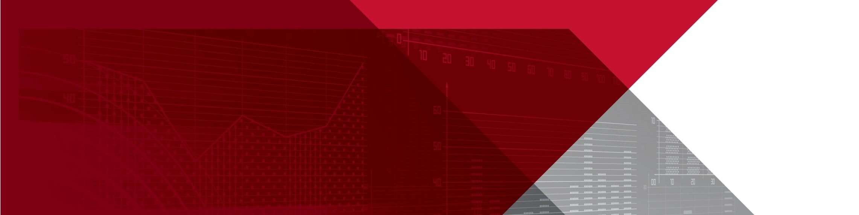Psychosocial health and safety and bullying in Australian workplaces

Indicators from accepted workers’ compensation claims

Annual statement, 5th edition, 2019

Introduction

Psychosocial health is the physical, mental and social state of a person. Workers exposed to adverse workplace design and culture are at greater risk of developing a psychological injury caused by mental stress.

This is the fifth annual national statement issued by Safe Work Australia to identify trends in psychosocial health and safety and bullying in Australian workplaces. This statement presents information from accepted workers’ compensation claims involving mental stress; that is, claims when the work-related injury or disease results from the person experiencing mental stress or being exposed to mentally stressful situations.

The prevalence of this type of claim provides a limited indicator for the psychosocial health and safety status of Australian workplaces. The   
mental stress claims data includes a sub-category for work-related harassment and/or workplace bullying. This sub-category is assigned to claims when the employee was a victim of:

* repetitive assault and/or threatened assault by a work colleague or colleagues, or
* repetitive verbal harassment, threats, and abuse from a work colleague or colleagues.

This sub-category broadly aligns with the nationally accepted definition of workplace bullying of repeated and unreasonable behaviour directed towards a worker or a group of workers that creates a risk to health and safety (*Fair Work Act 2009, s.789FD(1)*). Excluded are assault cases where the physical injuries were considered more serious than the mental stress involved in the incident.

Work-related mental stress claim trends

Figure 1 shows that the frequency rate (claims per 100 million hours worked) of mental stress claims has fallen in the 16 years from 2002–03 to 2017–18p. While the rate for harassment and/or bullying claims has increased over that same period, it remains less than the peak in 2010–11. However, rates for both mental stress and harassment and/or bullying claims have risen over the last two years. This trend data is an approximate indicator of the psychosocial health and safety status of Australian workplaces over time and should be interpreted with caution. External factors such as changes to jurisdictional legislation are highly likely to have influenced the scope of claims involving mental stress over the reporting period.

**Figure 1: Mental stress and sub-category harassment and/or bullying: Frequency rates, 2002–03 to 2017–18p\***

**Figure 1 is a line chart and shows the trend for mental stress has fallen over the 16 year period from 72.8 to 50.2 claims per 100 million hours worked. Over the same period, the trend for harassment and/or workplace bullying has increased from 6.6 to 14.9 claims per 100 million hours worked.
**

* 2017–18 data are preliminary and subject to change.

** Victoria only provides data on the top-level category of mental stress claims, and is not included in the data for Harassment and/or workplace bullying. See explanatory notes for further details.

Work-related mental stress sub-category breakdown

Table 1 provides key statistics for claims involving mental stress as the main mechanism of injury or disease for 2016–17, broken up by mechanism sub-category. 2016-17 data has been used, as 2017-18 data is still preliminary and therefore may underestimate median time lost and costs. This data shows that, while mental stress claims only make up a small proportion of claims, the median time lost and median direct cost associated with mental stress claims are significantly higher compared to those observed for all workers’ compensation claims.

Table 1: Number, time lost, direct cost, frequency rate and incidence rate for mental stress claims, 2016–17

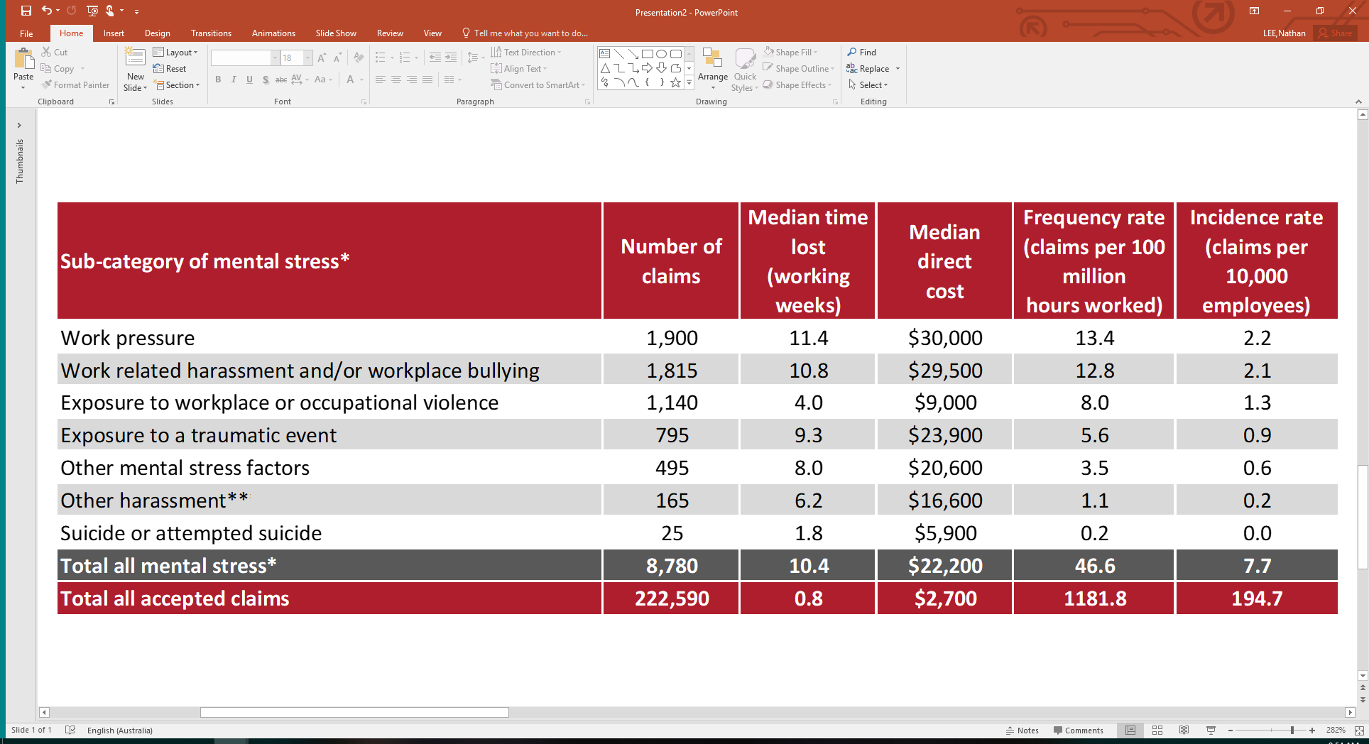

*Victoria only provides data on the top-level category of mental stress claims, so is included in the total but not the breakdown of sub‑categories. See explanatory notes for further details. As a result, figures for the total mental stress claims may not equal the sum of columns.

**The *Other harassment* sub-category includes victims of sexual or racial harassment by a person or persons including work colleague/s.

**Notes:**

1. The *mechanism of incident* classification identifies the overall action, exposure or event that best describes the circumstances that resulted in the most serious injury or disease.

2. In previous statements, the amount of median compensation paid were calculated after excluding ‘zero dollar’ claims. In this report, all serious claims (including ‘zero dollar’ claims) have been included in calculations.

Work-related mental stress sub-categories by sex

The frequency rate of workers’ compensation claims for harassment and/or bullying made by female employees was more than twice as high as the rate of these claims made by males over the three years 2015–16 to 2017–18p combined. Similarly, the rates for claims made by females relating to work pressure and exposure to workplace or occupational violence were more than twice that of similar claims made by males.

**Figure 2: Frequency rates by sex and mental stress sub-category, 2015–16 to 2017–18p combined**

**Figure 2 is a bar chart and provides a breakdown of the frequency rates of workers' compensation claims for males and females by mental stress sub-categories for the three year  period 2015-16 to 2017-18 combined.
**

**Note:** Mental stress sub-category data excludes information from Victoria. See explanatory notes for further details.

Work-related harassment and/or bullying by occupation and industry

Occupations with a high risk of exposure to work-related harassment and/or workplace bullying include *Other miscellaneous and administrative workers; Other clerical and office support workers;* and *Other miscellaneous labourers.*

**Figure 3: Top 10 occupations with the highest frequency rates of work-related harassment and/or bullying,   
2015–16 to 2017–18p combined**

Figure 3 is a bar chart showing the 10 occupations with the highest frequency rates of work-related harassment and/or bullying for the three year period 2015-16 to 2017-18 combined. 

*This group includes coding clerks, production assistants, proof readers, radio dispatchers & examination supervisors.

**This group includes classified advertising clerks, meter readers & parking inspectors.

*** Police in Western Australian are covered by a separate workers’ compensation scheme and not included in the data.

**Notes**:

1. Occupations are limited to those associated with more than 50 claims.

2. Victorian data is not included. See explanatory notes for further details.

Industry groups with high rates of claims involving work-related harassment and/or workplace bullying include *Public order and safety services; Civic, professional and other interest group services;* and *Residential care services.*

**Figure 4: Top 10 industry groups with the highest frequency rates of work-related harassment and/or bullying,   
2015–16 to 2017–18p combined**

Figure 4 is a bar chart showing the 10 industry groups with the highest frequency rates of work-related harassment and/or bullying for the three year period 2015-16 to 2017-18 combined. 

* Police in Western Australian are covered by a separate workers’ compensation scheme and not included in the data.

**Notes**:

1. Industries are limited to those associated with more than 50 claims.

2. Victorian data is not included. See explanatory notes for further details.

Research

The *Bullying and Harassment in Australian Workplaces: Results from the Australian Workplace Barometer 2014–15* report shows that in 2014–15, using the national definition, 9.4 per cent of Australian workers participating in the survey reported they had been bullied at work in the previous six months. The 2014-15 finding represents a 39 per cent increase in the prevalence of workplace bullying compared to that reported by participants in the 2009‑11 iteration of the Australian Workplace Barometer, when 7.0 per cent reported they were bullied.

In 2018 the Australian Human Rights Commission conducted a national survey to investigate the prevalence, nature and reporting of sexual harassment in Australian workplaces and the wider community.

The results of the survey are more detailed and robust than in the past, with more than 10,000 Australians surveyed (five times the number who have participated in previous years). The survey findings are informing the [National Inquiry into Sexual Harassment in Australian Workplaces](https://www.humanrights.gov.au/our-work/sex-discrimination/projects/national-inquiry-sexual-harassment-australian-workplaces).

Background

The House of Representatives Standing Committee on Education and Employment report *Workplace bullying: “We just want it to stop”,* tabled on 26 November 2012, contained 23 recommendations that focus on:

* defining what bullying is and is not
* promoting and strengthening existing legislative and regulatory frameworks
* improving workplace cultures
* enhancing tools for the prevention and early resolution of workplace bullying incidences, and
* providing an individual right of recourse.

Recommendation 18 of the report states “*The Committee recommends that Safe Work Australia issues an annual national statement which updates any emerging trends of its collated data from each of the state and territory regulators, and the Commonwealth, with respect to psychosocial health and safety generally and workplace bullying specifically.*” This statement is produced annually in response to this recommendation. For the full report go to [aph.gov.au](http://www.aph.gov.au/).

The Fair Work Commission

From 1 January 2014, a worker (including an employee, contractor, apprentice or volunteer) who is covered by the *Fair Work Act 2009* and reasonably believes they have been bullied at work may apply to the Fair Work Commission for an order to stop the workplace bullying. More information is available at <http://www.fwc.gov.au>.

**Other related Safe Work Australia publications**

These and other reports are available at

[safeworkaustralia.gov.au](http://www.safeworkaustralia.gov.au).

* Work-related psychological health and safety: A systematic approach to meeting your duties
* Guide for Preventing and Responding to Workplace Bullying, May 2016
* Dealing with Workplace Bullying - A Worker’s Guide, May 2016
* Work-related Mental Disorders profile, 2015
* The Incidence of Accepted Workers’ Compensation Claims for Mental Stress in Australia, April 2013

Data source and explanatory notes

Data are sourced from the National Dataset for Compensation-based Statistics (NDS) and include all accepted workers’ compensation claims for temporary incapacity, permanent incapacity and fatalities made under jurisdictional workers’ compensation schemes. Claims are coded according to the Type of Occurrence Classification System 3rd Ed. Revision 1 (TOOCS). Industry and occupation level data are presented using the Australian and New Zealand Standard Industrial Classification (ANZSIC) 2006 and Australian and New Zealand Standard Classification of Occupations (ANZSCO) 2006. Data presented for mental stress are national figures but data for subcategories of mental stress exclude Victoria because its data are not coded to that level of detail. Data for 2017–18 are preliminary (denoted by the letter ‘p’) and subject to future adjustment. Police in Western Australia, who are covered by a separate scheme that does not report to Safe Work Australia, are excluded. Workers’ compensation statistics provide the only national administrative data indicators for psychosocial stressors in Australian workplaces. The hours worked data used to calculate frequency rates were provided by the Australian Bureau of Statistics in 2019.

Please note that the data included in this report relates only to accepted workers’ compensation claims for mental stress. The data does not include incidences where a worker is not covered by workers’ compensation arrangements, ineligible to make a claim, or has otherwise experienced work‑related mental stress or bullying and harassment but decided not to make a claim. It also excludes bullying and harassment claims where the worker experienced physical injuries that were perceived to be greater than the psychological impact. As such, the data is likely to under-report the true incidence of work-related mental stress.